**Ability to Prepare data, Model Data in Power Bi**

KO1:Able to Navigate the Query Editor, use Query Editor to Prepare a Power BI Data Model and access the Underlying Query Code

* Accessing the power query editor in Power BI

Step1:- Loading the csv data

* + select the get data option as shown in the fig and select the more option to view the different data sources

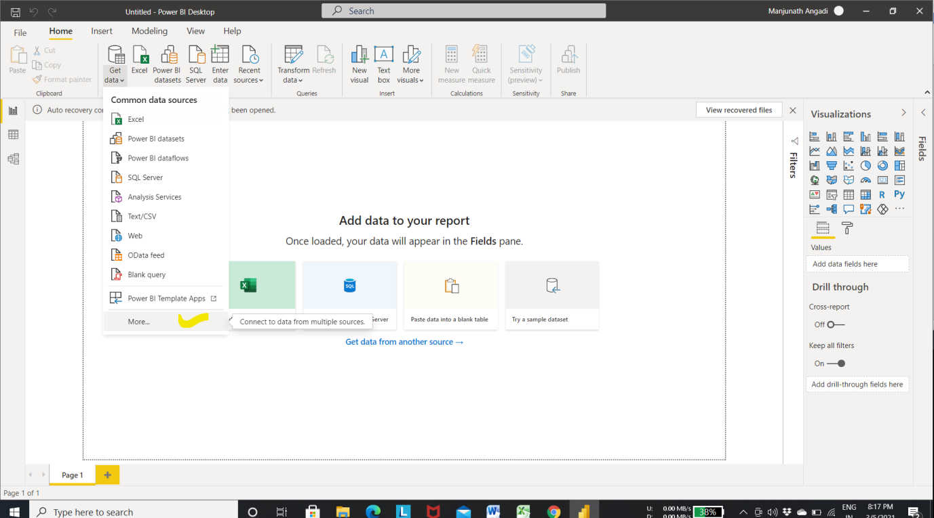

Step 2:- Select the text/ csv to load the csv file

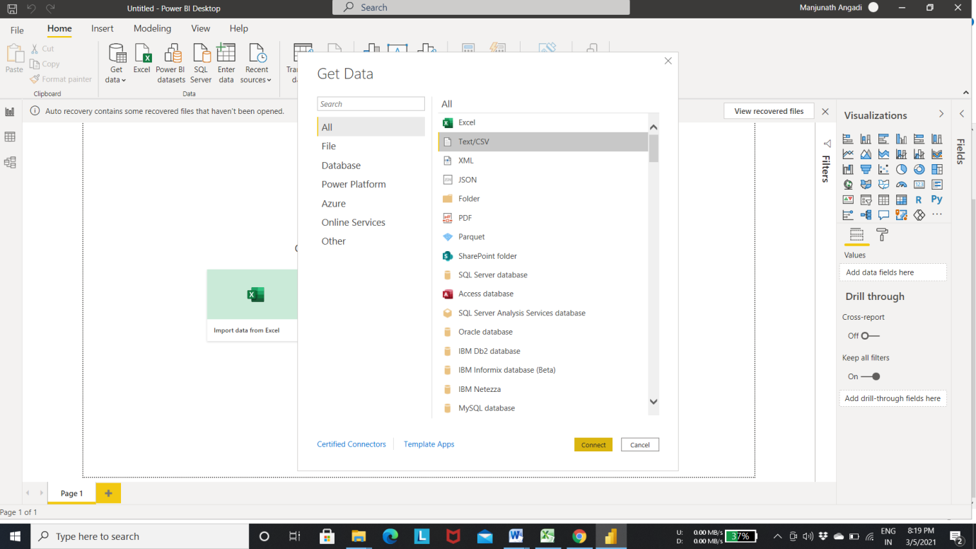

Step 3 :- choose the text/ csv file that you want to load

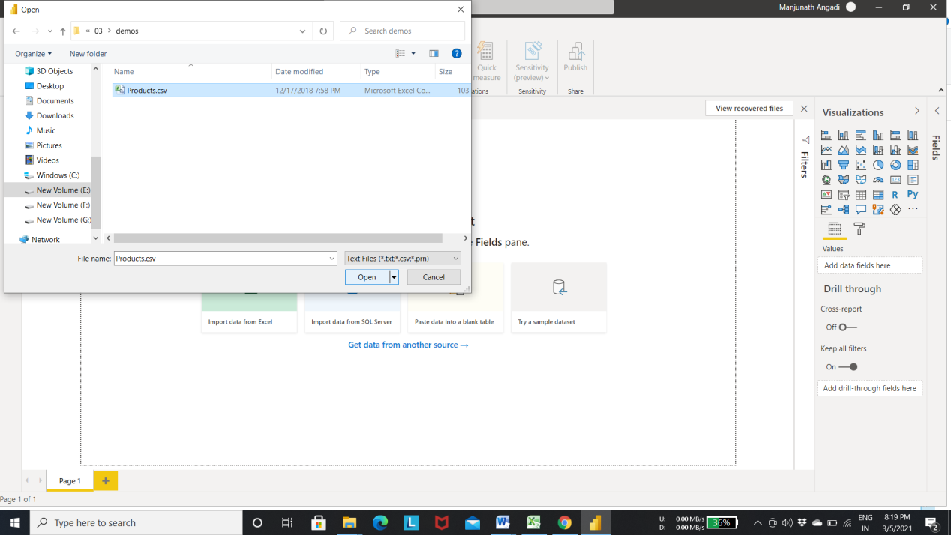

Step 4:- click on load to load the data into power BI

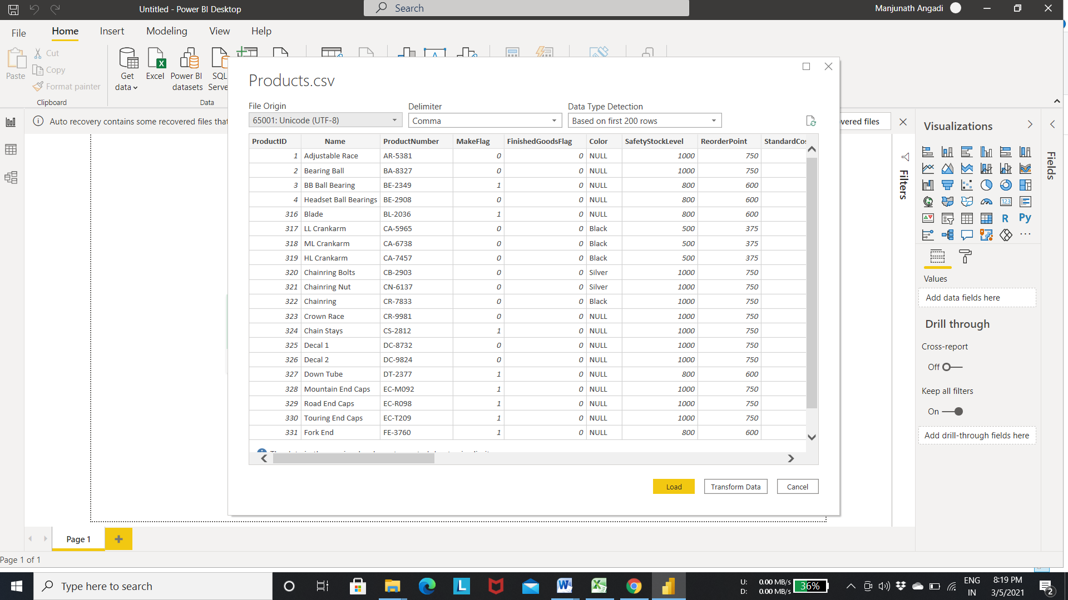

Output : the table is loaded into the power bi as shown in the below fig

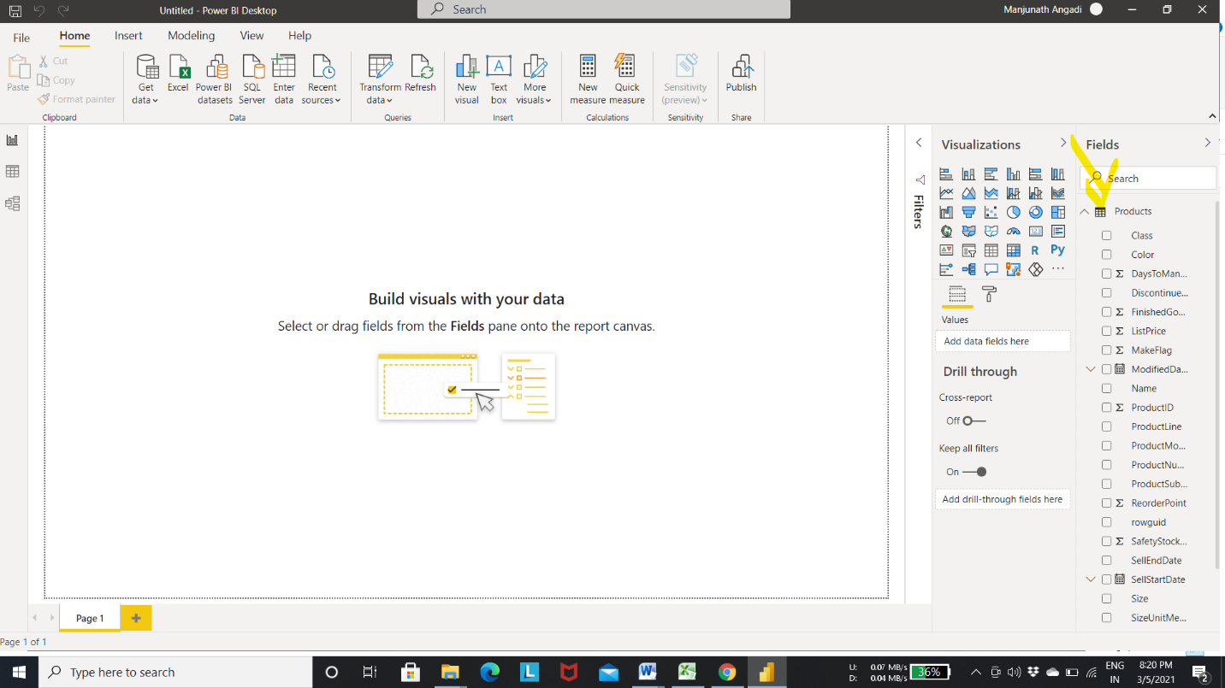

Step 5 :- select the transform data to move to the power query editor

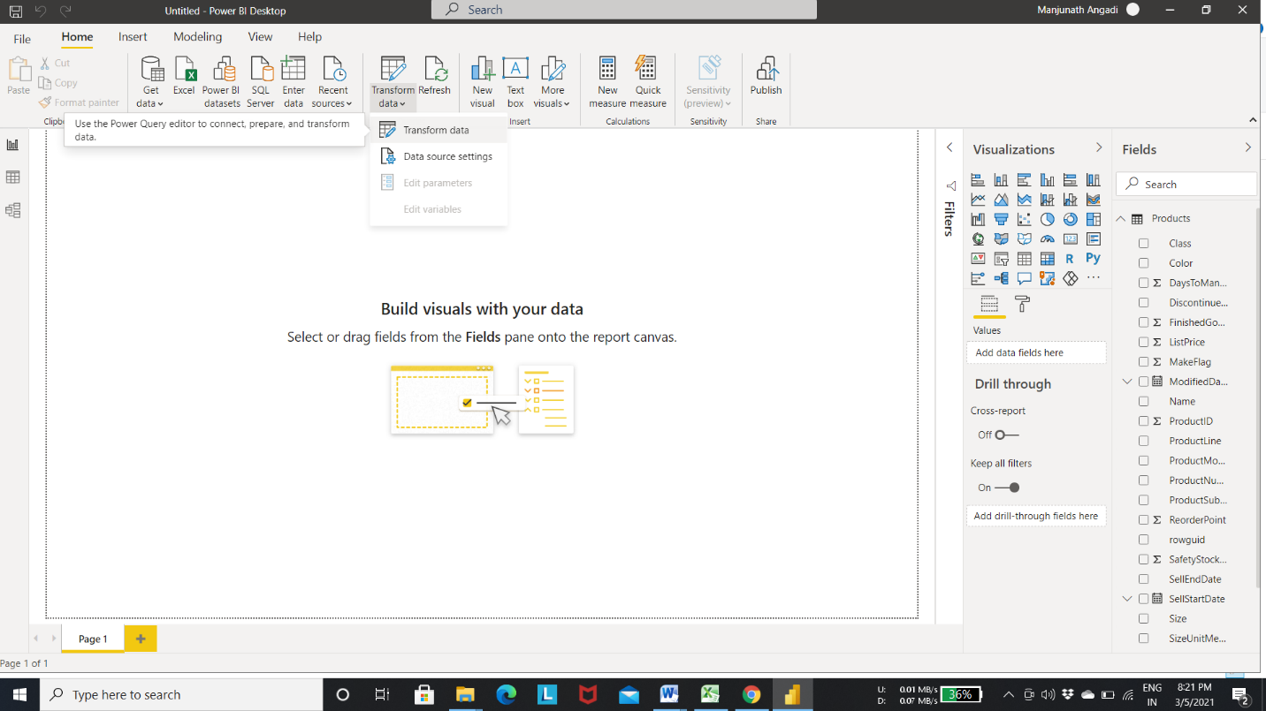

Output :- below fig shows the power query editor

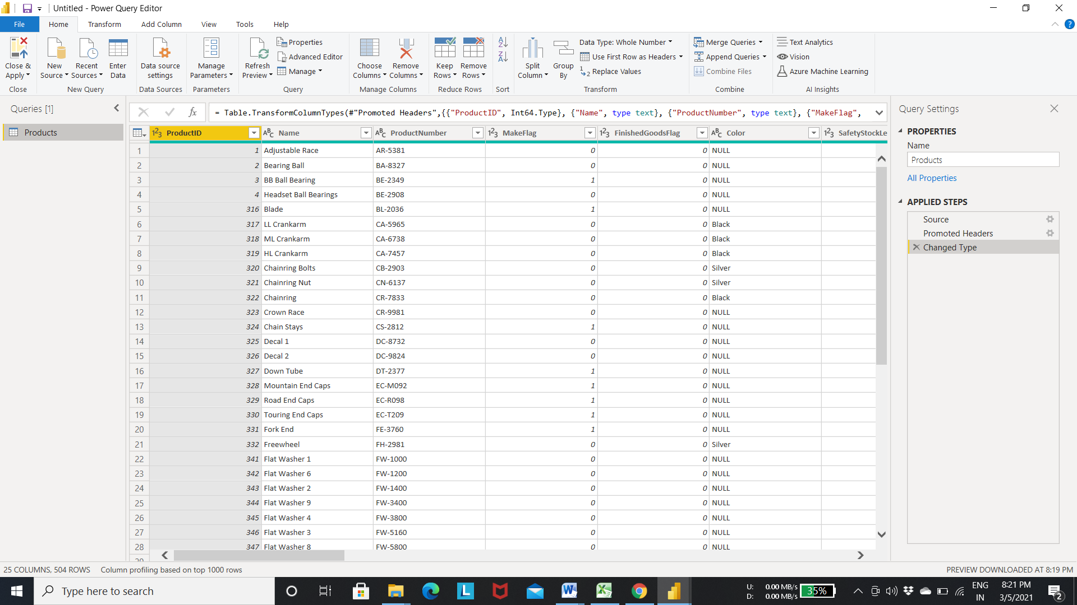

Step 6:- in the above fig product number contains the product code and number to separate them into 2 columns use the split column delimiter as shown in the below fig

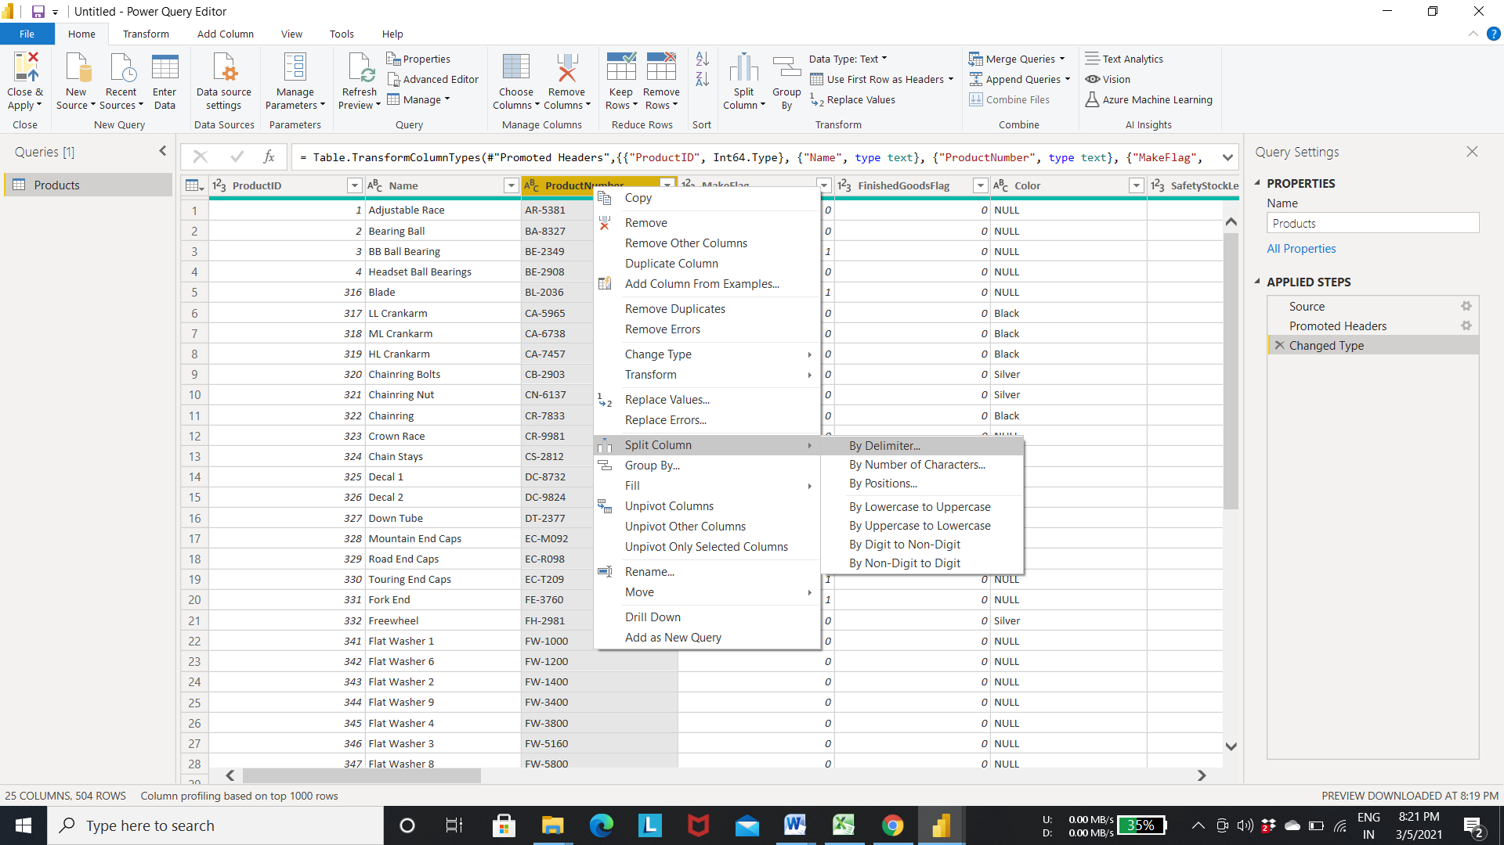

Step 7: the below window appears after selecting split column by delimiter . the query editor automatically detects the delimiter so click ok to apply changes.

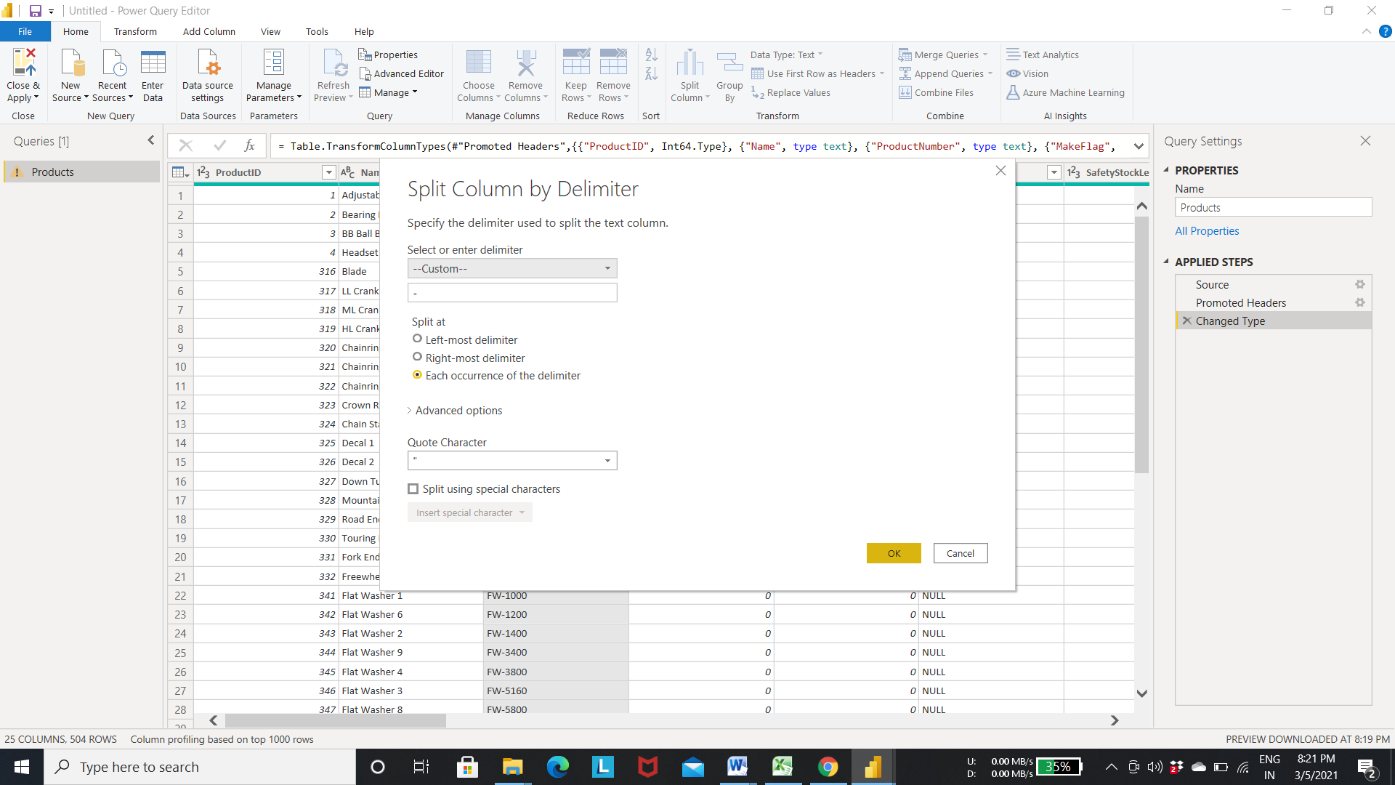

Output : splits the column by delimiter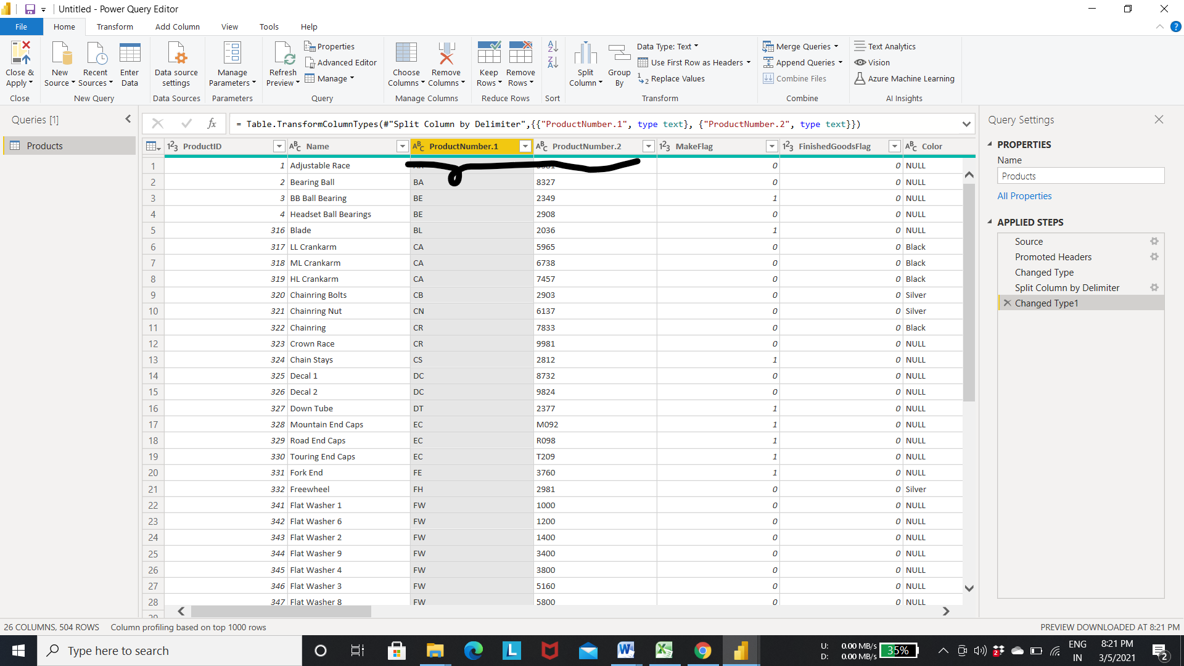

* To Rename the column

Step 8: To Rename the column right click on the column and select the rename option

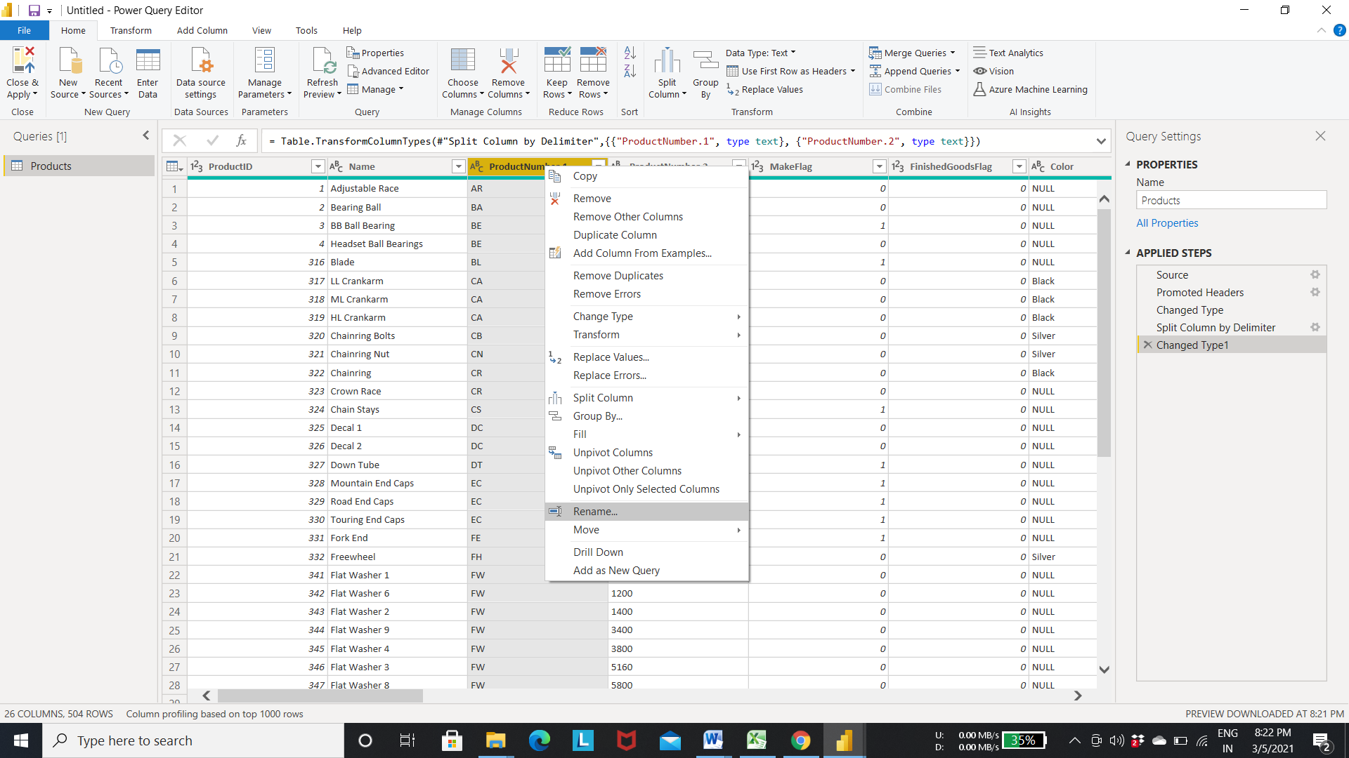

Output :- Result after Renaming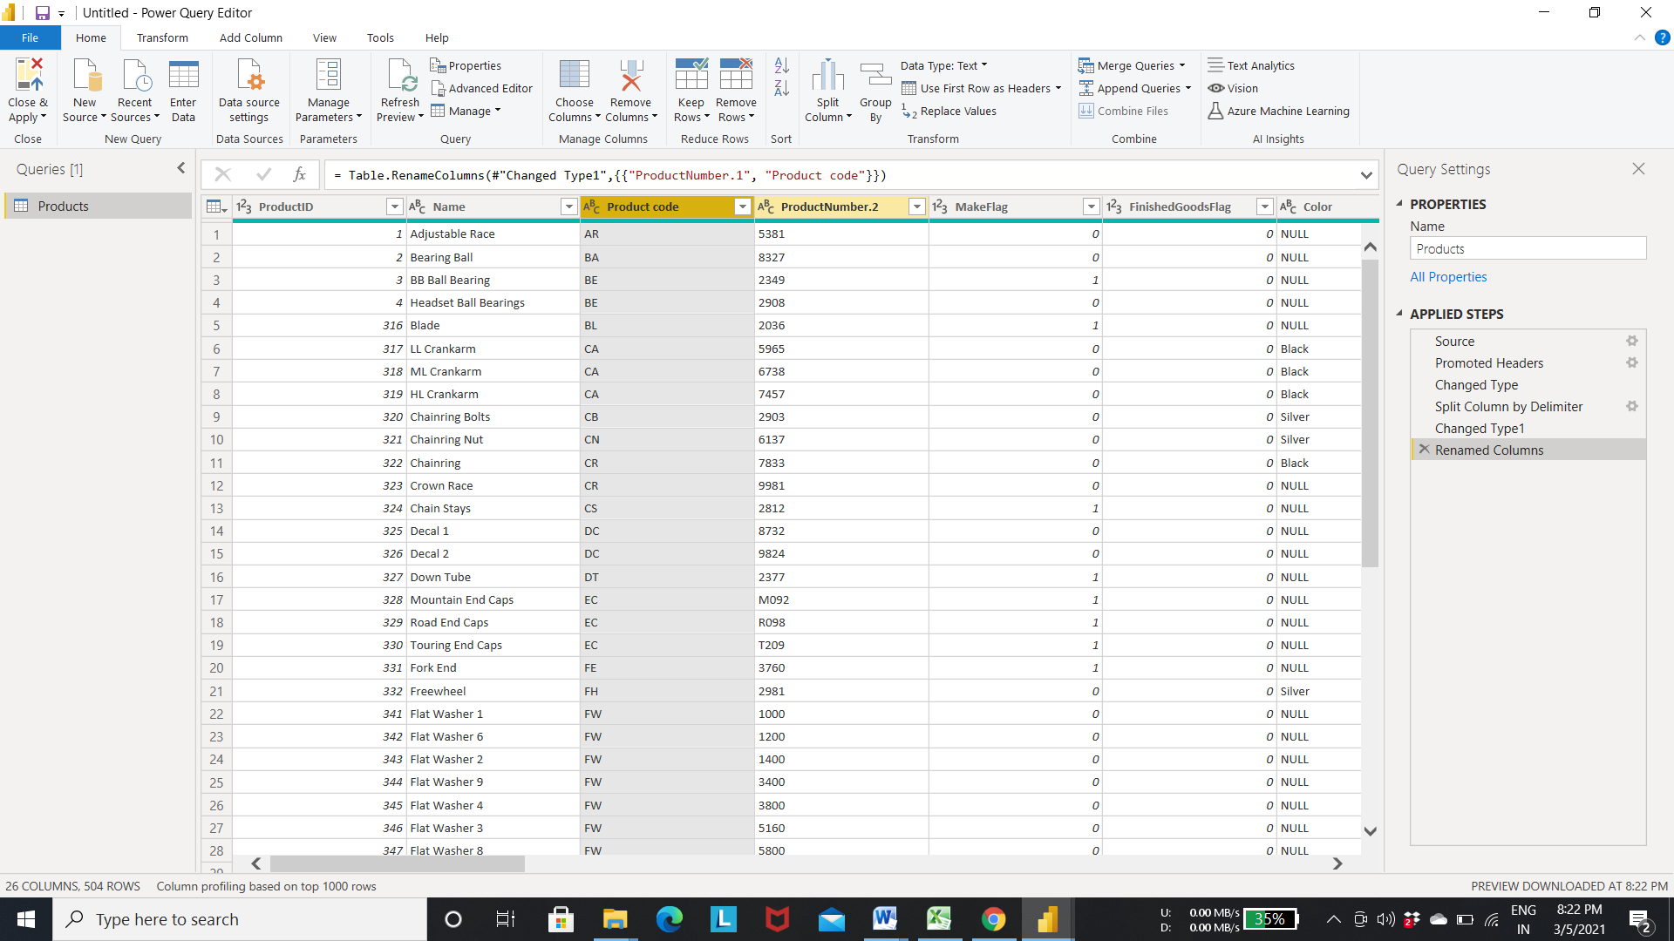

* To filter column use the following steps

Step 9:- select the values in the list to filter records

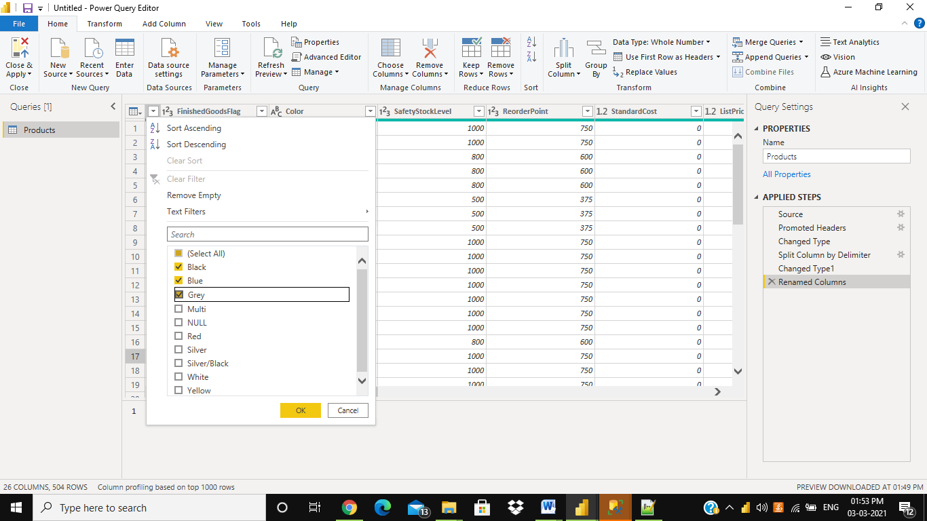

Output : Records after filtering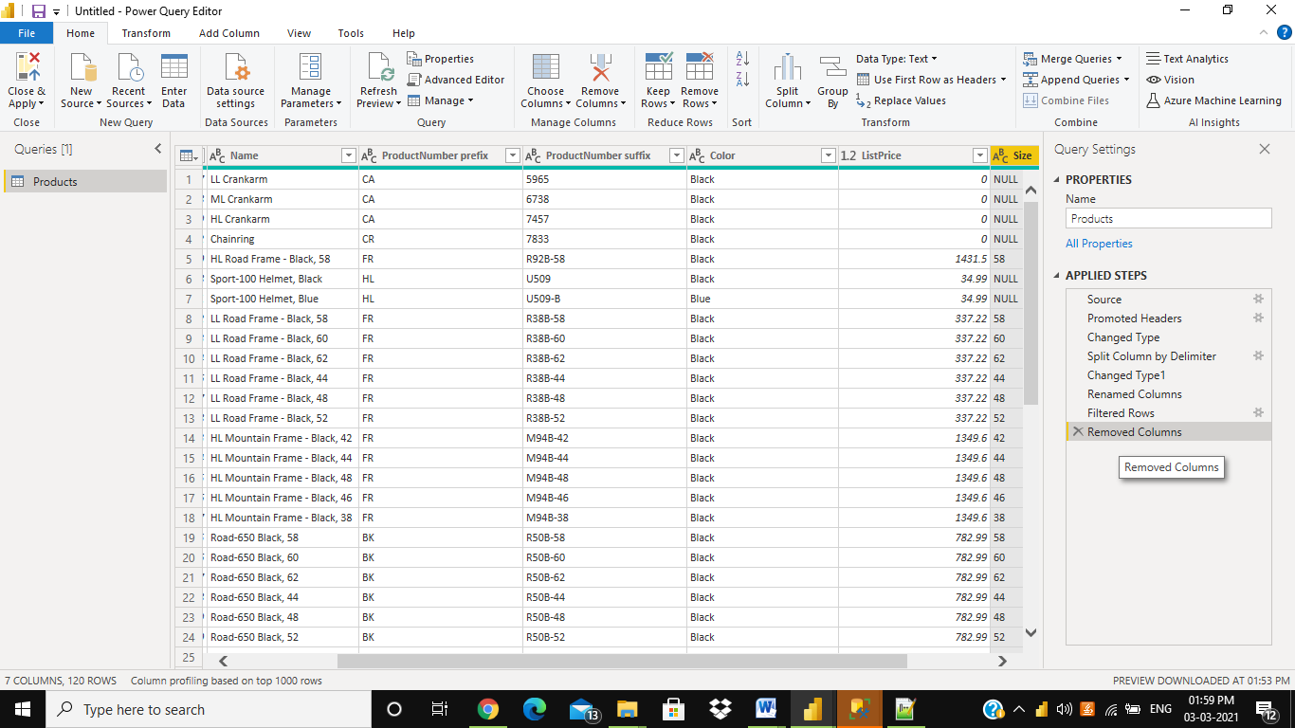

Step 10:- click on close and apply to save the changes and load transformed records into the power bi 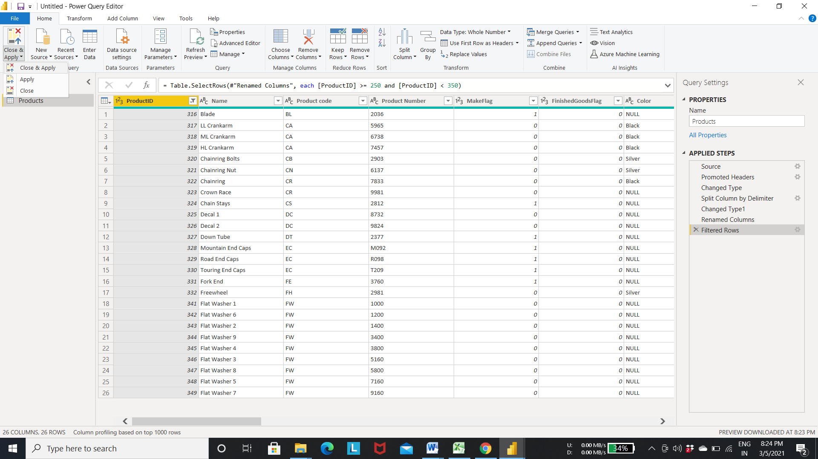

Output: The tranformed data is loade into th e power bi for creating the visualization 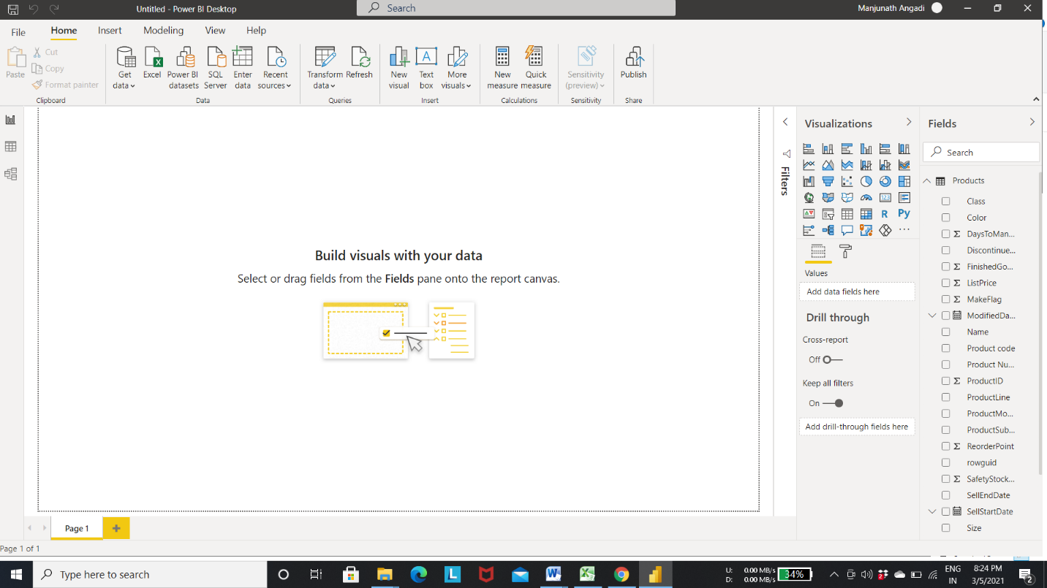

Output 1: click on data tab to view the tables -> select the product table to view the records of that table

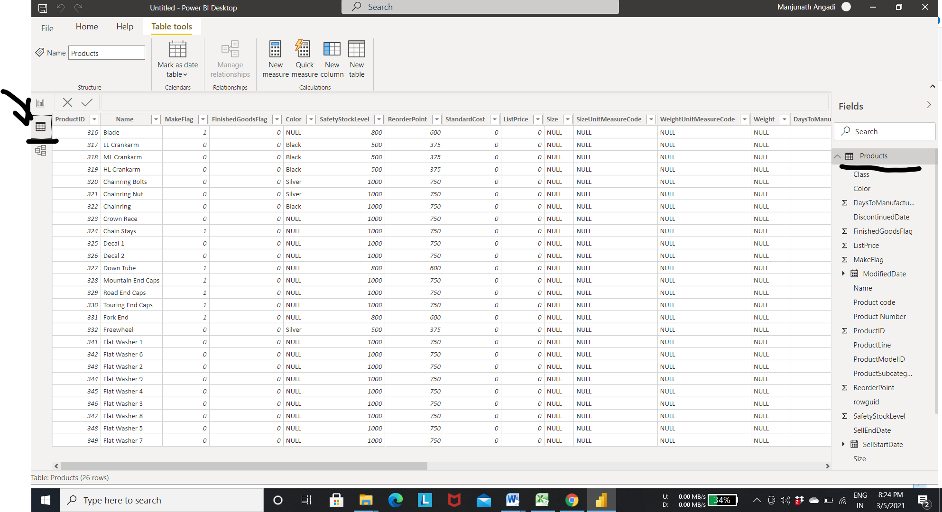

* **Access PowerQuery Editor in Excel**

Step 1:- open the excel editor

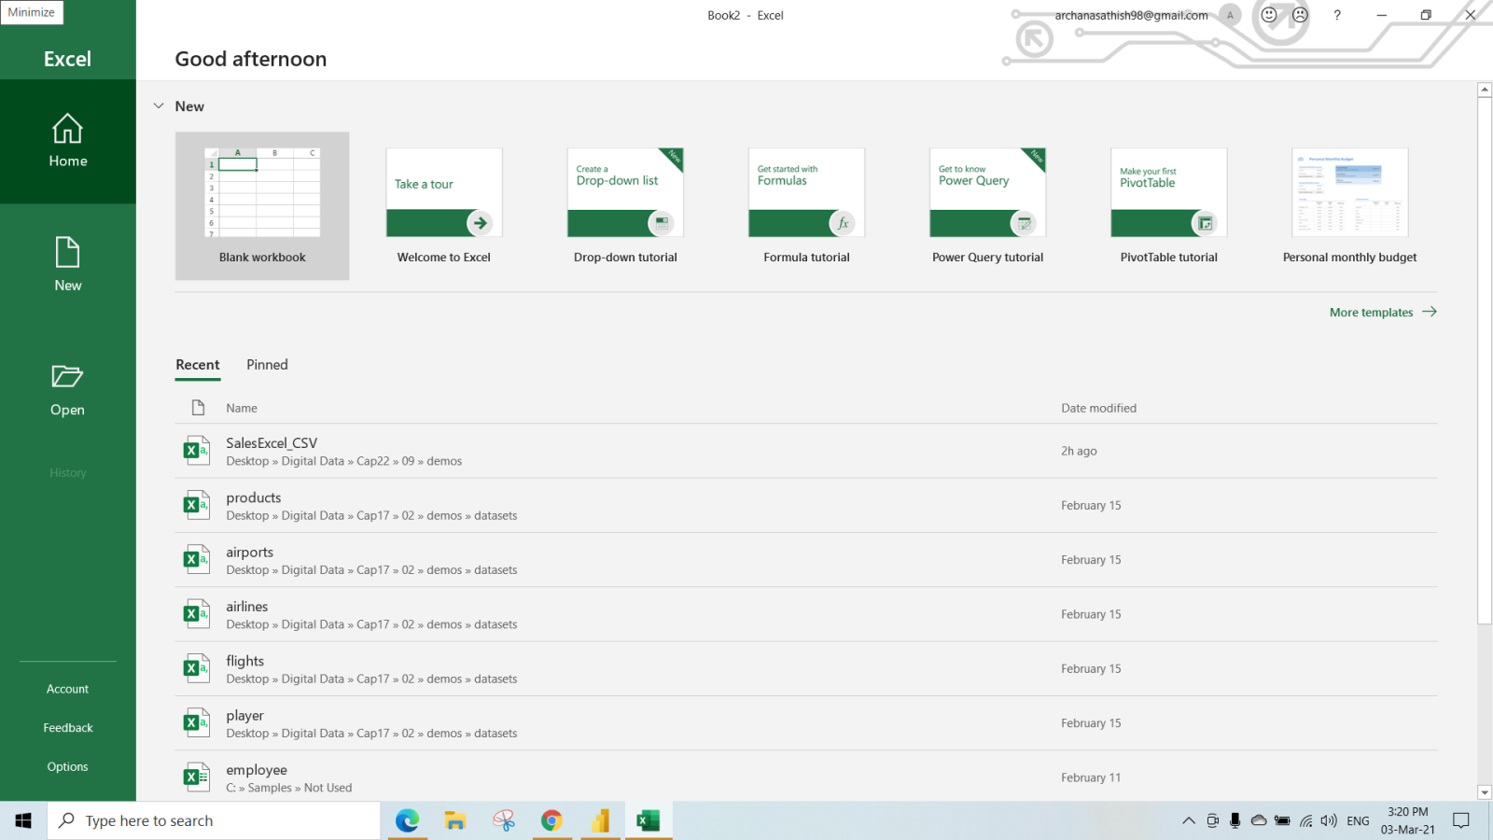

Stept 2: - Go to the data tab-> select the Get data to load the different data from different sources

* + For the current demo select the From file->From Text/CSV

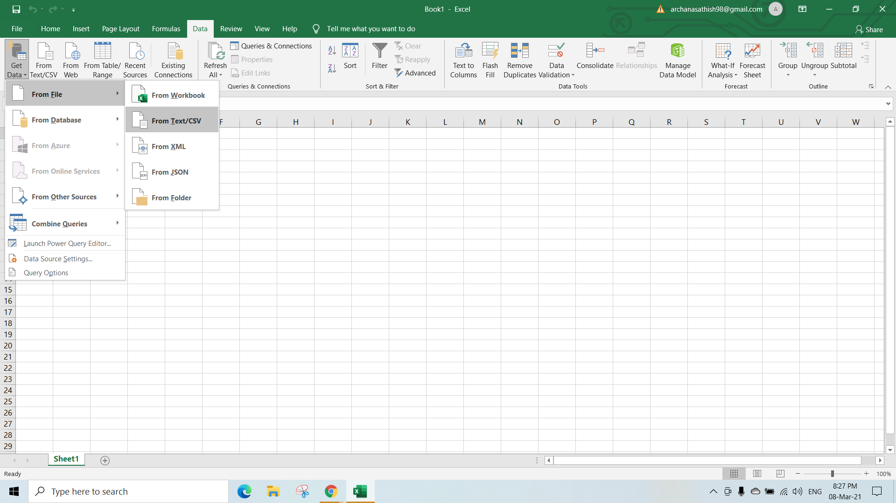

Step 3:- select the file you want to load into the Excel editor-> click on import

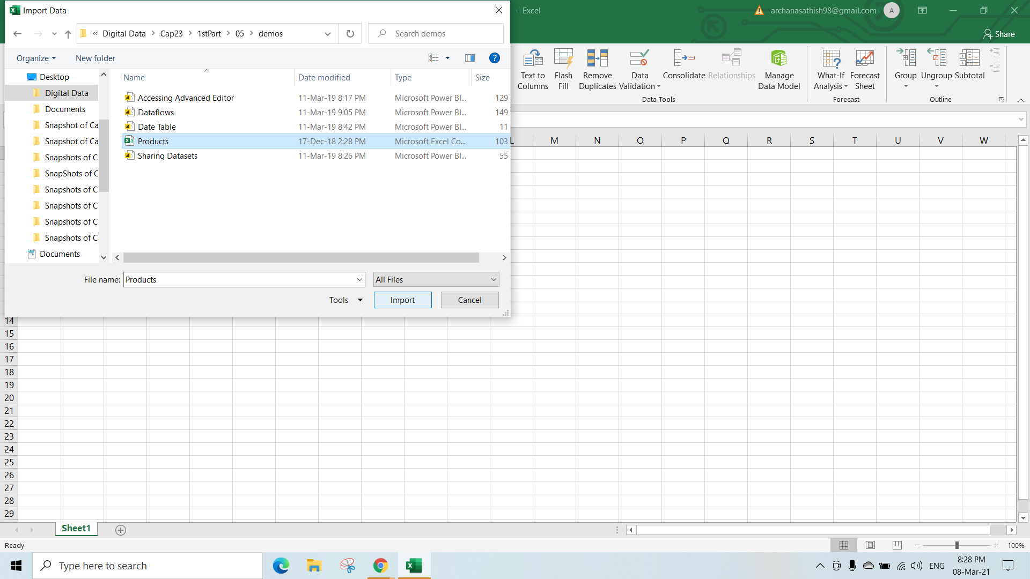

Step 4:- The Below fig shows the sample data

* Click on load to load the data without transformation.
* If the data is not correct and want to transform the data then choose the transform data as shown in fig.
* For the current demo we are transforming the data .

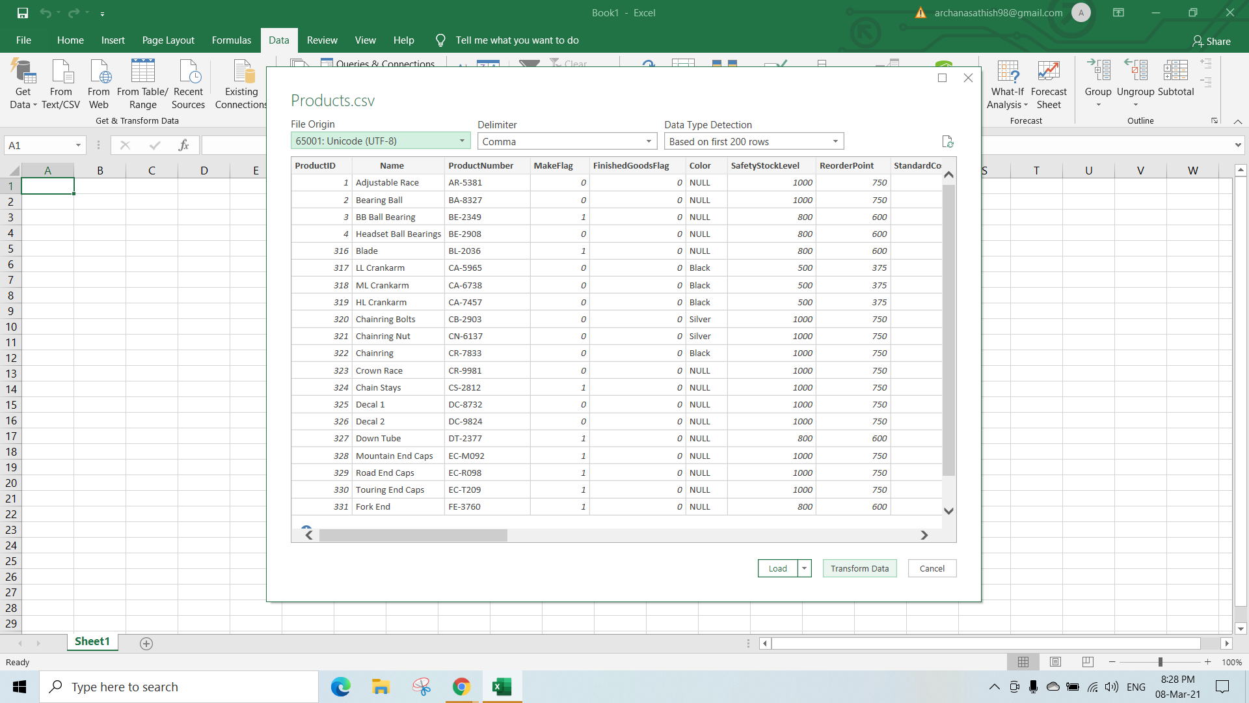

Step 4:- After clicking the transform data power query window will open up . Here we can apply the transformation same as in the Power BI power query editor.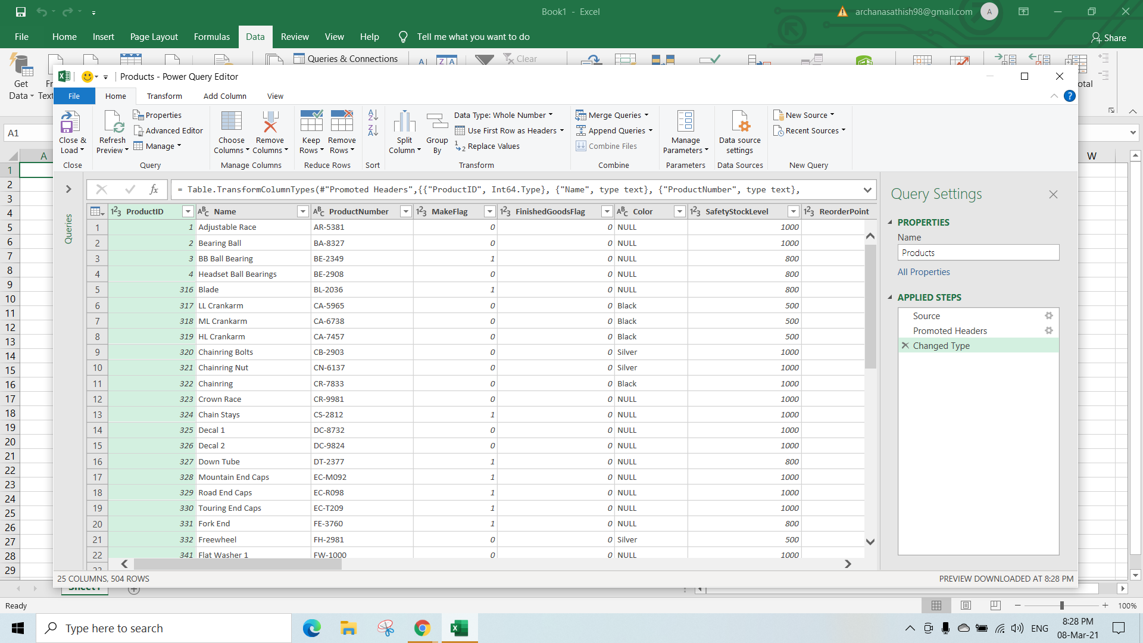

Step 5:- Transformation can be applied to any columns.

* Here we are applying the simple filter transformation.
* **Select the column** you want to filter->**right click** on the column-> **select the the values** to display the rows.
* Now the selected value rows will be displayed.

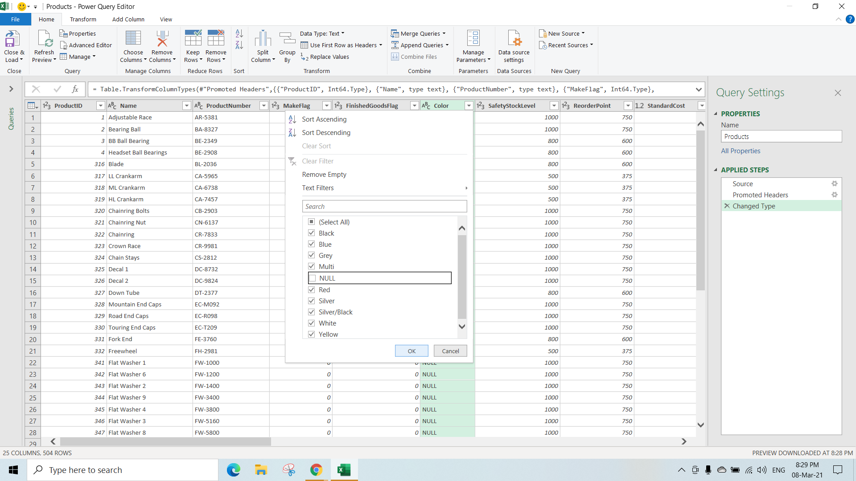

Output Step 5:- Result of filter transformation

* Click on **close& load** as shown in the fig to apply the changes made in the power query editor and to load the data to the table in excel.

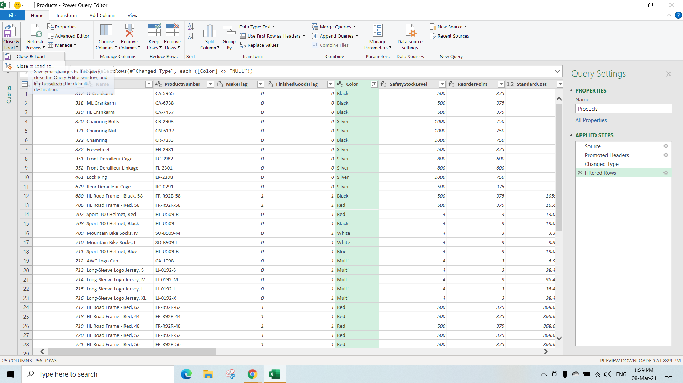

Output:- Products table after loading the data from the **Power query editor**.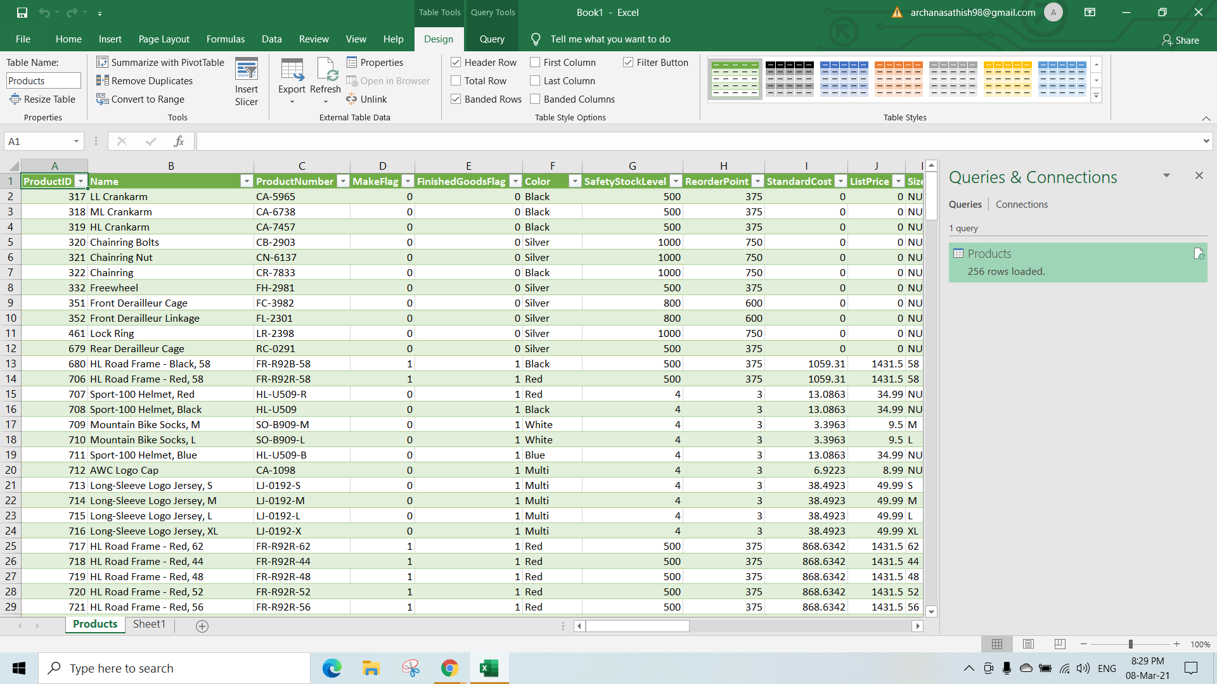

Step 7:- Again if we missed something and want to tansform the data then to launch the power query editor follow the steps.

* Click on **Get Data**-> select the **launch power query Editor** option.

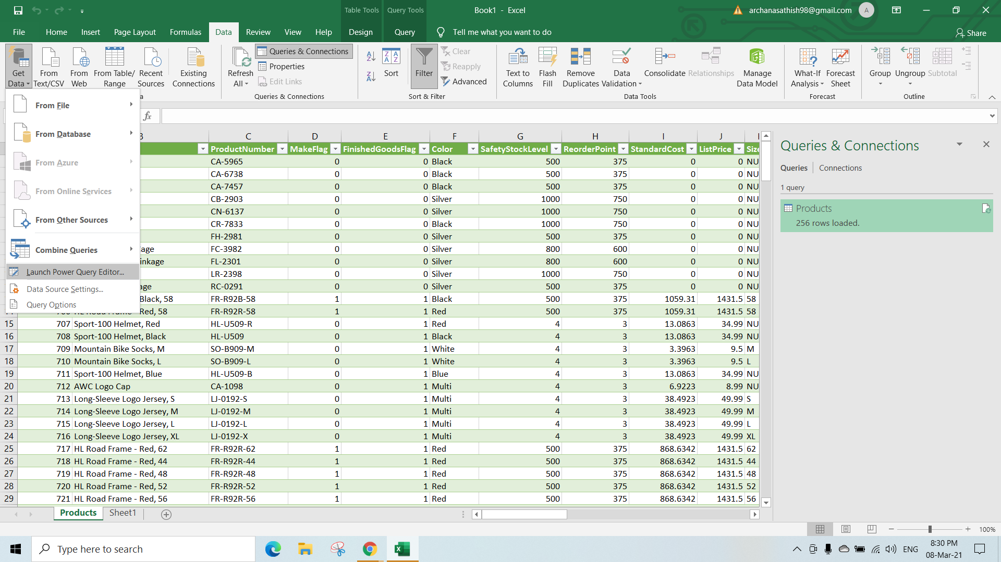

Output Step 7:- Open the power query editor.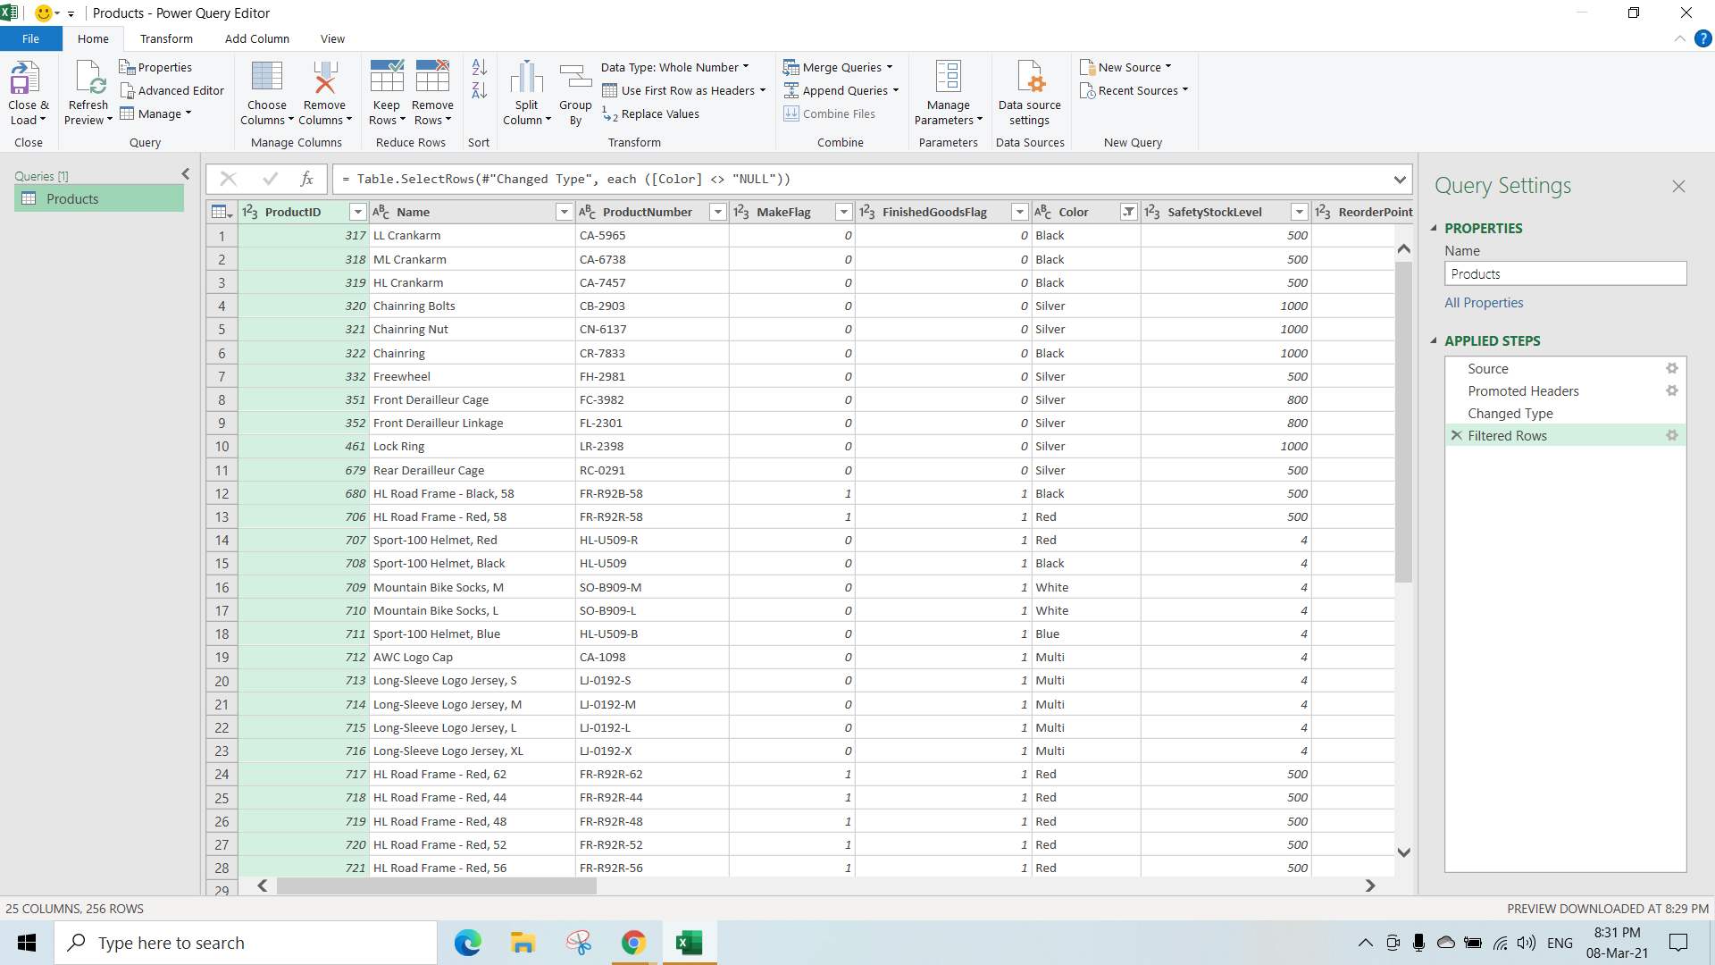

Step 8 :- Click on **close and load** to go back to the excel editor.

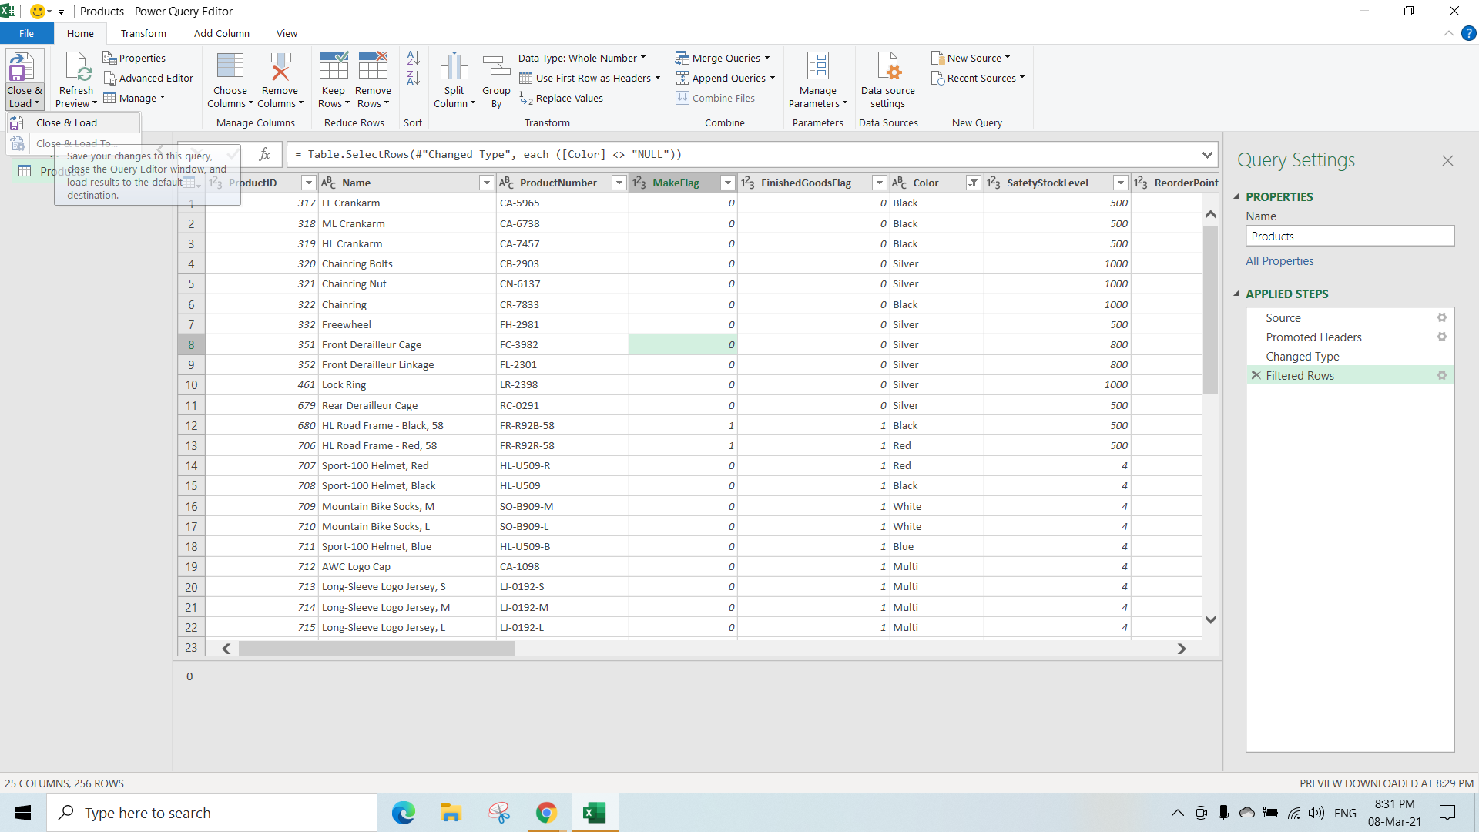

Step 9:- Excel Editor

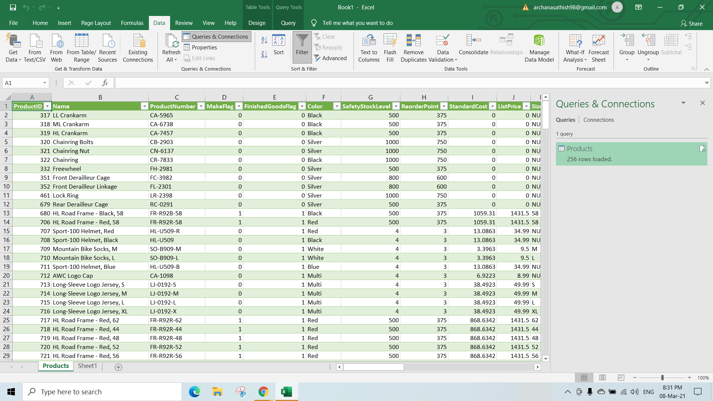

* Accessesing the power query editor in SSAS(SQL server analysis server)
  + To install the Analysis service follow the youtube link
    - https://www.youtube.com/watch?v=UD3B8CqvYpE&t=3s

Step 1:- Create a new project in the visual studio

* Select the **Analysis Services Tabular Project** -> **Enter the project Name**-> click on **create** and this window will appear
* In tabular Model Designer select the workspace server

-> select your **current version of sql server**

-> click on **ok .**

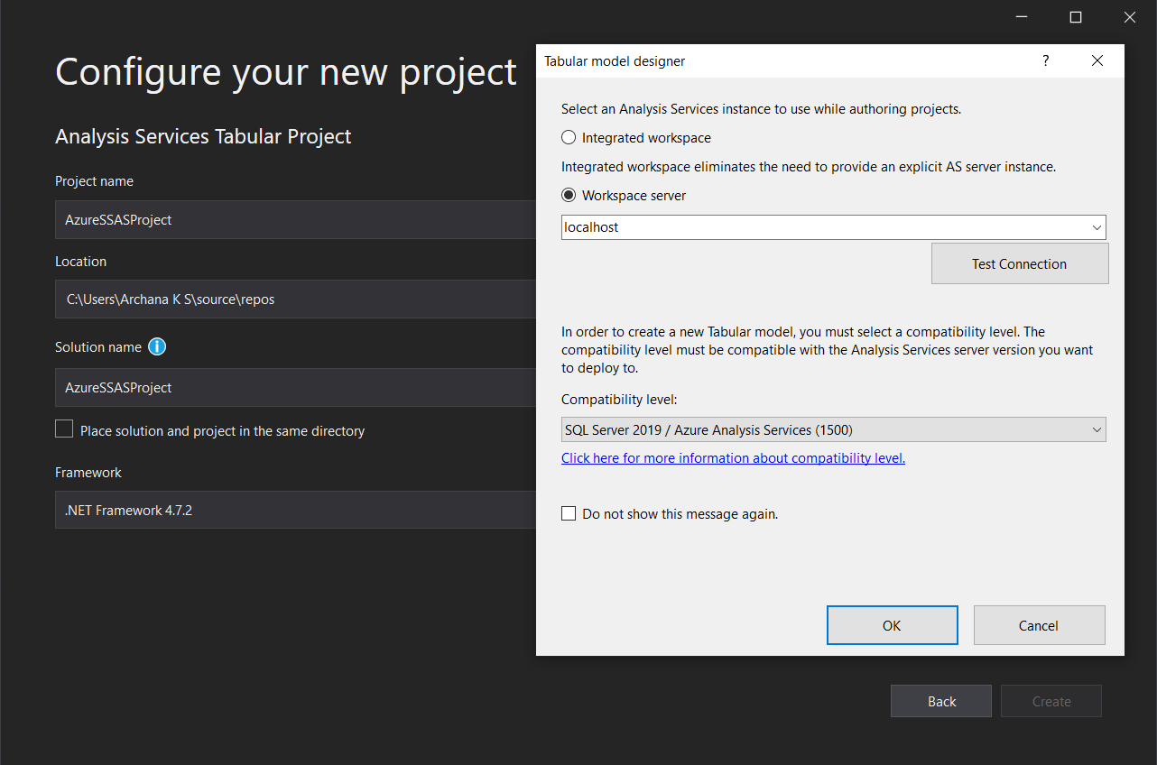

Step 2:- On creating the Project the following window will appear

* In the solution Model explorer select the data source

-> **right click**

->menu will appear to **import the data**

-> select the **Import From Data Sources**

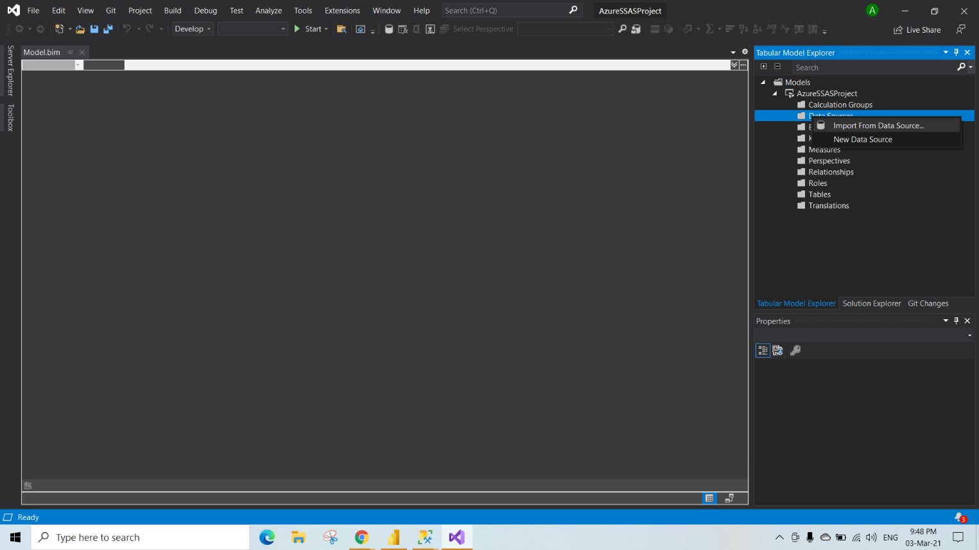

Step 3:- Select the data source From which you want to load the data.

* In the below fig we are loading the data From the **Azure Sql Database**
* Select the **Azure sql database** **-> click on connect**

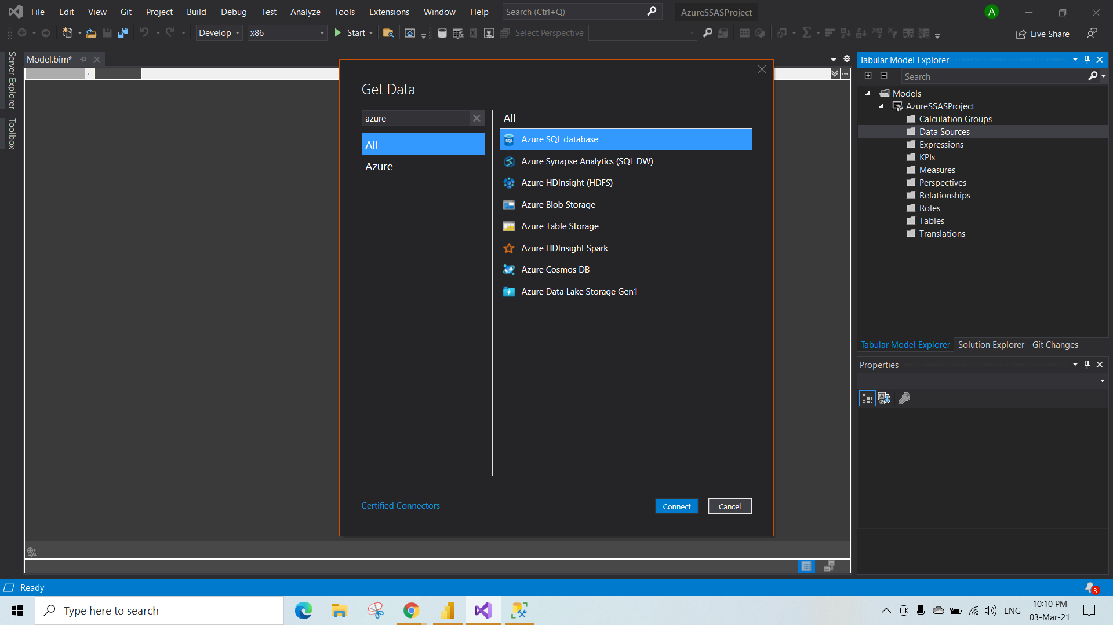

Step 4:- Enter the **server Name** and **database name** to connect to the database.

->click on ok.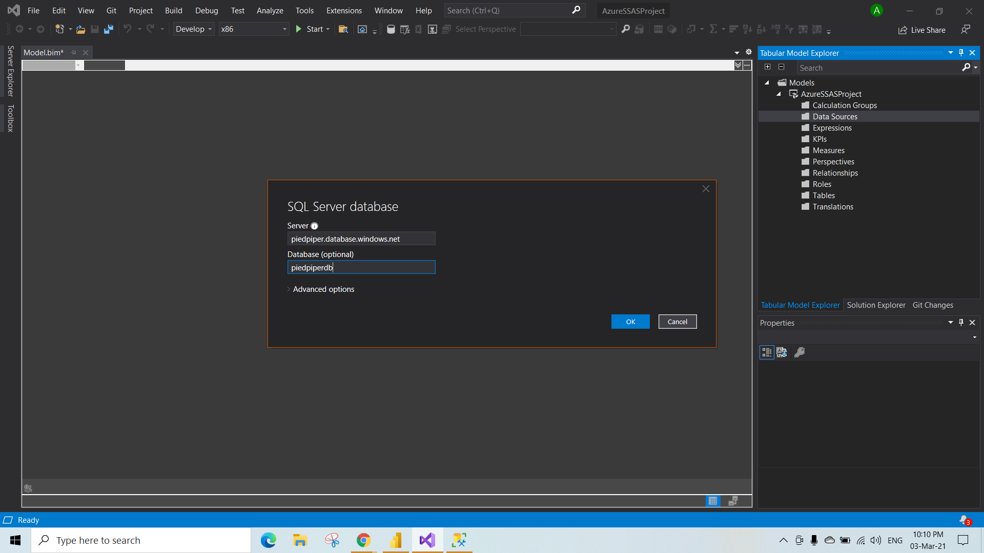

Step 5:- Authenticate By entering the **Admin name** and **Password** for the database.

-> Click on connect.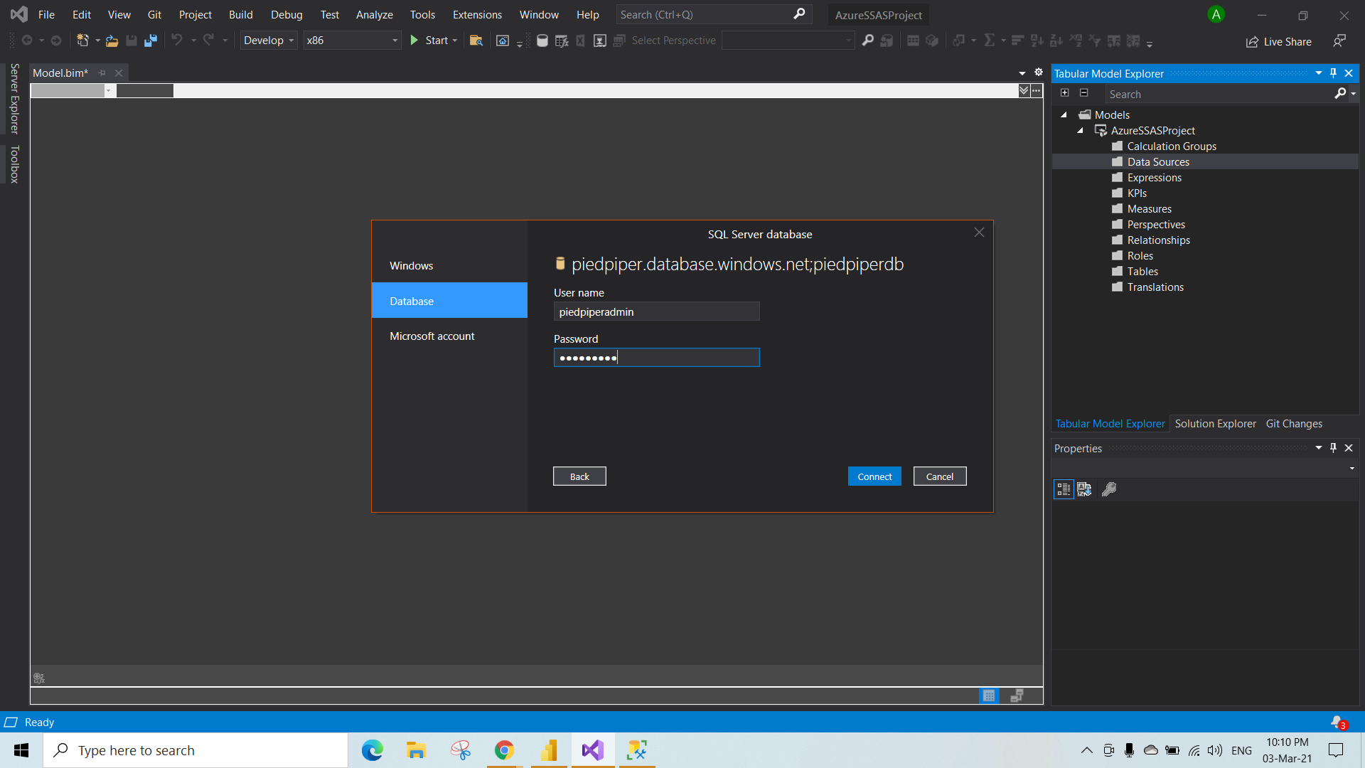

Step 6:-The Navigator window will appear .

->**select the tables** to load into the database. (In below fig we are loading the products table)

-> Click on **transform data** as shown in fig to access the power query editor.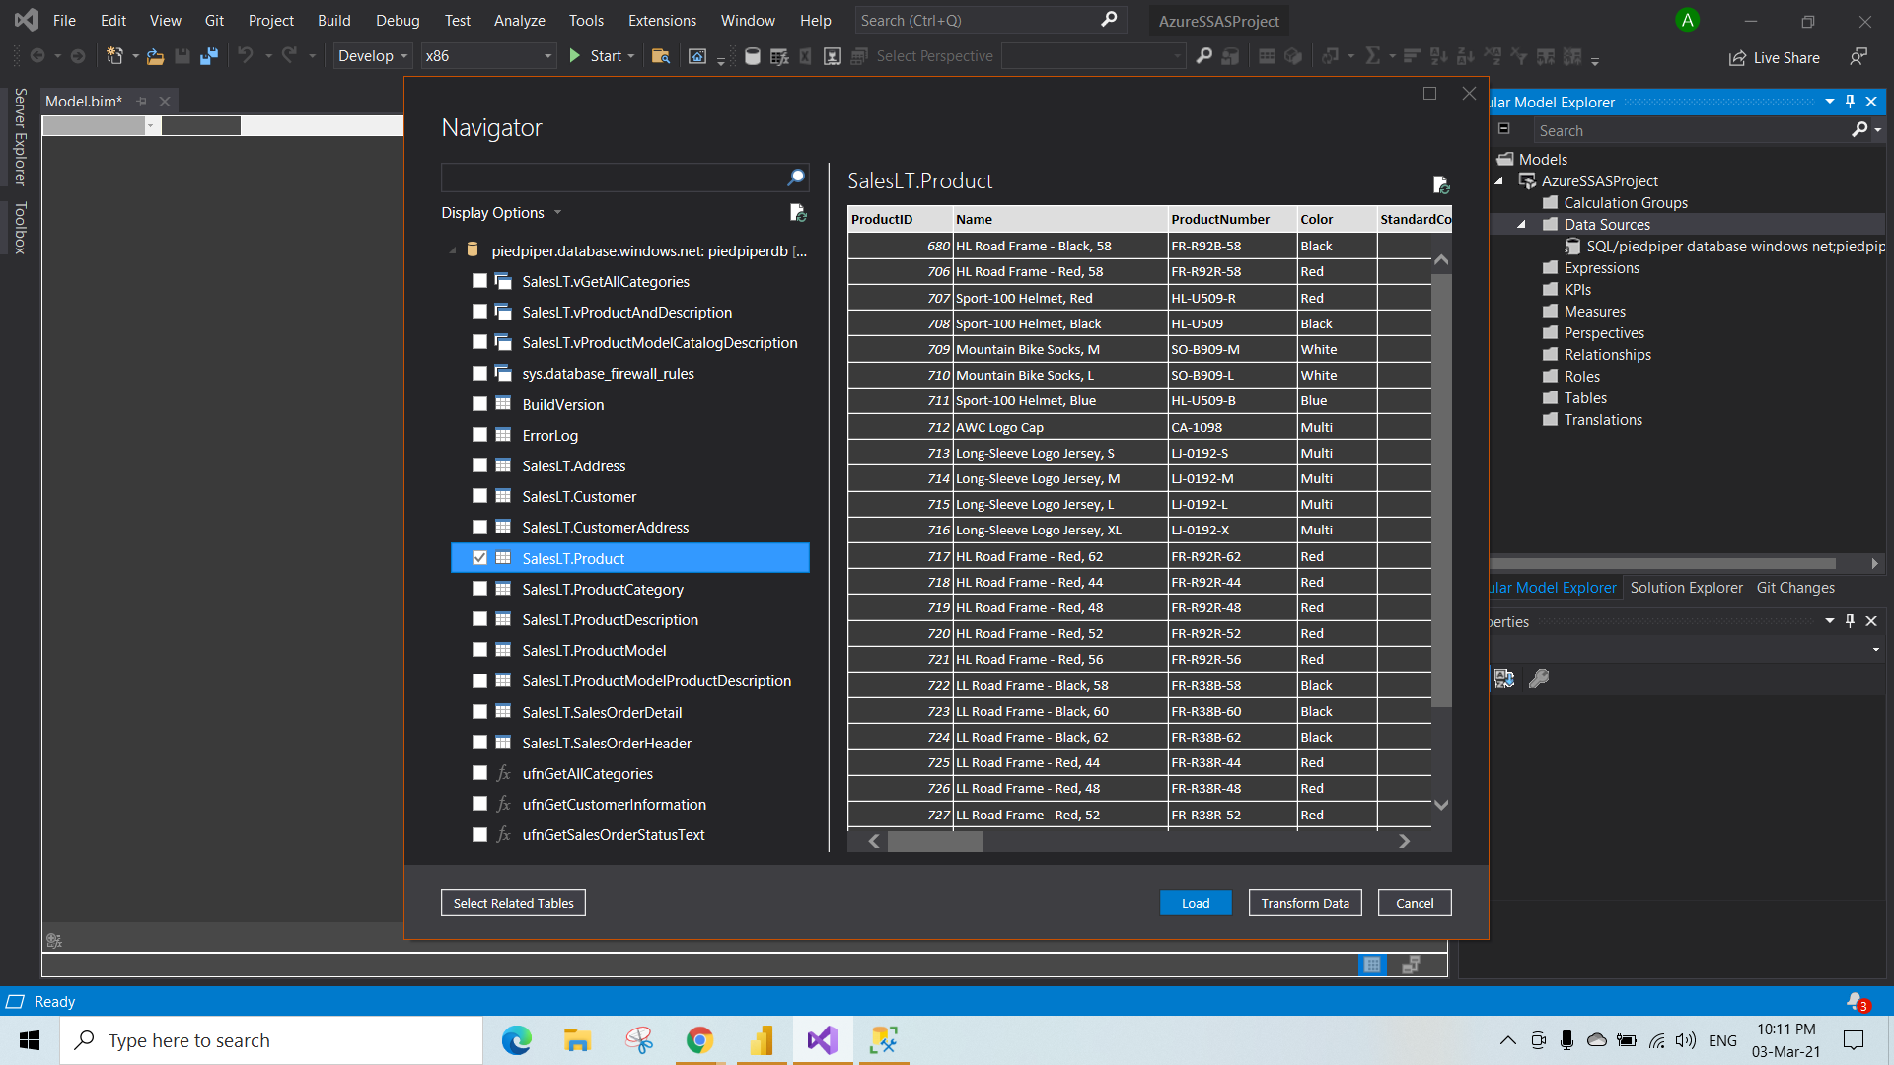

Output Step 6:- Power query Editor to edit/transform the data.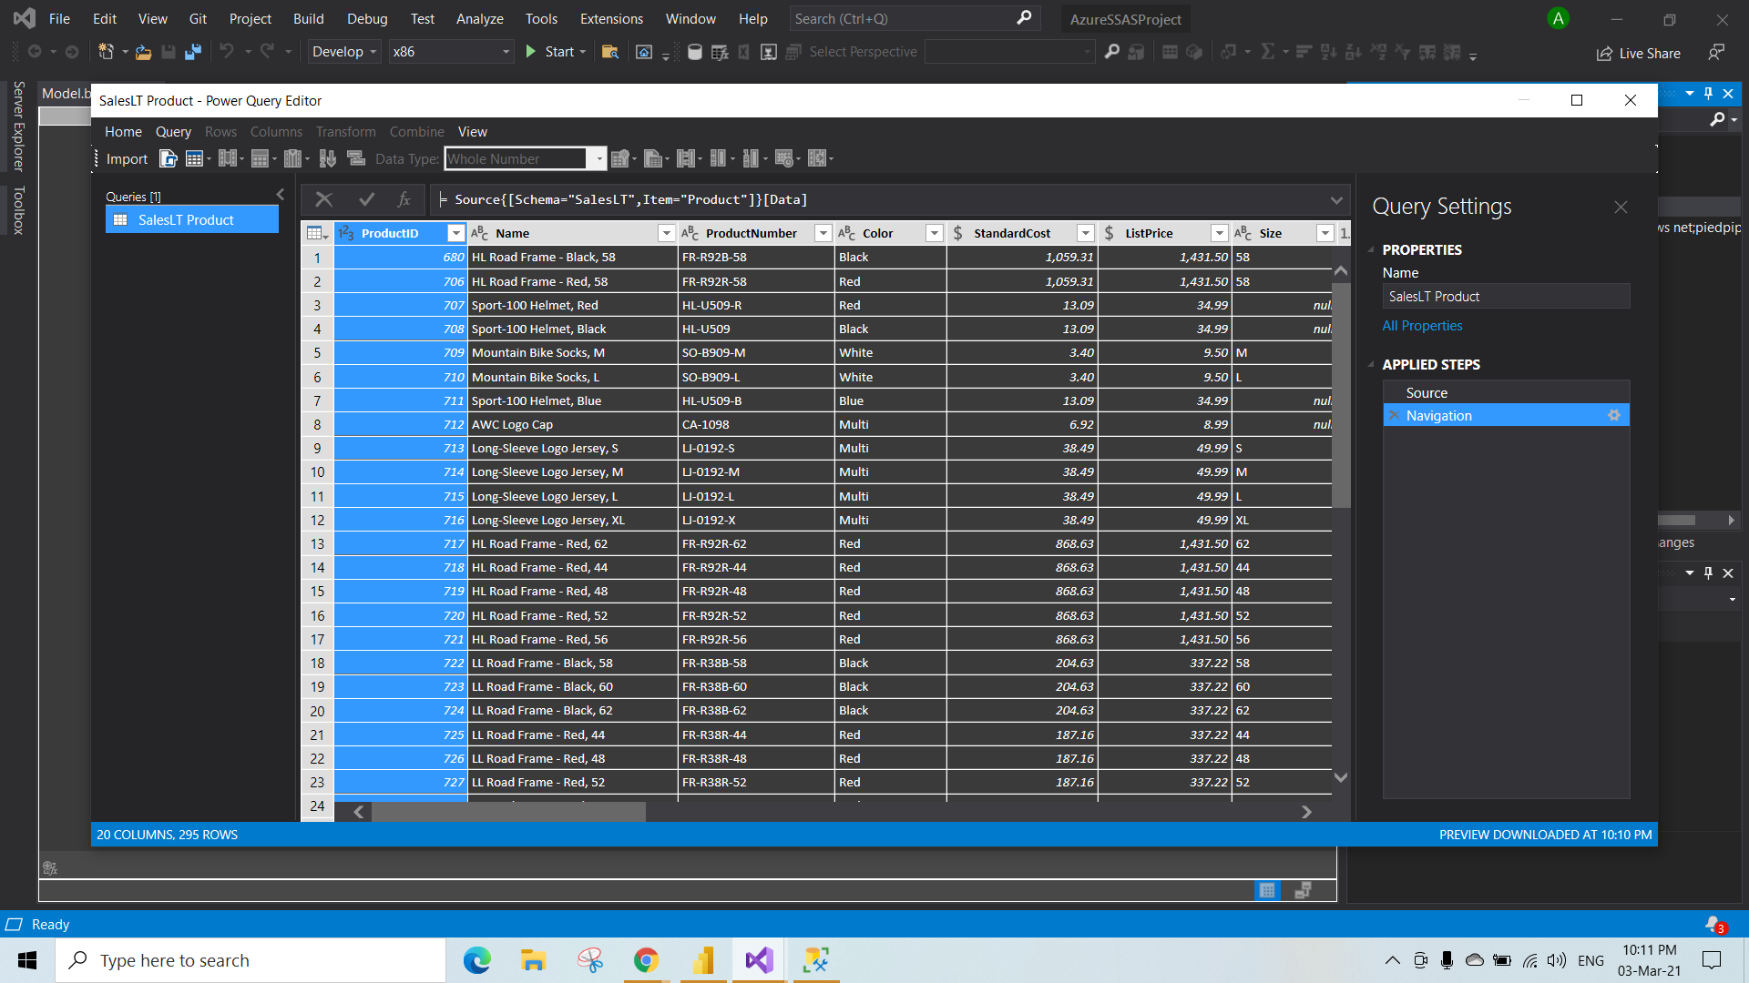

Step 7:-Here transformation can be done same as in the Power bi power query editor.

* In the below fig we are splitting the Product Number column by delimiter to do that follow the steps
* Right click on the column -> select the split by column-> By delimiter .To split the column

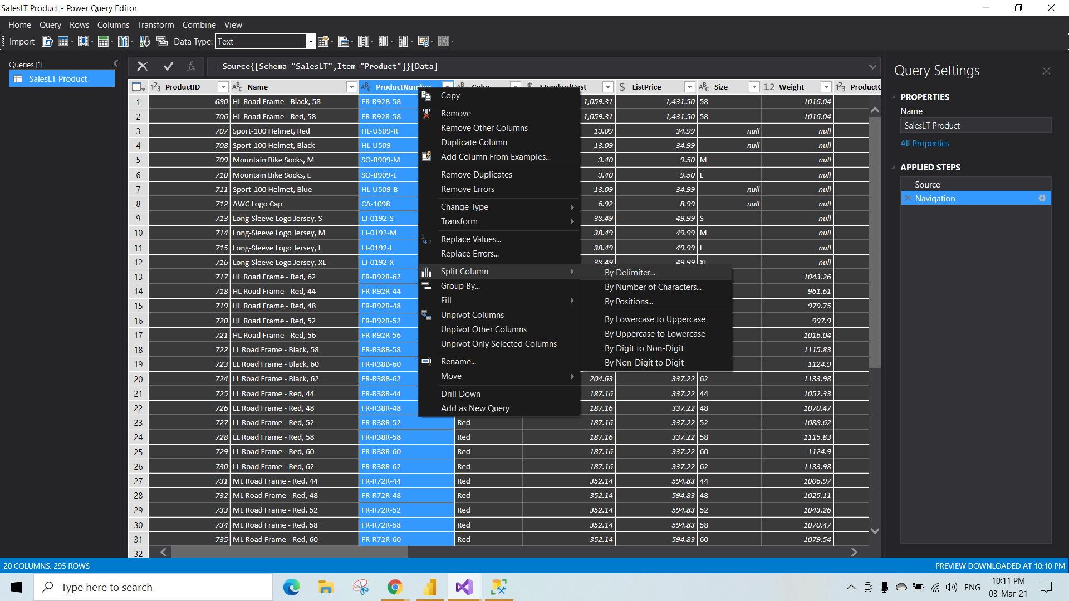

Step 8:-The power Query editor automatically detects the delimiter -> click on ok to split the column by delimiter.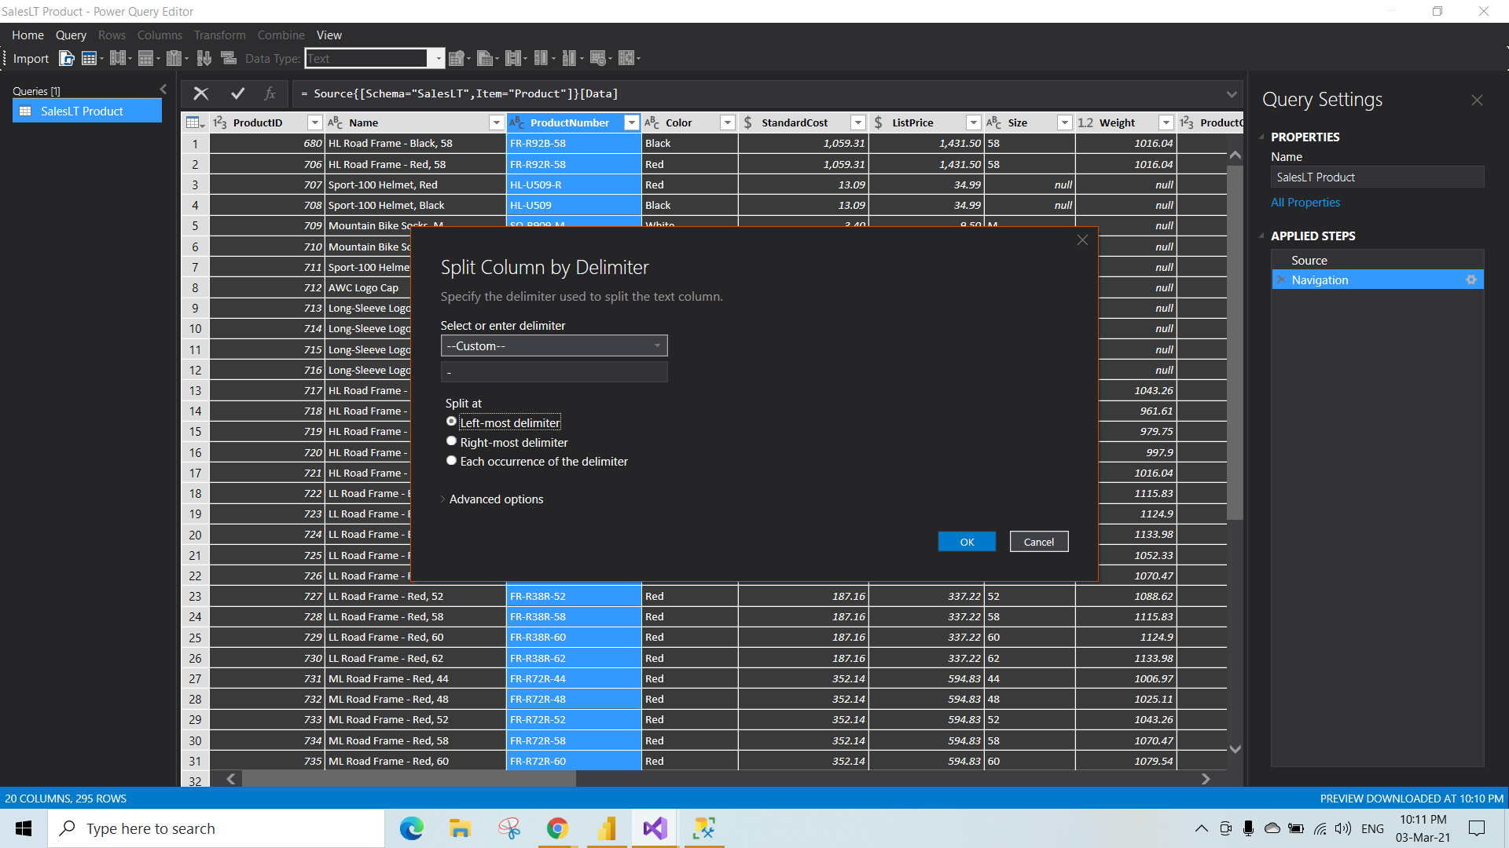

Output Step 8:- Two column will generate as a result of previous step.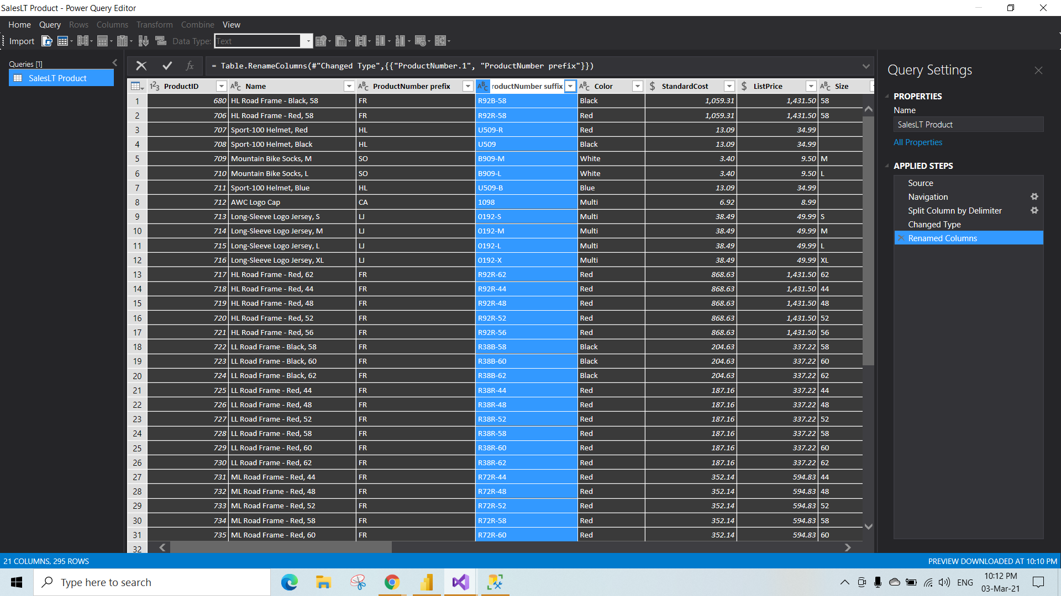

Step 9:- Filter can be applied by right click on the column-> select the values you want -> click on ok to apply the filter.

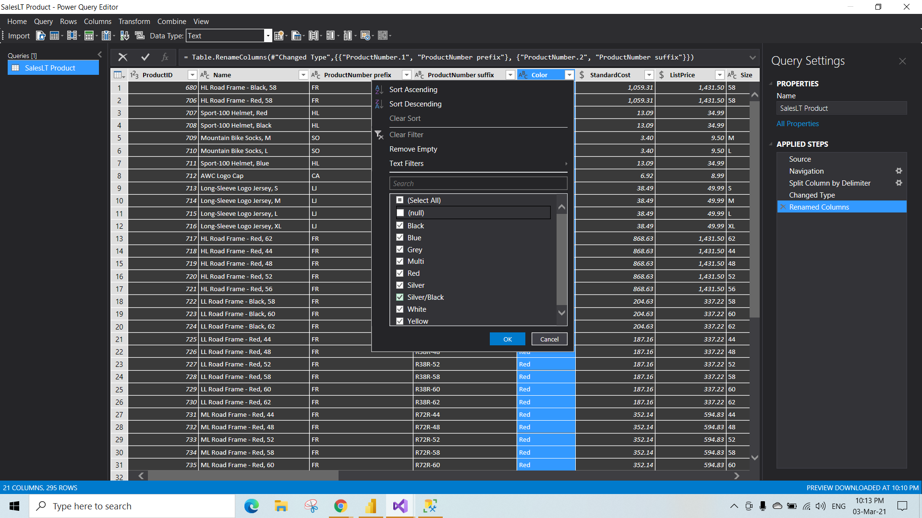

Step 10:-The below fig shows the result of step 9 . and to save the changes follow the steps

* Goto Home menu present at top left Corner.
* Select the close & apply. To Save the changes and to exit the power query editor.

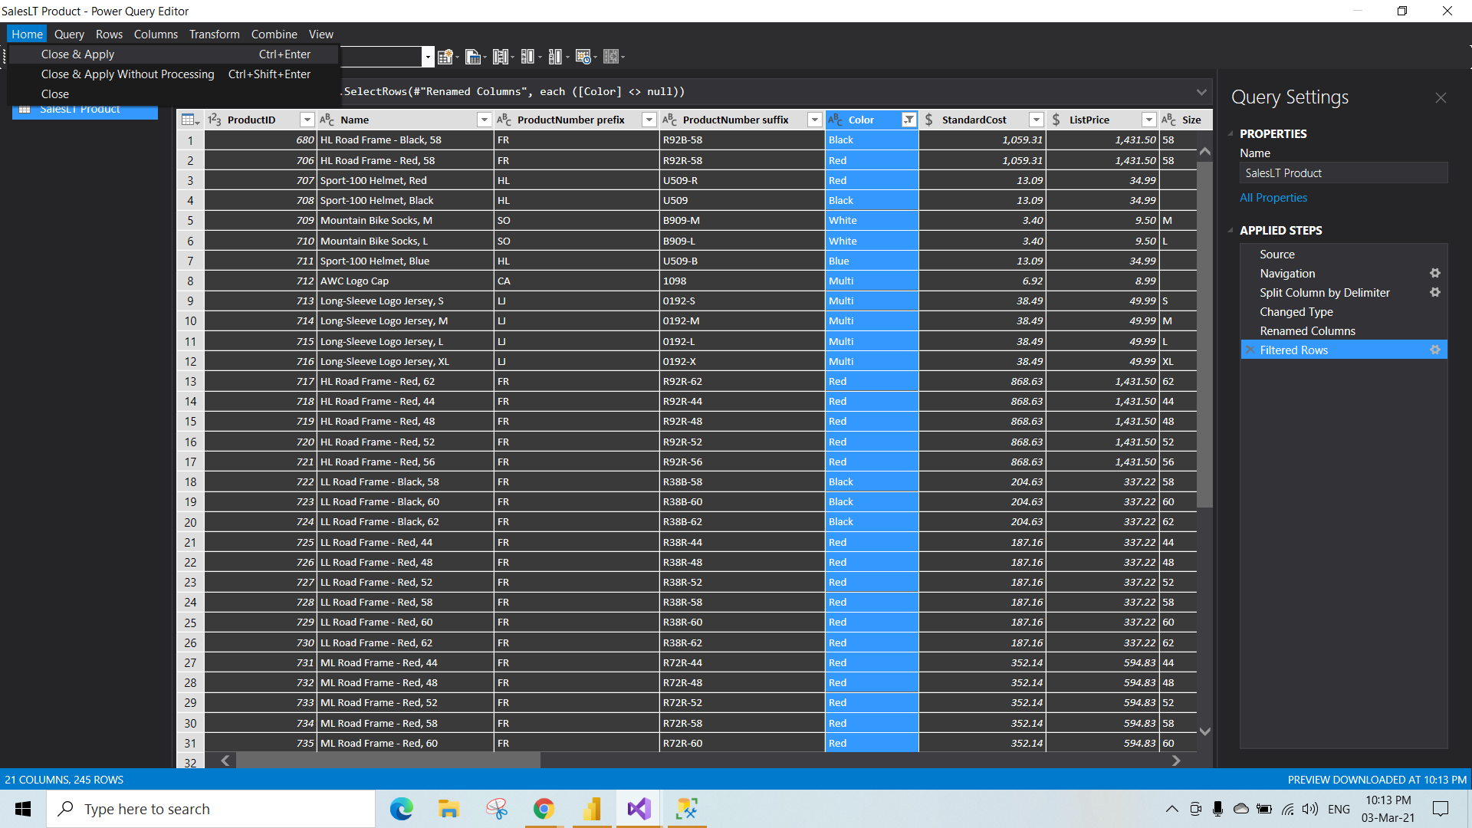

Step 11:-Data processing success window will appear as shown in fig.

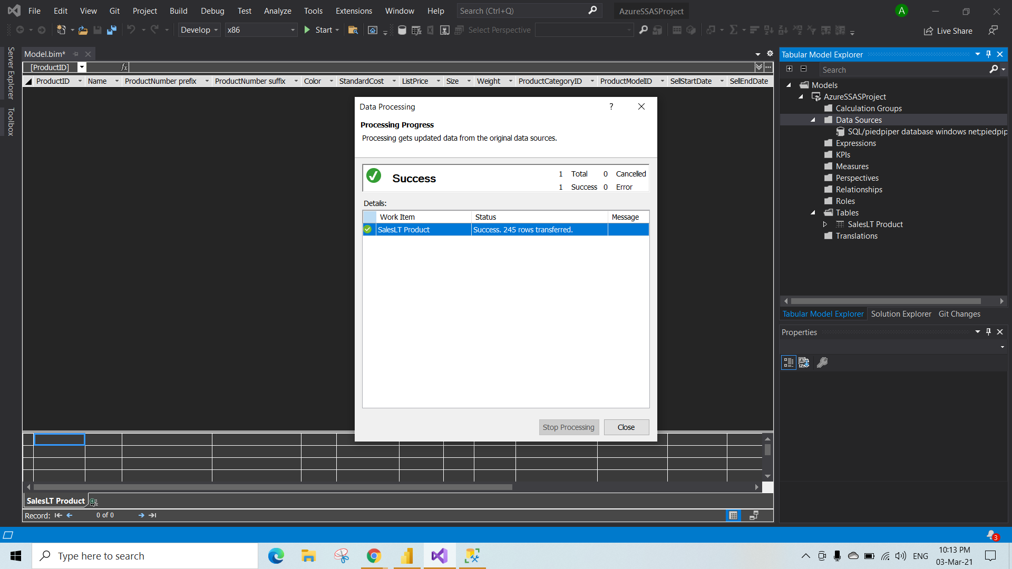

Step 12:- Data will get loaded into the SSAS as tabular Form as shown in fig.

* If you have missed anything/want to transform the data. To go back to the power query editor right click on the table as shown in the fig and select the table properties.

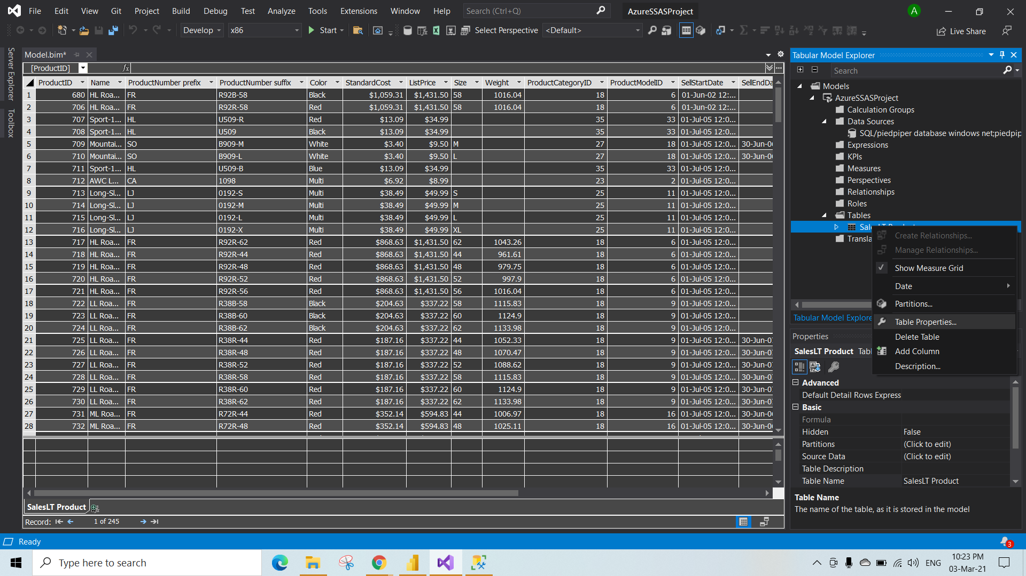

Step 13:- Select the design to launch the power query editor Again.

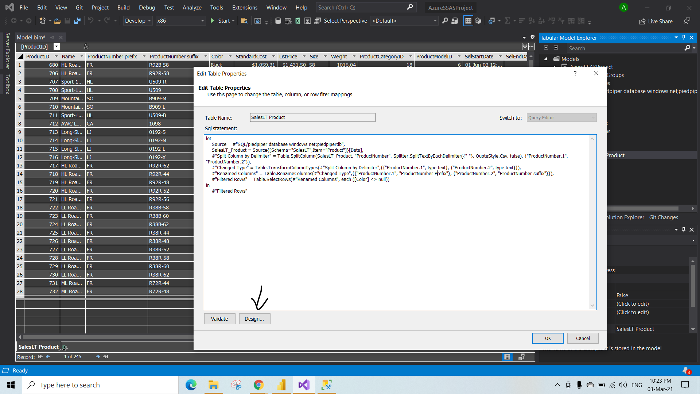

Step 14:-Output of step 13. And to go back to the ssas again click on the close and update as shown in fig.

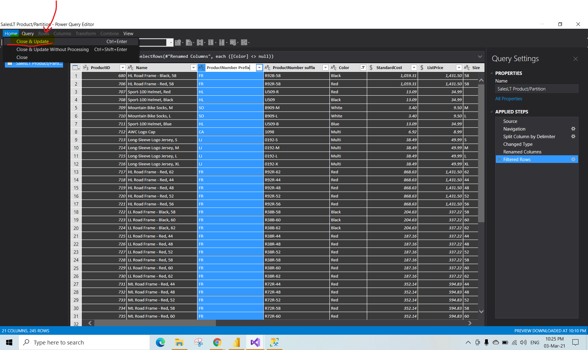

Accessing the Underlying Query Code

* Accessing M code using the advanced query editor.

Step 1:- Open any project that you have created previously to view the code.

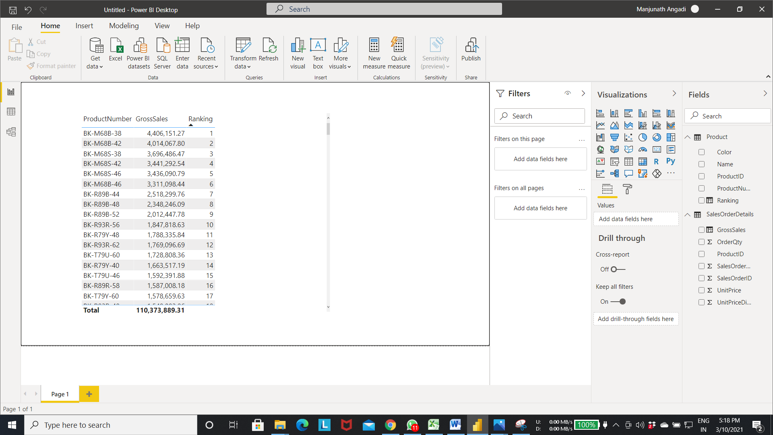

Step 2:- Select transform data From Home menu as shown in fig.

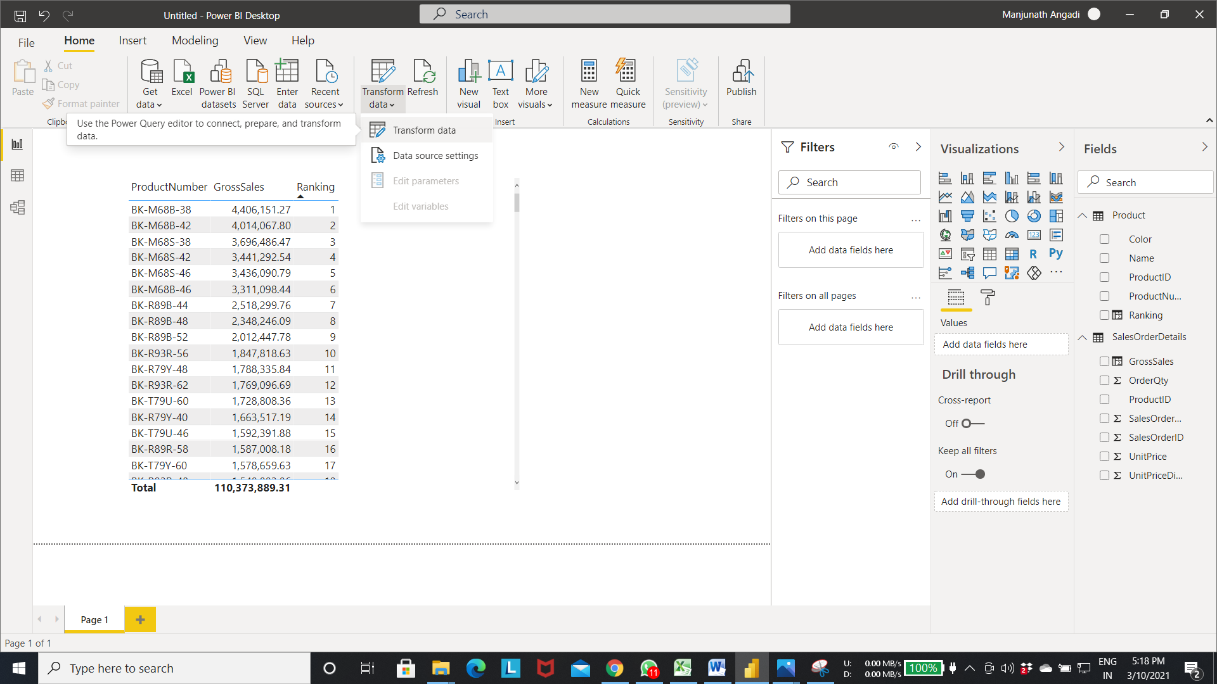

Step 3:- The power query editor will pop up. In this select the Advanced query editor as shown in the fig.

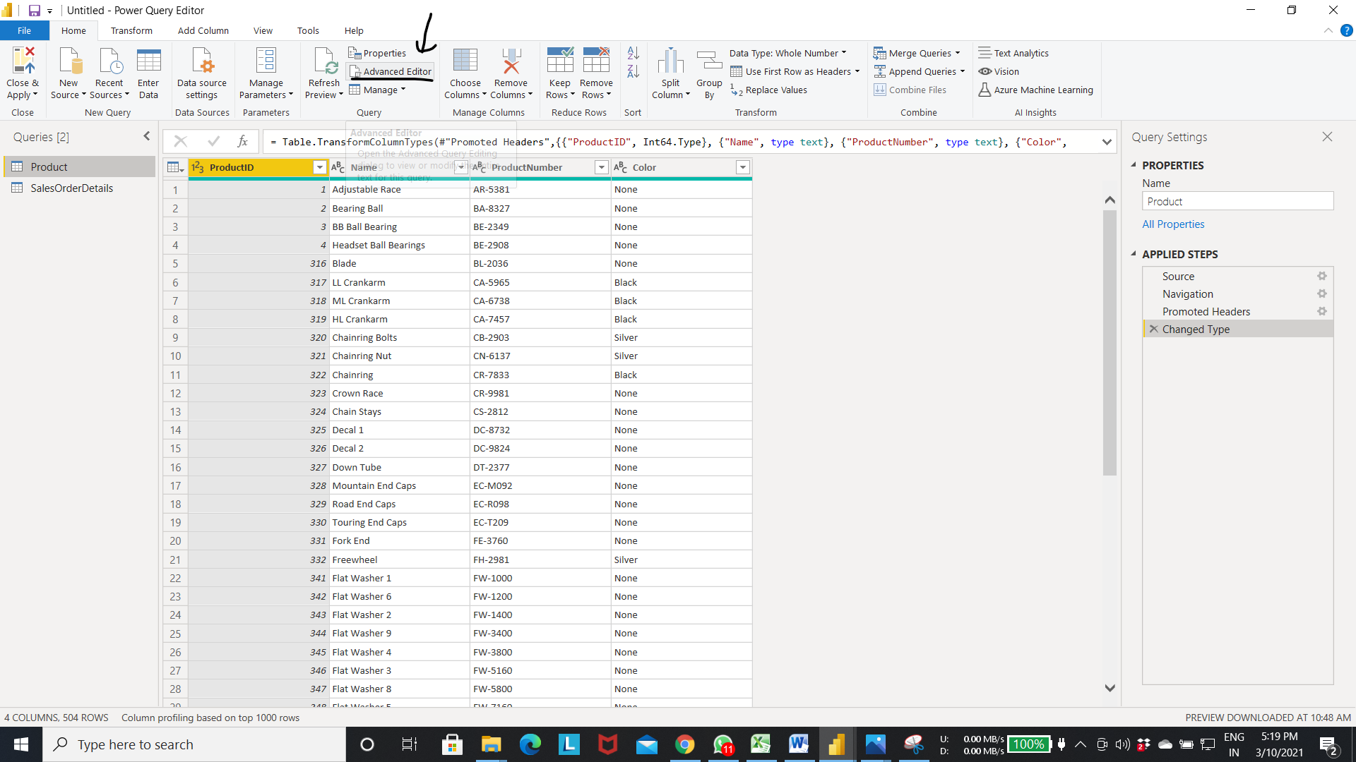

Step 4:- Here in the advanced editor window shows the underlying code . this code is generated based on the transformation that we seen seen in the previous steps

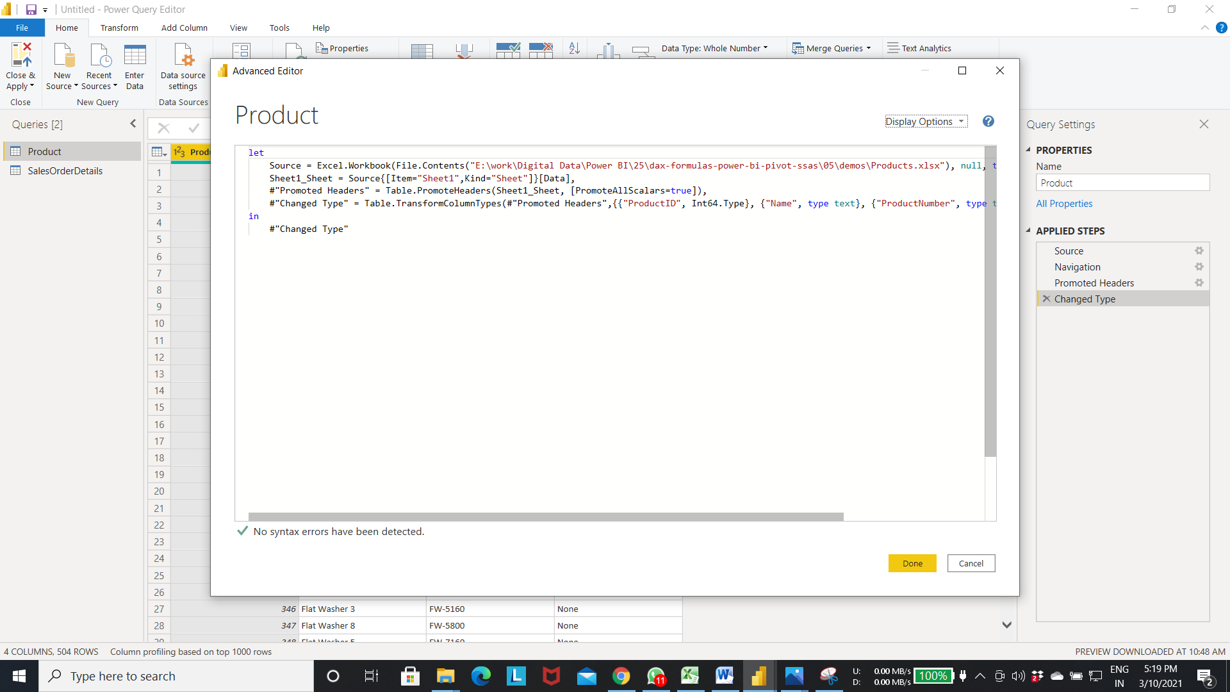

let

Source = Excel.Workbook(File.Contents("E:\work\Digital Data\Power BI\25\dax-formulas-power-bi-pivot- ssas\05\demos\Products.xlsx"), null, true),

Sheet1_Sheet = Source{[Item="Sheet1",Kind="Sheet"]}[Data],

#"Promoted Headers" = Table.PromoteHeaders(Sheet1_Sheet, [PromoteAllScalars=true]),

#"Changed Type" = Table.TransformColumnTypes(#"Promoted Headers",{{"ProductID", Int64.Type}, {"Name", type text}, {"ProductNumber", type text}, {"Color", type text}})

in

#"Changed Type"

Step 5:- Click on close and apply to go back to the editor.

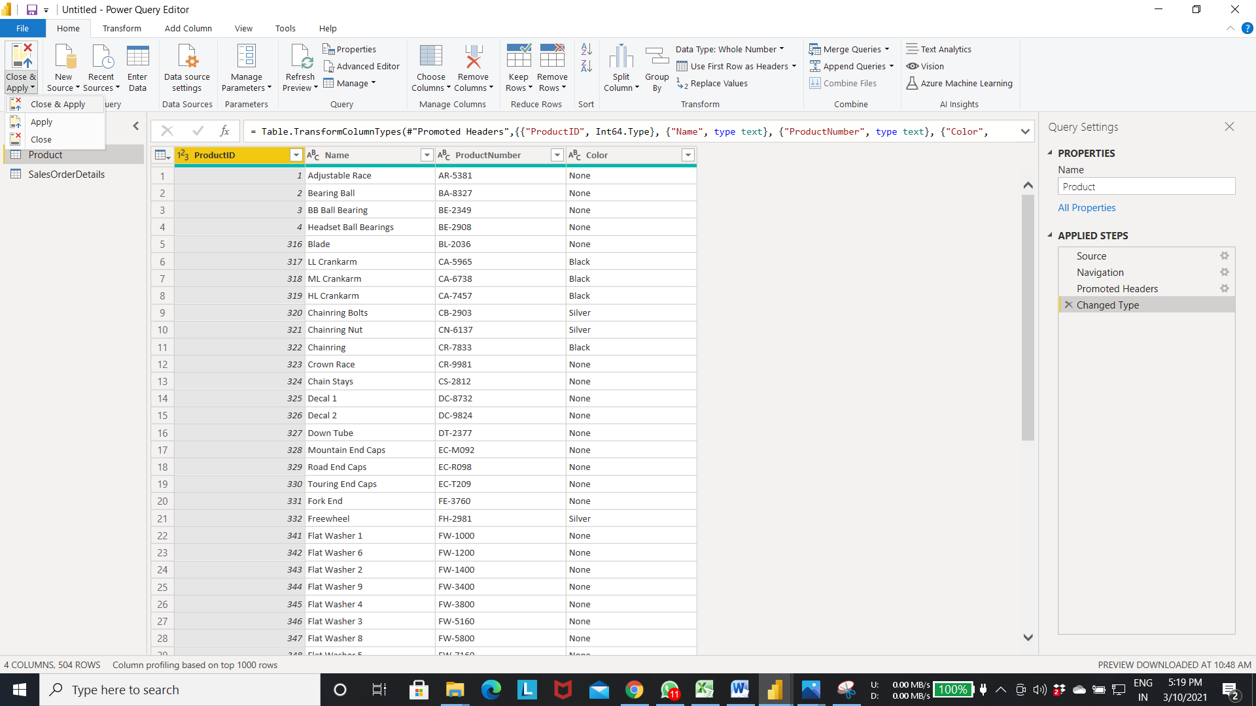

* Creating a power Bi data flow.

Step 1:- open the power bi service in the website log in through your credentials.

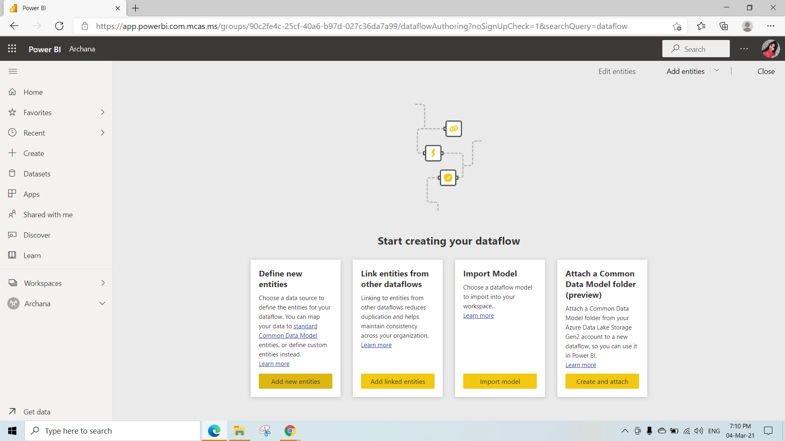

Step 2:- Open a workspace -> select new -> select DataFlow . To create new dataflow.

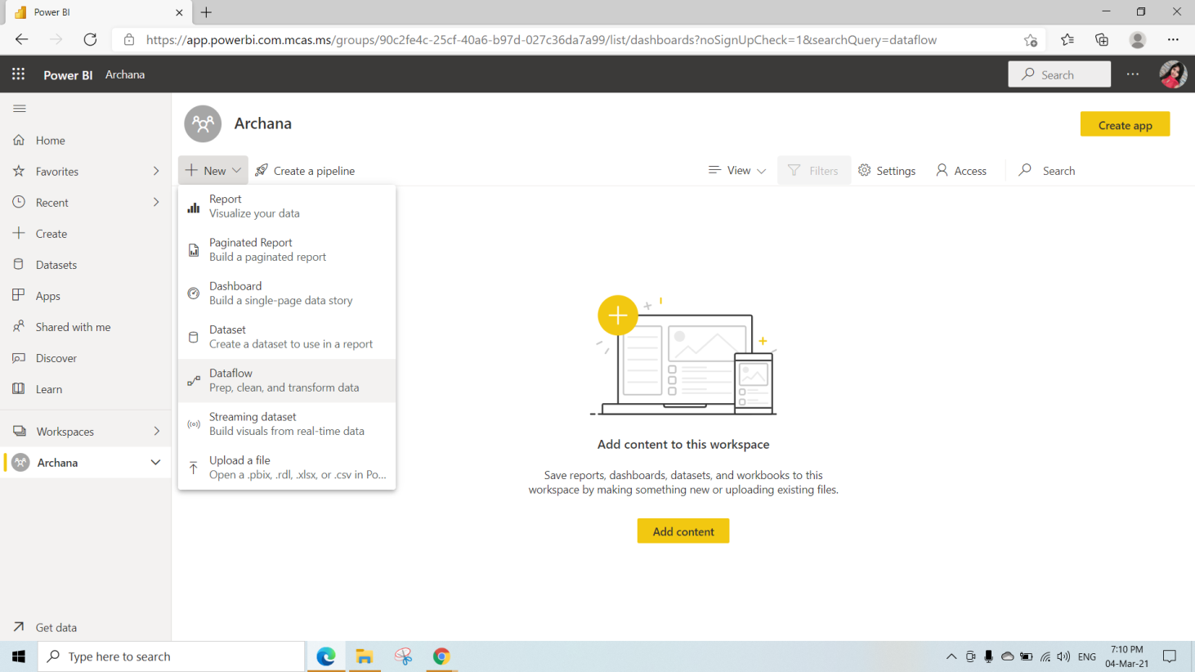

Step 2:- Select the blank query.

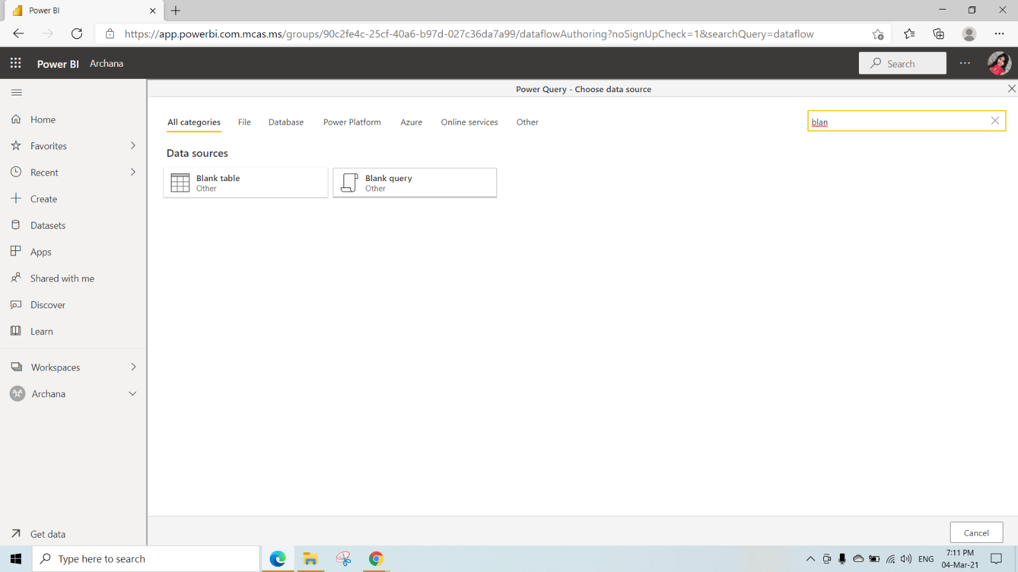

Step 3:-Paste the Date Time table M code for the as shown below in the editor as shown in below fig.

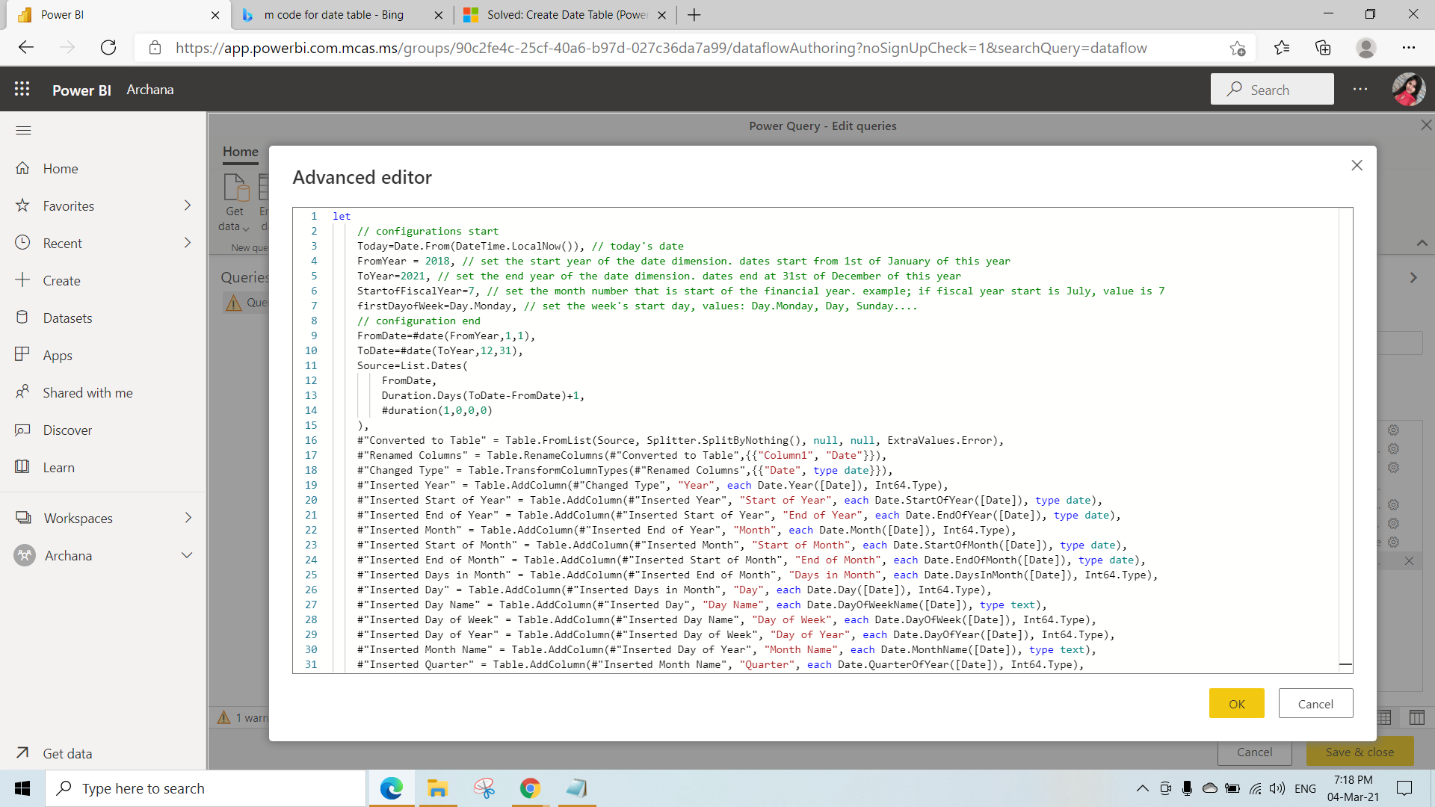

Step 4:- The data gets loaded in the power query editor. Based on the Mcode.

* Select Save and close to load the data into the data Flow

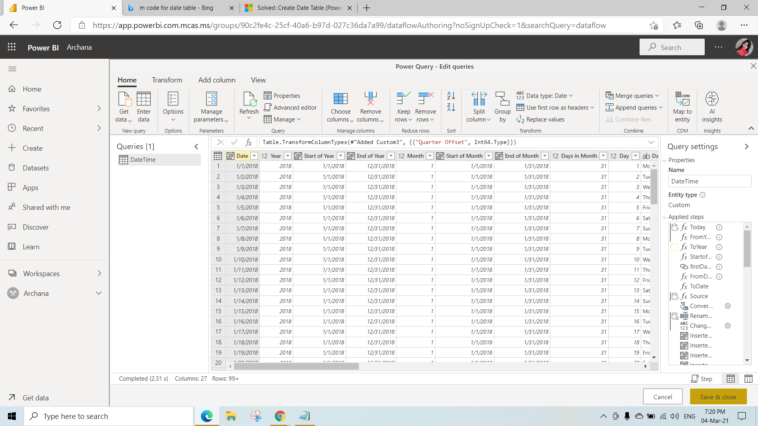

Step 5:- Enter the Name of the dataflow and click on save . to save the dataflow.

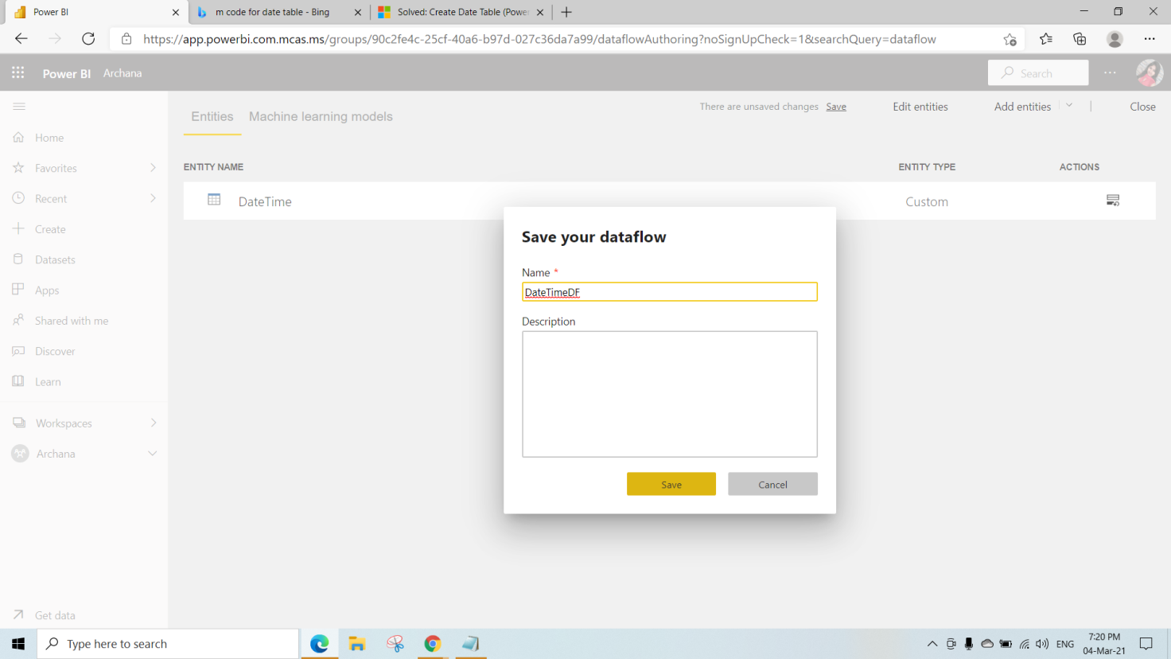

Step 6:- Data Flow got created as DateTime. we can use this dataflow to import in any project.

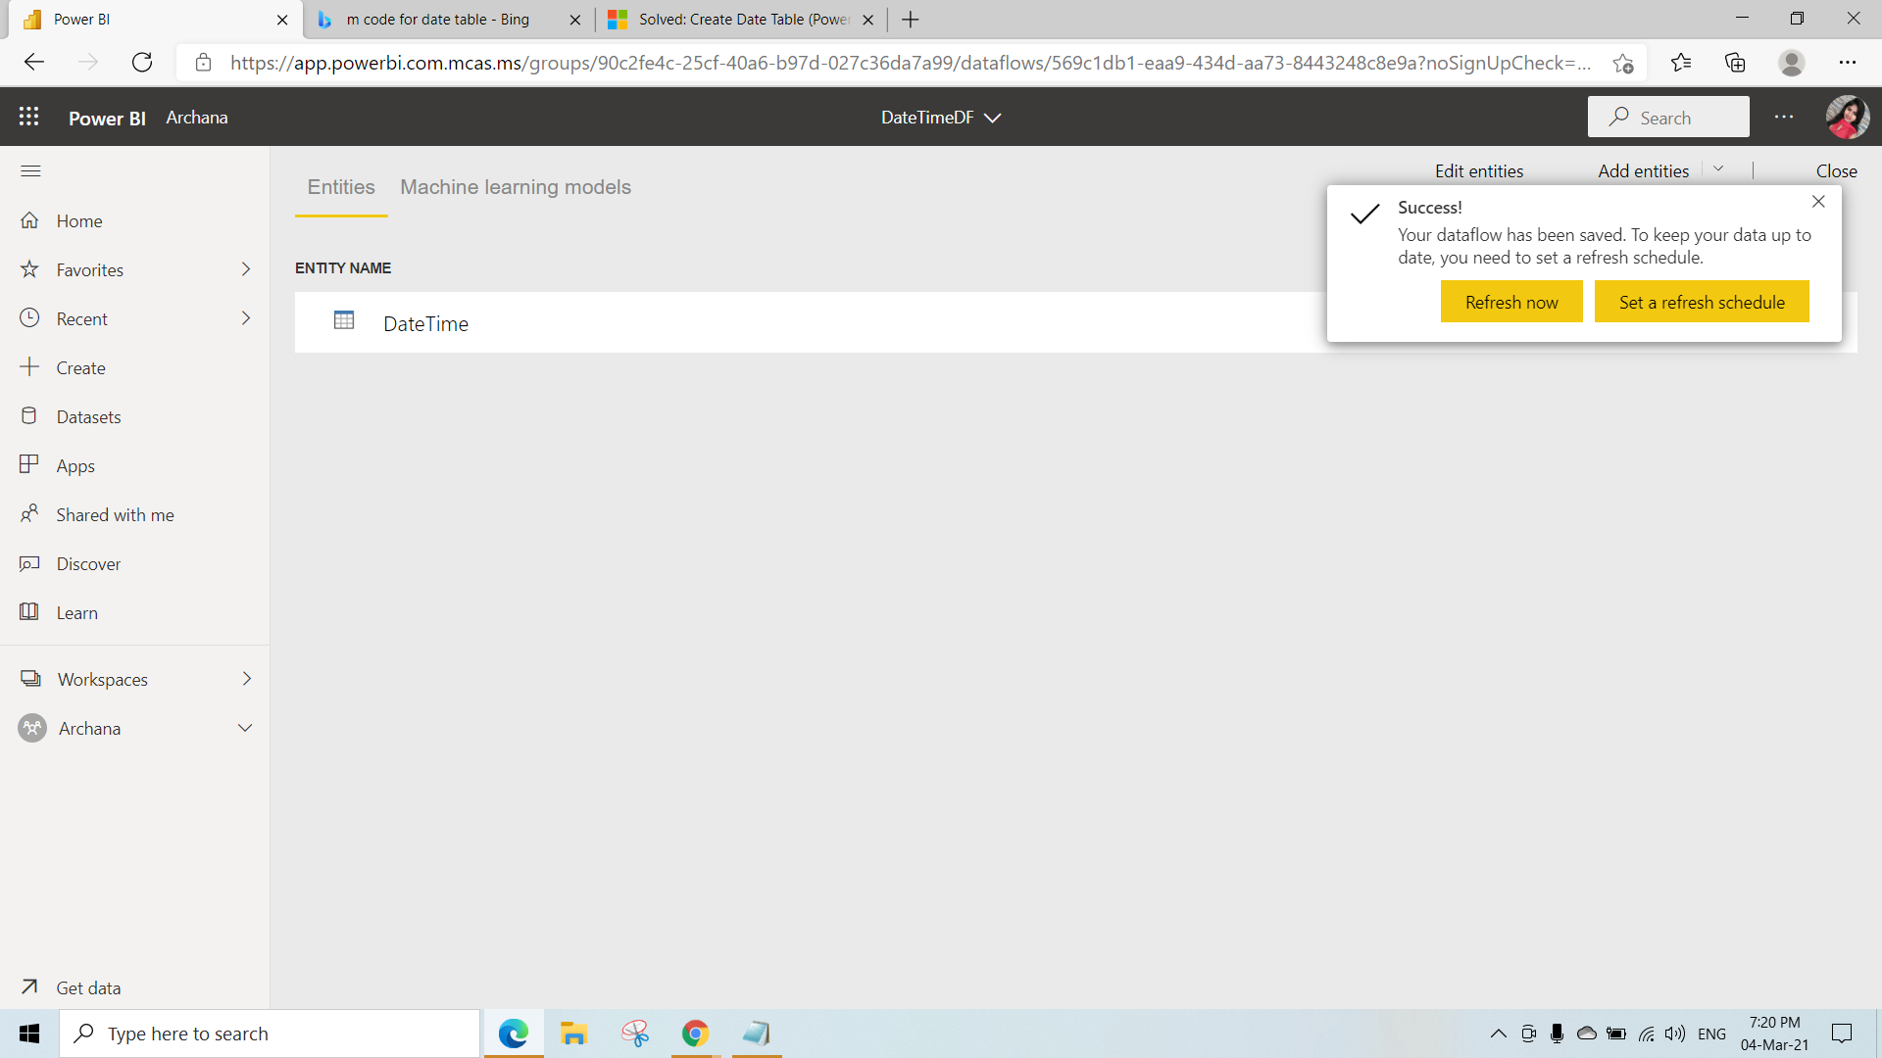

Step 7:- To load the dataflow into powerbi desktop application follow the steps.

* Select the get data-> view more -> select power platform-> click on connect.

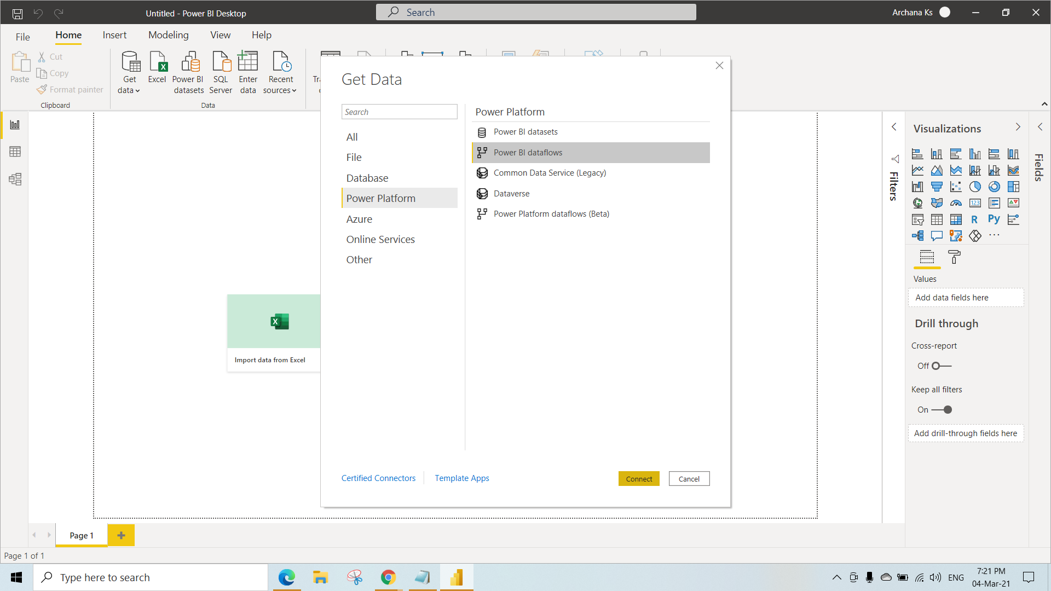

Step 8:- Click on sign in to powerbi server.

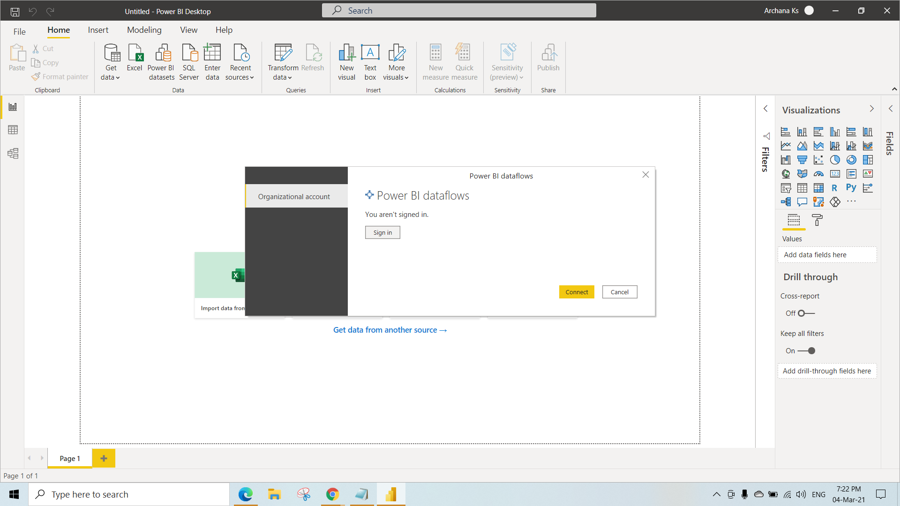

Step 9:- After signing with credentials click on connect to see the dataflows.

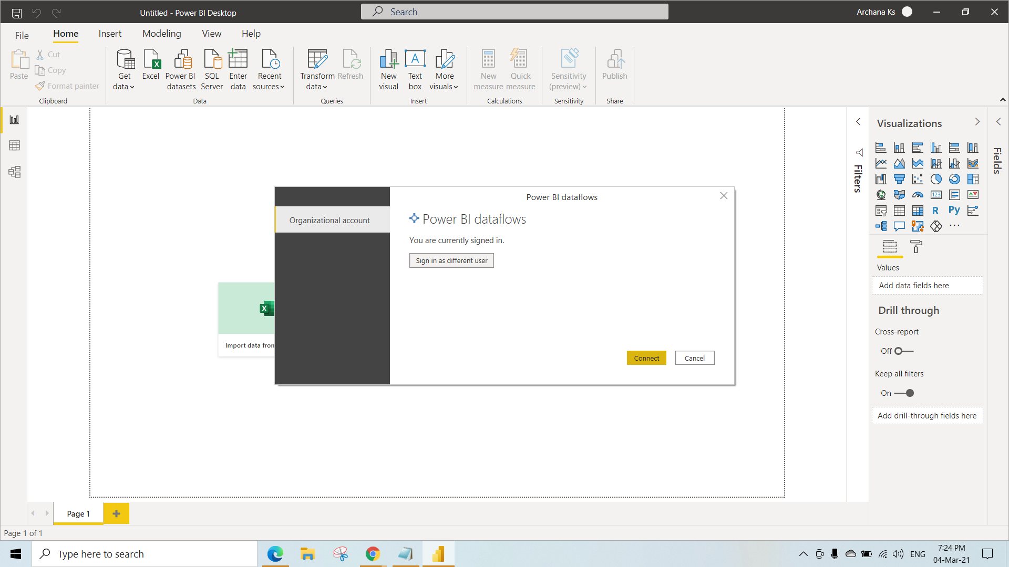

Step 10:-Select the dataflow -> click on load to load the dataflow into the powerbi as table.

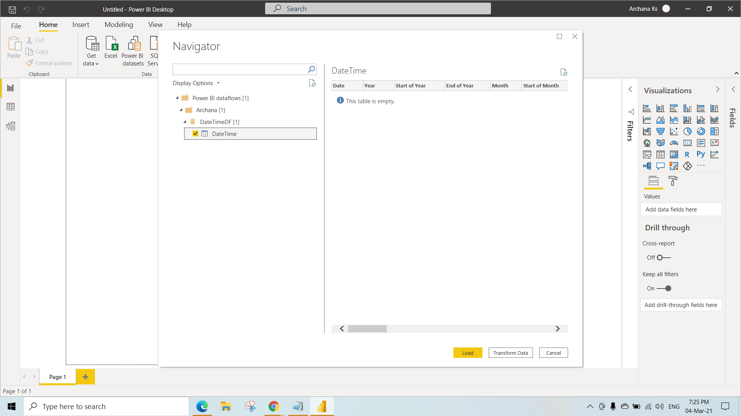

Step 11:-Date Time table is got loaded into the Power bi Desktop App

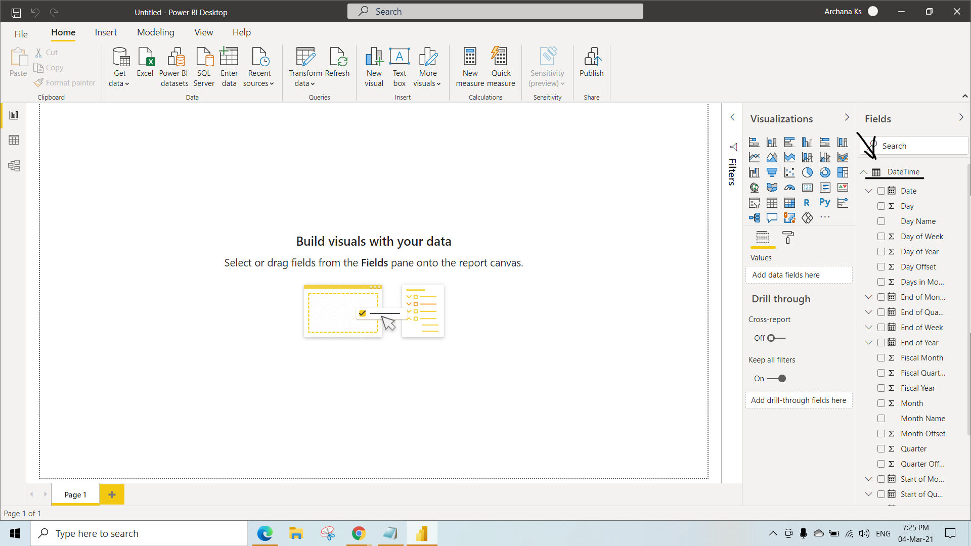

* Copying M Code.

Step 1:- Select the Get data-> search for blank query as shown in fig

-> select the blank query

-> click on the connect

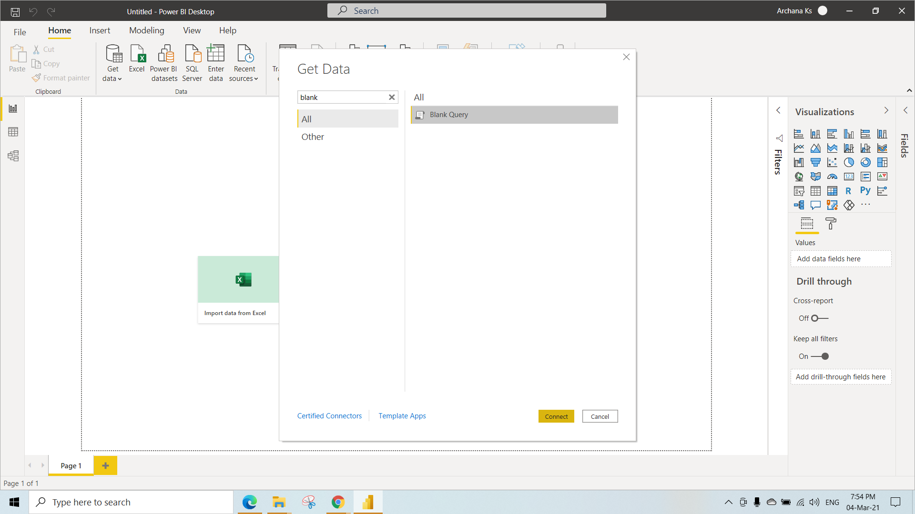

Step 2:- click on advanced query editor(as explained in the accessing underlying code) the window will open up write code as shown in the fig .

let

Source= List.Dates(#date(1998,01,01),100,#duration(1,0,0,0))

in

Source

The above code creates the 100 dates from the 1998,01,01. So copy the code in the advanced editor to create the table.

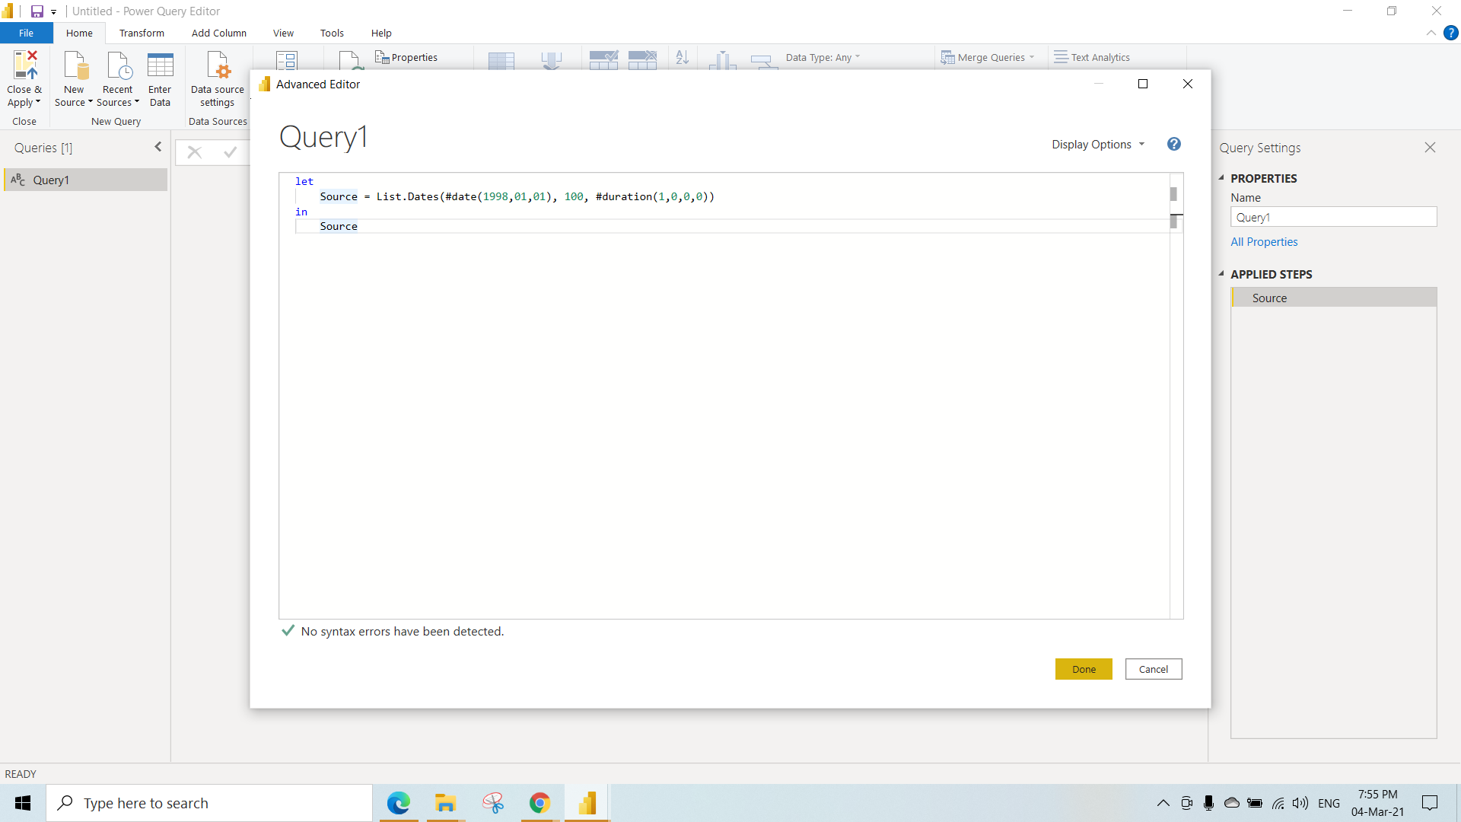

Step 3:- Output of the above code.

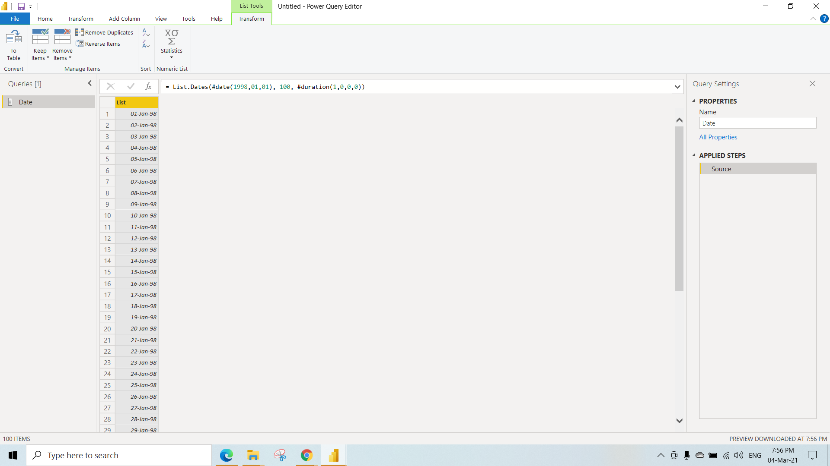

Step 4:- Click on to table as shown in the fig to convert list to table.-> click ok to convert.

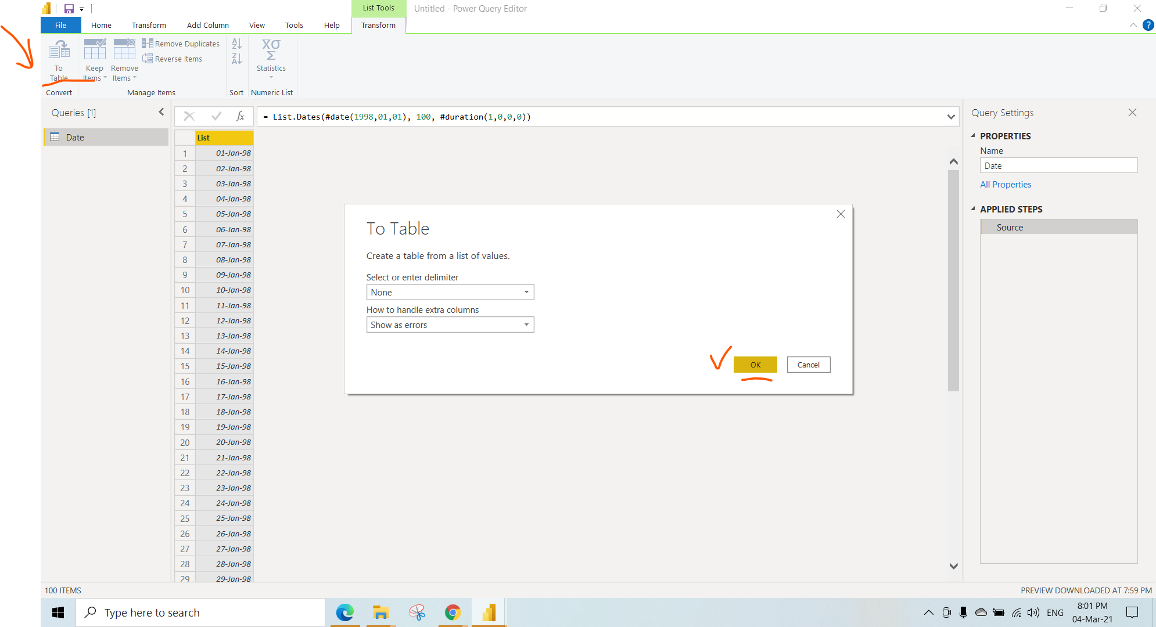

Step 5:- Go to Home and select close and apply to load the data into powerbi as table.

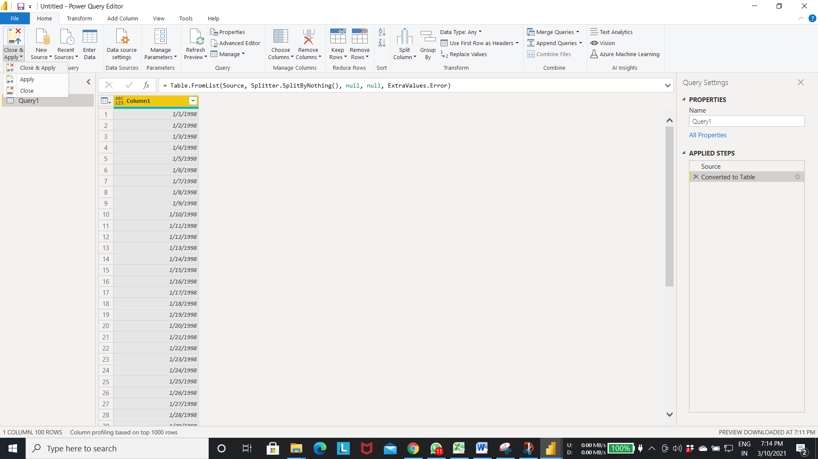

Step 6:- As a result data got loaded into the power bi.

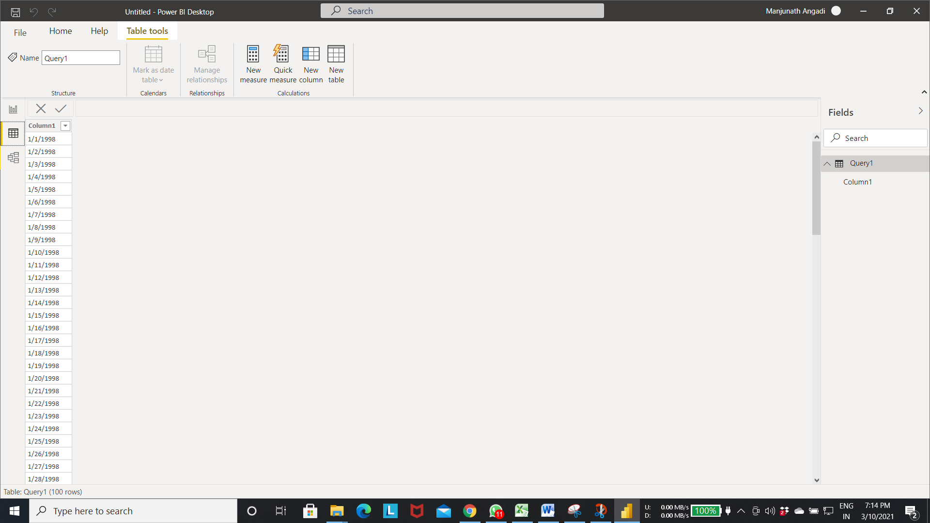

Step 7:- Relationship diagram for the table.

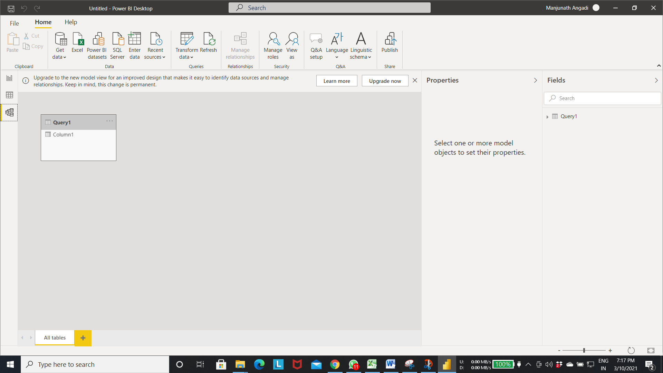

KO 2: Able to Add and Remove Steps in Data Recipe

* If we make any transformation inside the power query editor that will be added as step in the applied steps.
* If we make any wrong changes to the data. we can remove the step from the Applied steps to get the previous data.
* In the applied steps we can move between the steps to see the data transformation at that step by selecting the step from the applied steps.

Step 1:- 1. select text/csv to load the file into the powerbi as a table 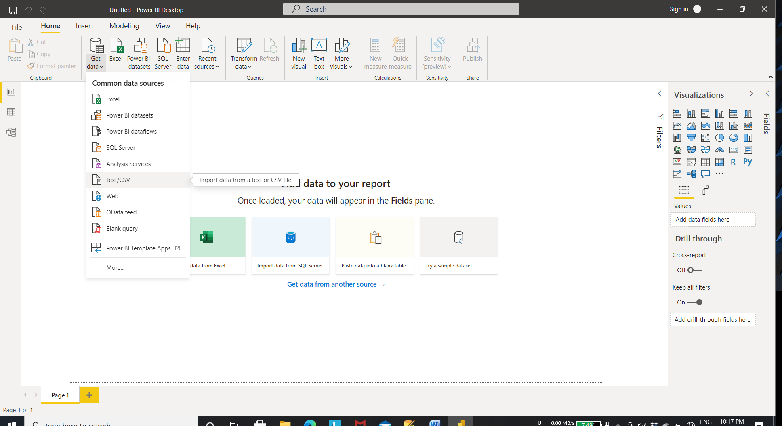

Step2:- Select the products file to load as table into the power bi.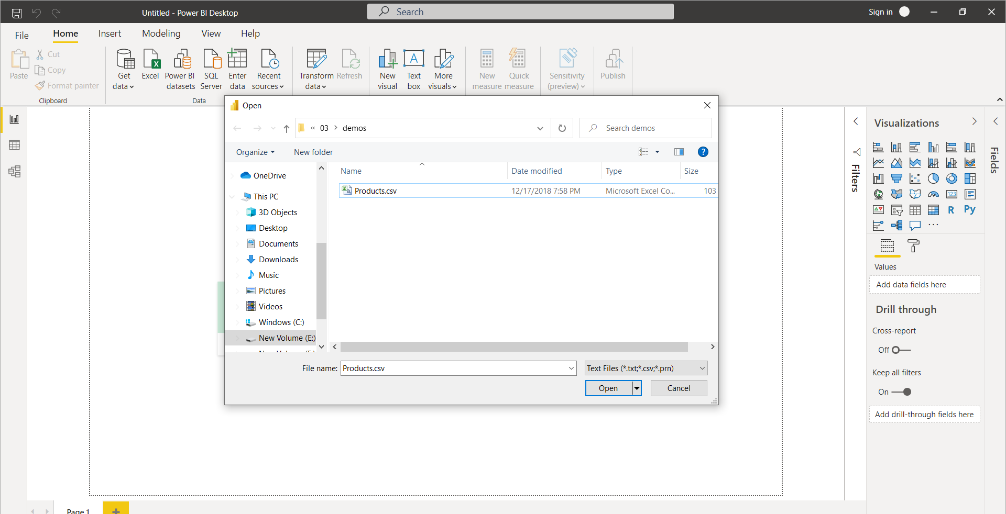

* If we make any transformation inside the powerquery editor that will be added as step in the applied steps.

Step3:- 3. select transform to open the power query editor to transform the data before loading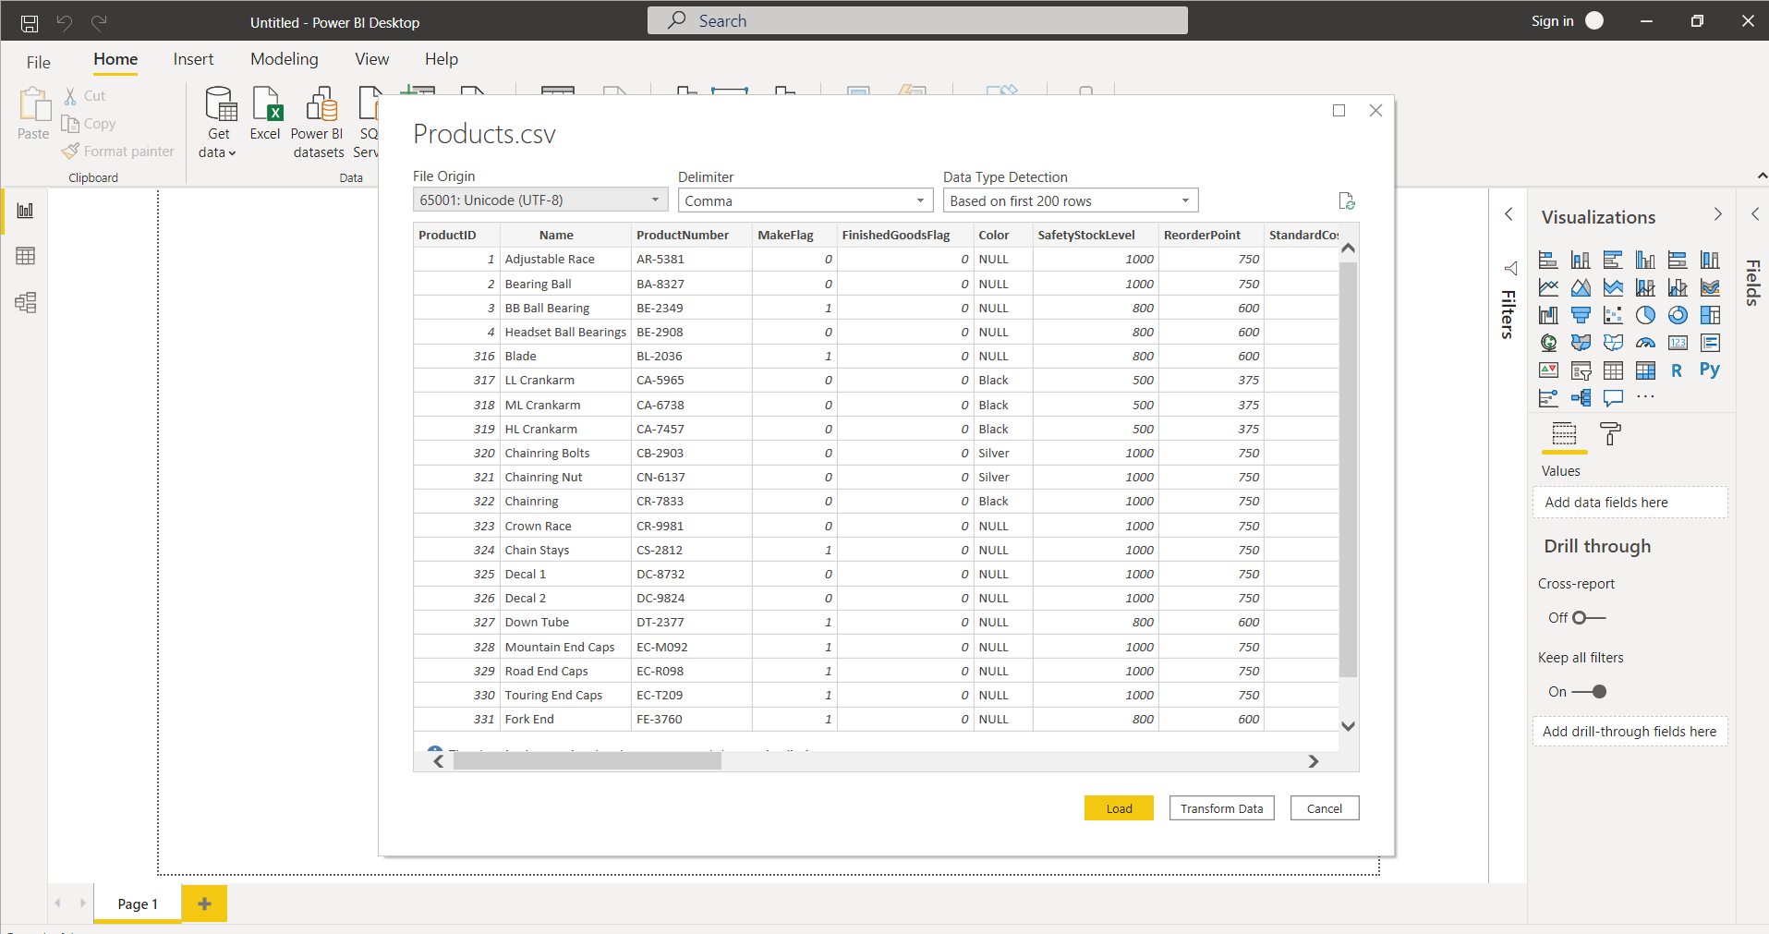

Step 4:- Power query editor view in power bi. We can see the changes made to the steps inside the applied steps as shown in below diagram .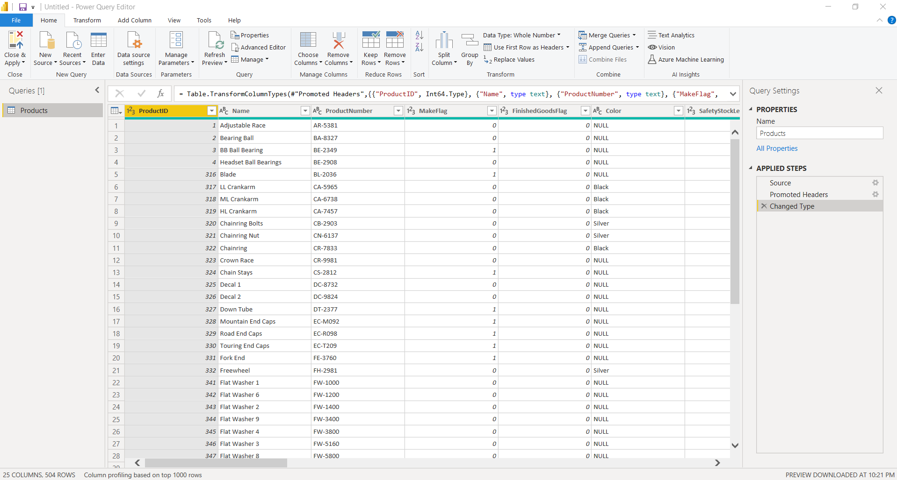

Step 5:- Select the arrow pointed icon to apply transformation to the column.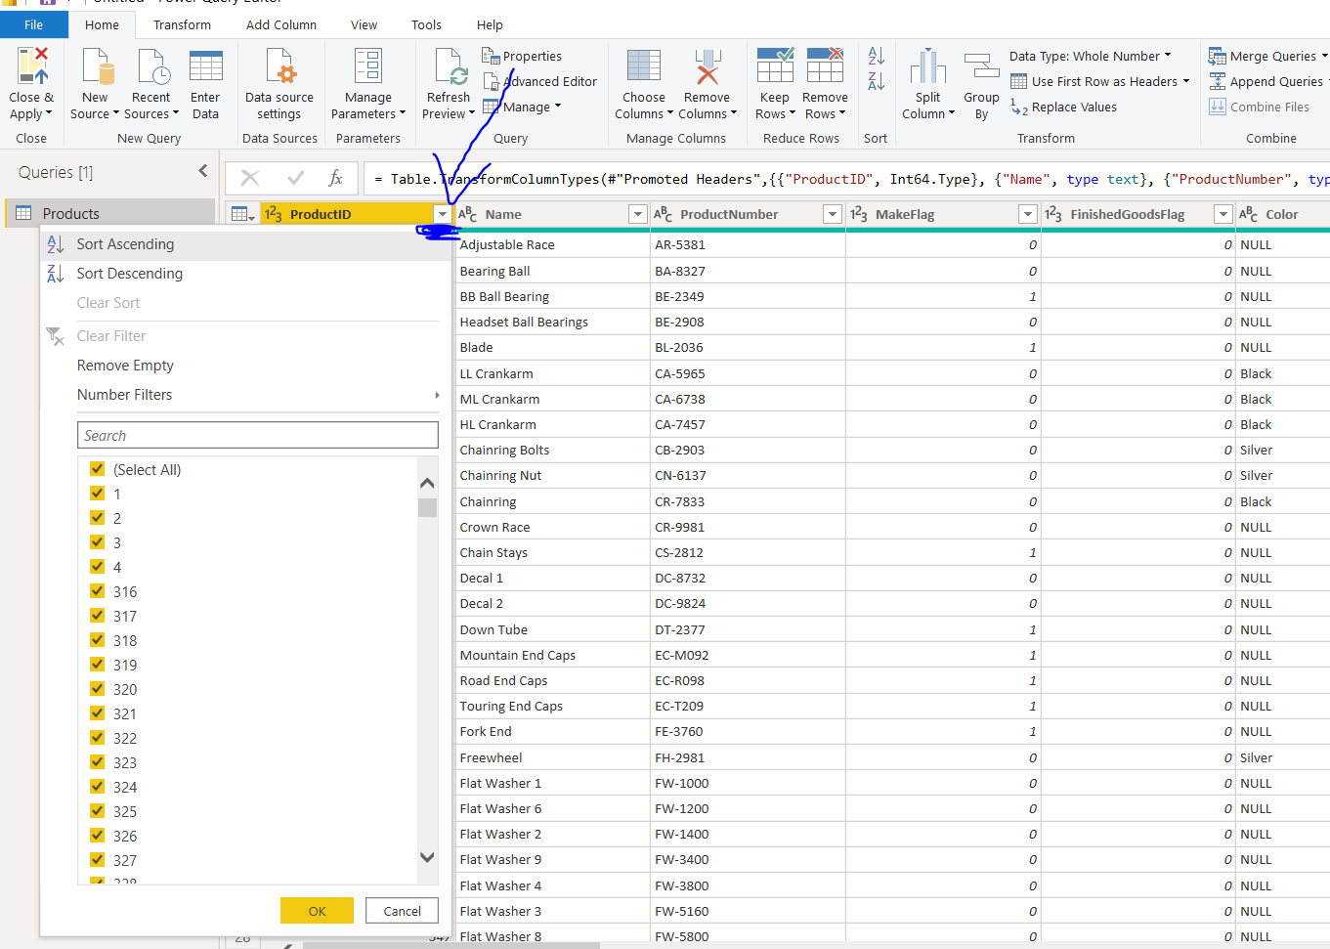

Step 6:- Select the number filter as shown in fig to filter the records based on condition.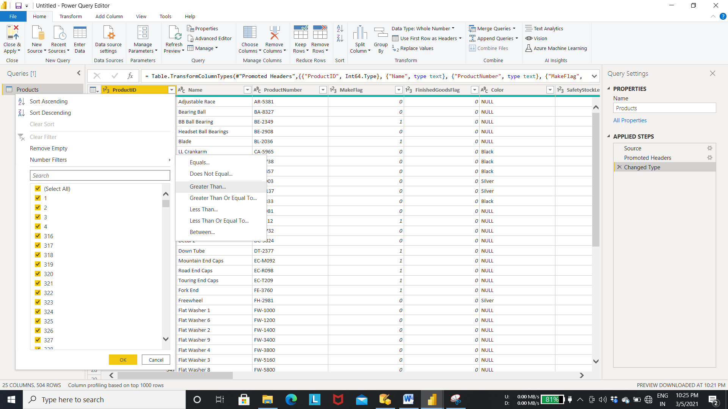

Step 7:- select the filter condition and click ok to see the filter condition. Apply the condition(In the below diagram filtered the rows with Product ID column value greater than 300). 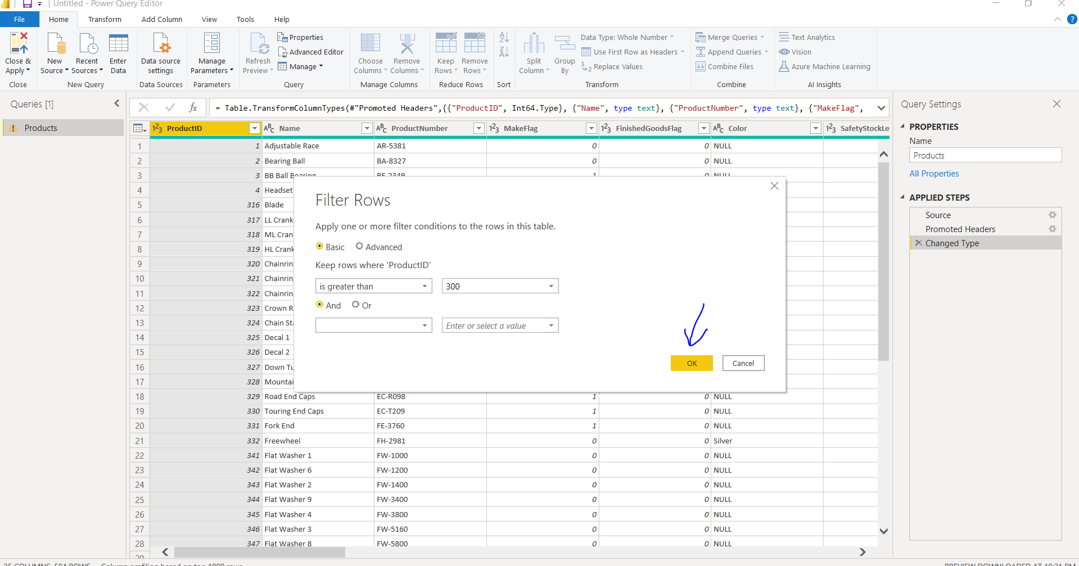

Output:- filter query add the step into the applied steps as (Filtered Rows as shown in the figure)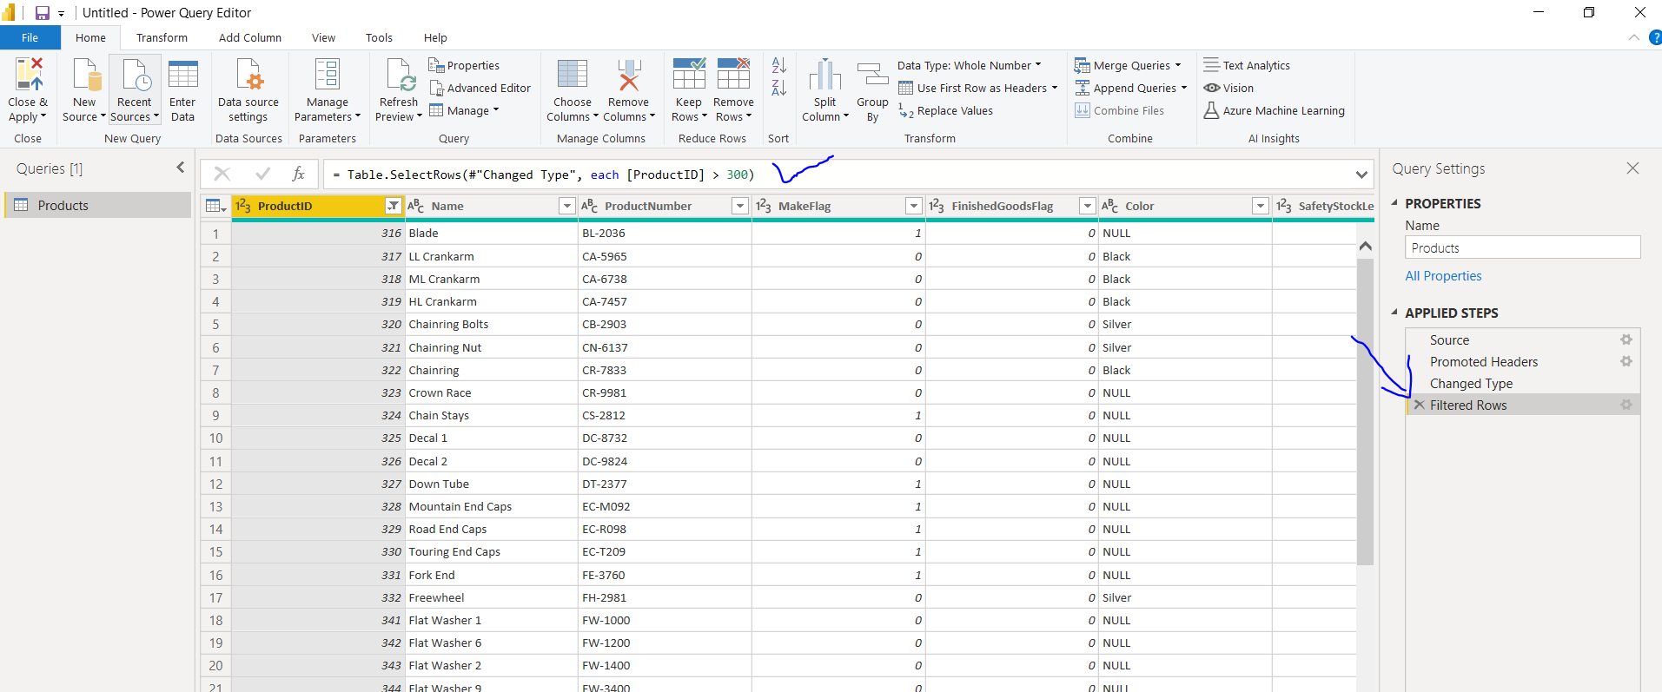

* Changing the data type of the column

Step 8:- currently the data type of product id is decimal number.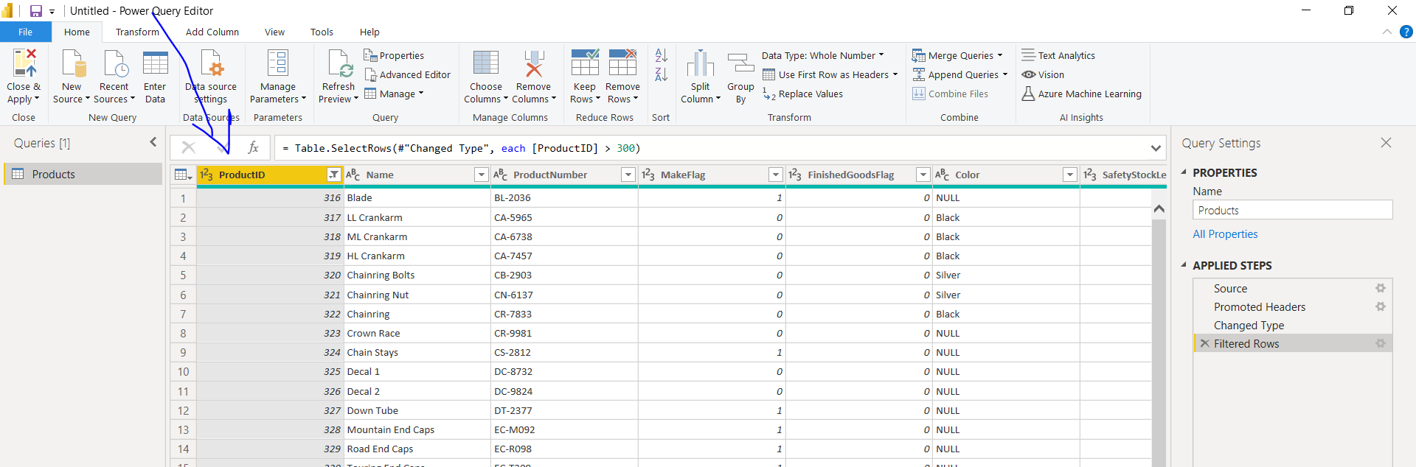

Step 9:- if we want to change the datatype of the product id column select the arrow pointed icon to change the datatype and select the type you want to change ( In the below fig Product id column is converted From Decimal Number to Text). 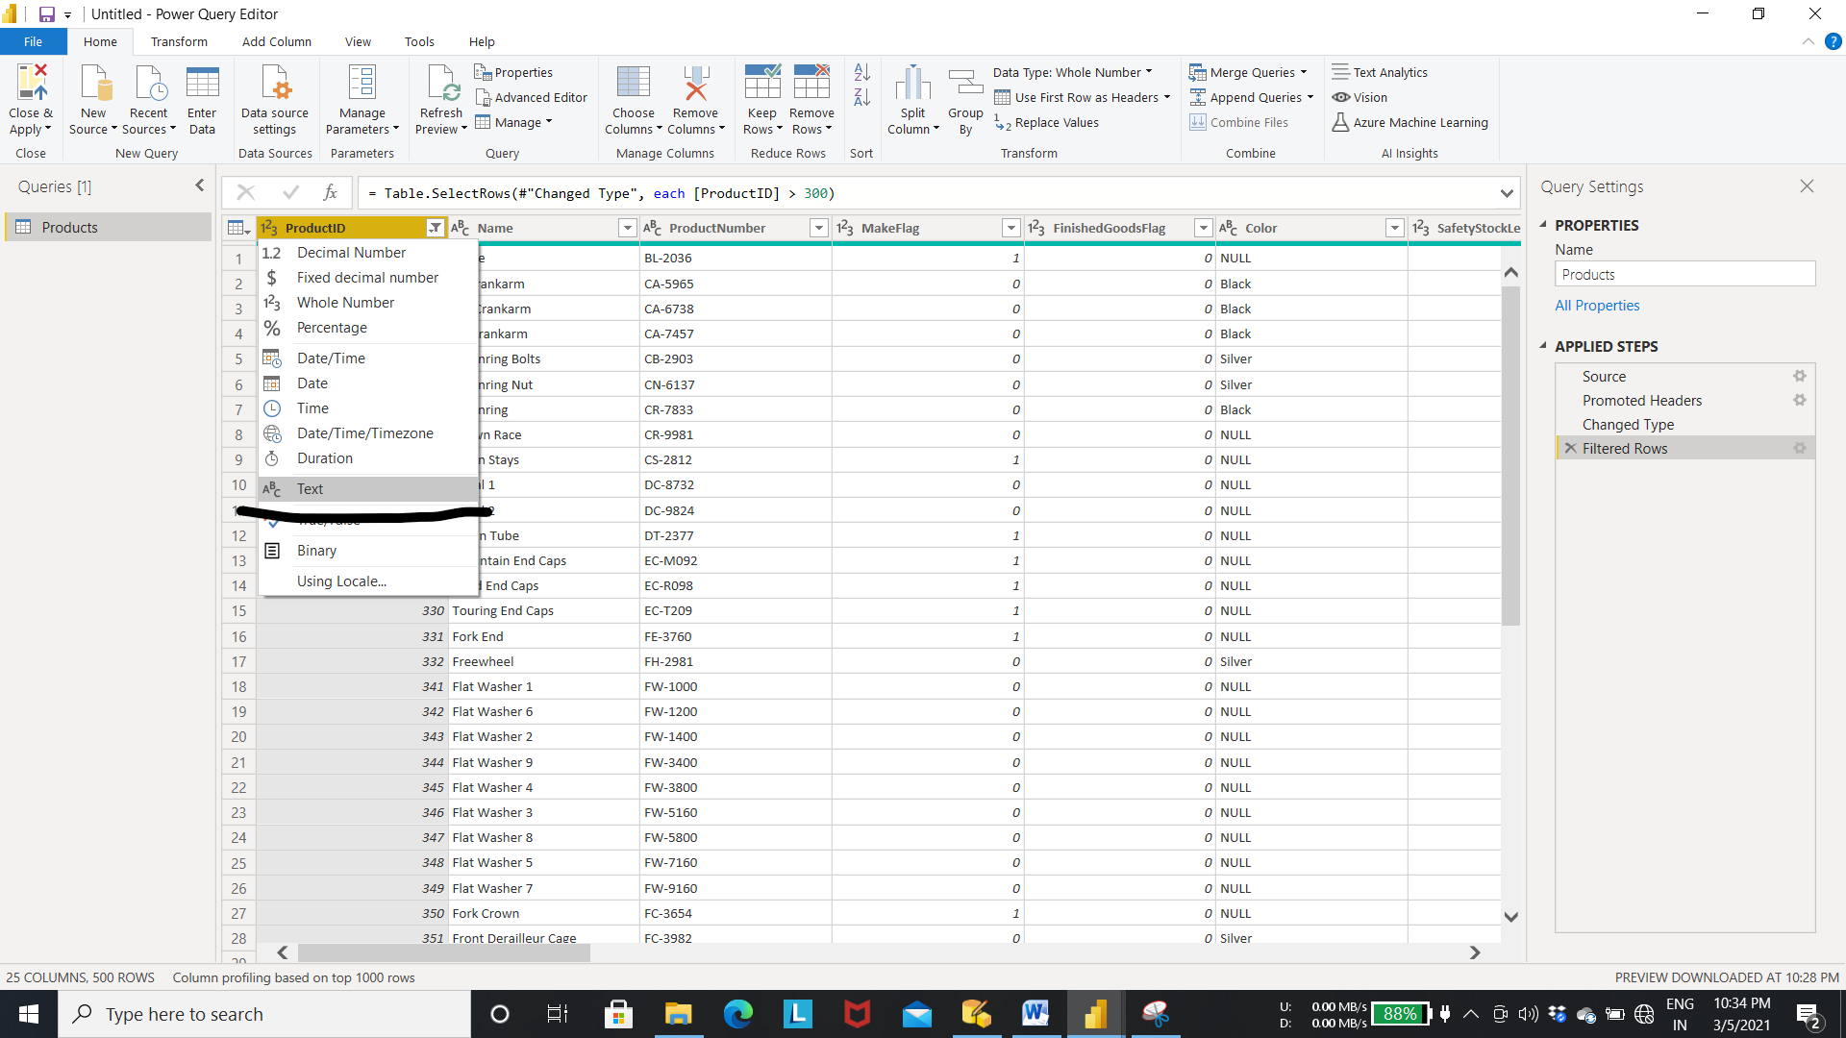

Output Step 9:- product id column changed to text datatype and the (changed Type1 is added to the applied steps as a result of transformation).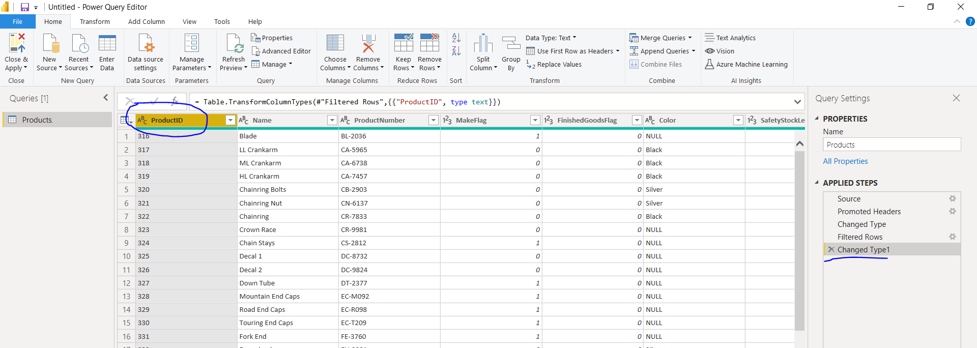

* If we make any wrong changes to the data. we can remove the step from the Applied steps to get the previous data.

Step 10:- if the chages made is wrong we can rollback to previous data by deleting the step inside the applied step (To delete the step click on the cross mark as shown in the figure).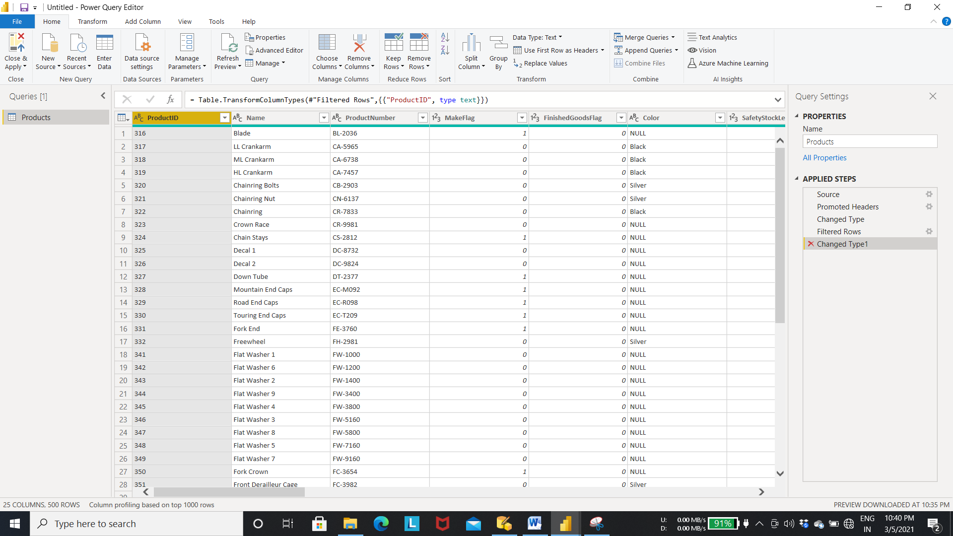

Output Step 10:- After removing changed type1 step from the applied steps (applied chages will get deleted).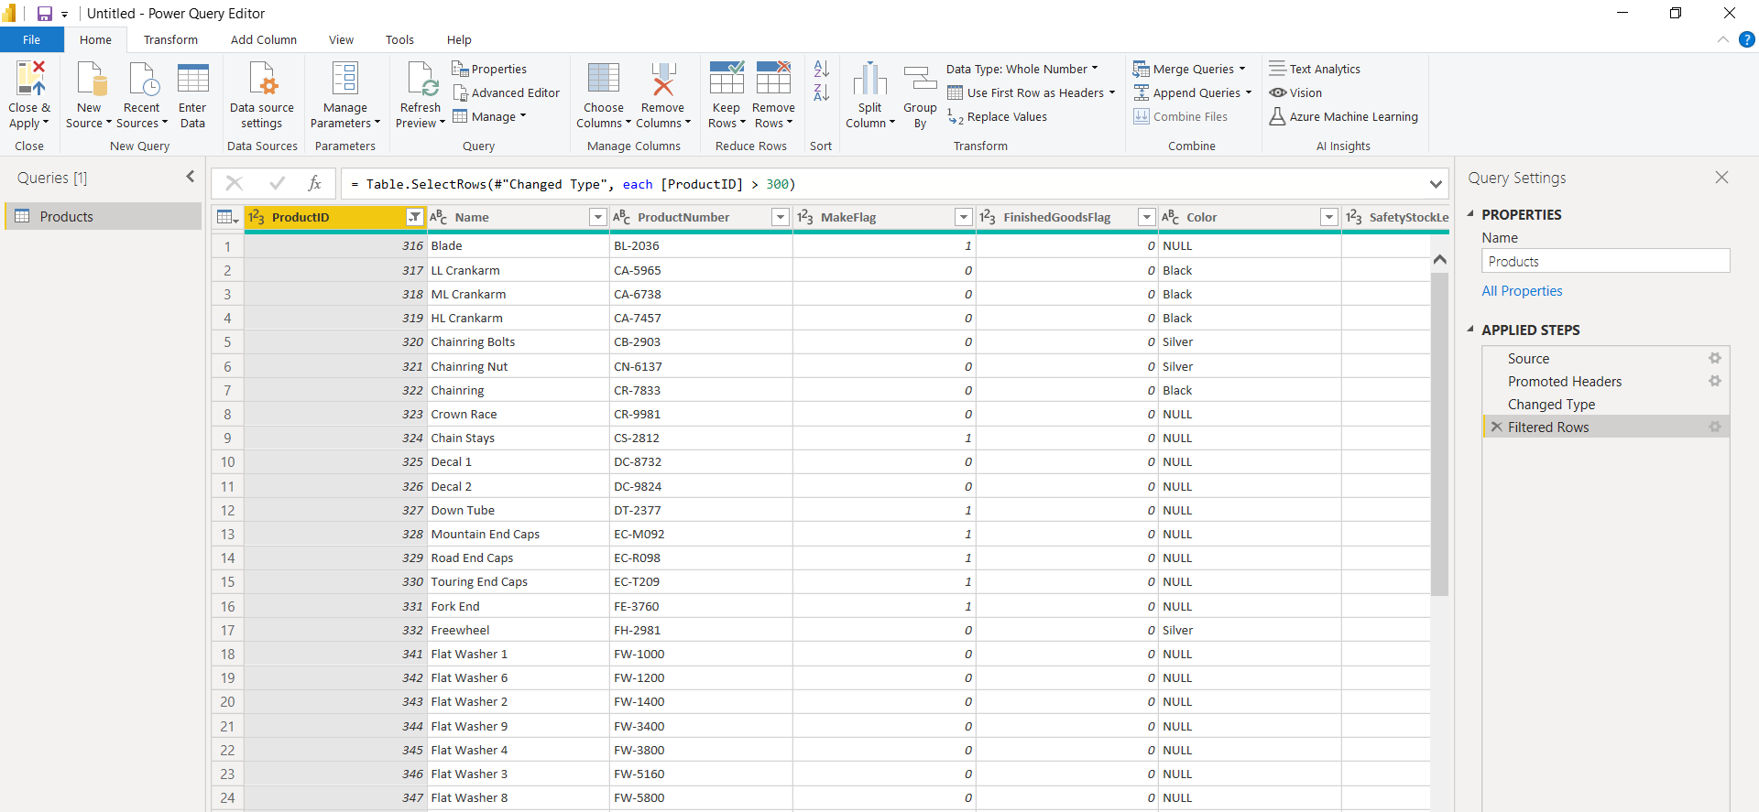

Step 11:- To rename the column(choose rename step From the drop down menu as shown in figure).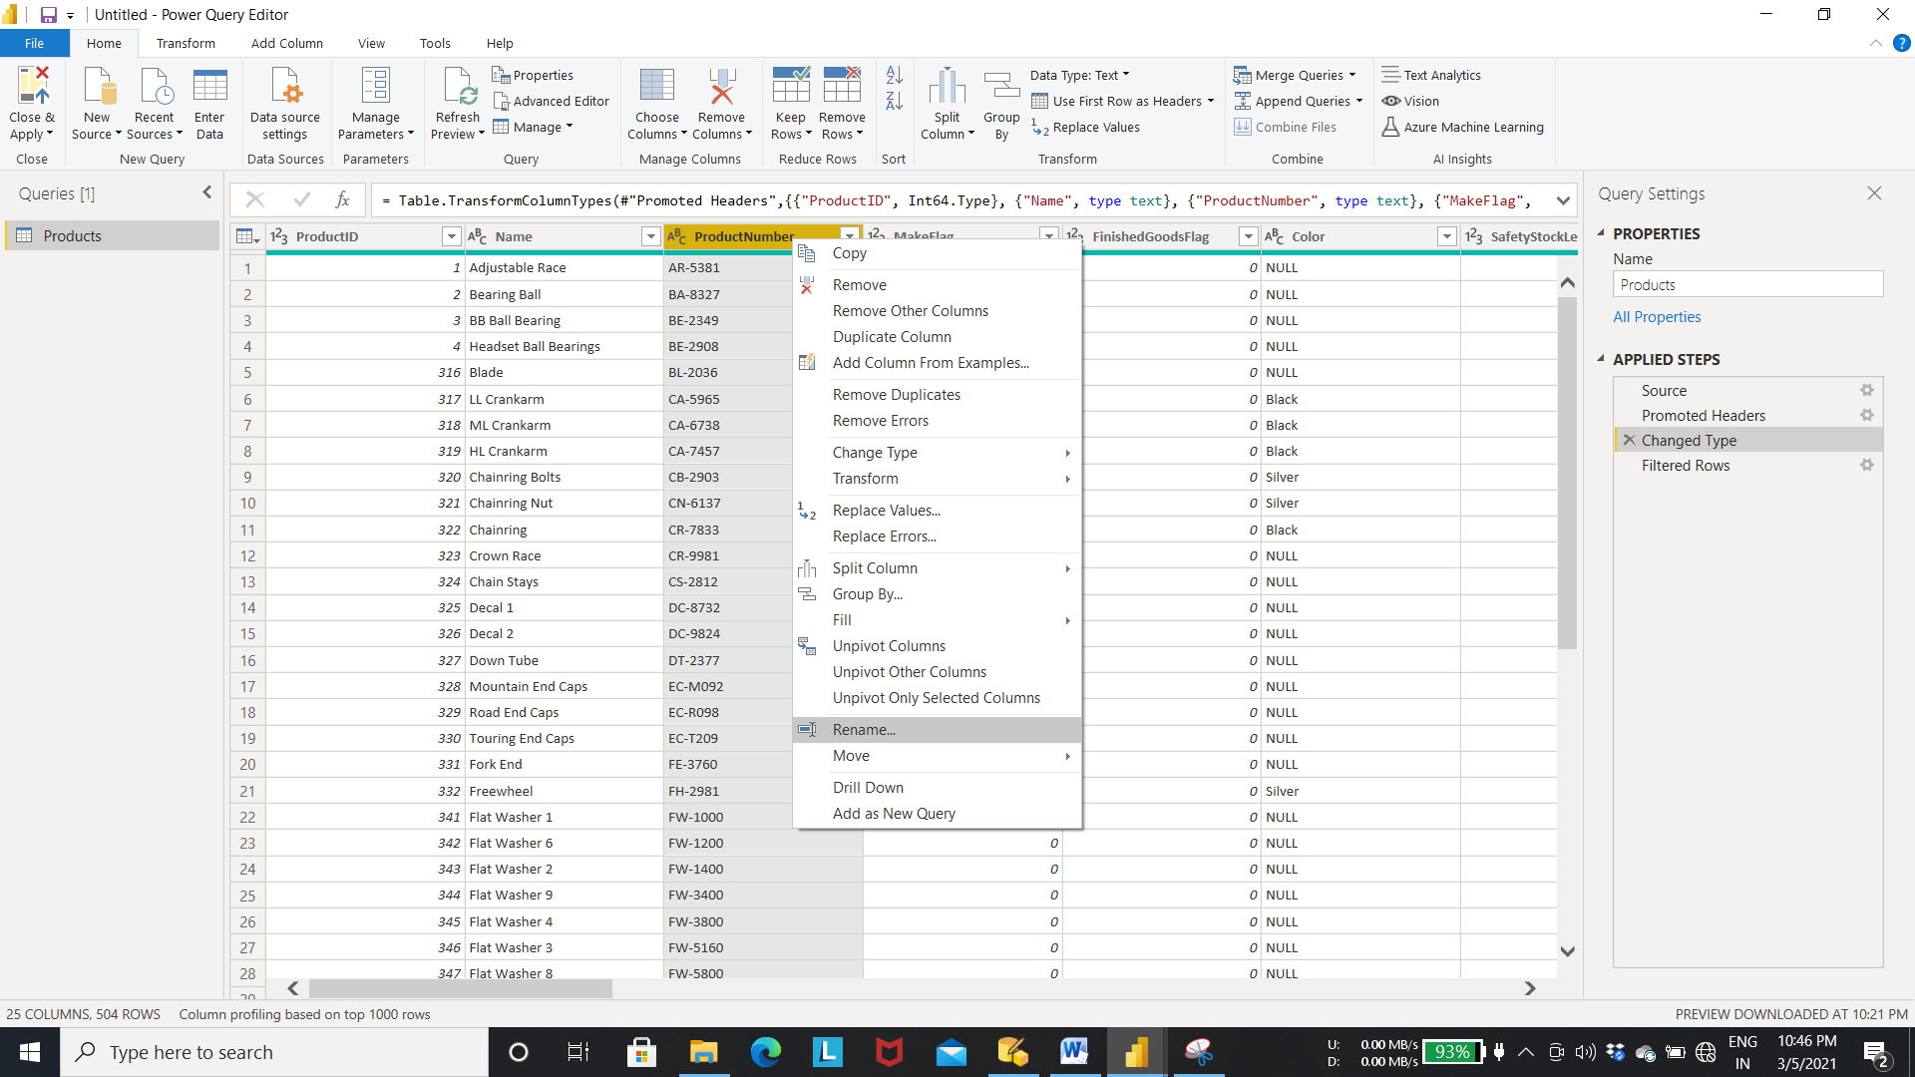

Output Step 11:- Result Table After Renaming the column (Renamed column step is added to the applied step as shown in the fig).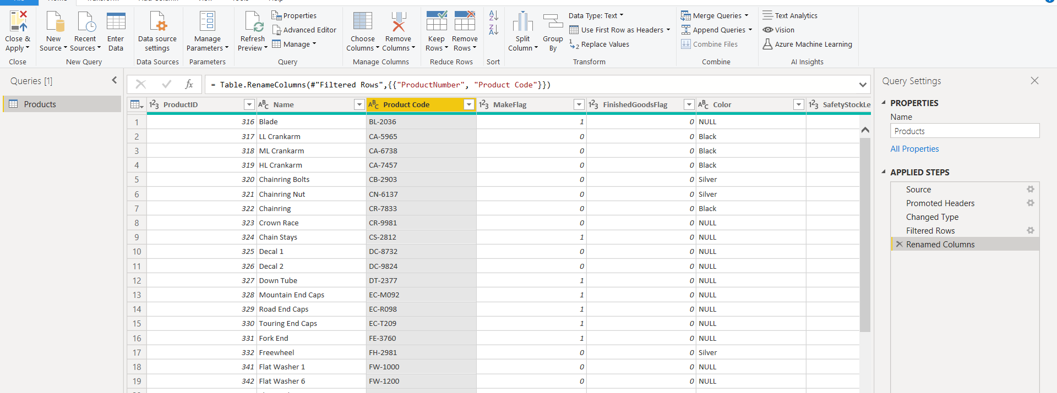

* In the applied steps we can move between the steps to see the data transformation at that step by selecting the step from the applied steps.

Step 12:- If we want to see the transformed data From previous step .

* Select the step from the applied step to see the chages made at that step 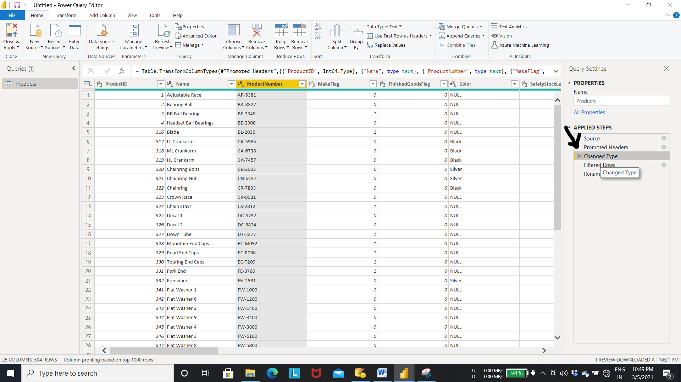

KO 3: Able to Improve the Data Model for Reporting

Step 1:- Click on the manage icon as shown in the fig to view the relationship between the tables and these relations are automatically detected by the power Bi .(or we can manually configure these relationships)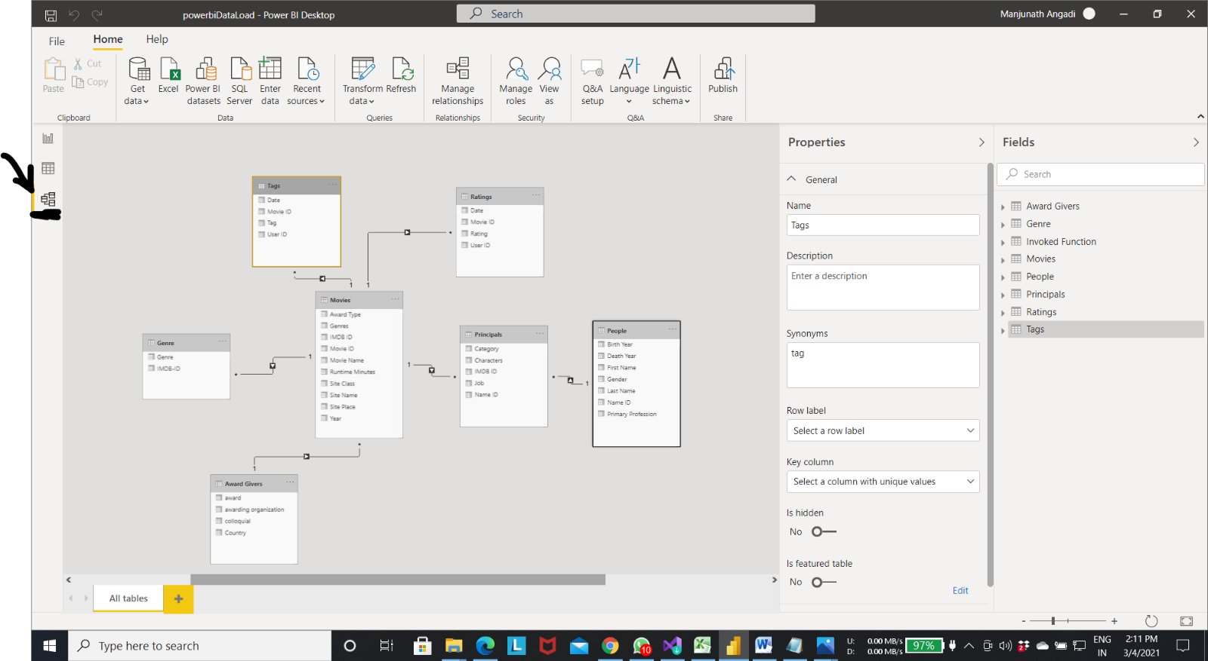

* Data hiding(hiding unwanted columns for the viewers).

Step 1:- select the column -> right click menu will appear to hide the columns to the viewer.

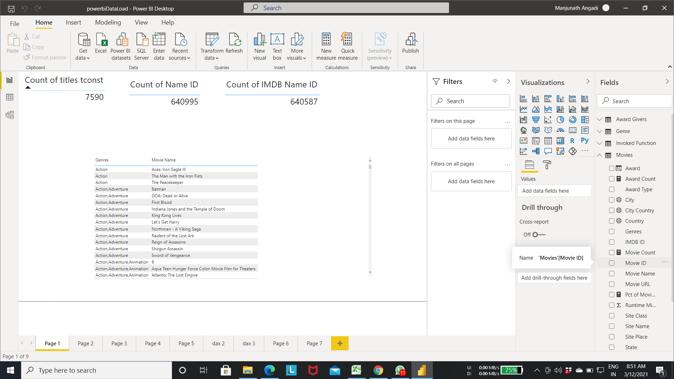

Step 2:- Select the hide option as shown in the fig to hide the column.

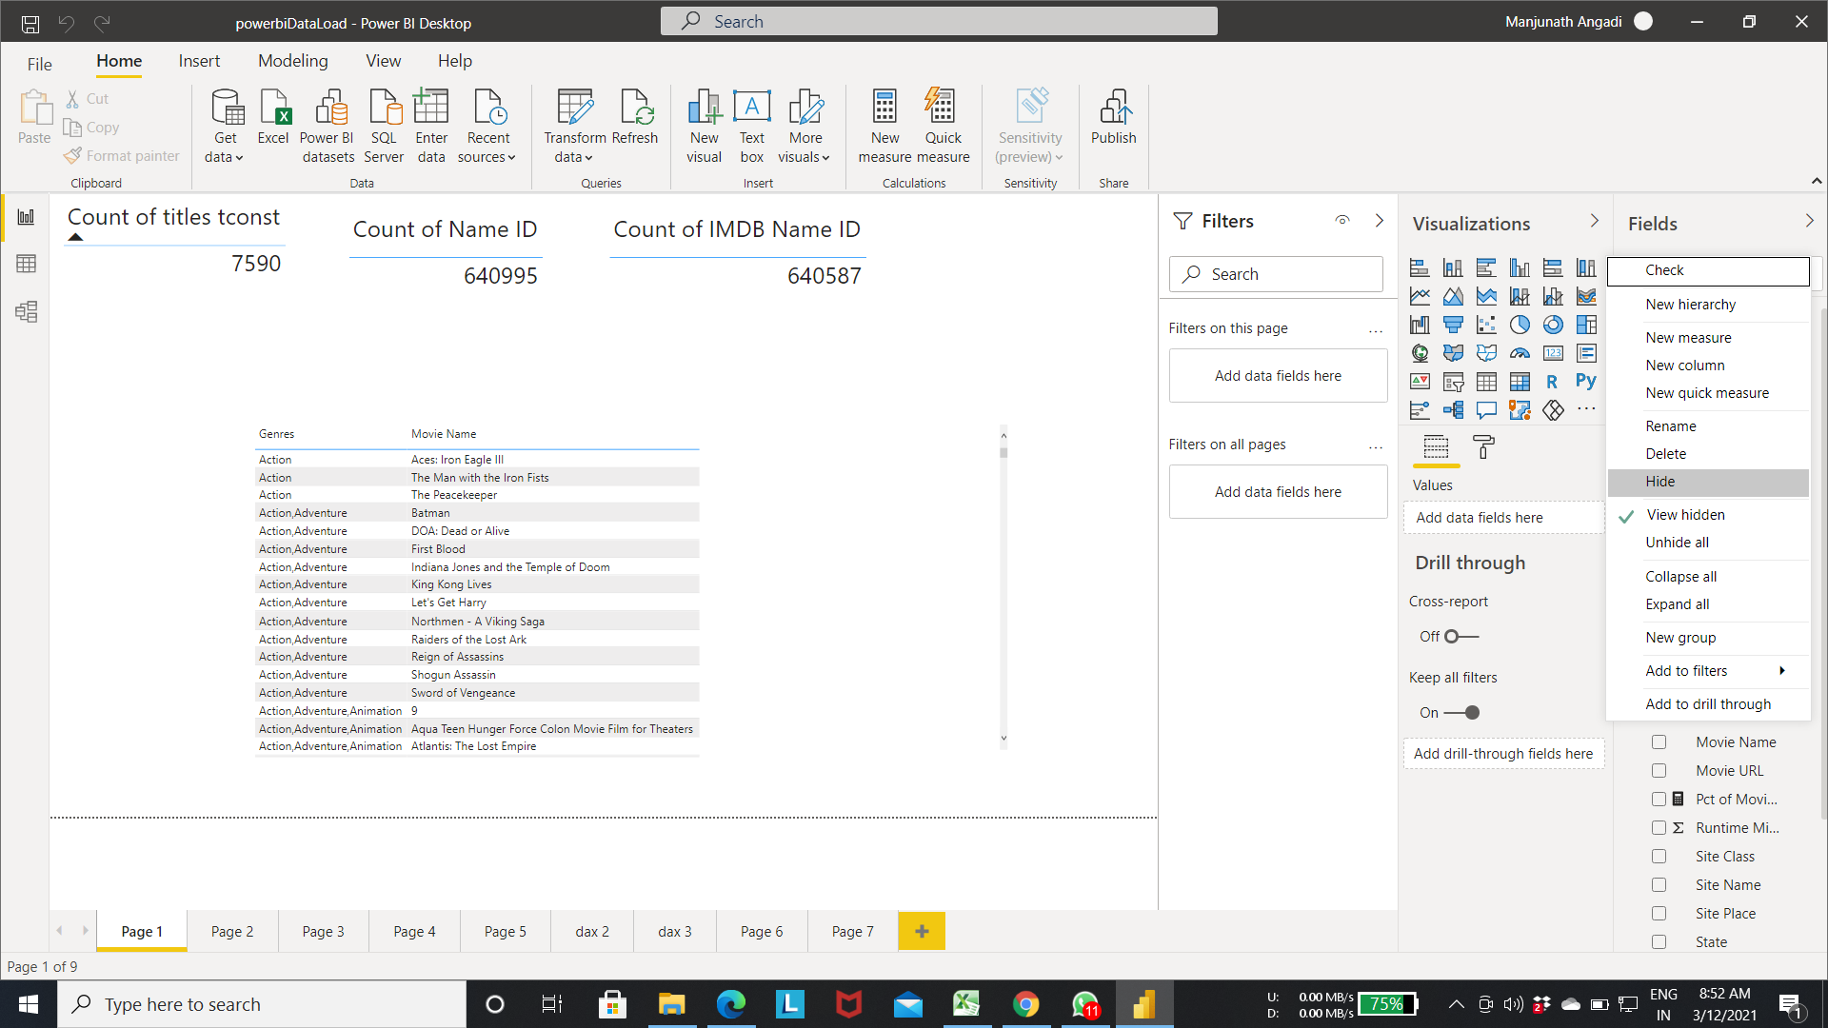

Step 3:- Output of step 2 in movies table we can see color change in the movie id attribute this means that column is hidden to the viewer.

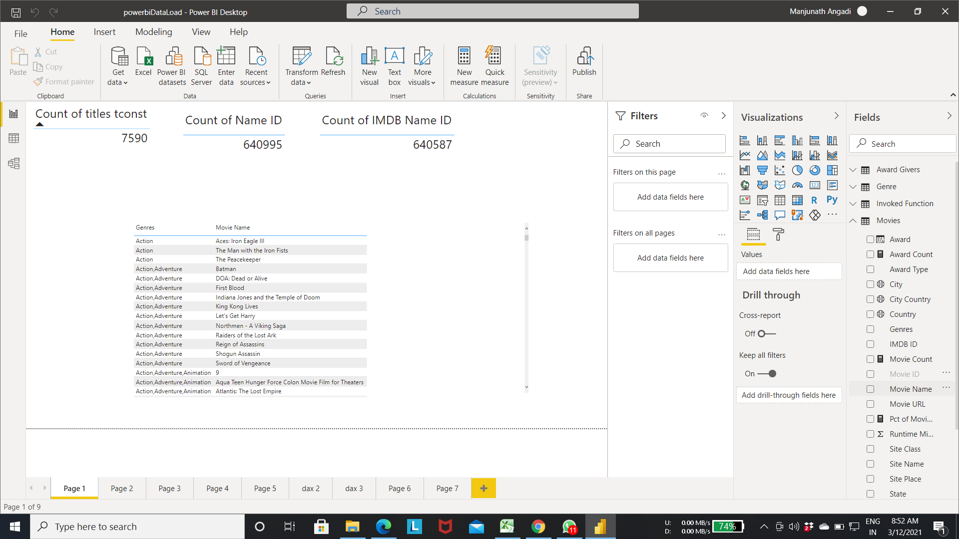

* Sorting columns data

Step 1:- Select the transform data as shown in the fig to open the power query editor.

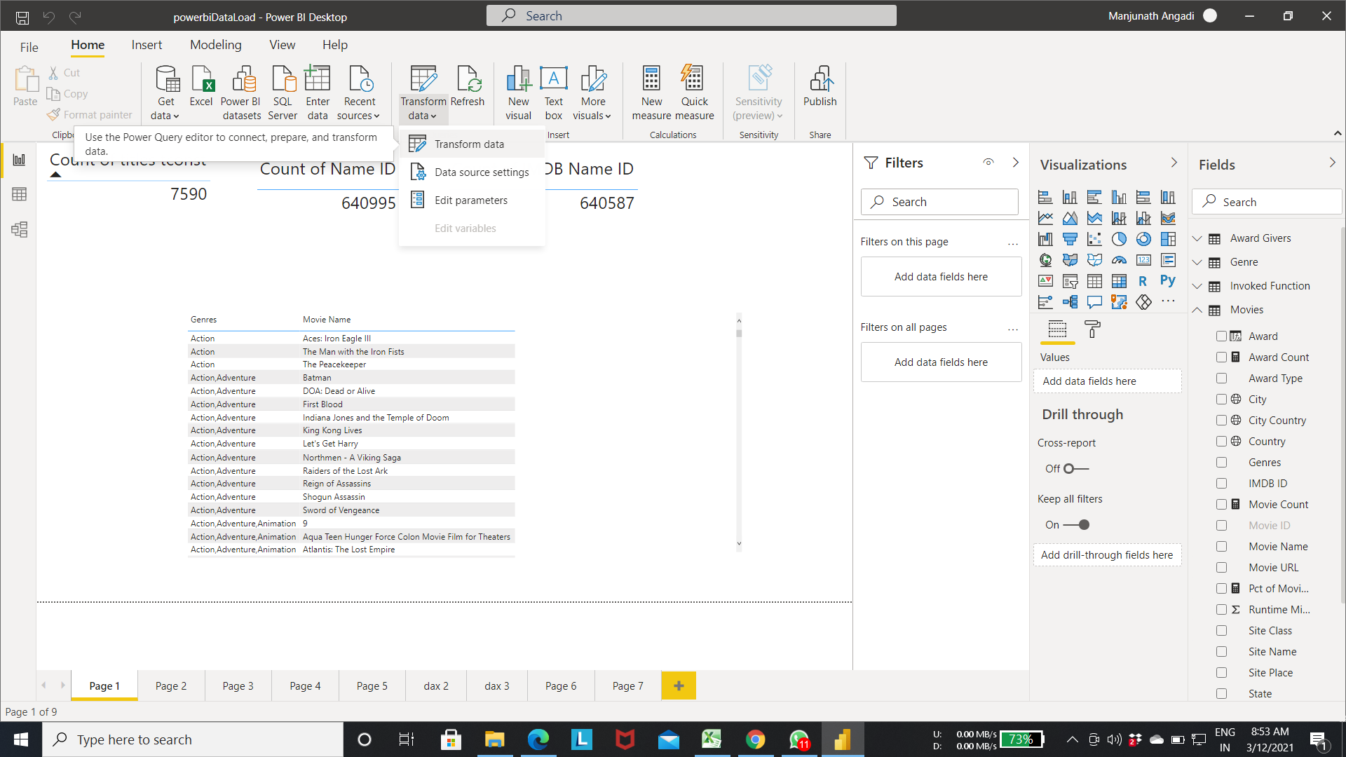

Step 2:- power query editor.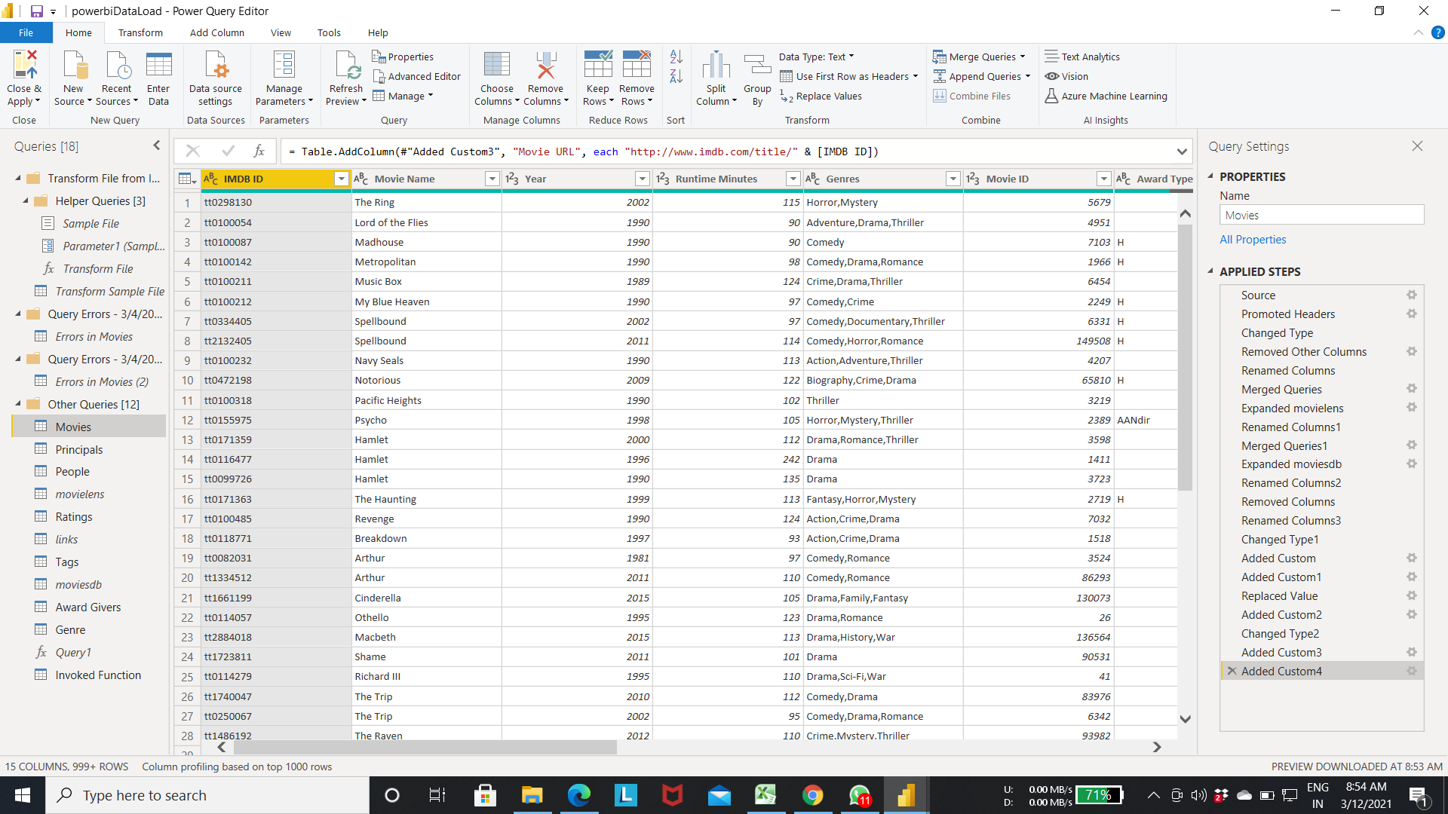

Step 3:- select the column-> right click

-> menu will appear to sort the records based on ascending or descending

-> choose the option best suited for your query.

-> Here we selected ascending.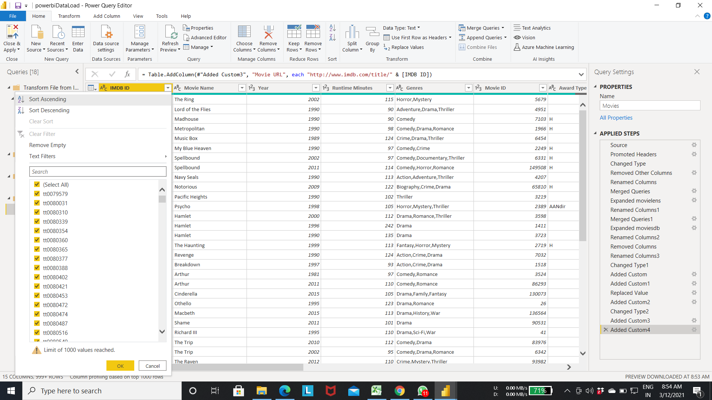

Step 4:- Result of step 3(After sorting the movie id column in ascending order).

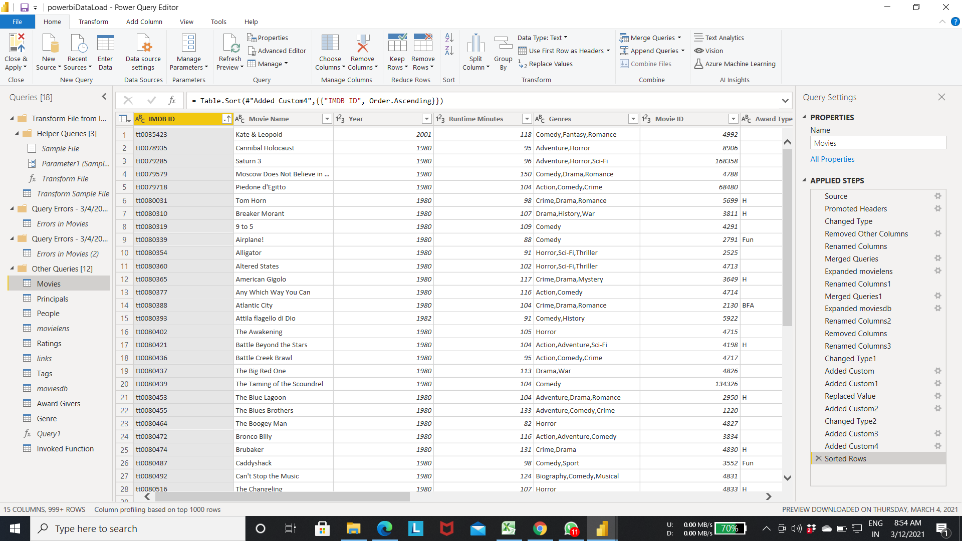

* **Data Types** (In power Bi there are only limited number of data types available for use).

Step 1:-As we can see from the below fig all columns are associated with particular data type based on the data present in the column.

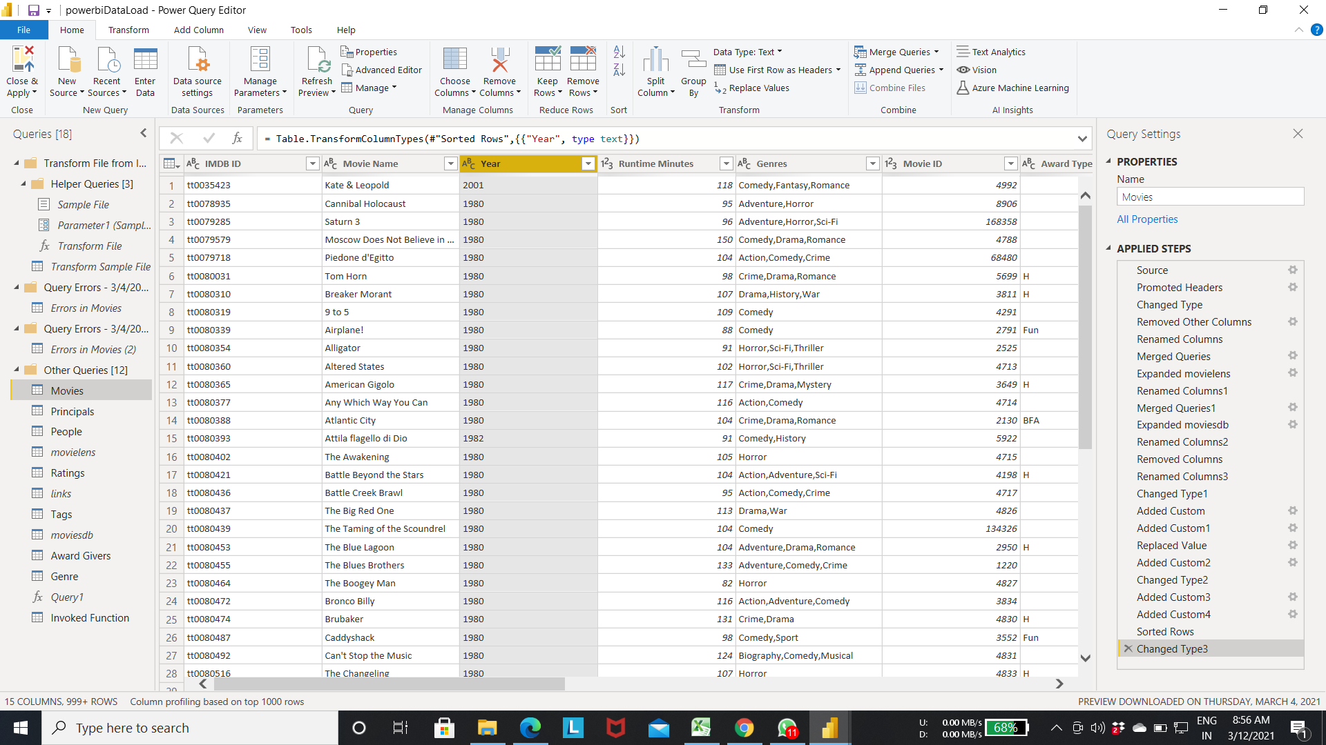

Step2:- If the data type recognized by the Power bi is incorrect / You want to change the data type of the particular column follow the steps.

* Click on the column-> menu will show for available data Types . As we can see in the below diagram there are only limited number of data types.
* Select the data type best suited for the column data.
* In below fig year is number type. But in the editor it is showing as text to change to number datatype select the **“whole number”** data type.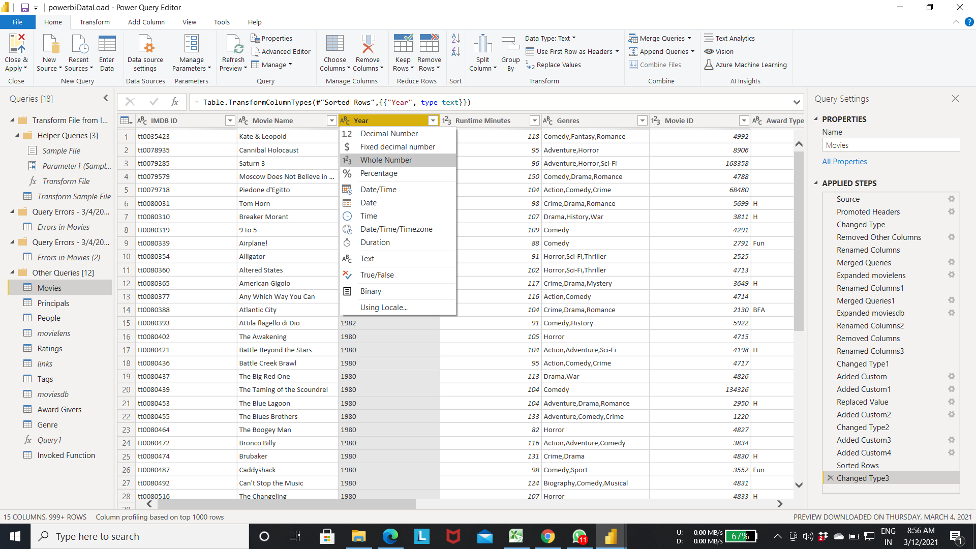

Output of Step 2:- year column is changed from text to number data type.

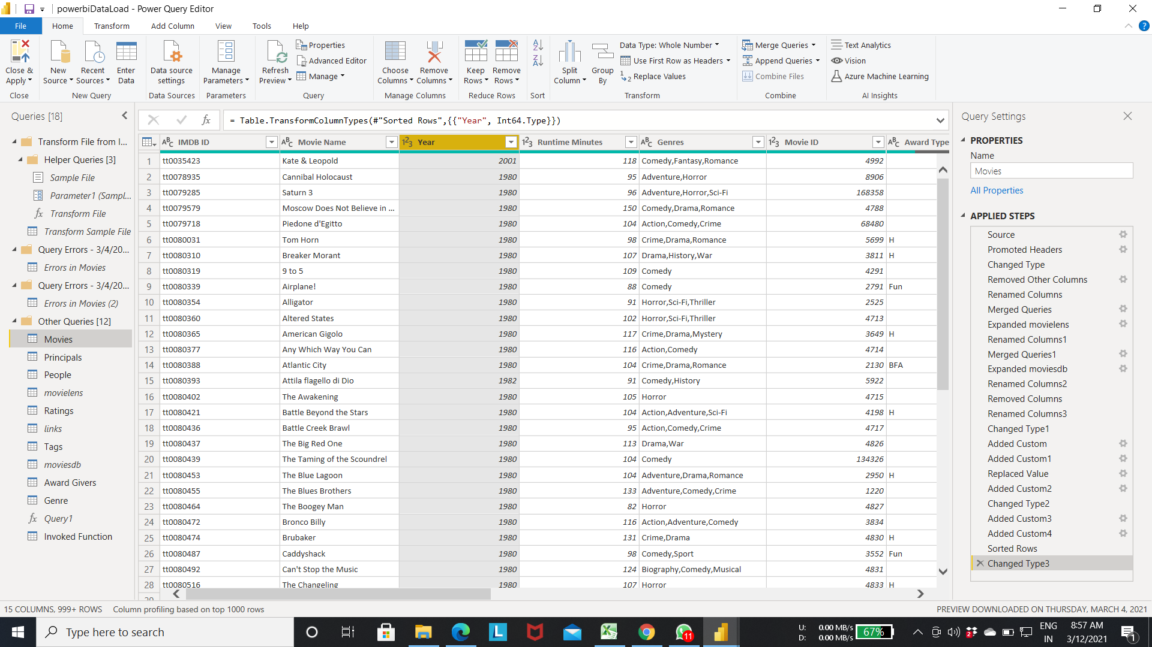

* **Preparing Data for geographic data categories.**
  + Geographic data categories helps us to point the correct location when we choose map for visualization.

Step 1:- We loaded the movie data set for pratical purpose.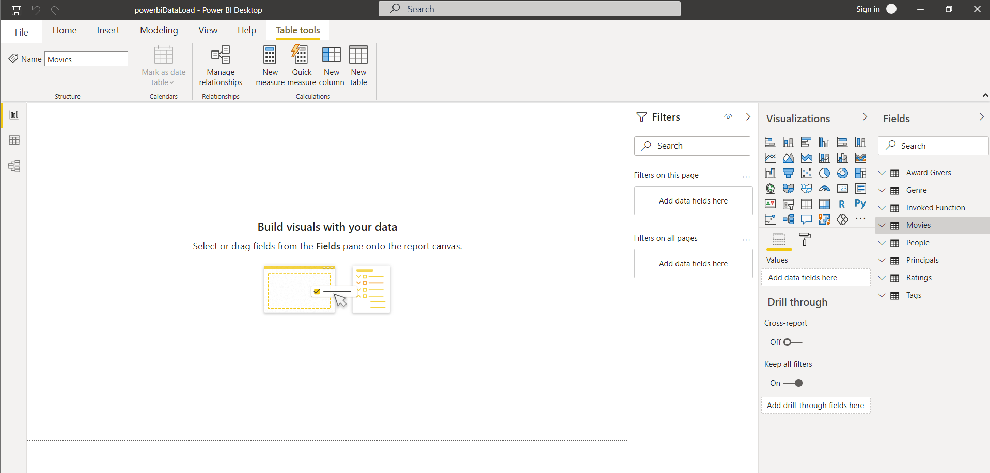

Step 2:- Below fig shows the avilable data categories present in the power Bi.

* If the attribute represent location,/city/postal code/state etc as shown in the fig.
* Select the appropriate data category best suited for the column. While applying the map visualization the data category helps to point correct location in the map.

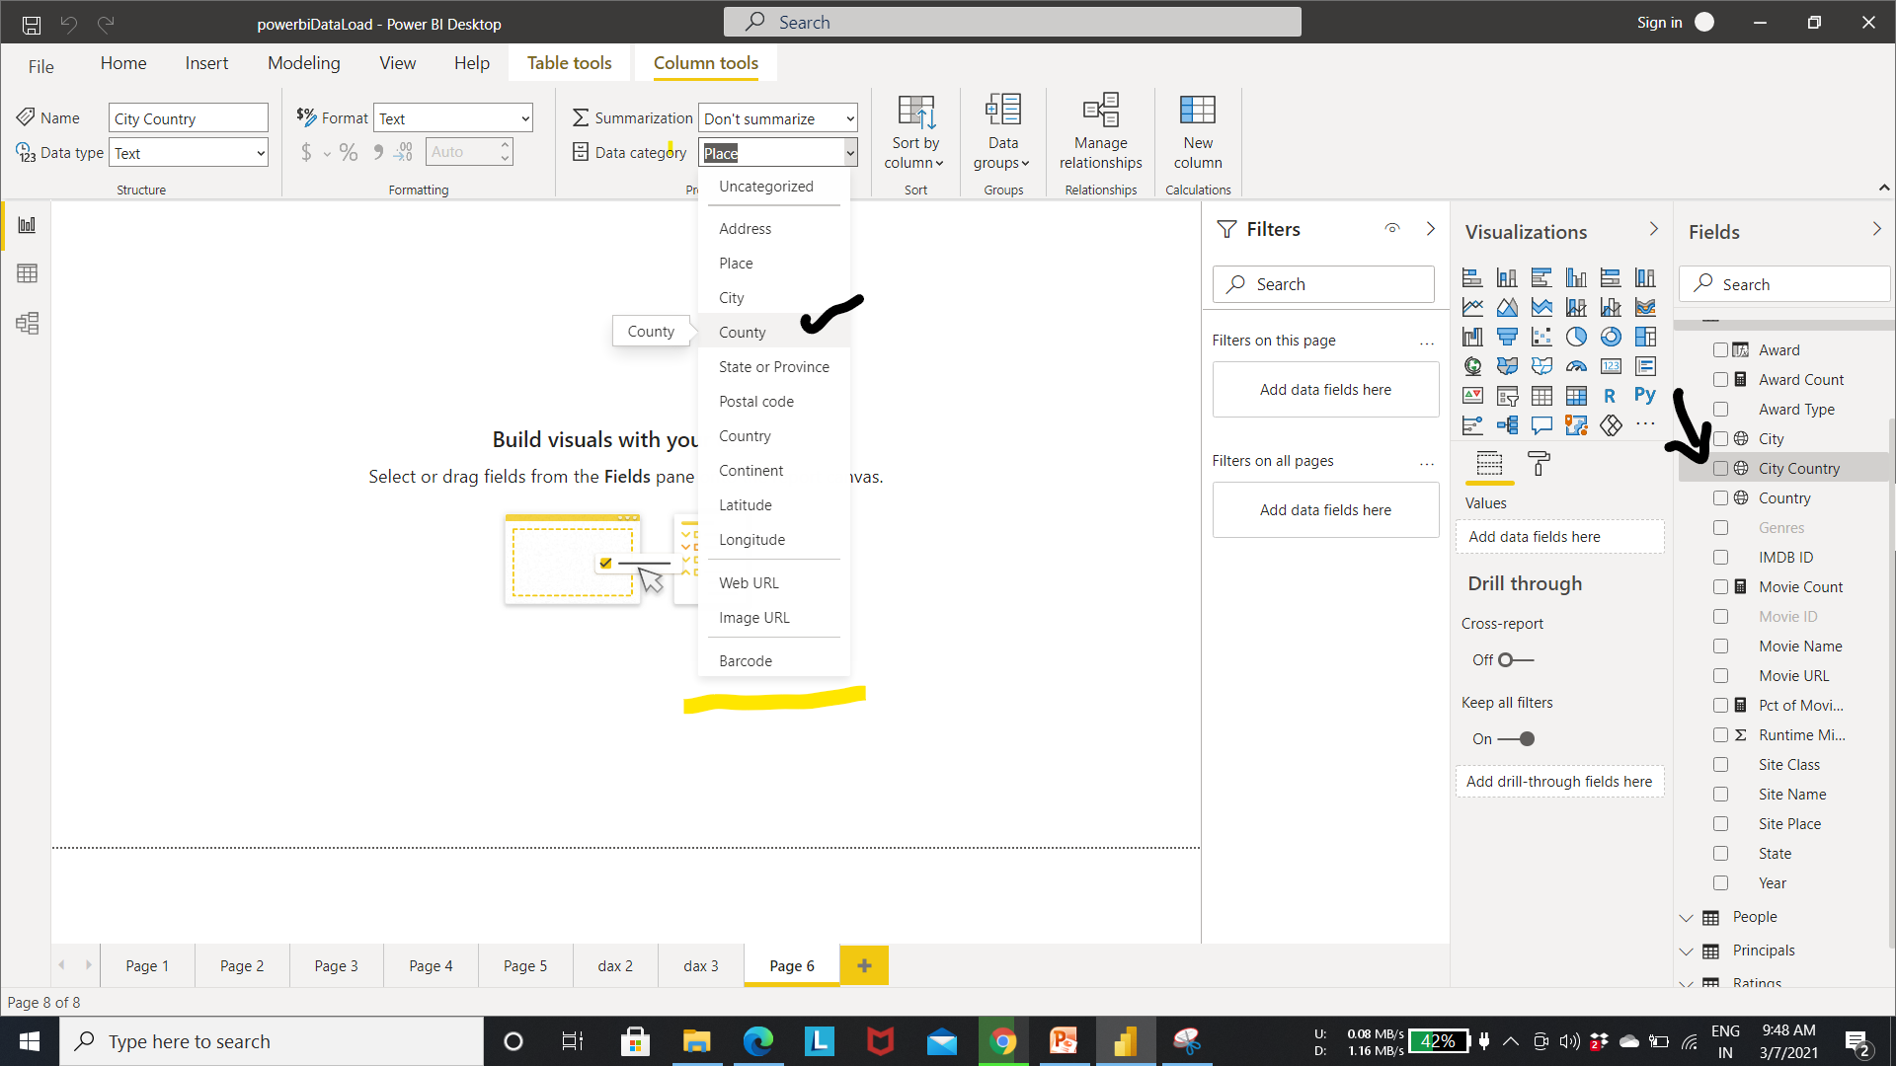

Step 3:- In below fig we selected “city country” attribute as place. Next time when we use this attribute power bi looks for the places present in the map with the city country and point the location correctly.

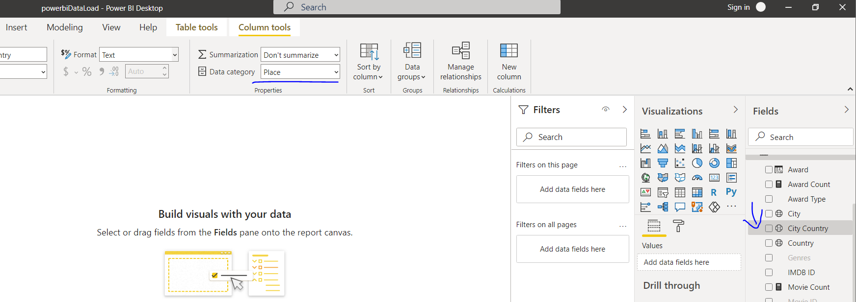

* **Assigning web URL data category.**

Step 1:- Select the attribute which stores the url link. Change it to web url category.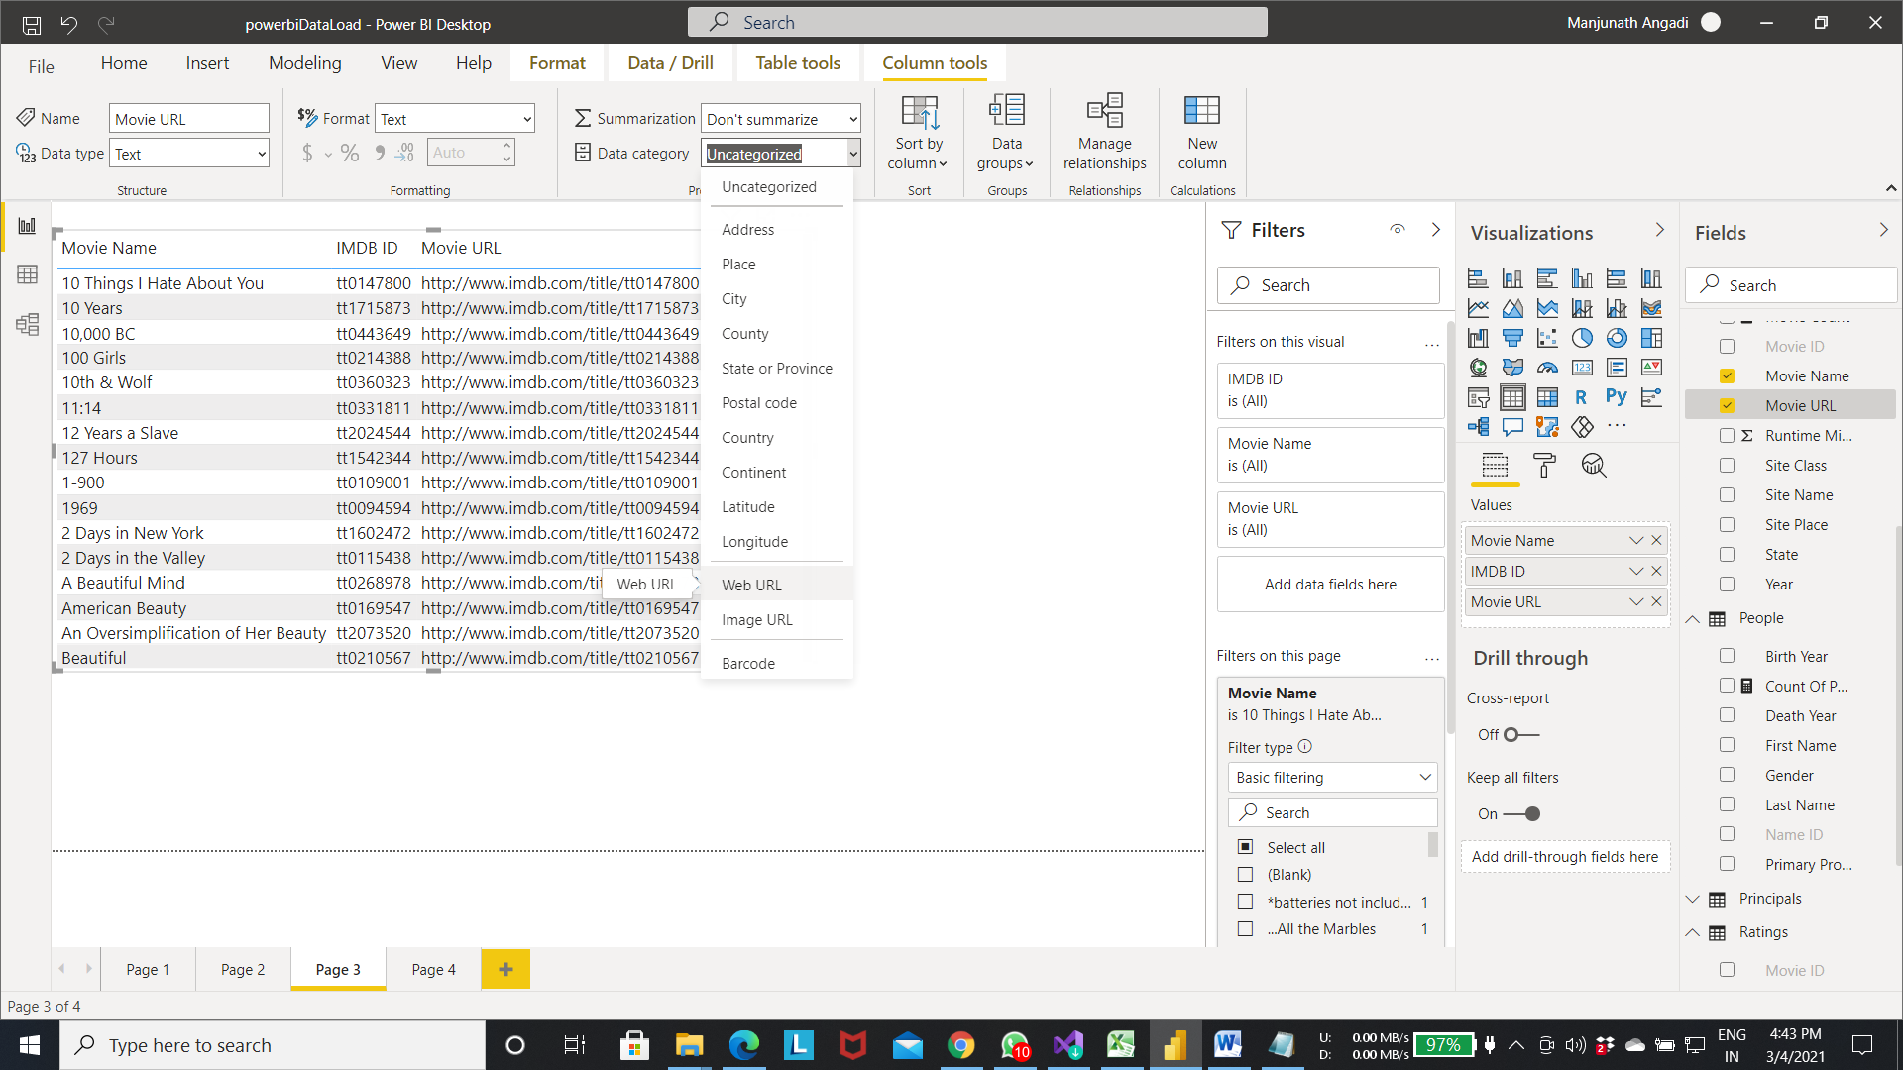

Step 2:- As we can see in the below fig the movie url column contains clickable links.

* click on the link it will redirect to the browser for the content.

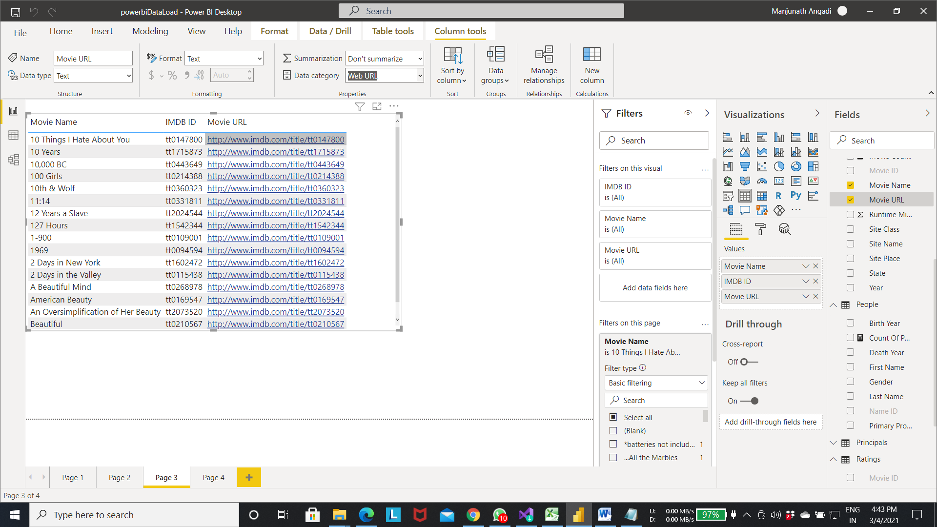

Output of step 2:- After click on the first record of the table. Content of the link will be showed in the browser.



* Map visualization.

Step 1:- Select the map visualization from the visualizations list.

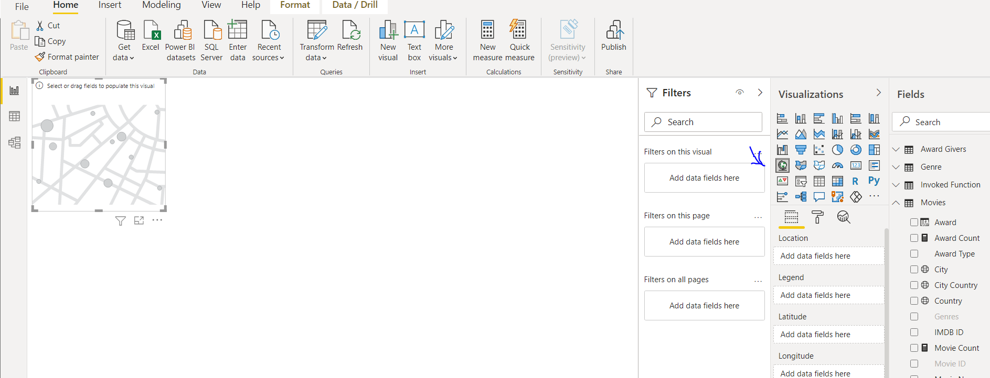

Step 2:- Select the attributes which represents the geographic location.(like city/state name, country name. longitude, latitude etc).

* In below fig we choosed the city,city country as geo location .
* Size attribute as the movie count which tells the number of movies made at that particular pointed location.

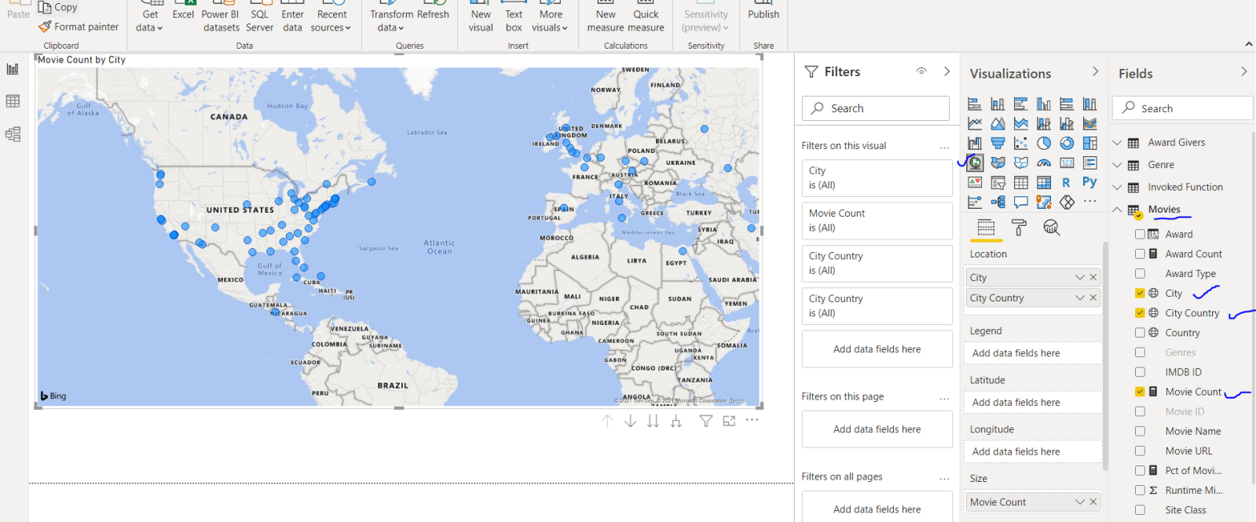

Step 3: From the below fig we can tell that most of the movies were made in north america

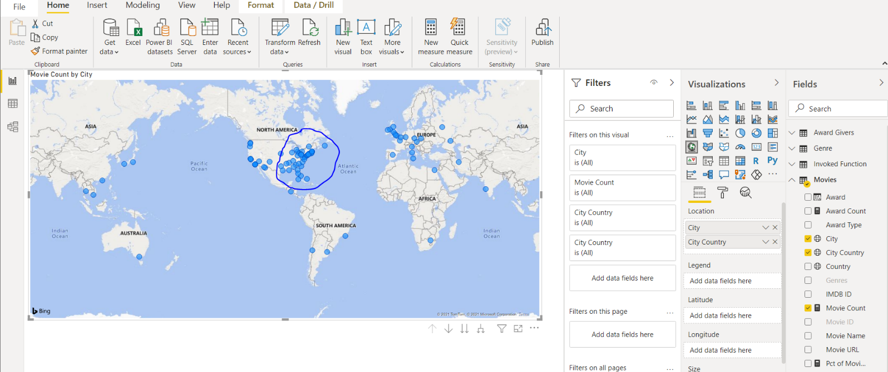

* **Default Summerization.**
  + When we load the data set the column are default summarized.
  + If we want we can change the summarization of the column to sum/ average etc .
  + By summarizing the data we can add value to the column/ for the table.
  + Summarization will help in different scenarios such as finding the total sales / finding the average price of the product etc.

Step 1:- As we can see from thebelow fig the rating column is by default set to don’t summarize which means no summary is applied to the column.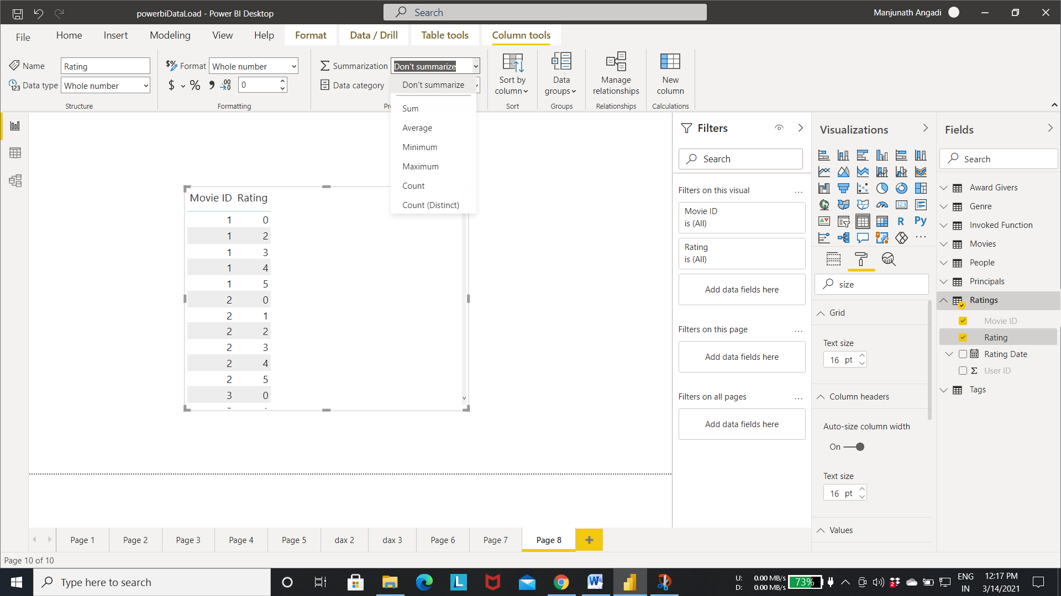

Step 2: setting the rating column to average.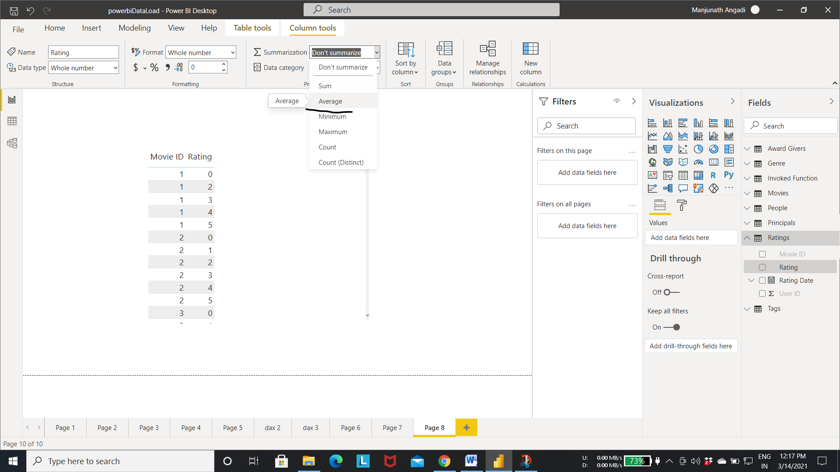

Step 3:- In below table it shows the average rating given to all the movies.

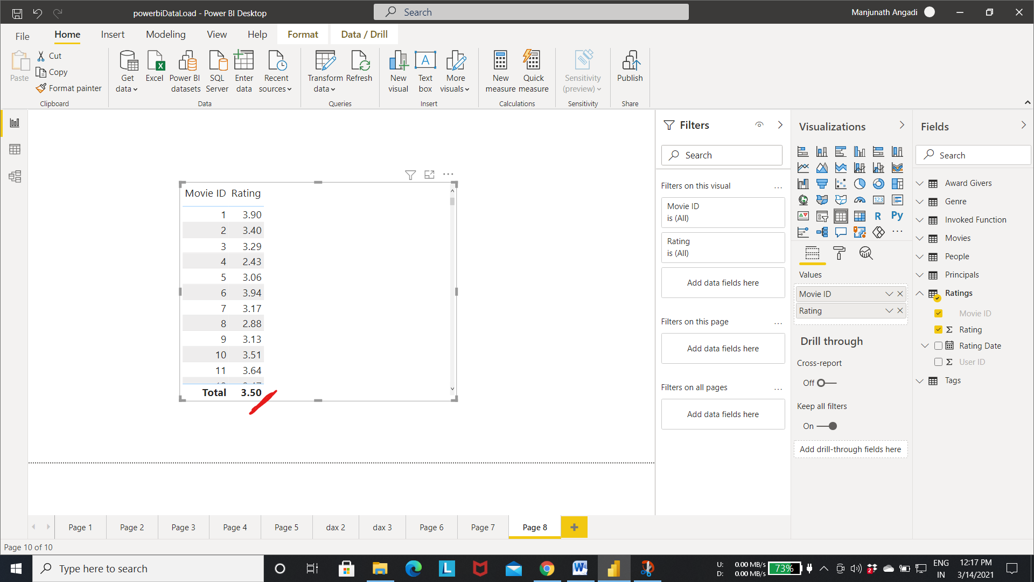

* **Enhancing the model for Q&A.**

Step 1:- Select the Q& A option from the menu as hown in the fig.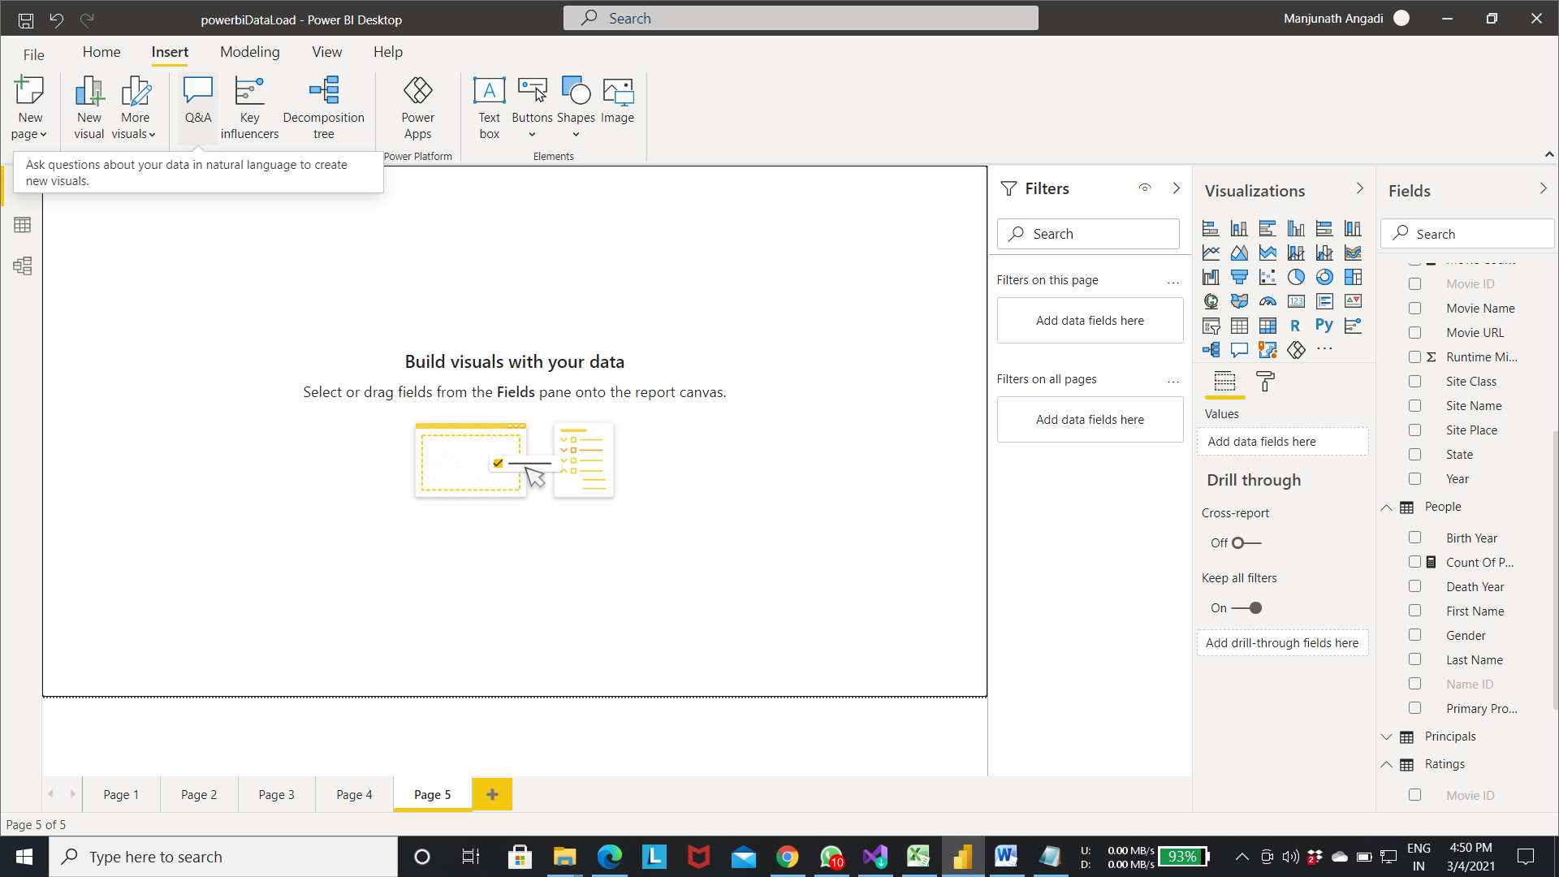

Step 2:-Below table appears with some suggestions to ask to the data.

* If we ask the correct question to the data the graph will show up.

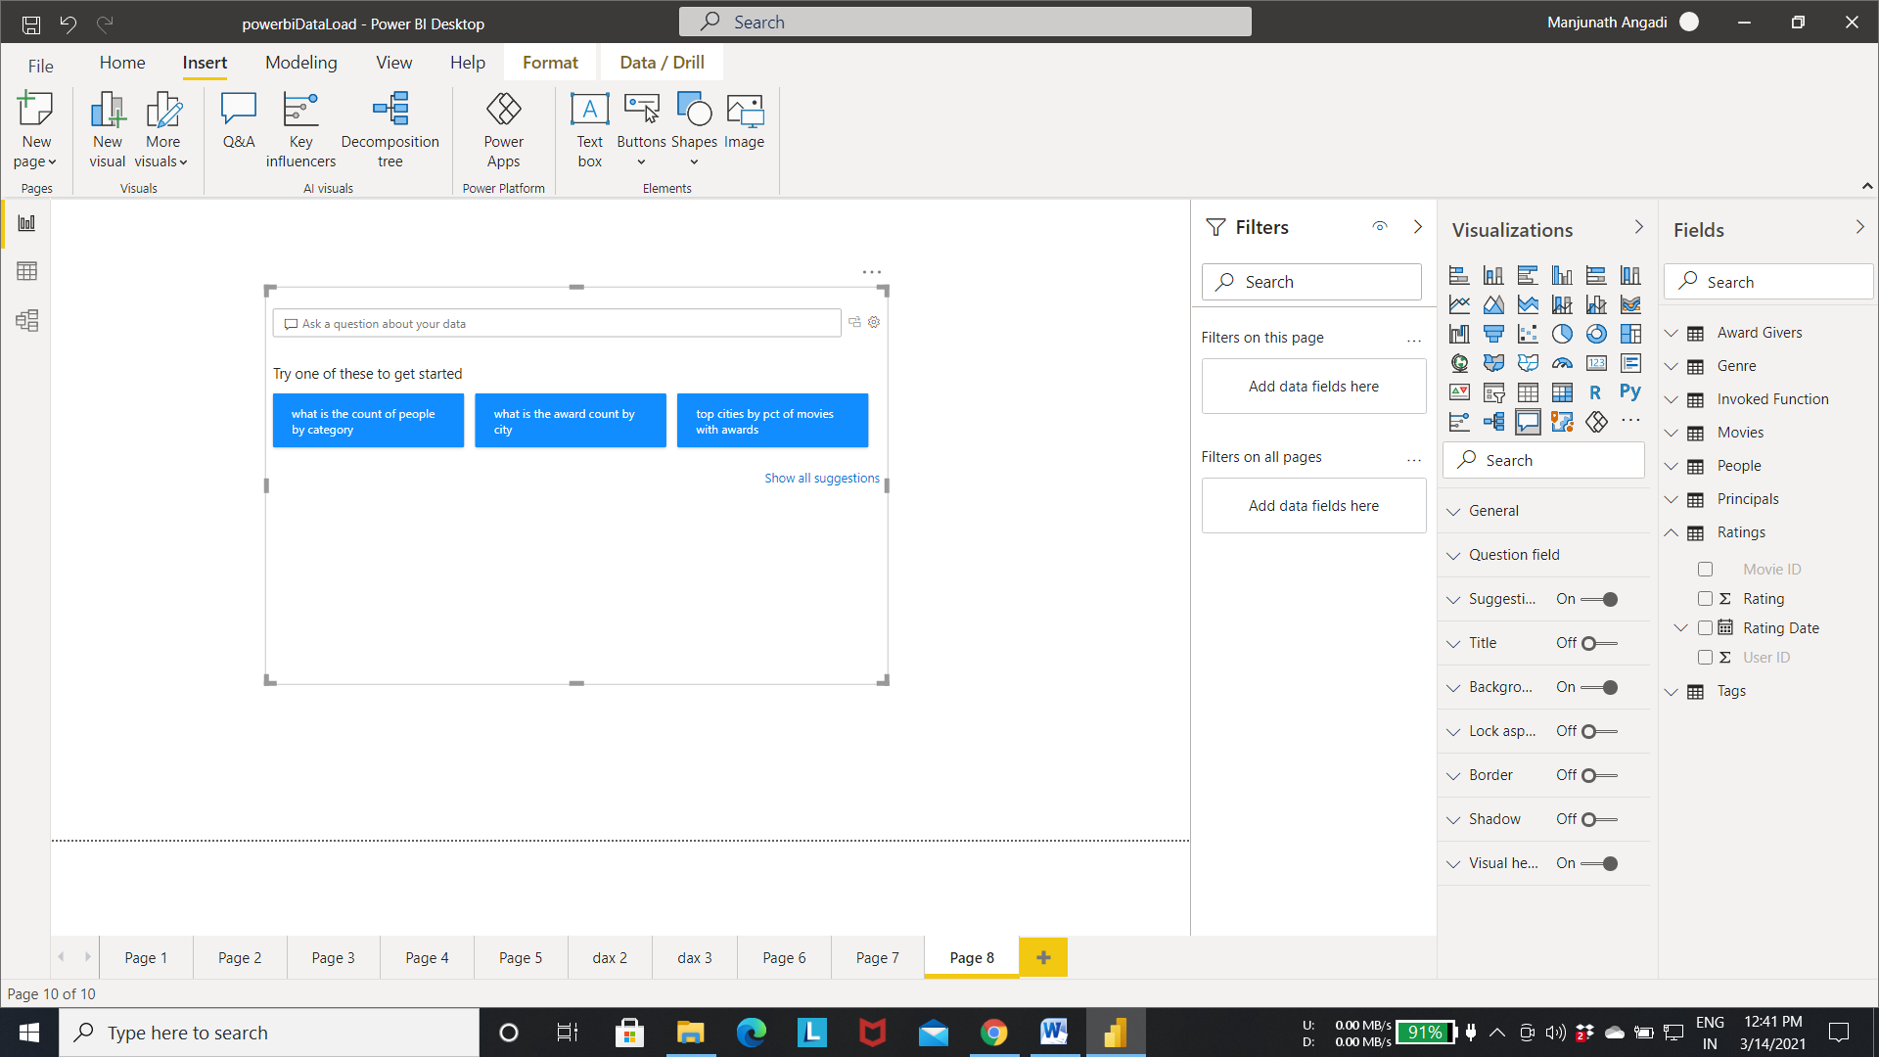

Step 3:- In the below fig we asked the “count of movies by year and by genre.”

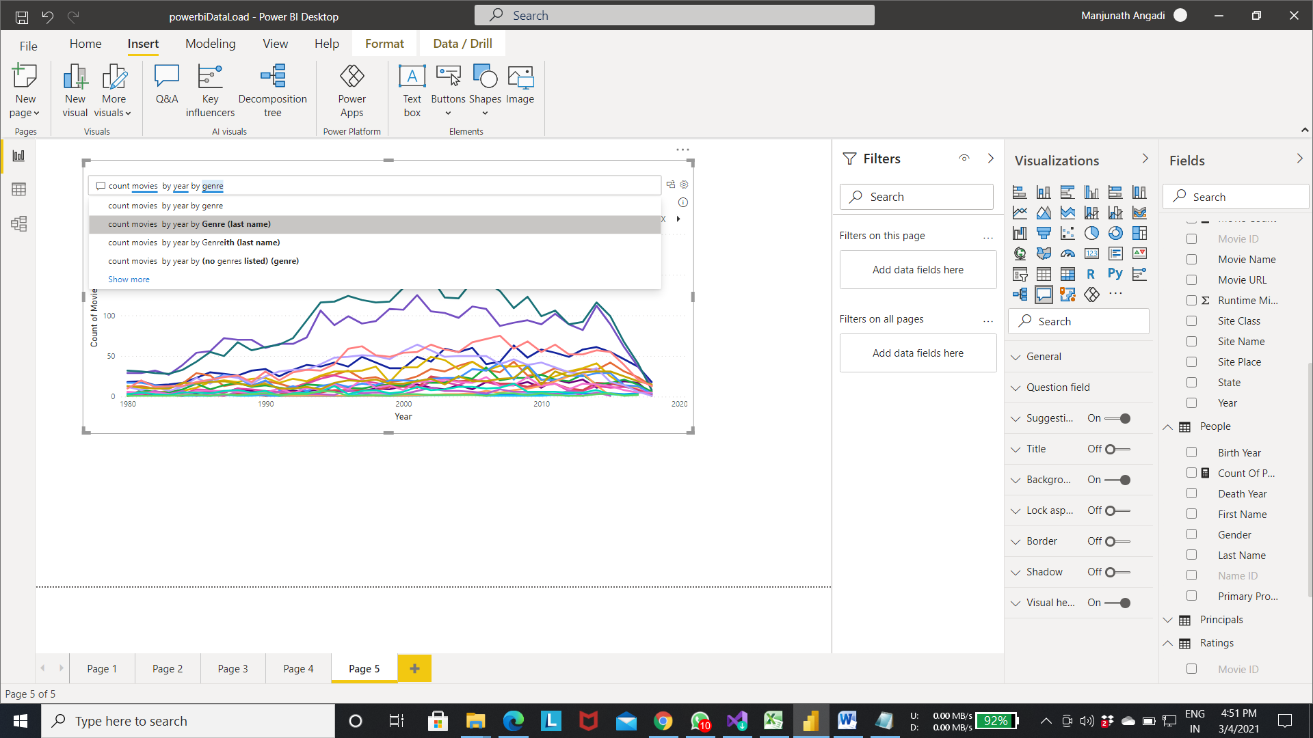

Step 4:-Below fig shows the graph of movie count fluctuation by year and by genre.

* We can select the particular genre From the legend of the graph to see the fluctuation of movie count year by year for that genre.

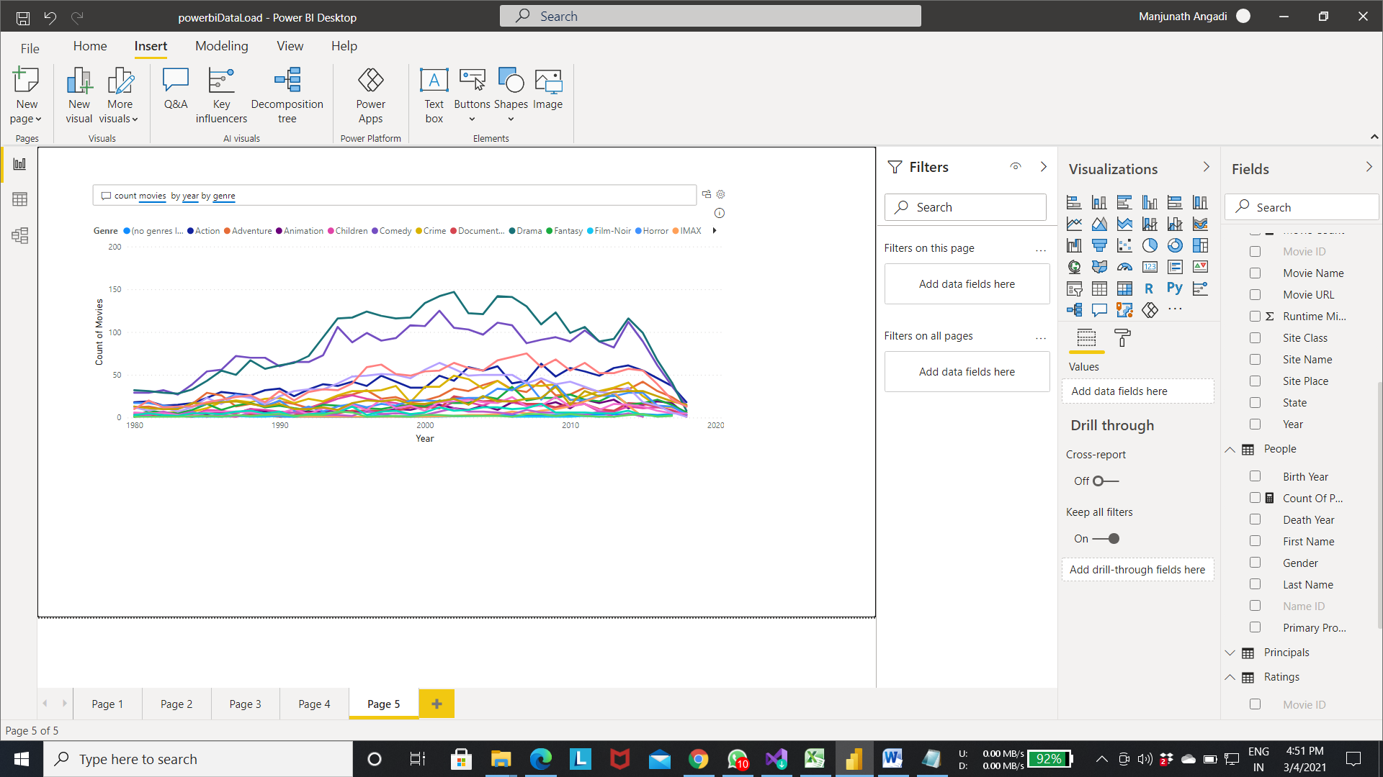

* **We can imporove the data set for Q & A by adding particular synonym to the attributes**.
  + By adding the similar words to the attribute will improve the Q & A model. Like some user may ask movie count by location instead of particular word city column . at that time synonyms will help to draw the visulization.

Step 5:- To add synonym word to the columns

* Select the model icon as shown in the fig.

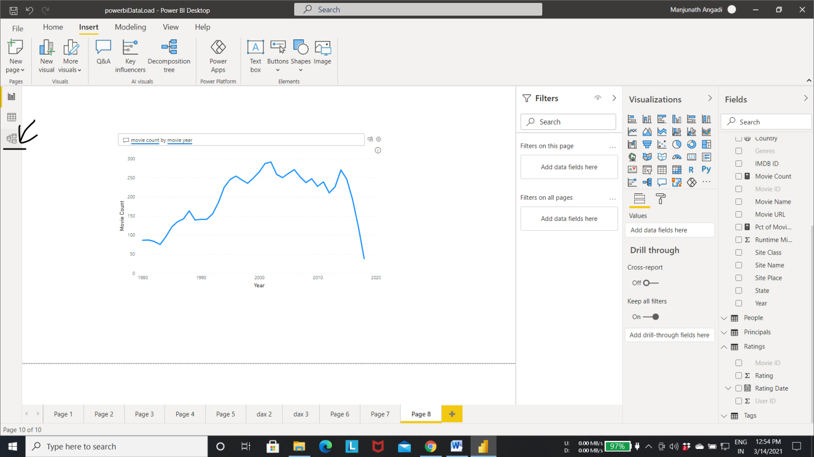

Step 6:- Select the Q & A setup

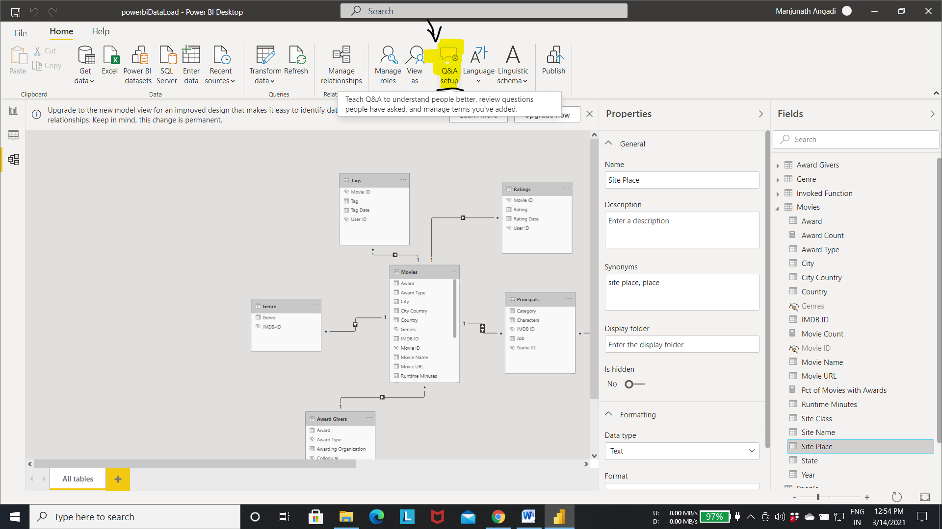

Step 7:-Pop up will appear to add the synonym to the attribute. Add the related word to the columns. In below diagram we added location to the “city country” attribute. Whenever the user ask the question with location as word the power bi will refer to “city country” column for the data.

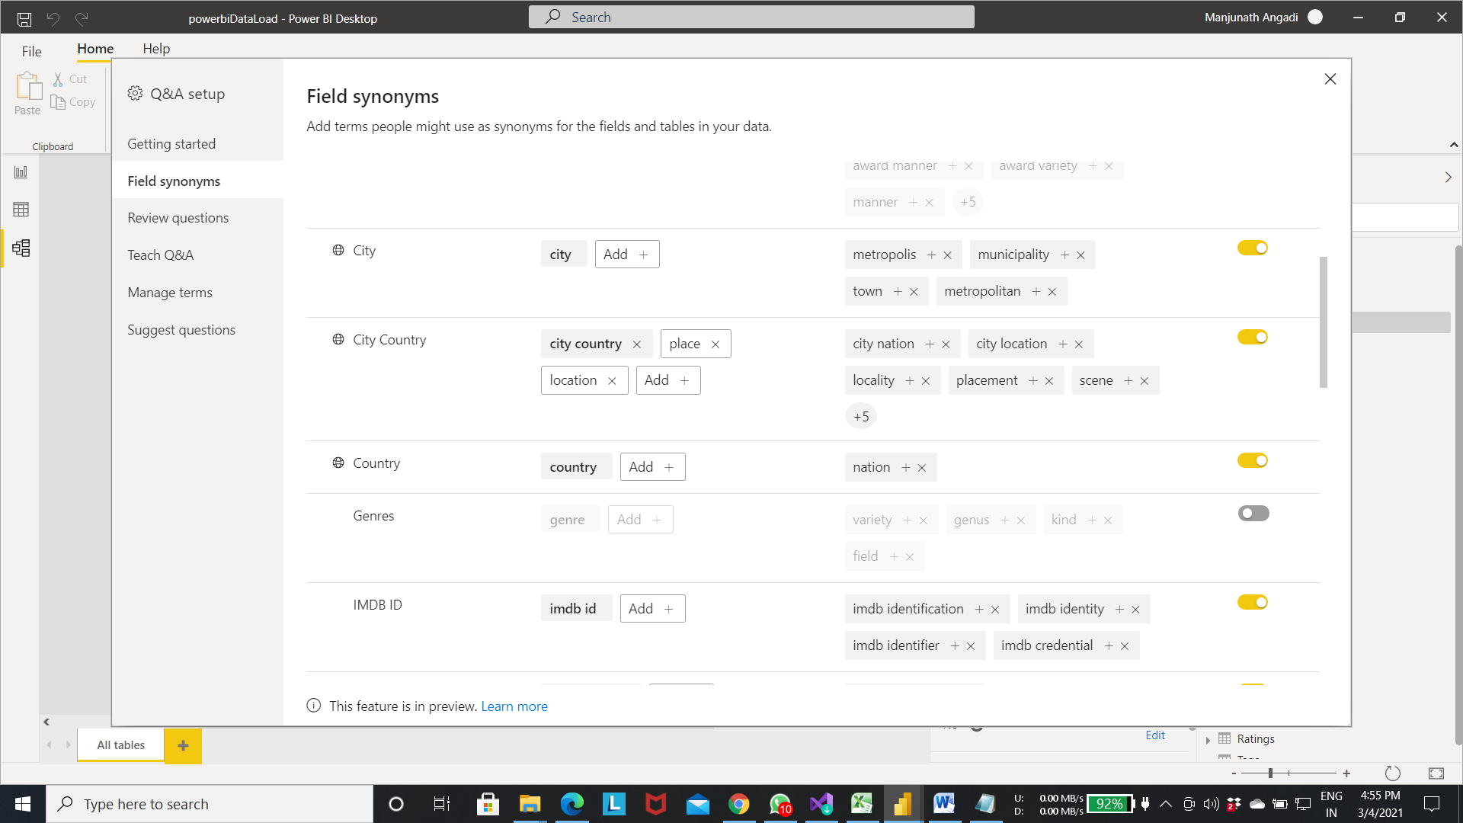

Step 8:- Now from in the below fig location word refers to the city country column for the data.

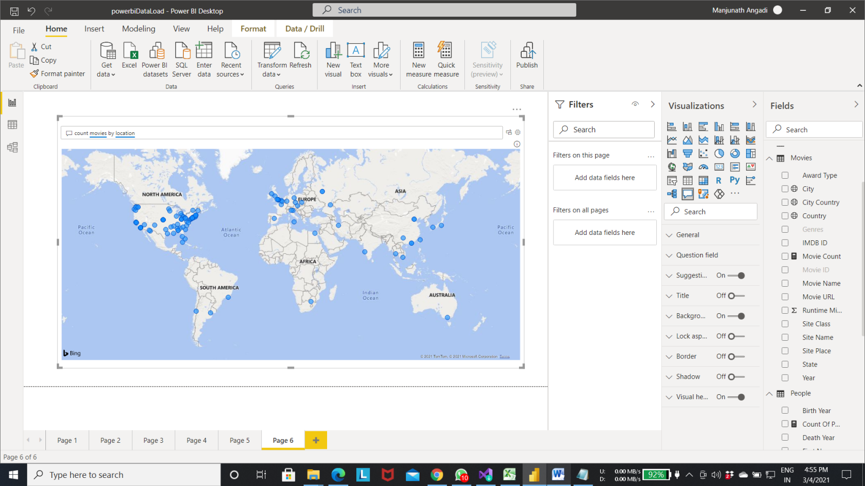

KO 4: Able to use DAX to enhance a Power BI Model.

* **Concatenating the column**

Step 1:- Select New column As shown in the figure.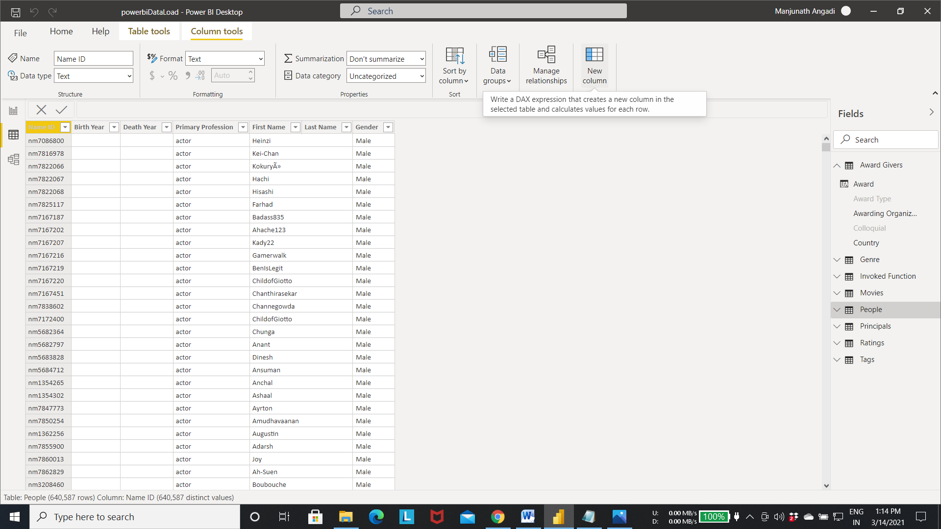

Step 2:- Write a DAX expression to concatenate the columns.

* Ex:- Full Name = [First Name] & " " & [Last Name]

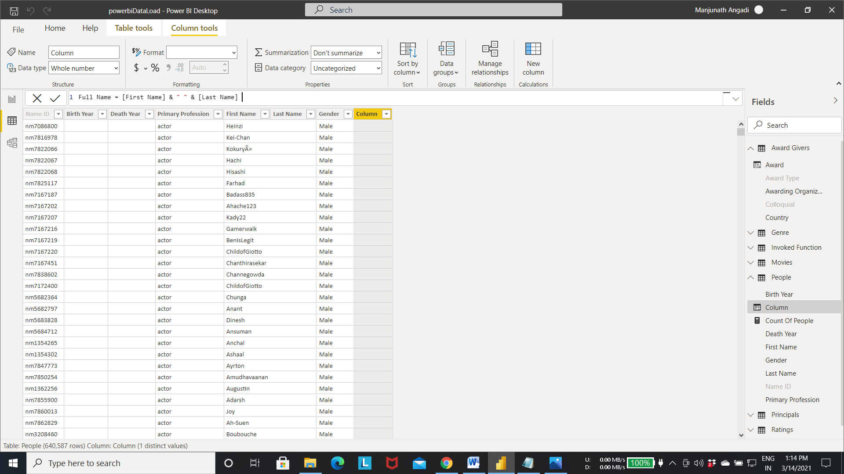

Step 3:- Click on the right mark near the expression editor to apply the changes as per the expression.

* The Above expression concatenate both column data into one column.
* Below fig shows the output of the above expression. And new column “full name” is created.

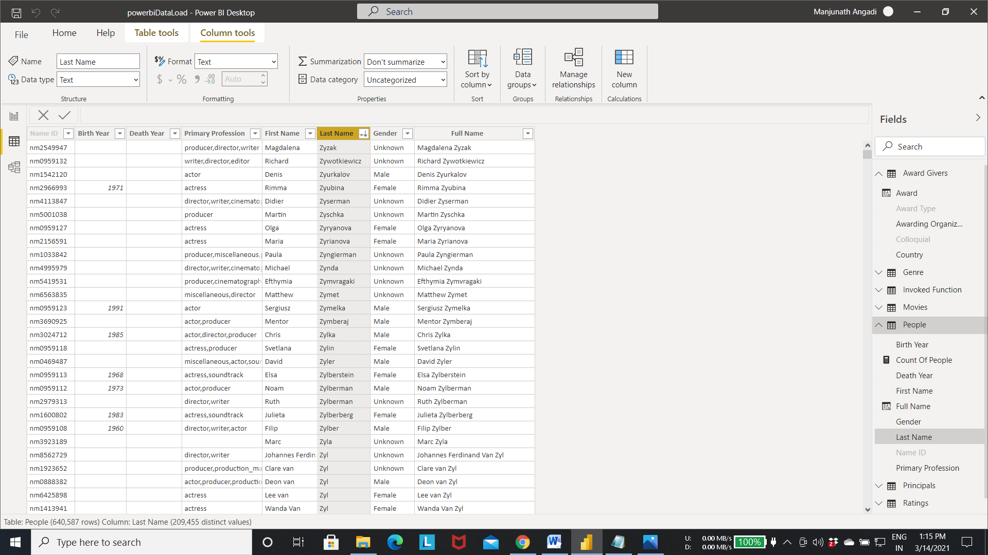

* **Calculating the value from the attributes.**
  + Below fig’s shows the calculation of age by using the birth year and the death year.
  + Select the new column for age attribute.

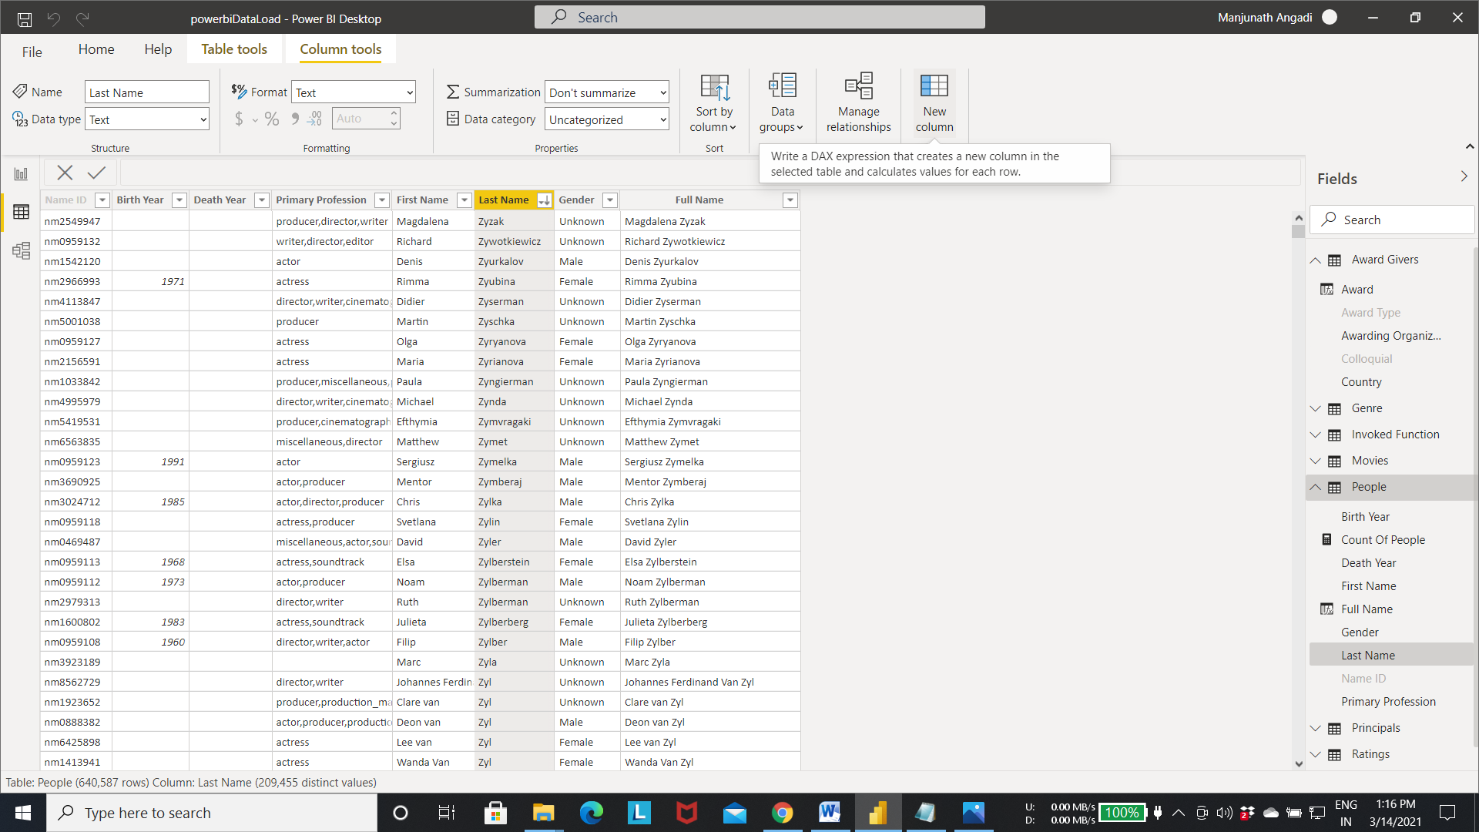

Step 2:- The below DAX query calculate the age by using the birth and death year

* Age =
* IF (
* ISBLANK(People[Death Year]) && ISBLANK(People[Birth Year]),
* BLANK(),
* if(ISBLANK(People[Death Year]),
* YEAR(NOW())-[Birth Year],
* [Death Year]-[Birth Year])
* )
* If the death year is present the above query calculate the age by substracting the death and the birth year or else currentyear-birthyear.

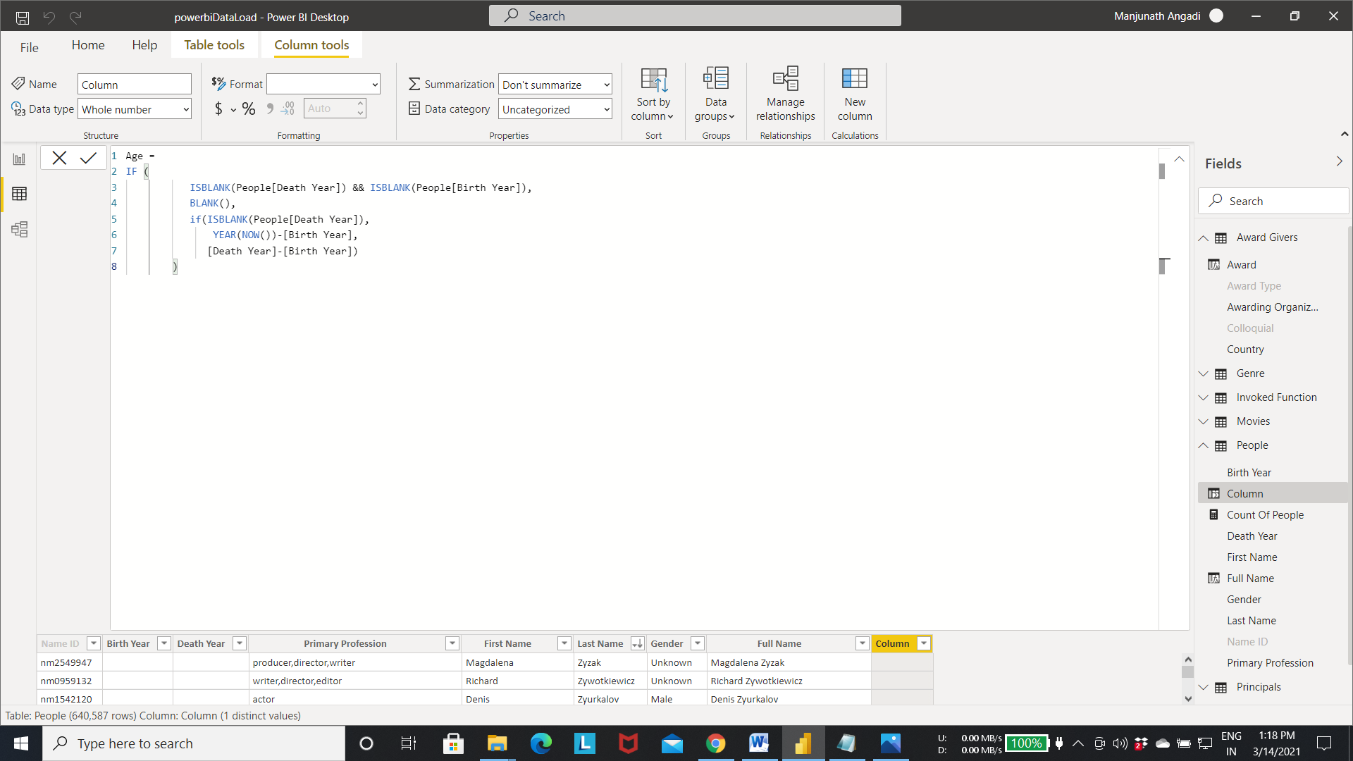

Output of step 2:- the age is calculated using the above expression.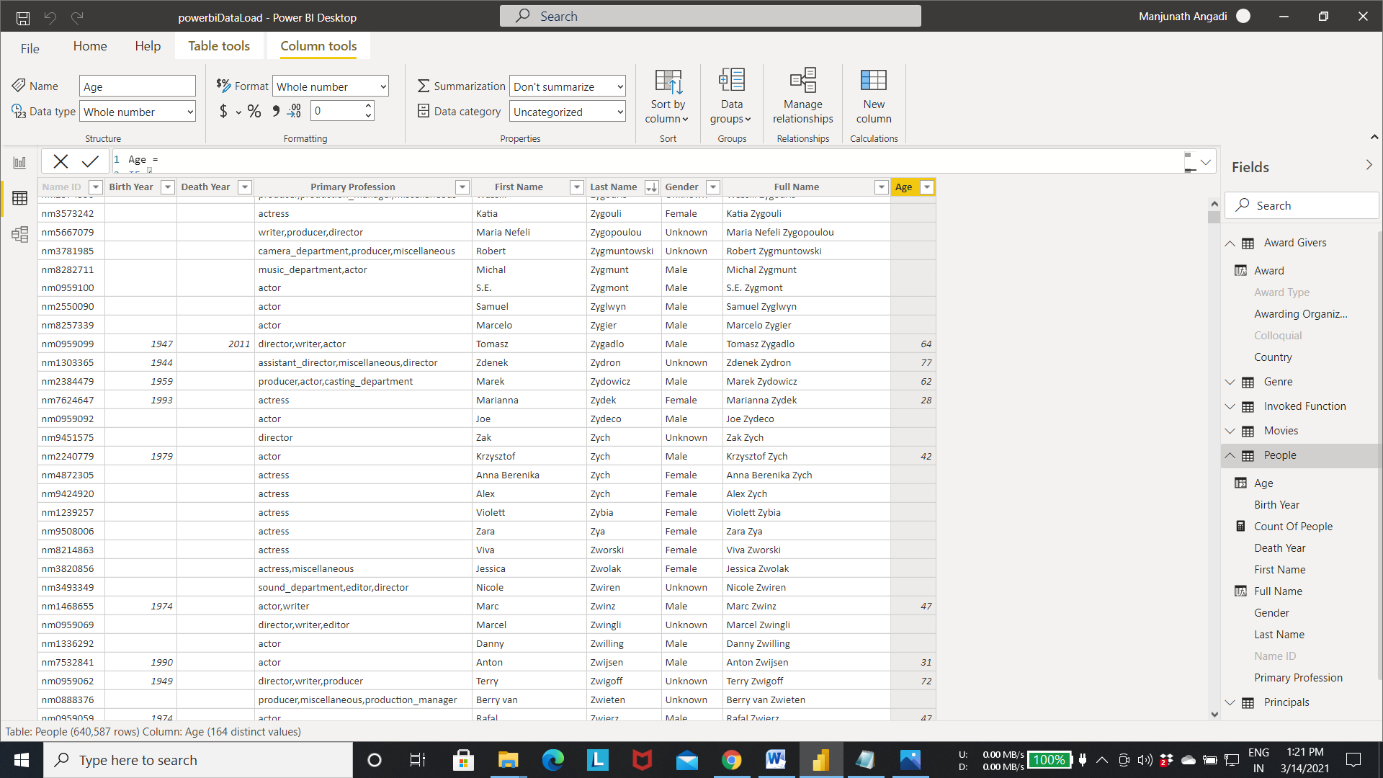

* **Using variable in DAX expression.**
  + Writing the expression again and again will make the query complex.
  + So the repeated code can be stored in a variable and can be used later whenever required by mentioning the name of the variable.
  + By using the variable the expression becomes easy to read.
  + Ex:- Age =
    - var deathyear=ISBLANK(People[Death Year])
    - var birthyear=ISBLANK(People[Birth Year])
    - var currentyear=YEAR(NOW())
    - Return
    - IF (
    - deathyear && birthyear,
    - BLANK(),
    - if(deathyear,
    - currentyear-[Birth Year],
    - [Death Year]-[Birth Year])
    - )

Step 1:- writing above query to calculate the age.

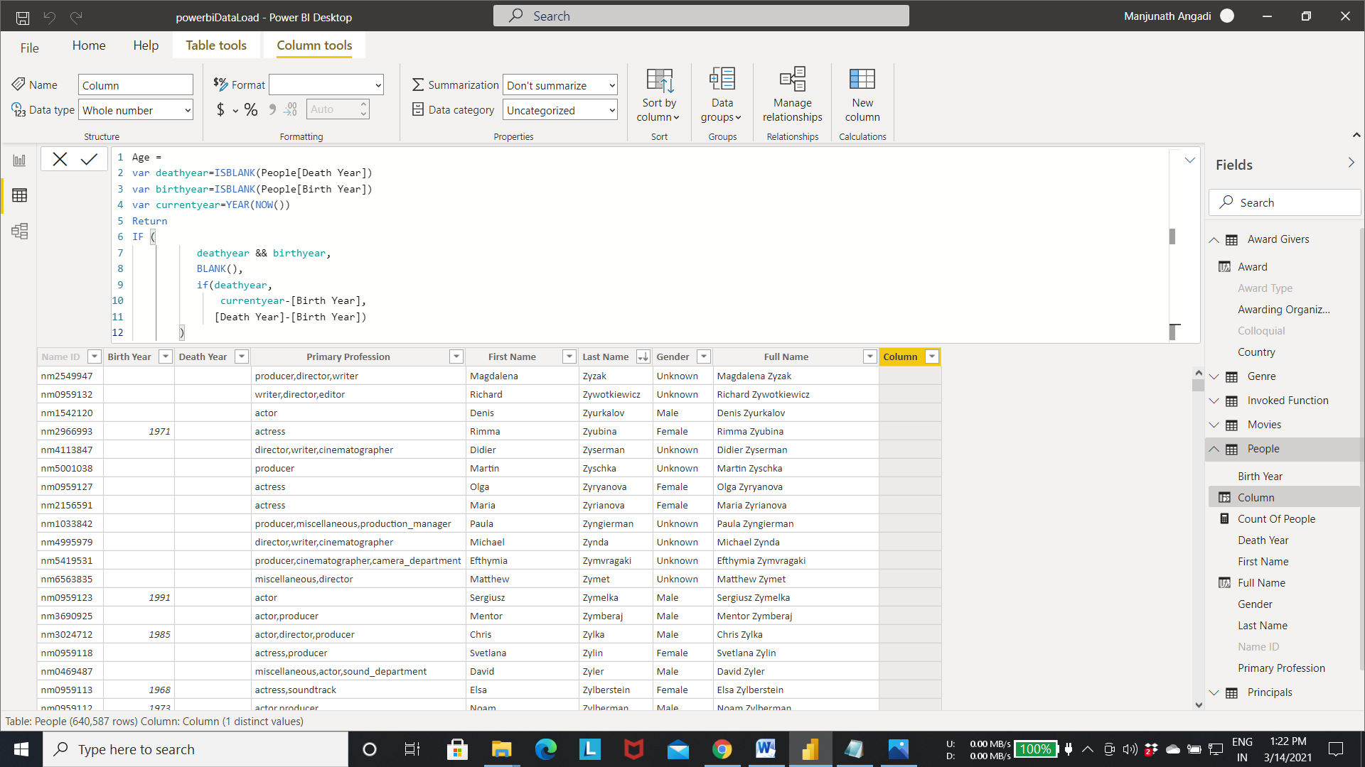

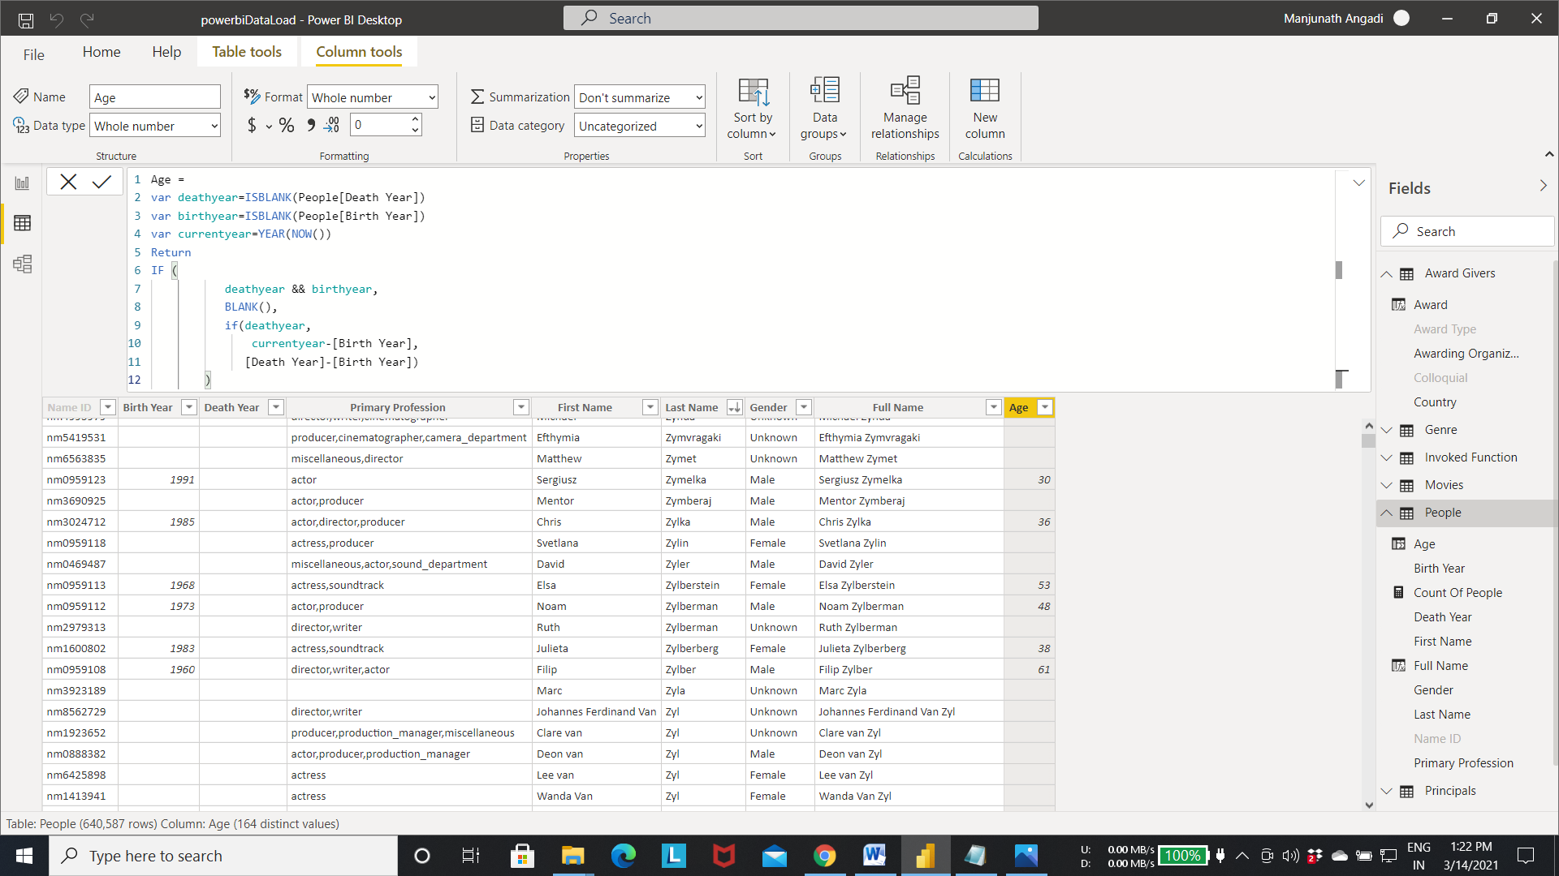

Output of Step 1

* **Performing a Lookup to a Related Table.**
* Fetching a value from one table to another table by comparing the values.(In simpler term performing a inner join operation similar to sql between 2 tables).
* Here Award Type in Movies is compared with Award in Award givers to fetch the award name given for the each movies.

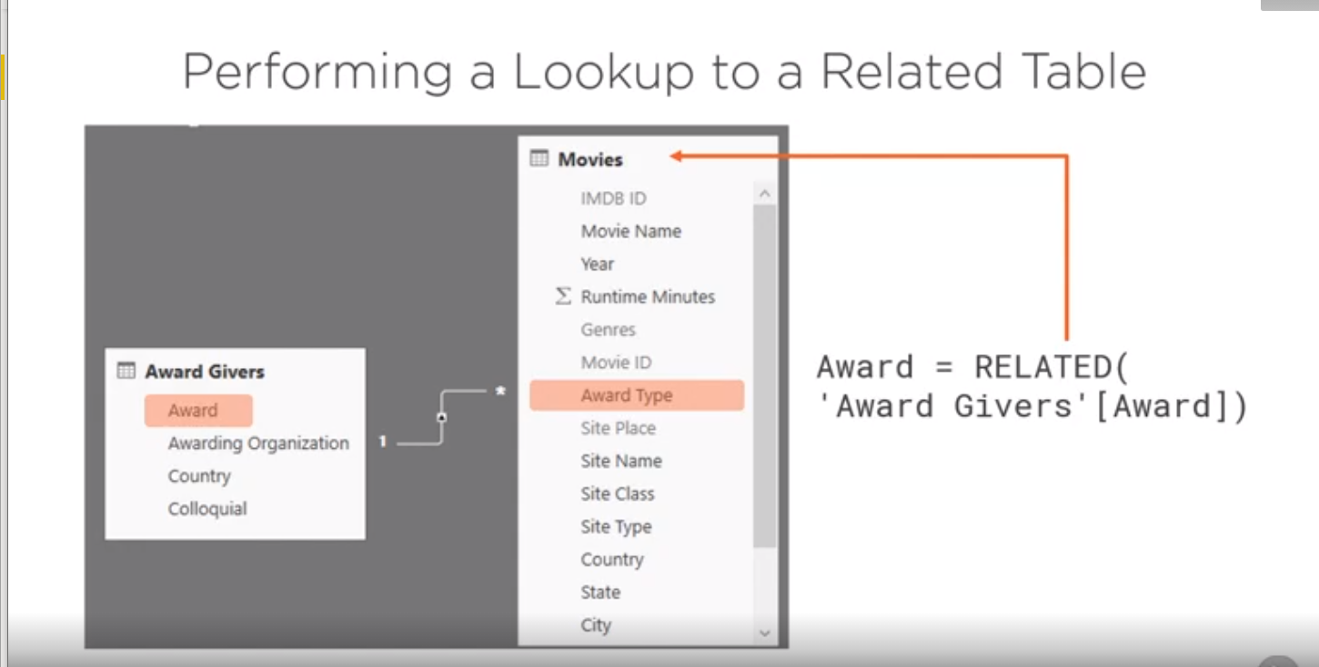

Step 1:- Calculation of award column in the Award givers using the below expression.

* Award = IF(
* LEFT([Award Type], 1) = "H" || ISBLANK([Colloquial]) || [Colloquial] = "" || LEFT([Colloquial],1) < "1",
* [Awarding Organization] & " " & [Colloquial],
* [Colloquial])
* The above query calculate the award name by combining the organization and colloquial column if the award type starts with “H” /blank/””/ colloquial length is less than 1. Or else it gives the award name from the colloquial column.

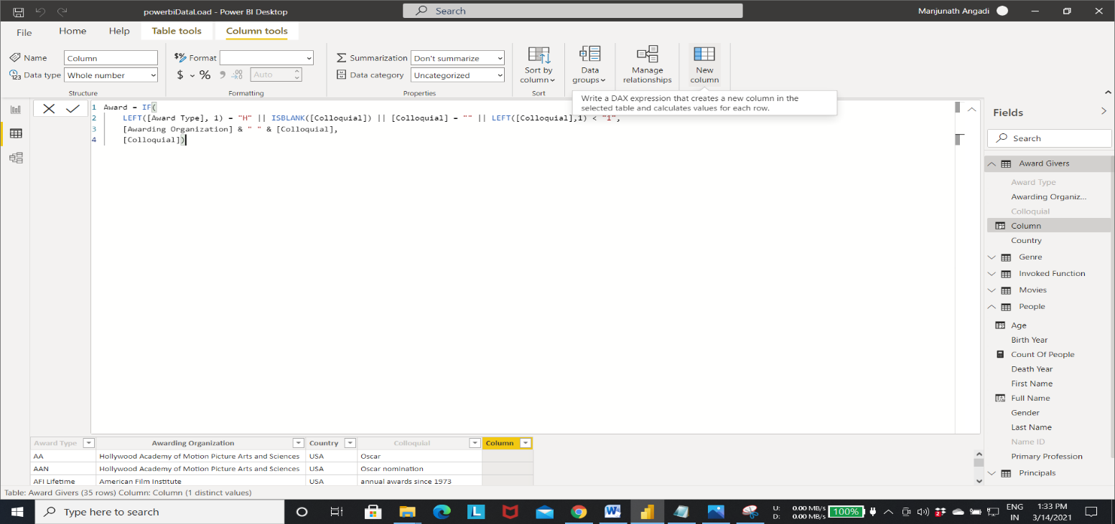Output of Step 1:- award column is created with award values calculated from the above expression.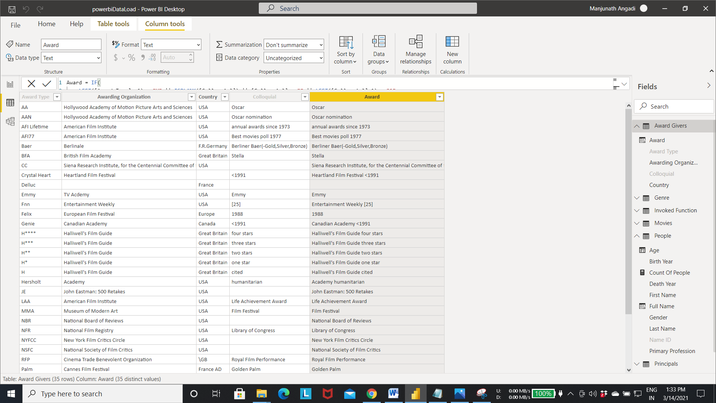

Step 2:- Select the new column option From movies table-> opens the expression editor.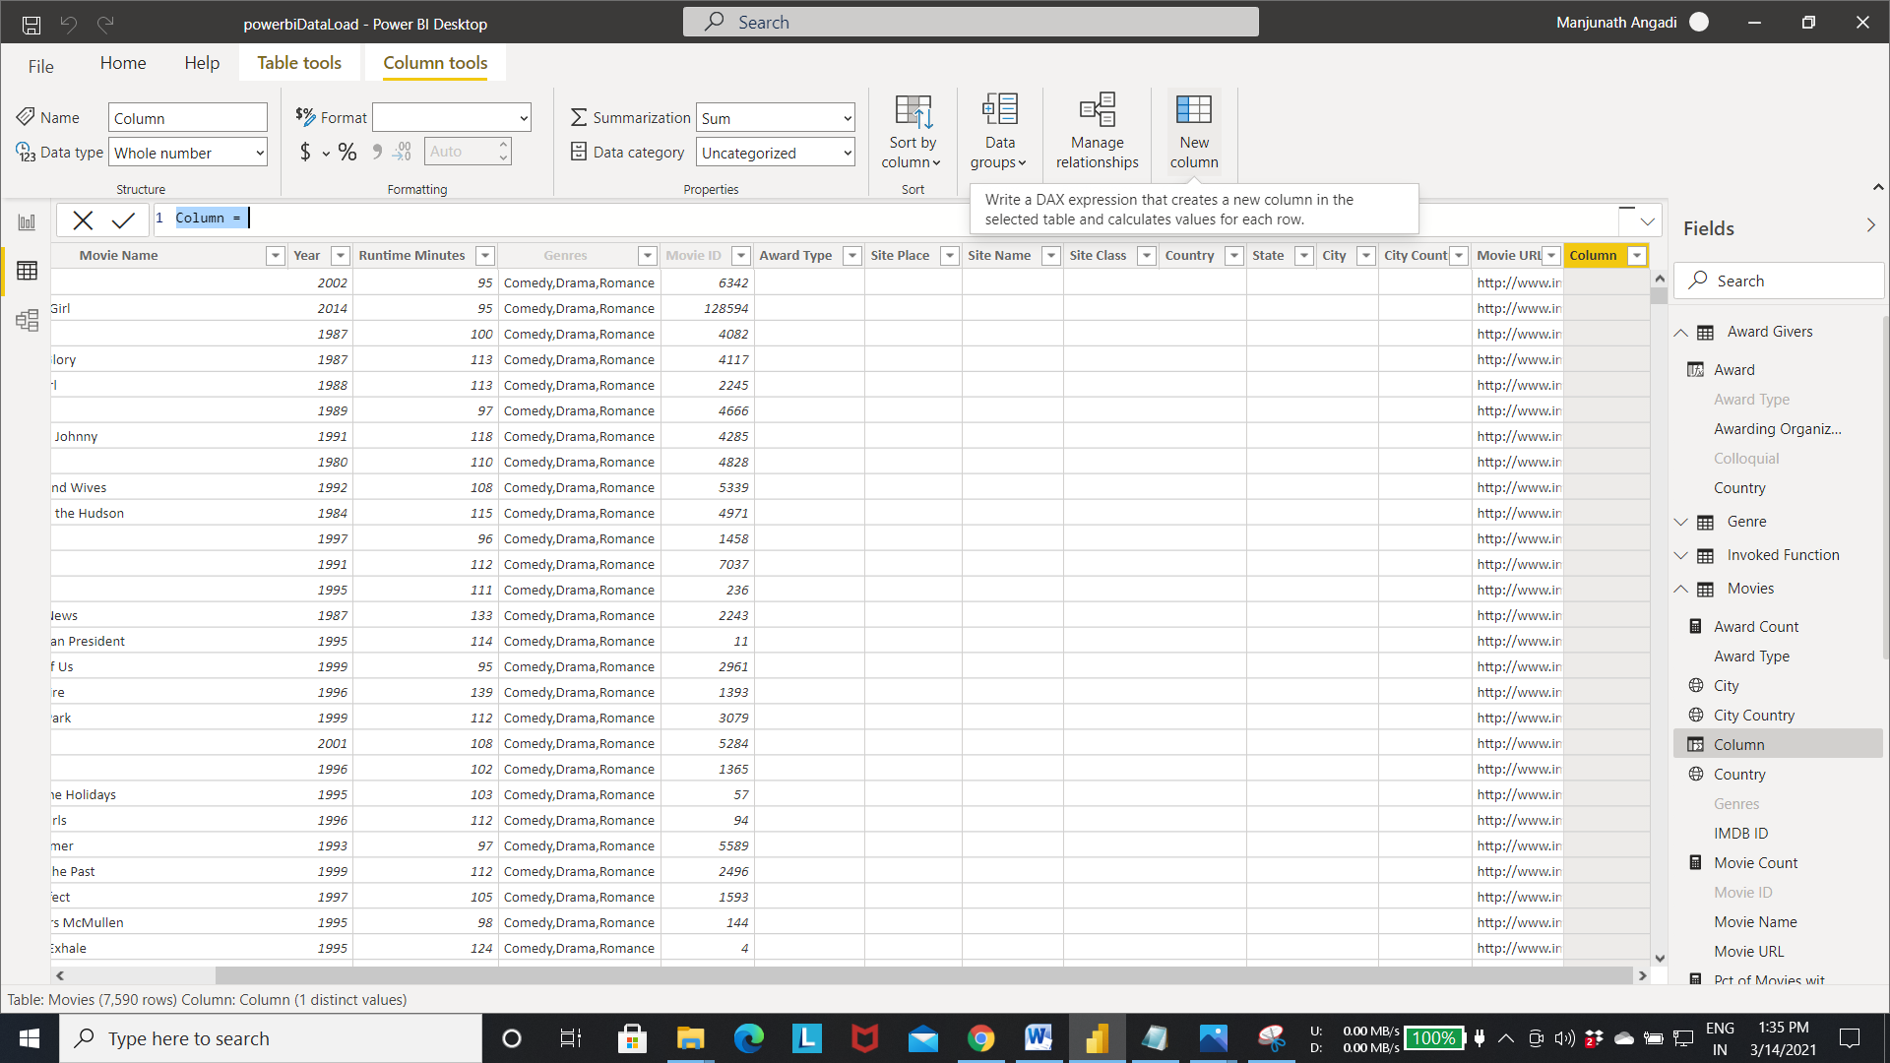

Step 3:-Write the below query to fetch the award column from the Award Givers to movies table.

* Award = RELATED('Award Givers'[Award])
* The above query fetch the award names From the Award Givers to movies table by comparing award Type column present in both the table.
* And also above query uses the relations between the table to fetch the records. If there is no realation between the 2 table means the above query does not execute.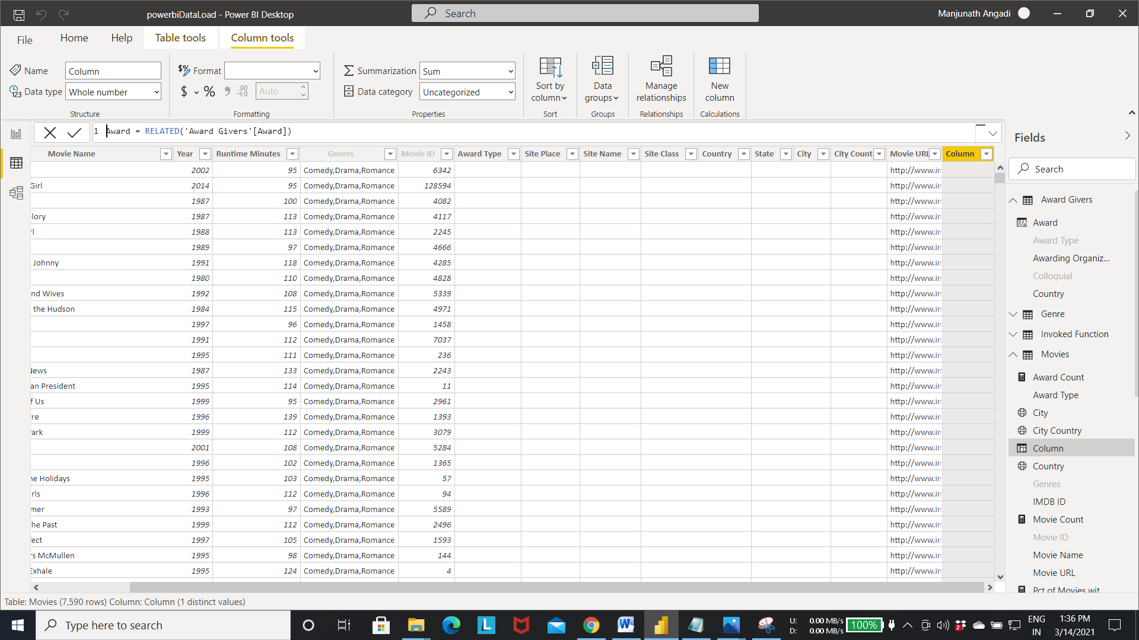

Step 4:- Result of Step 3.

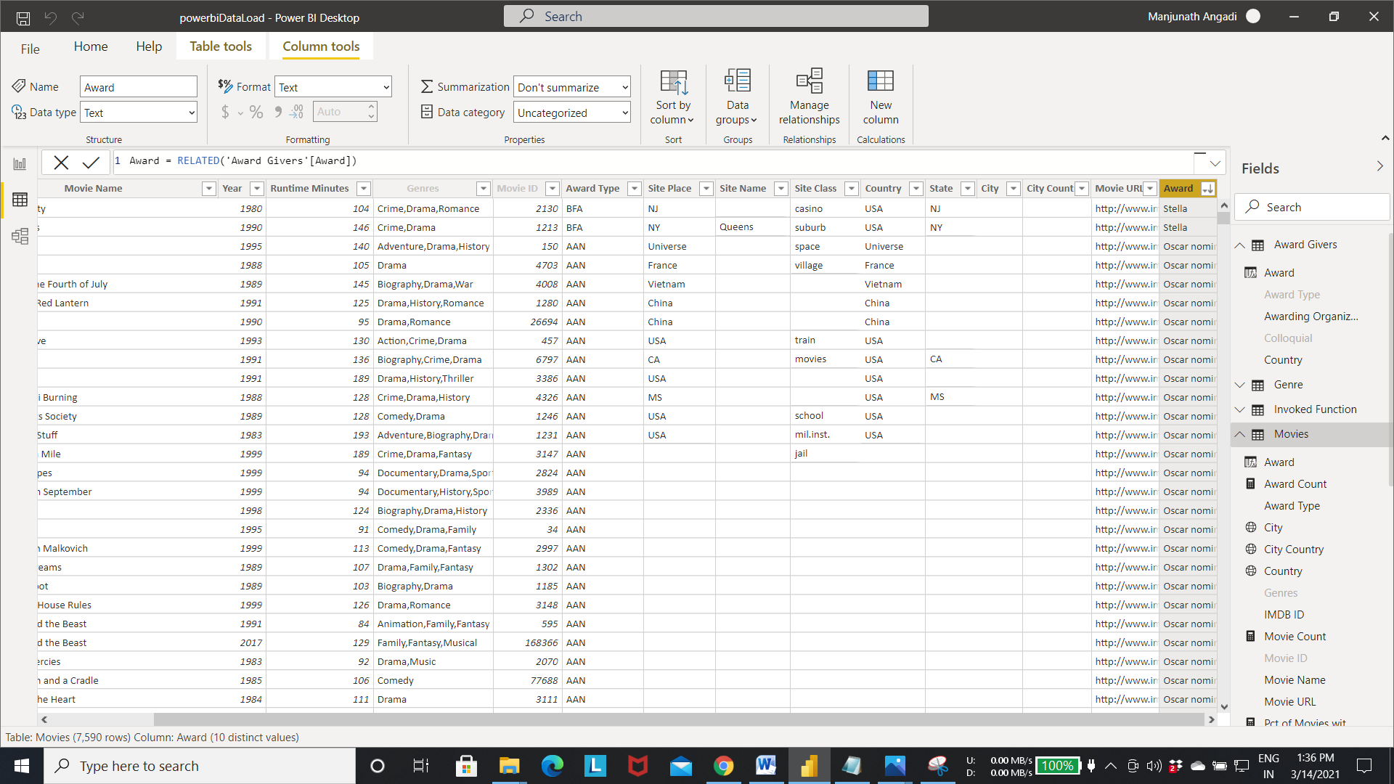

* **Creating measures.**
  + Measures:- In **Power BI** Desktop, **measures** are created and displayed in Report View or Data View. **Measures** you create yourself appear in the Fields list with a calculator icon.
  + Measures contains the calculated information based on the expression given at the time of creation.

Step 1:- Select the movies table as shown in the fig.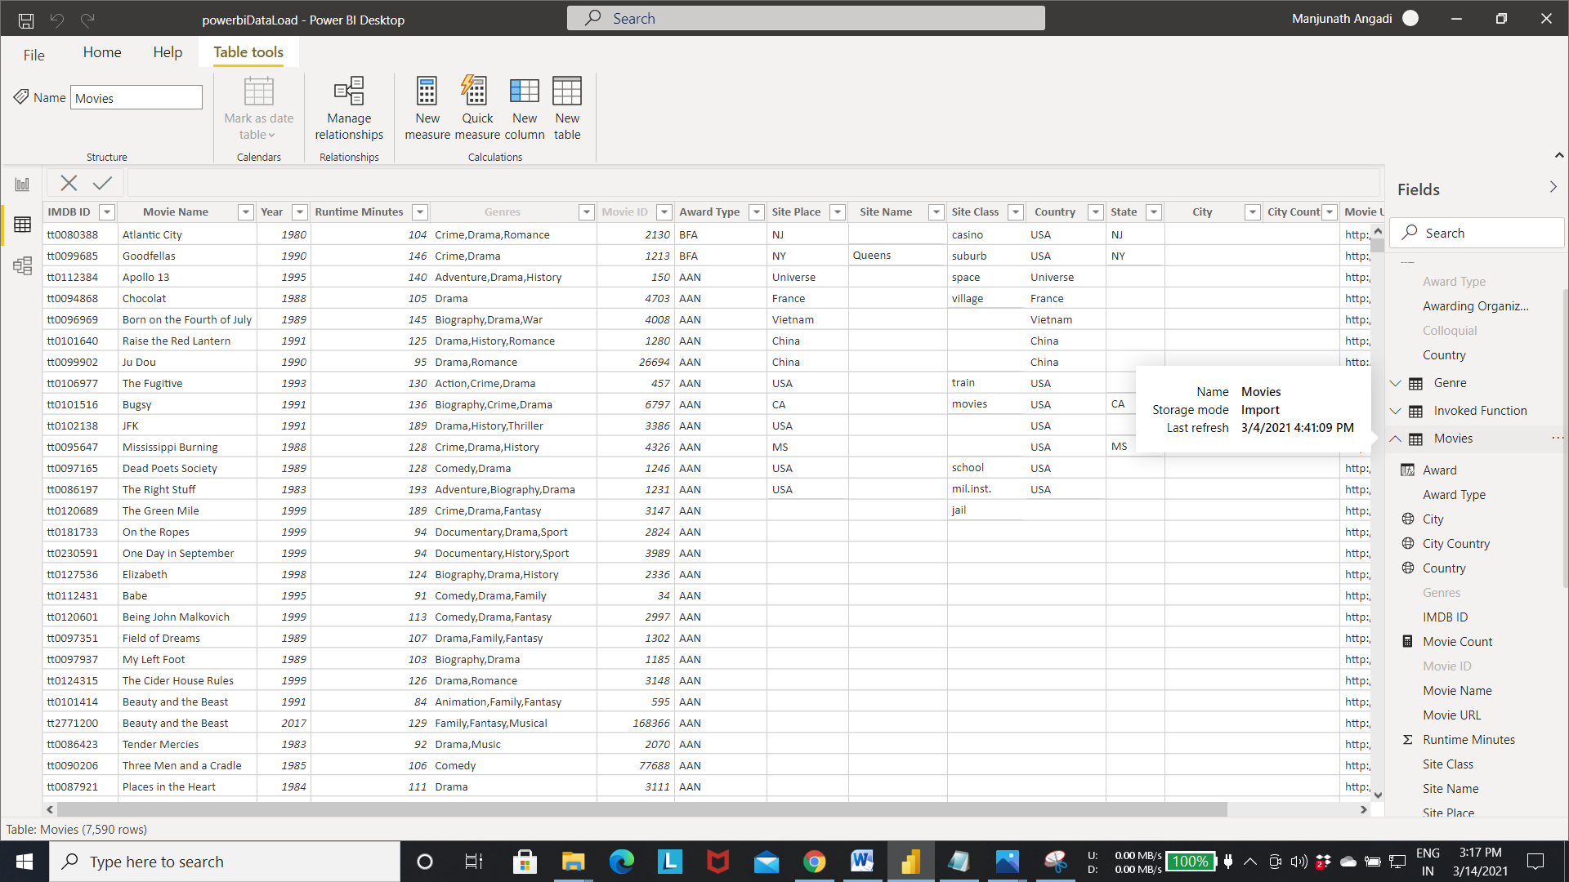

Step 2:- Right click on the movies table -> select the new measure option.

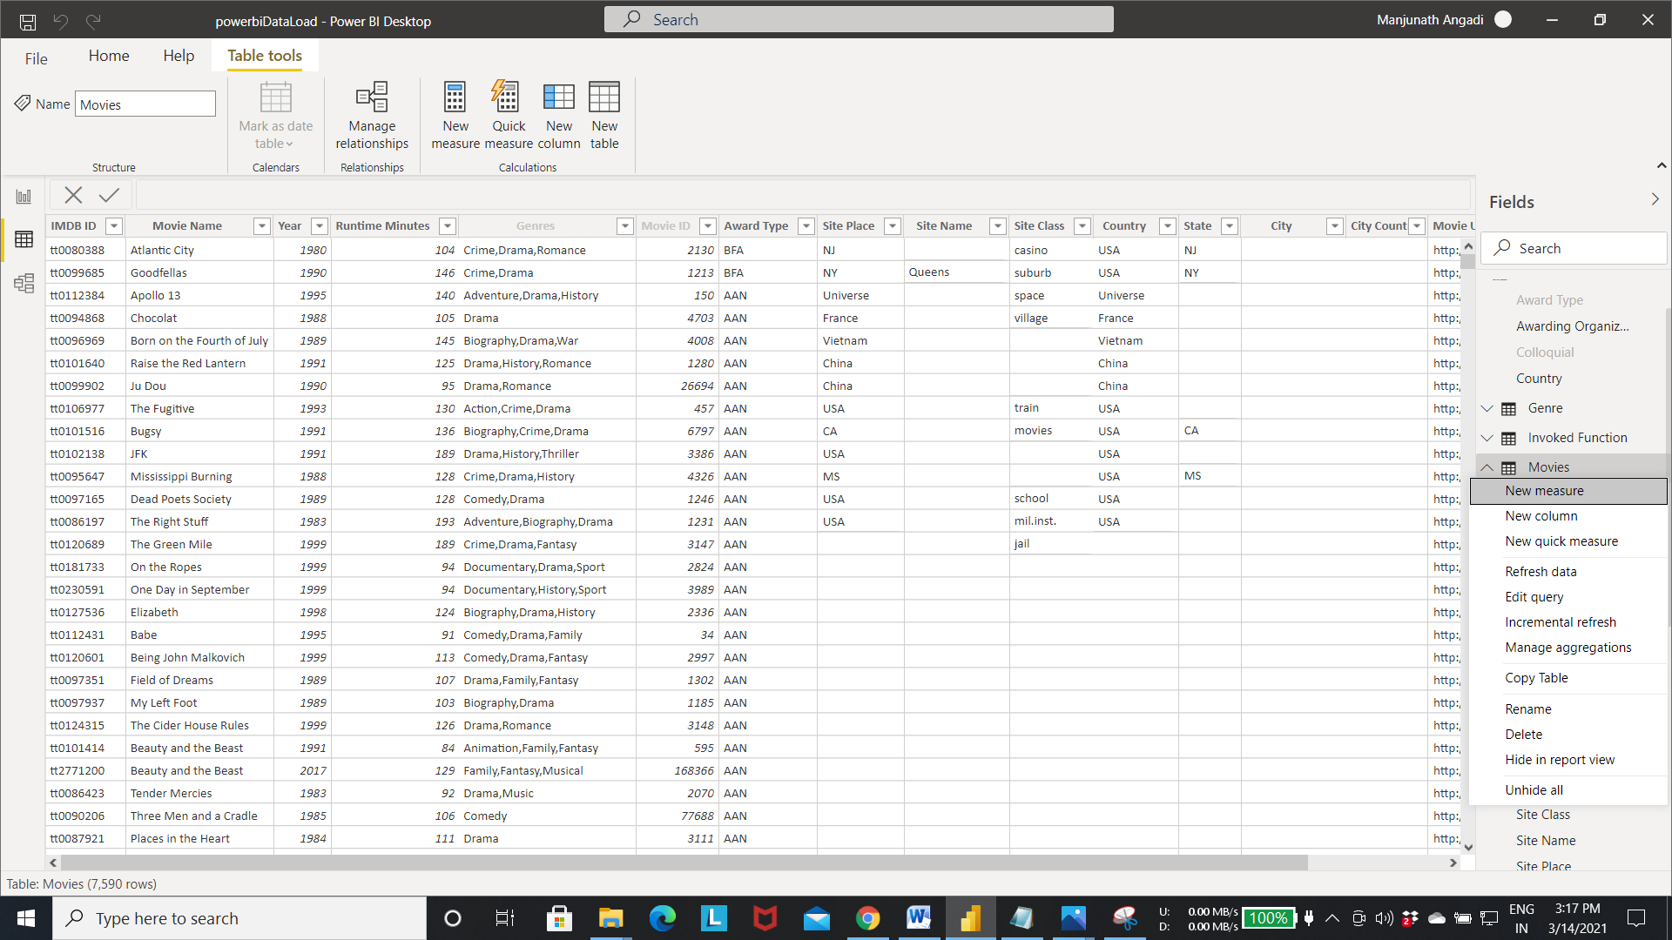

Step 3:- Expression editor will open up. Write the below expression to calculate the award count measure.

* Award Count = COUNTROWS('Movies') - COUNTBLANK(Movies[Award])

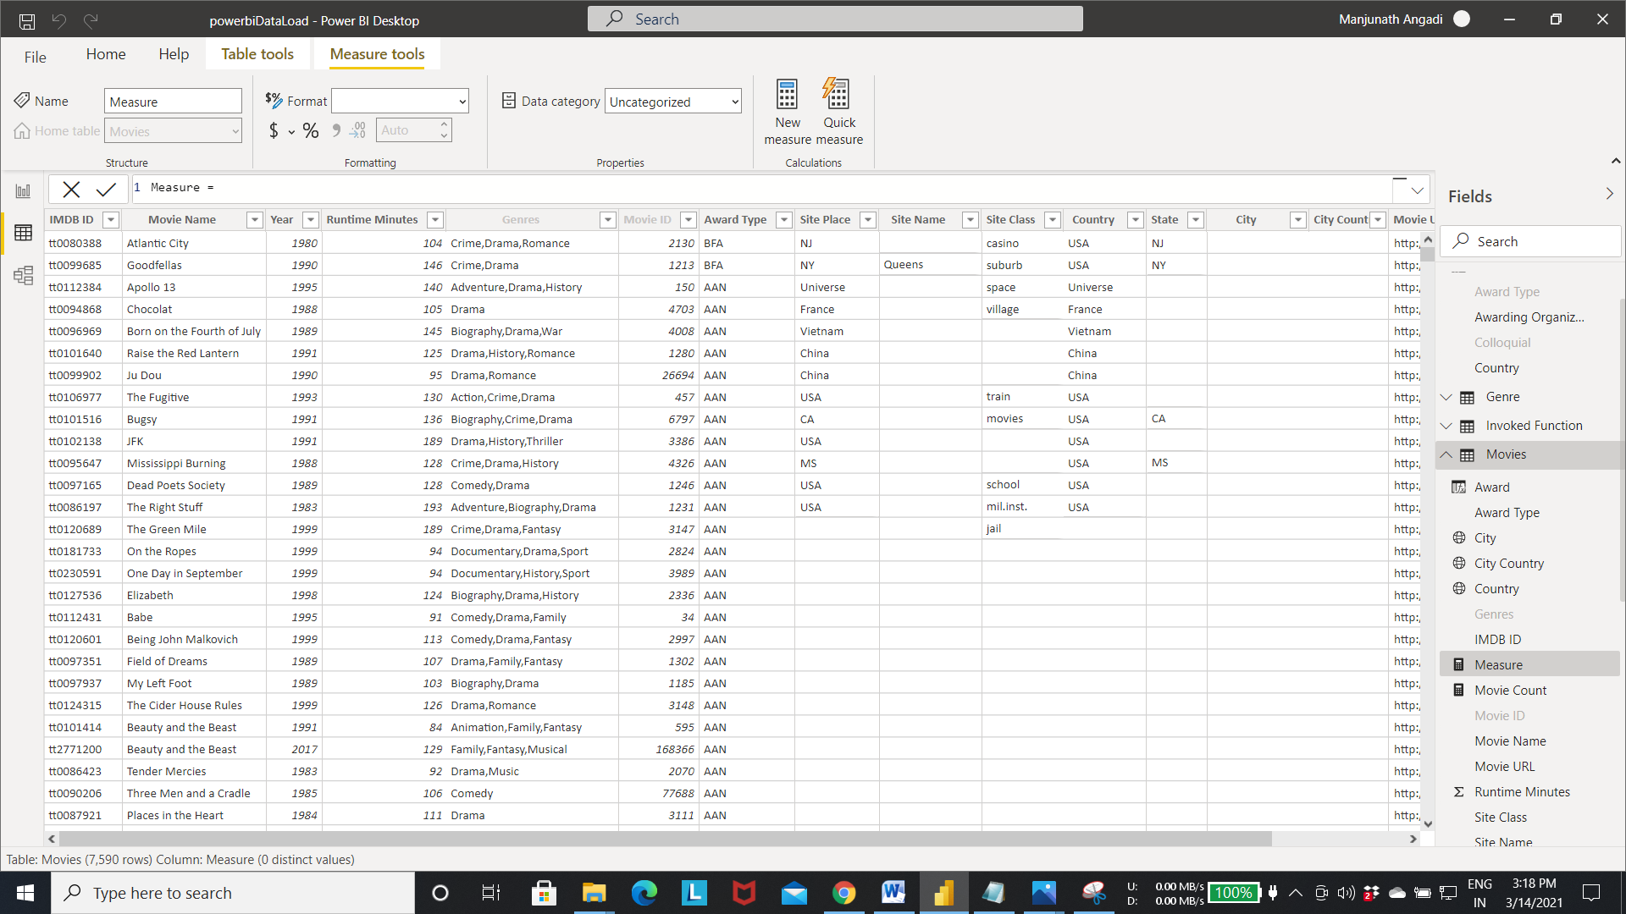

Step 4:-The above query creates the measure in the movies table. Which tells us the award count given to all the movies present in the movies table.

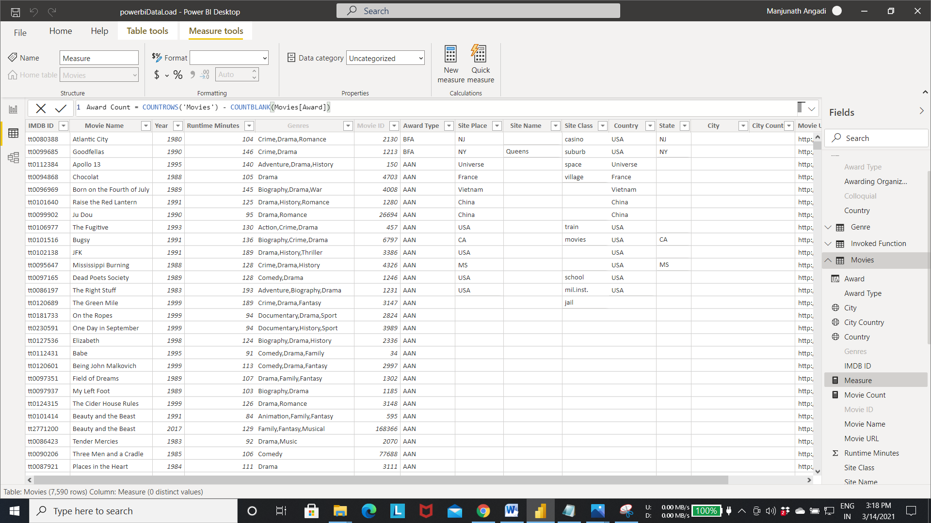

Step 5:- Award Count measure got created. Now we can use this measure as same as column in all the visualization.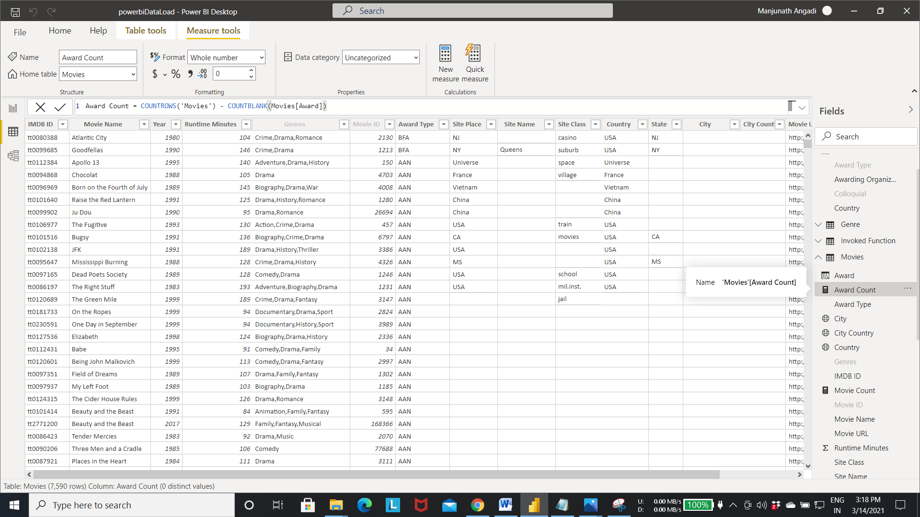

Step 6:- Creating another measure for calculating the percentage of movies with awards using calculate() function.

* Pct of Movies with Awards = [Award Count] / Calculate([Movie Count], ALL(Movies))
* For creating the above measure follow the same steps as mentioned in previous measure creation.

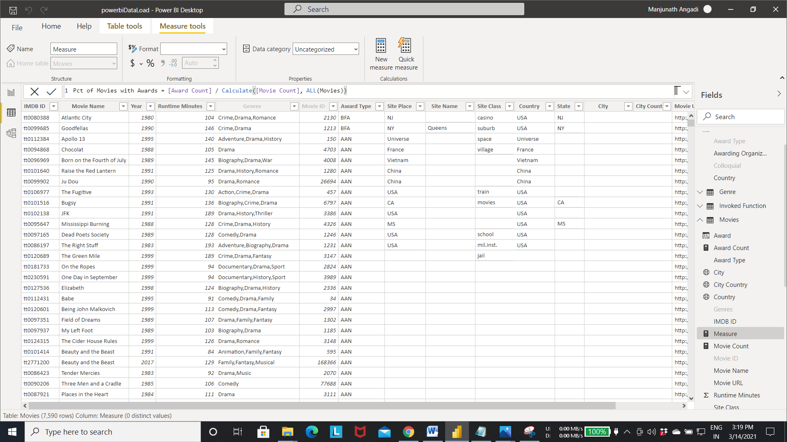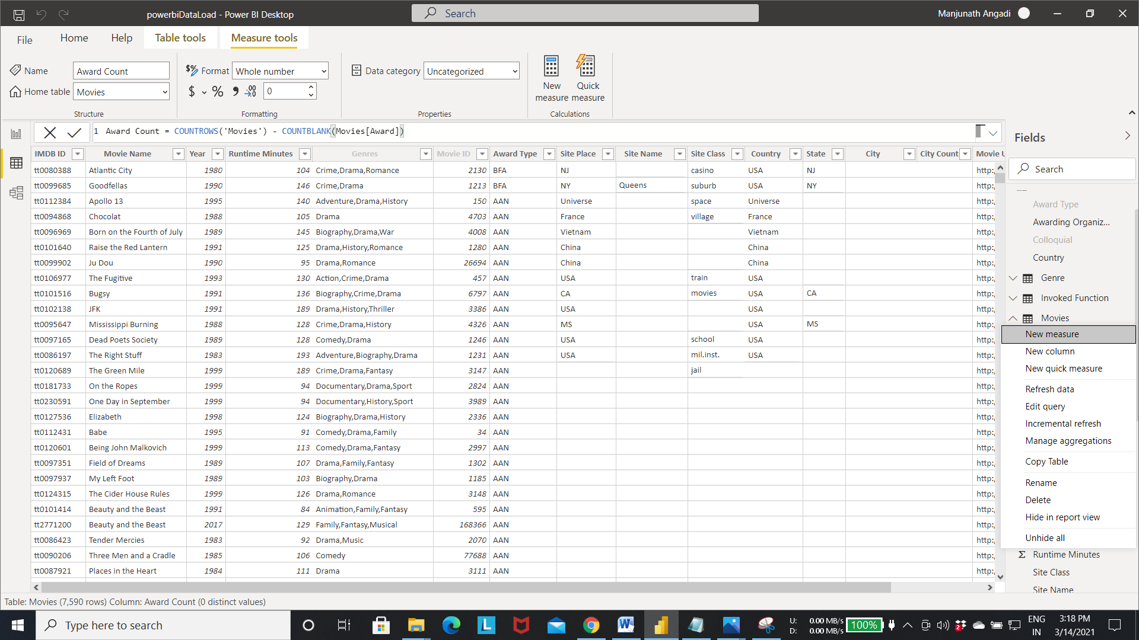

Output of the above query :-

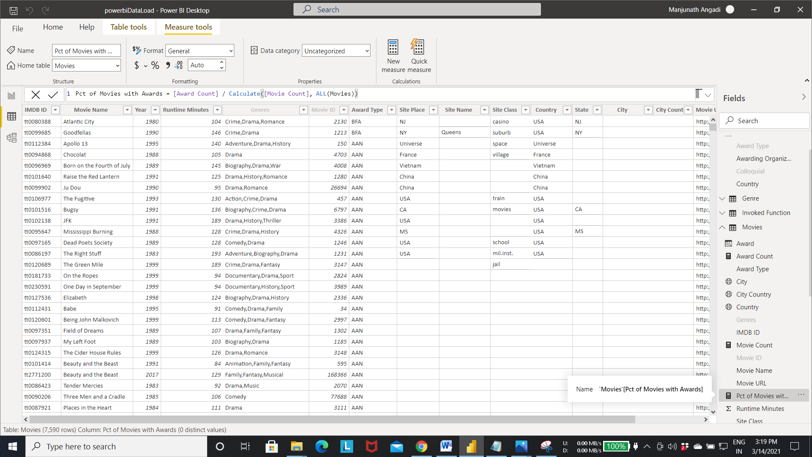

Step 1:- creating a table visualization using above measures.

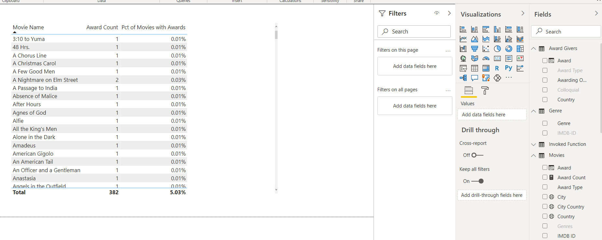

* **Creating a query parameter.**
  + For creating the query parameter first we need to create a query that accepts the parameter.
  + Then we have to create a query parameter to pass to the query for performing operation.

Step 1:- Select the transform data to open the power query editor.

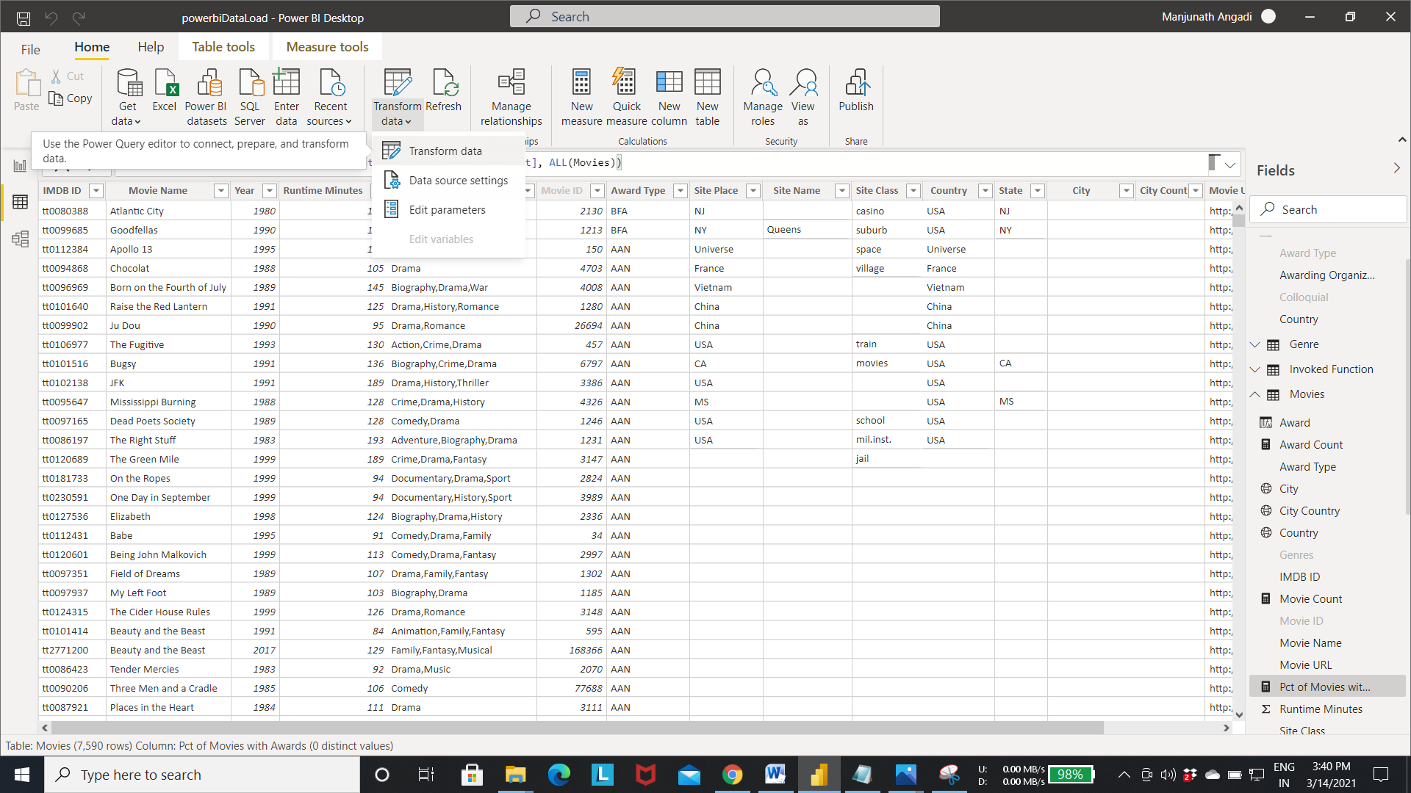

Step 2:- Select the blank query from new source as shown in fig.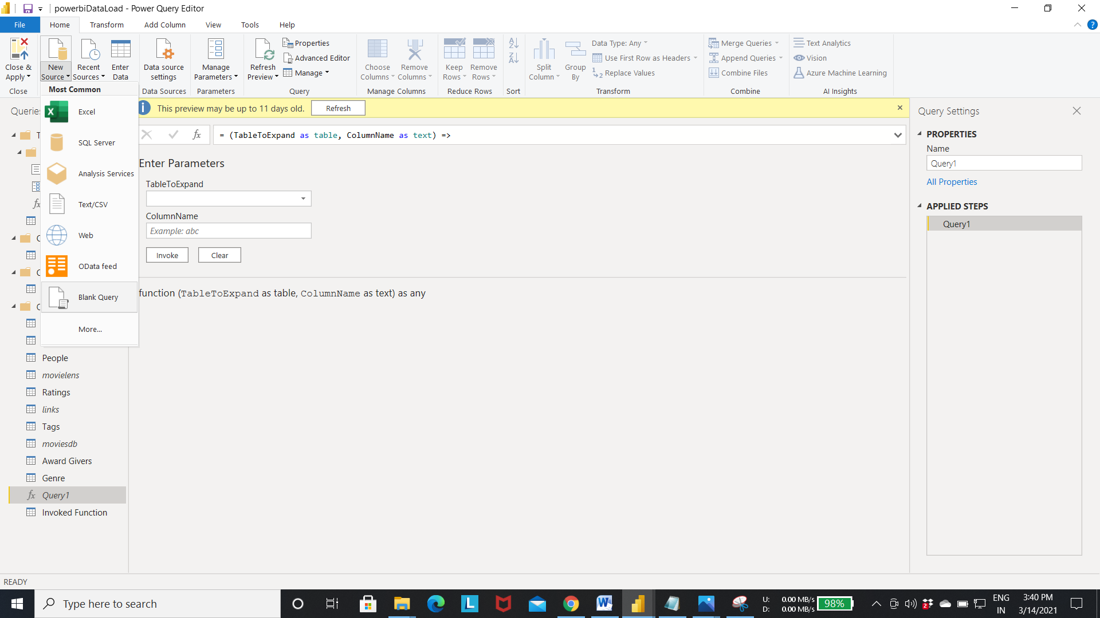

Step 3:-Select the advanced query editor to write the query.

* let
* Source = {1980..2018},
* #"Converted to List"={Source},
* #"Converted to List1"=#"Converted to List"{0}
* in
* #"Converted to List1"
* The above query will creates table year with list of values From 1980 to 2018.

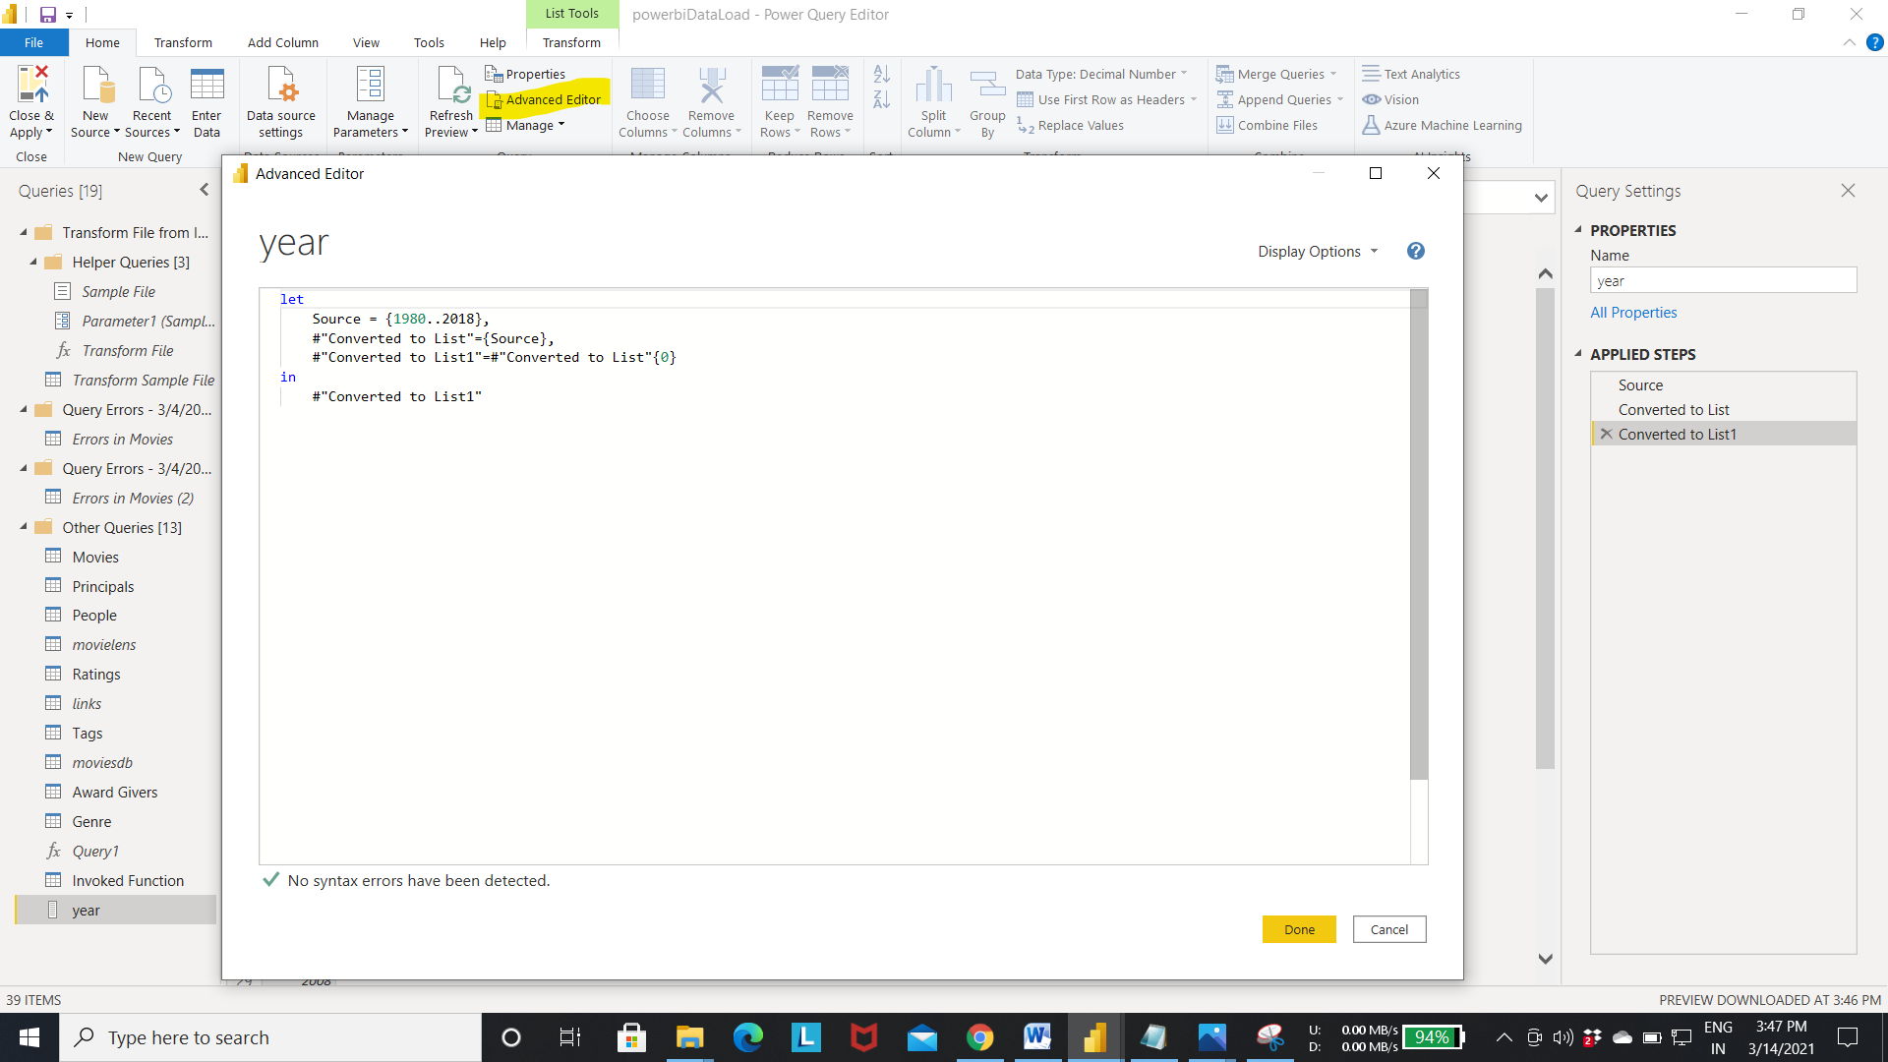

Output of Step 3:-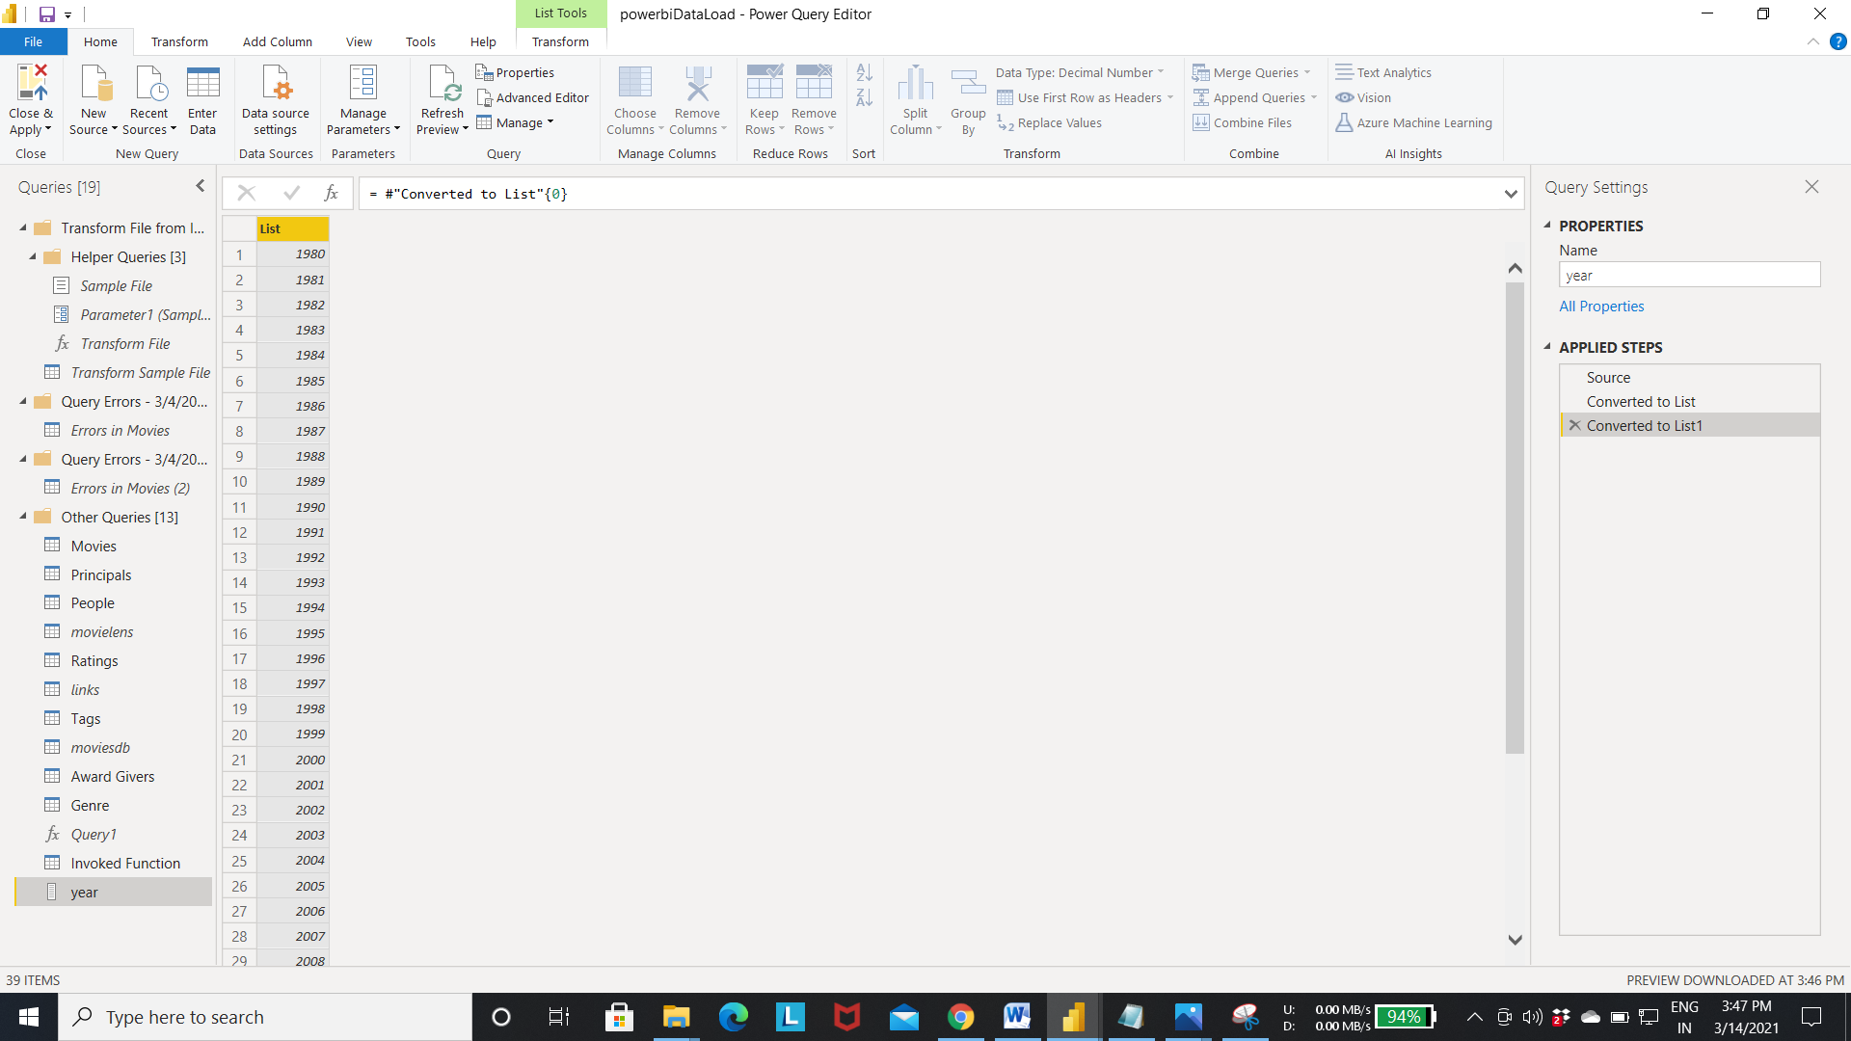

Step 4: For creating the parameter go to Manage Paramaters in home -> Select the new parameter.

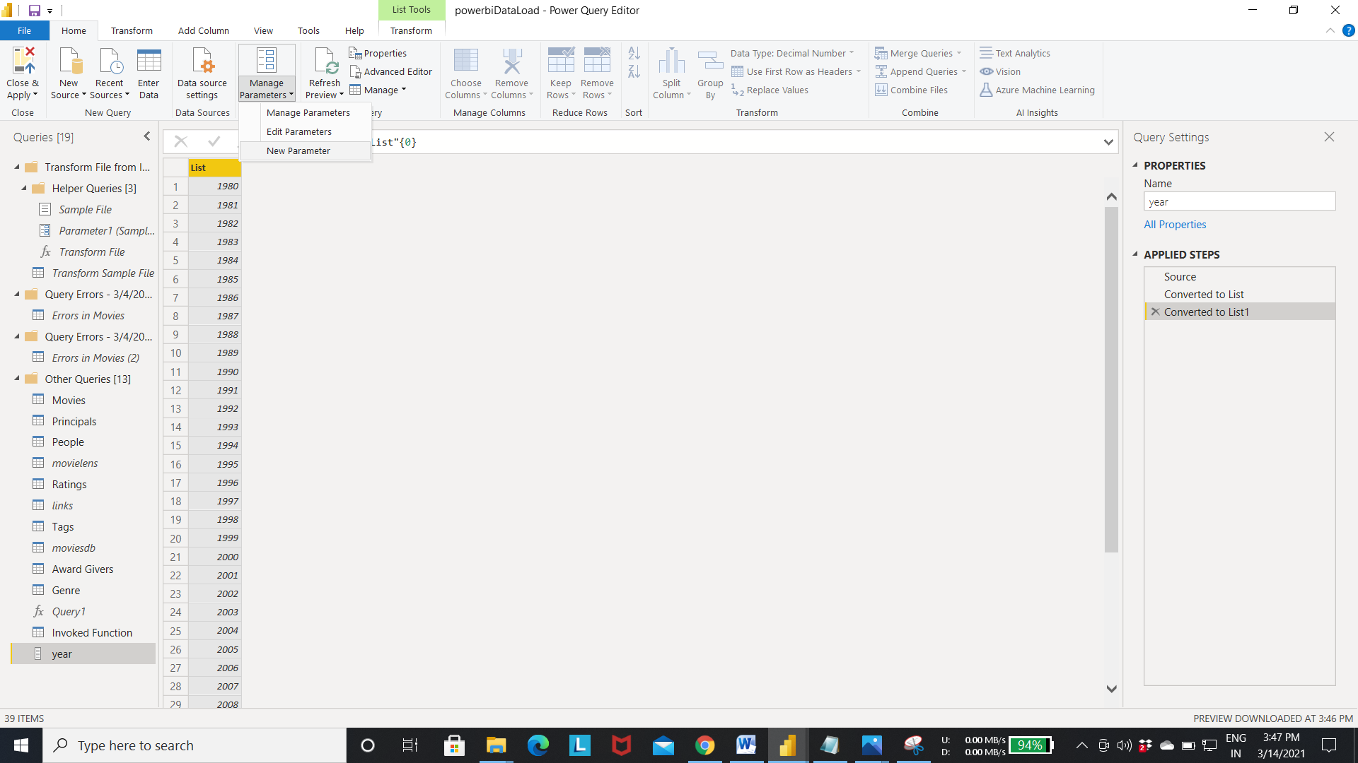

Step 5: - Open s the editor for creating the parameters.

* Enter the parameter name
* Select the data type of the parameter
* Select the query (In this example we selected the year query).
* Enter the current default value.

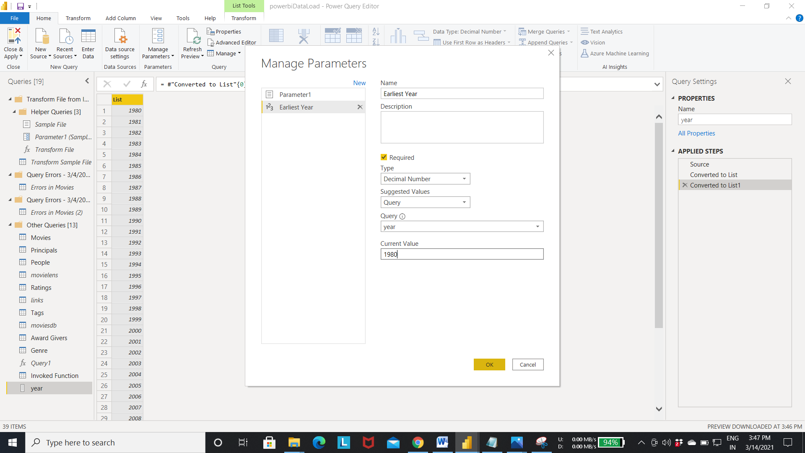

Step 6: Select New option as shown in the fig to create the new parameter.

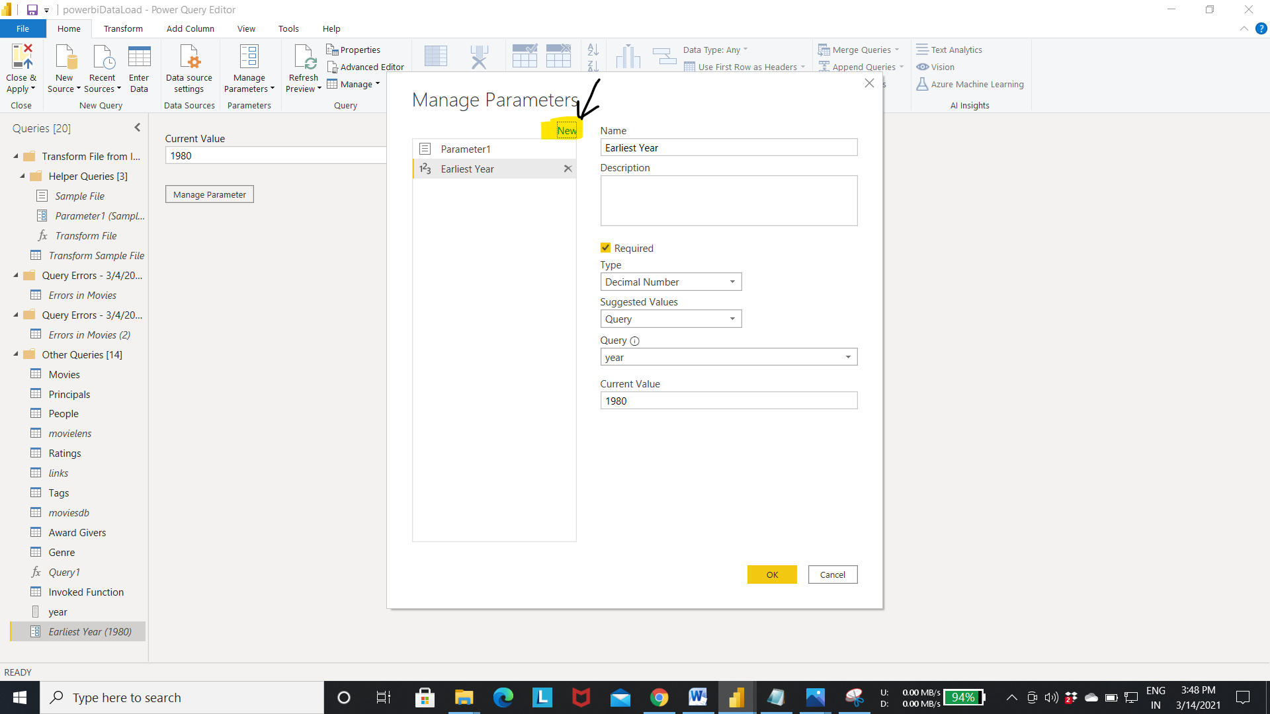

Step 7: Enter the details for the Latest year parameter as shown in the fig.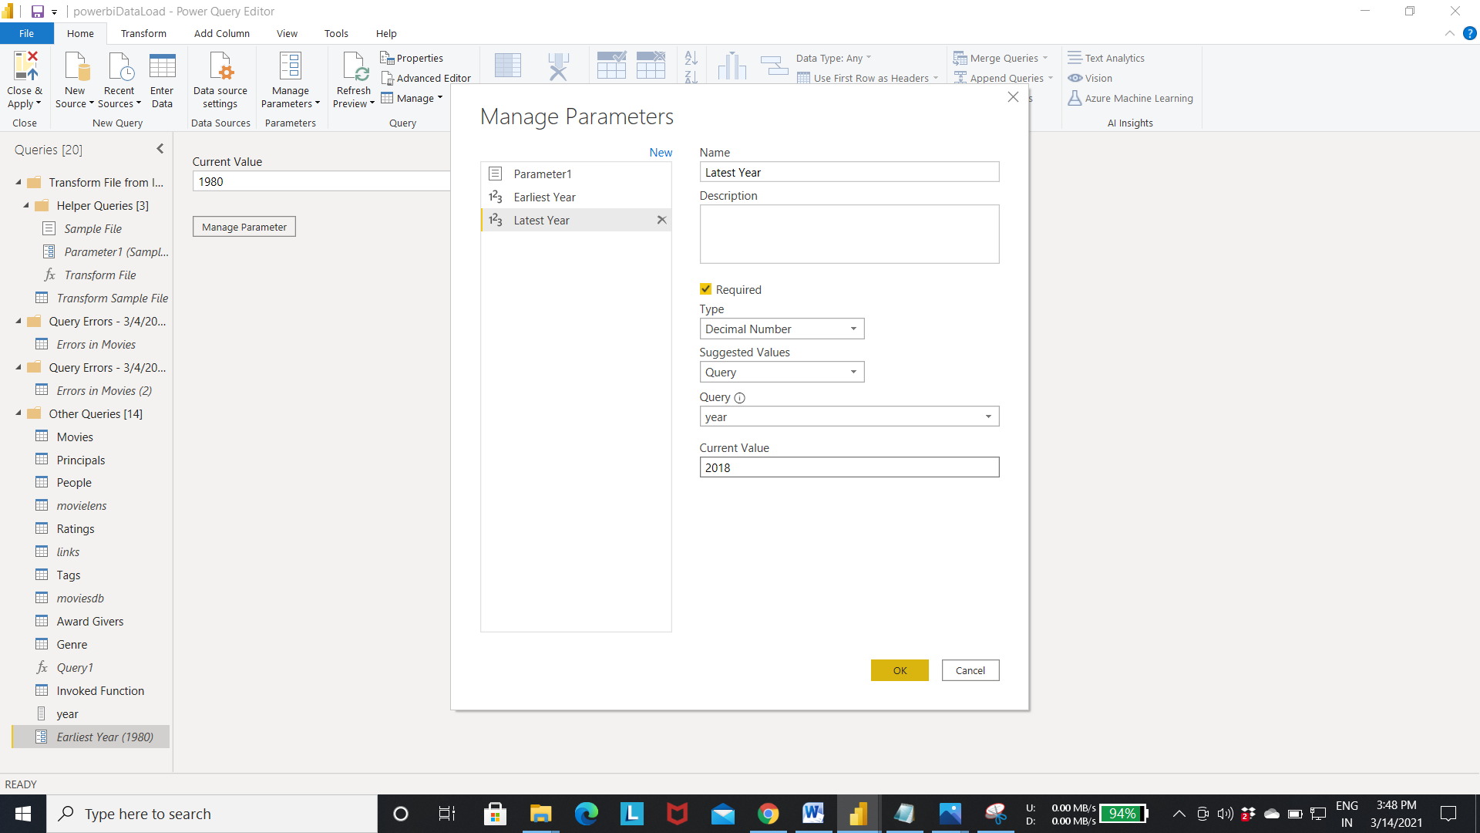

Output of step 7:-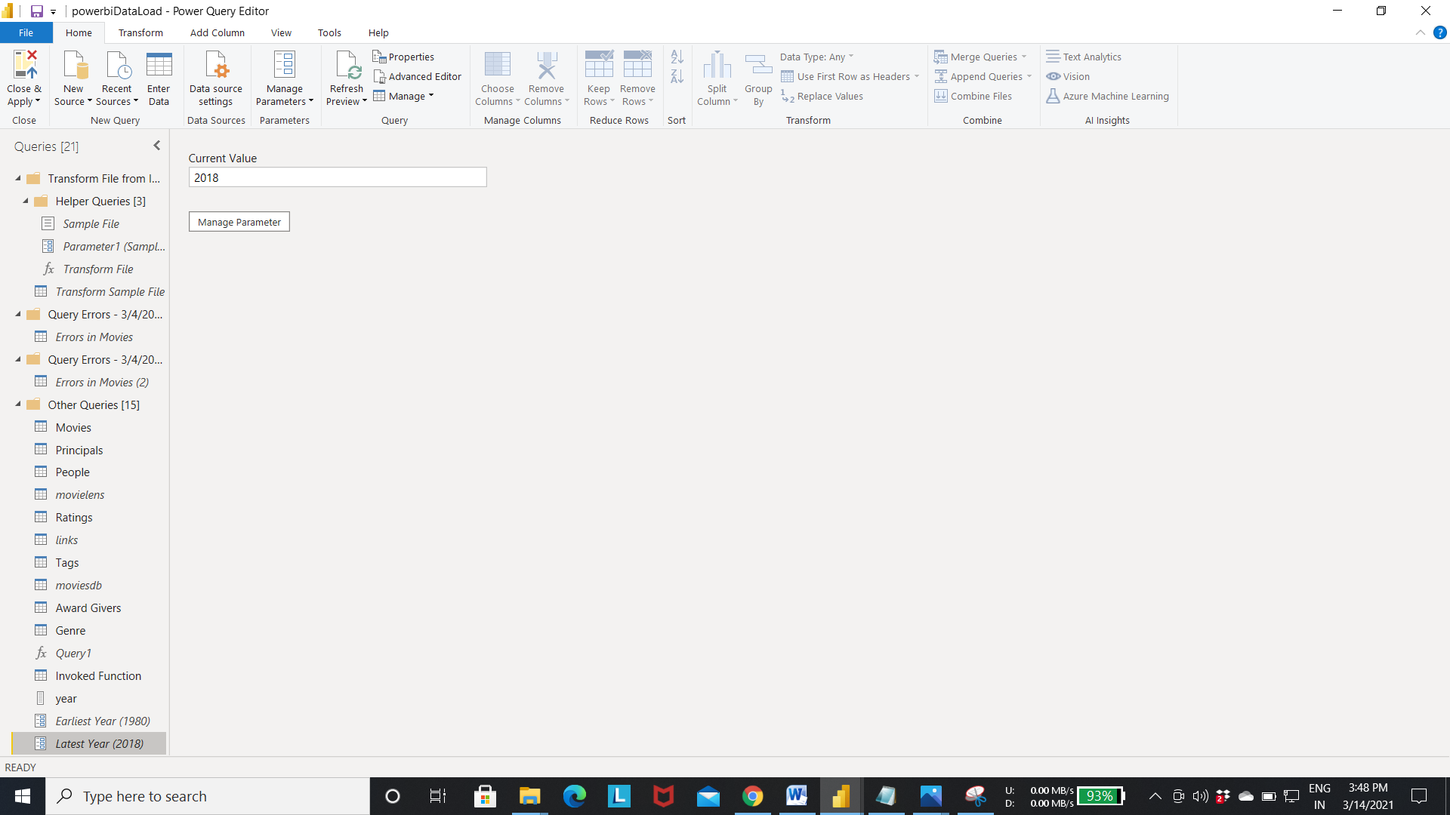

Step 8:- we can sort the column data using the query parameter that we created earliear.

Follow the steps to sort the column values.

* Select the year column-> right click ->select the number filter-> Select the between option to sort the records between range of values.

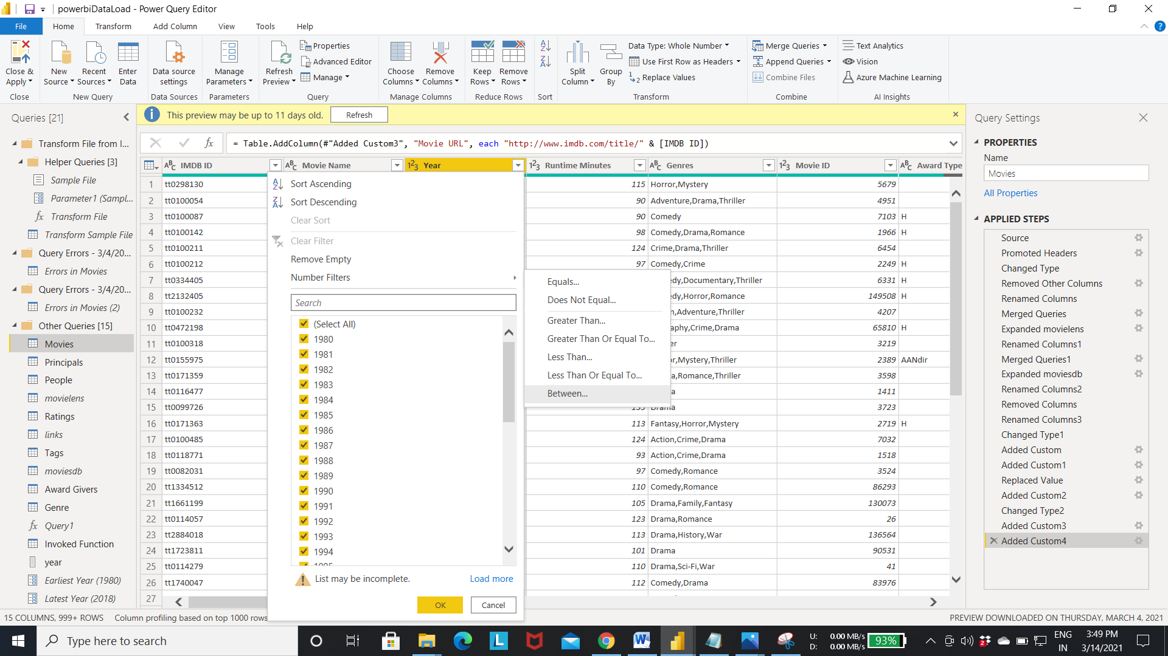

Step 9:- Select the parameter instead of decimal number.

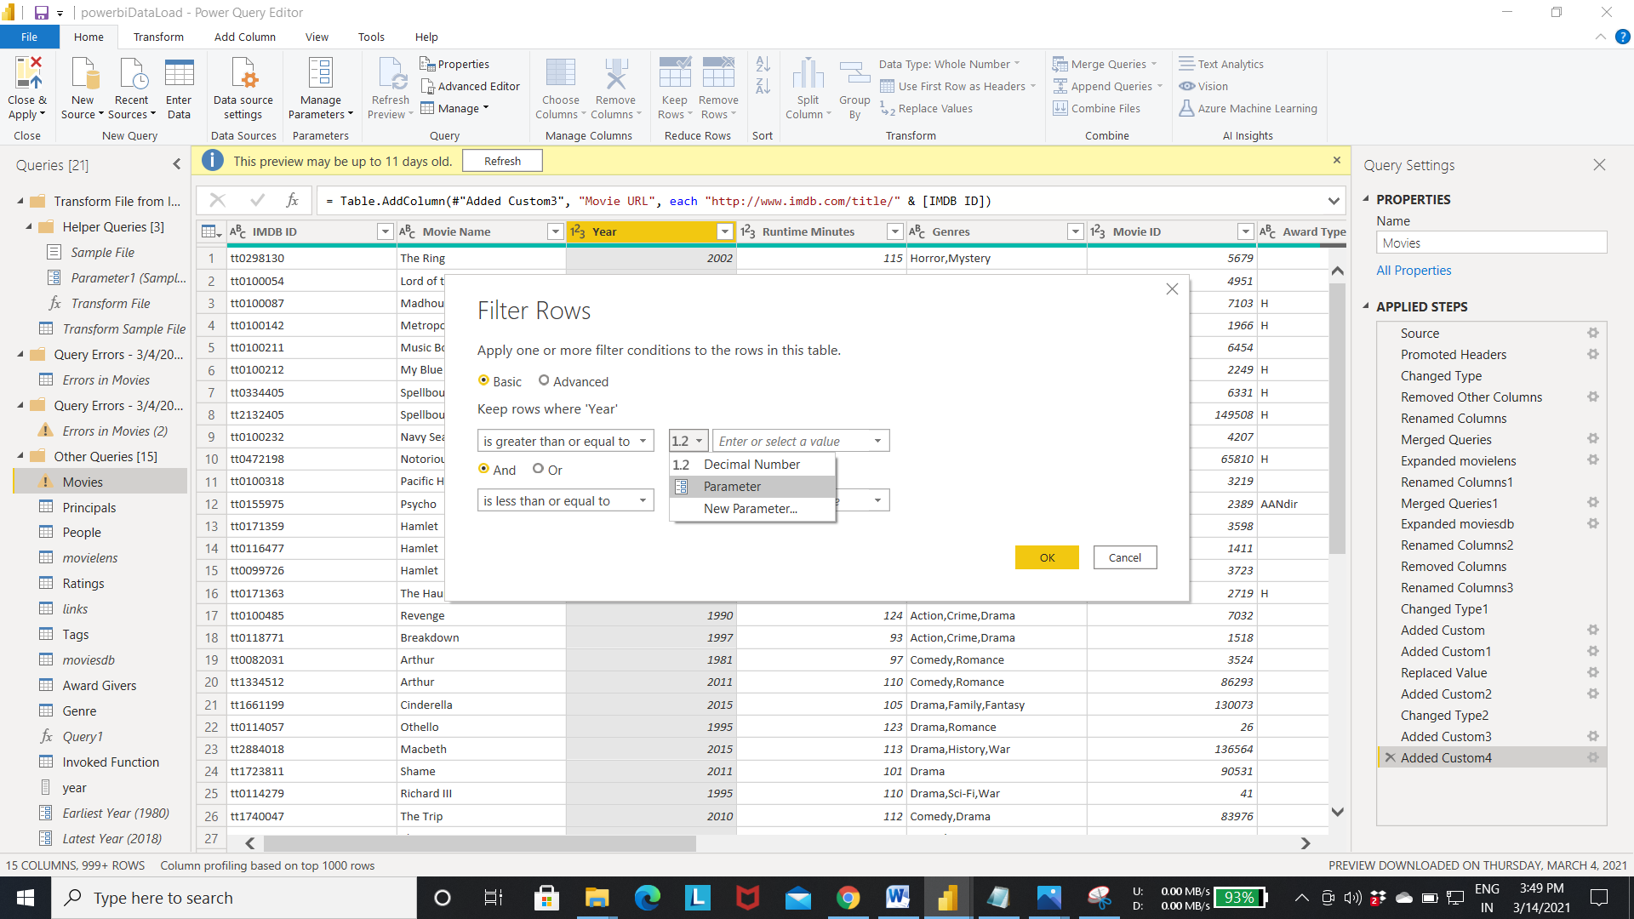

Step 10:- Enter the parameter name for the values instead of actual value.

Now the value is fetched from these parameters to sort the records.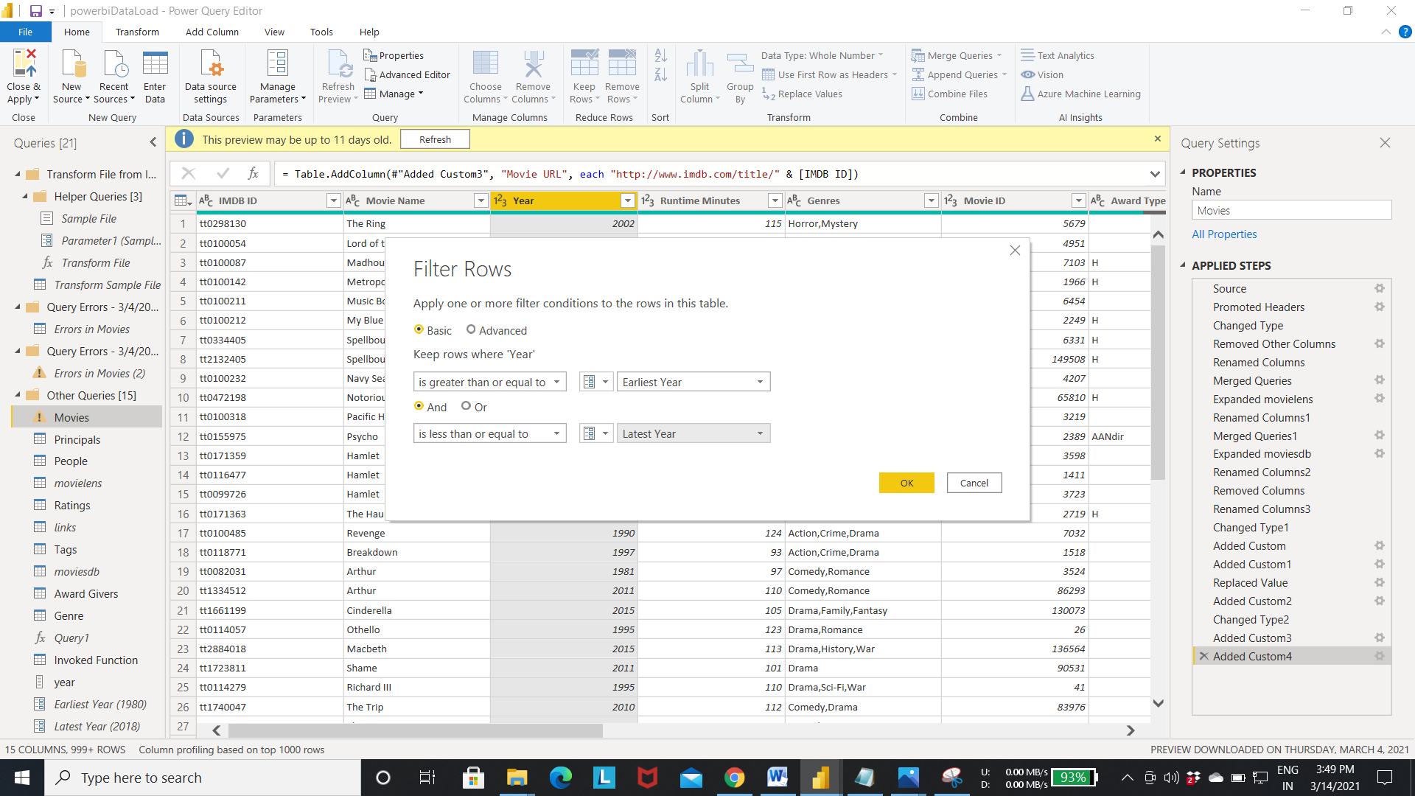

Output of step 10:- Result After Sorting the records.

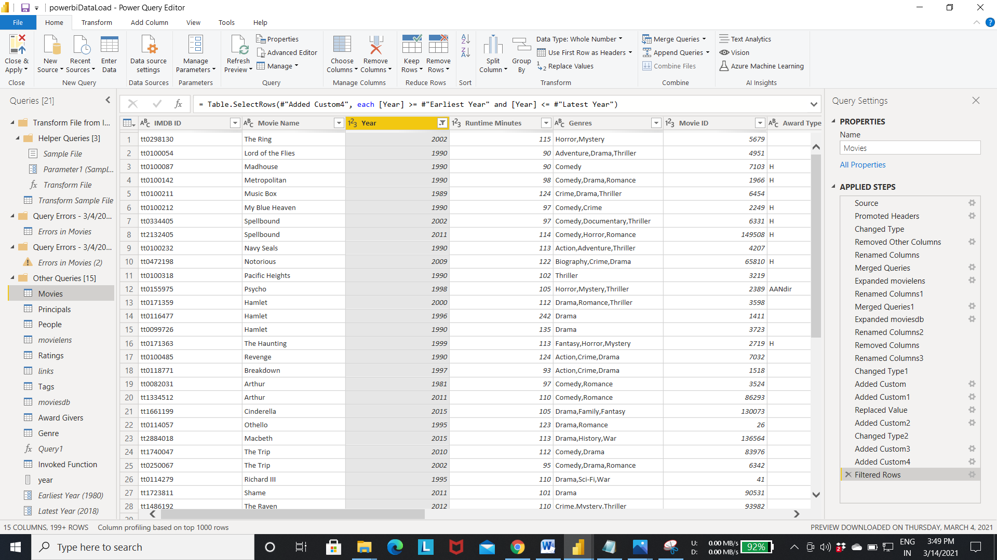

Step 11:- Select close and apply to move back to the query editor.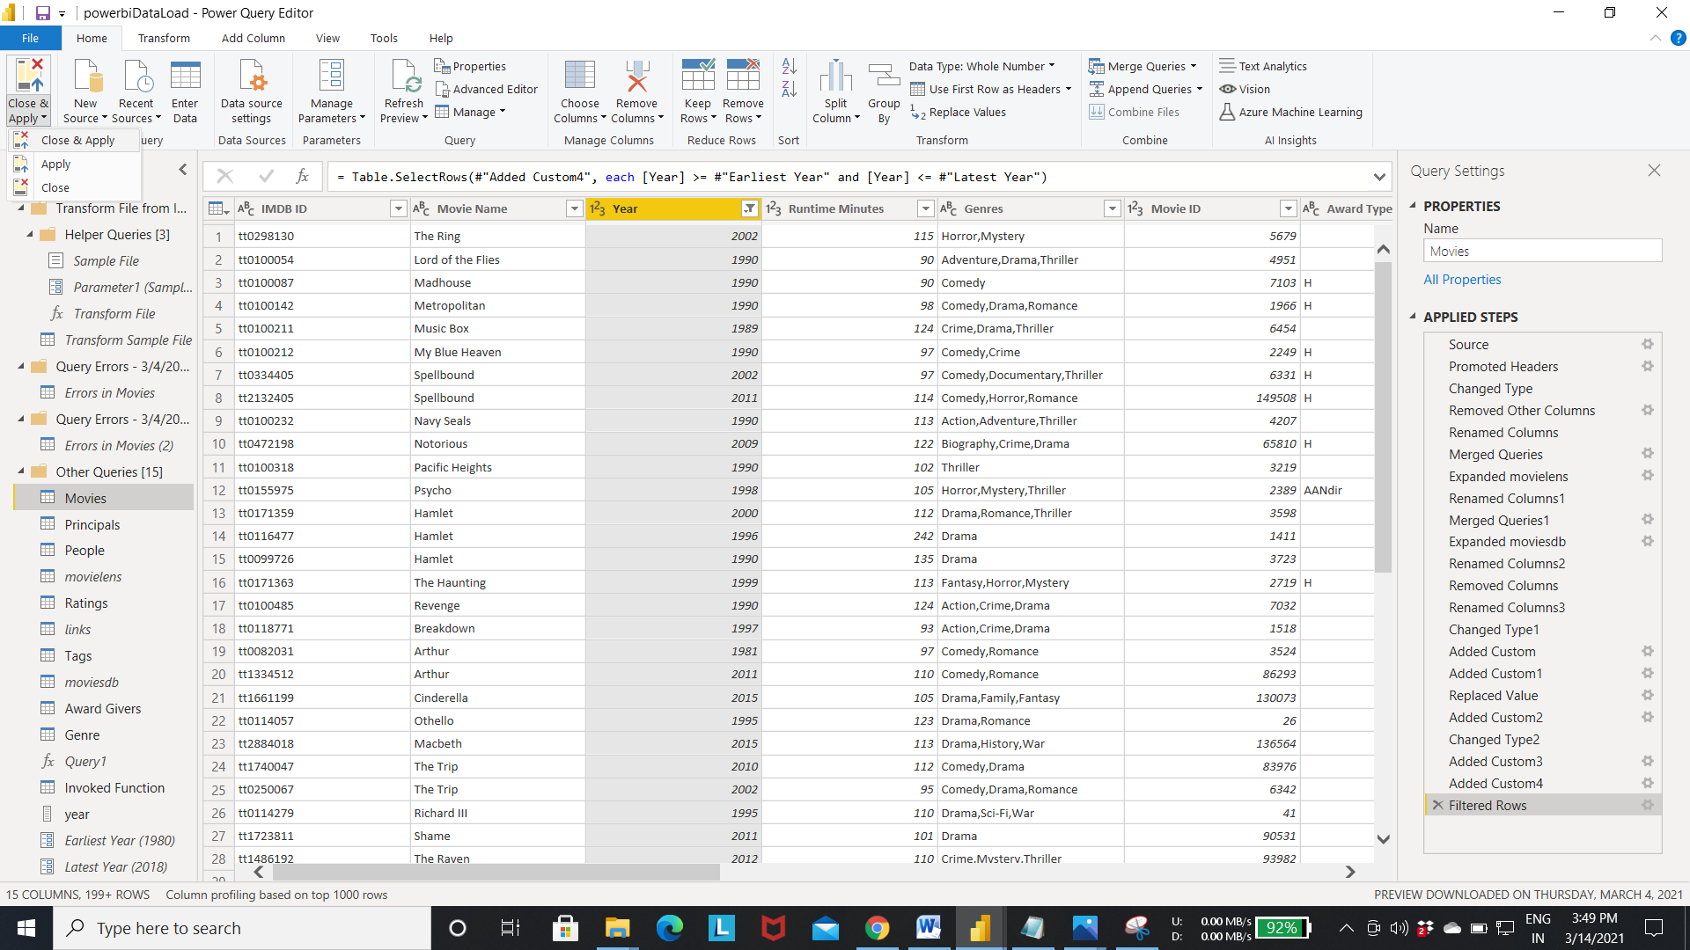

Step 12:- Select the New measure.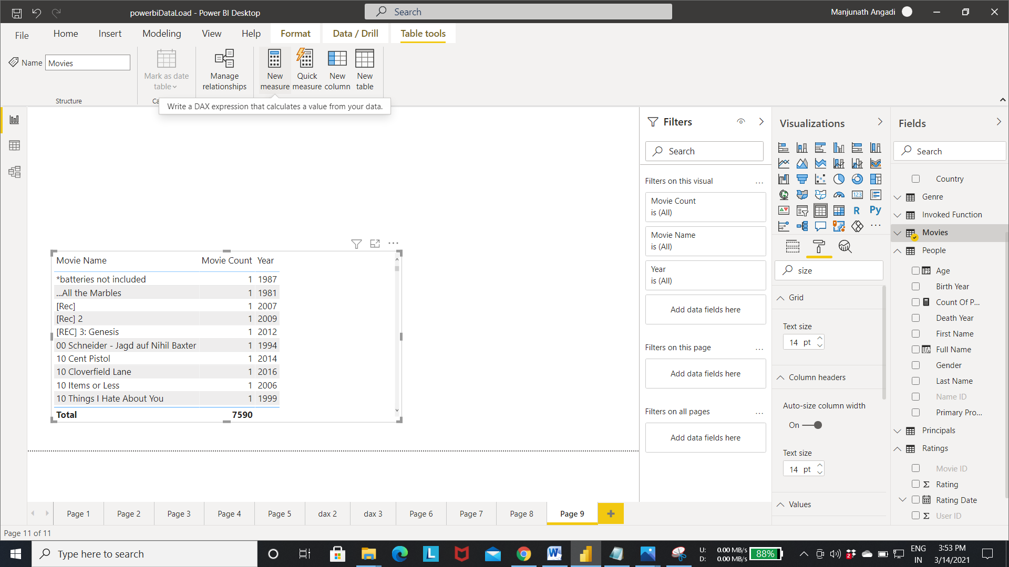

Step 13:- Write the below query to create a title measure.

* Title = "Movies Released Between " & FIRSTNONBLANK(Movies[Year], TRUE()) & " and " & LASTNONBLANK(Movies[Year], TRUE())
* The above query select the first and last non blank year from year column.

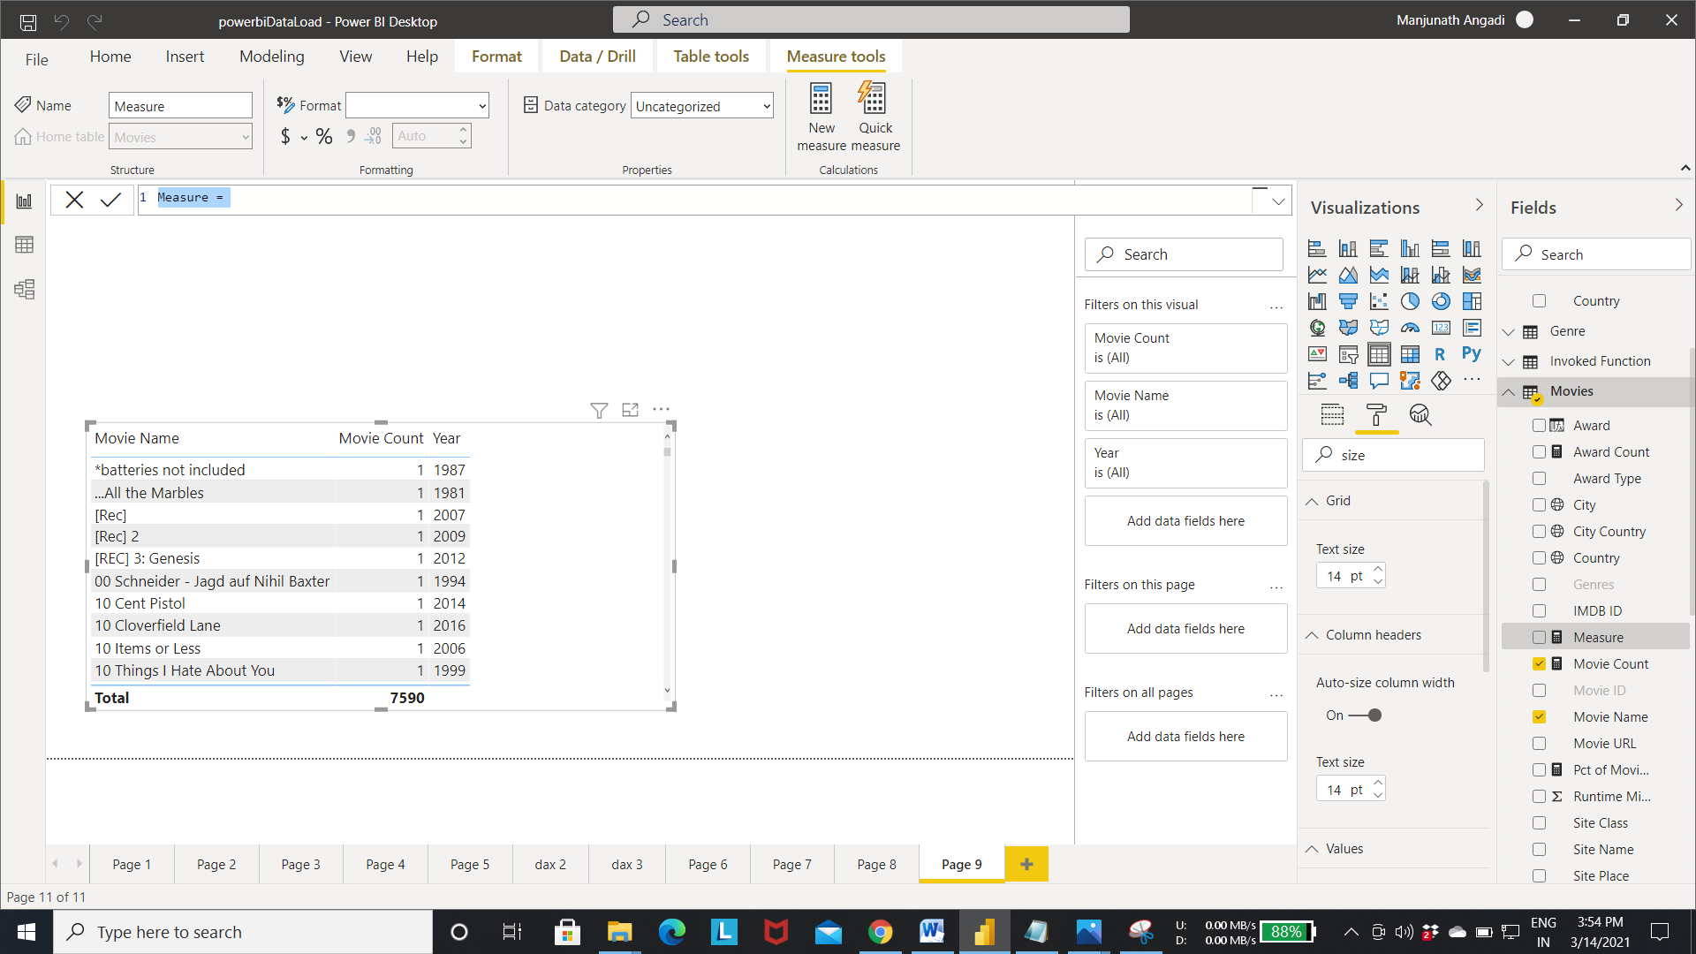

Output of step 13:- Title measure got created as shown in the fig.

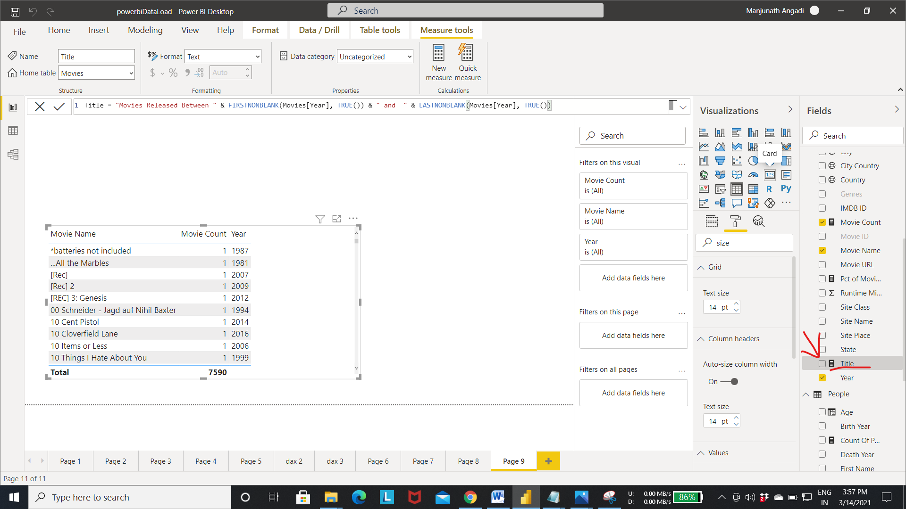

Step 14:- Select the card layout as shown in the fig. and add the title measure to the card layout.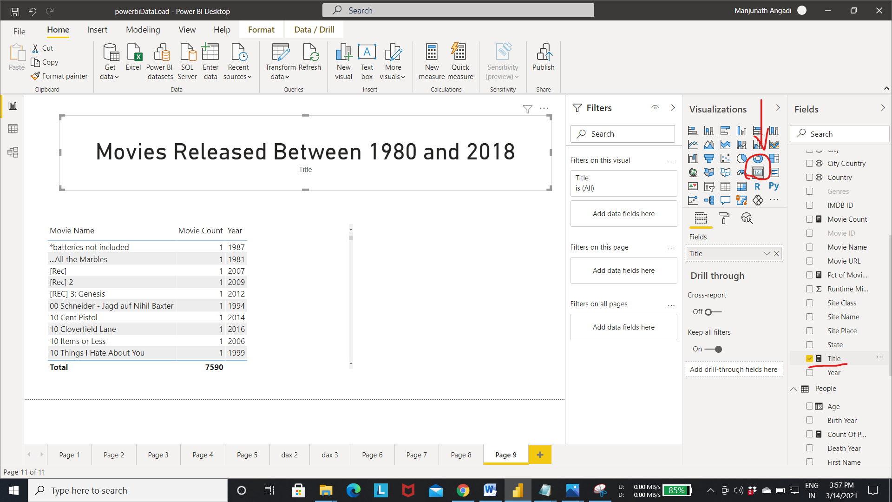

Step 15 :- To change the data set from the power bi edit the parameters that we created earlier.

* Select the edit parameter as shown in fig.

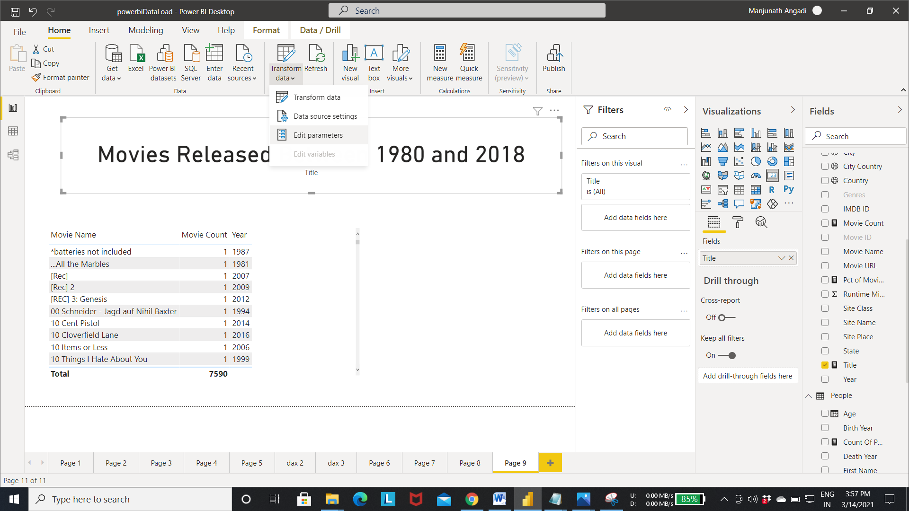

Step 16:- change the values of the both the parameter as shown in fig.

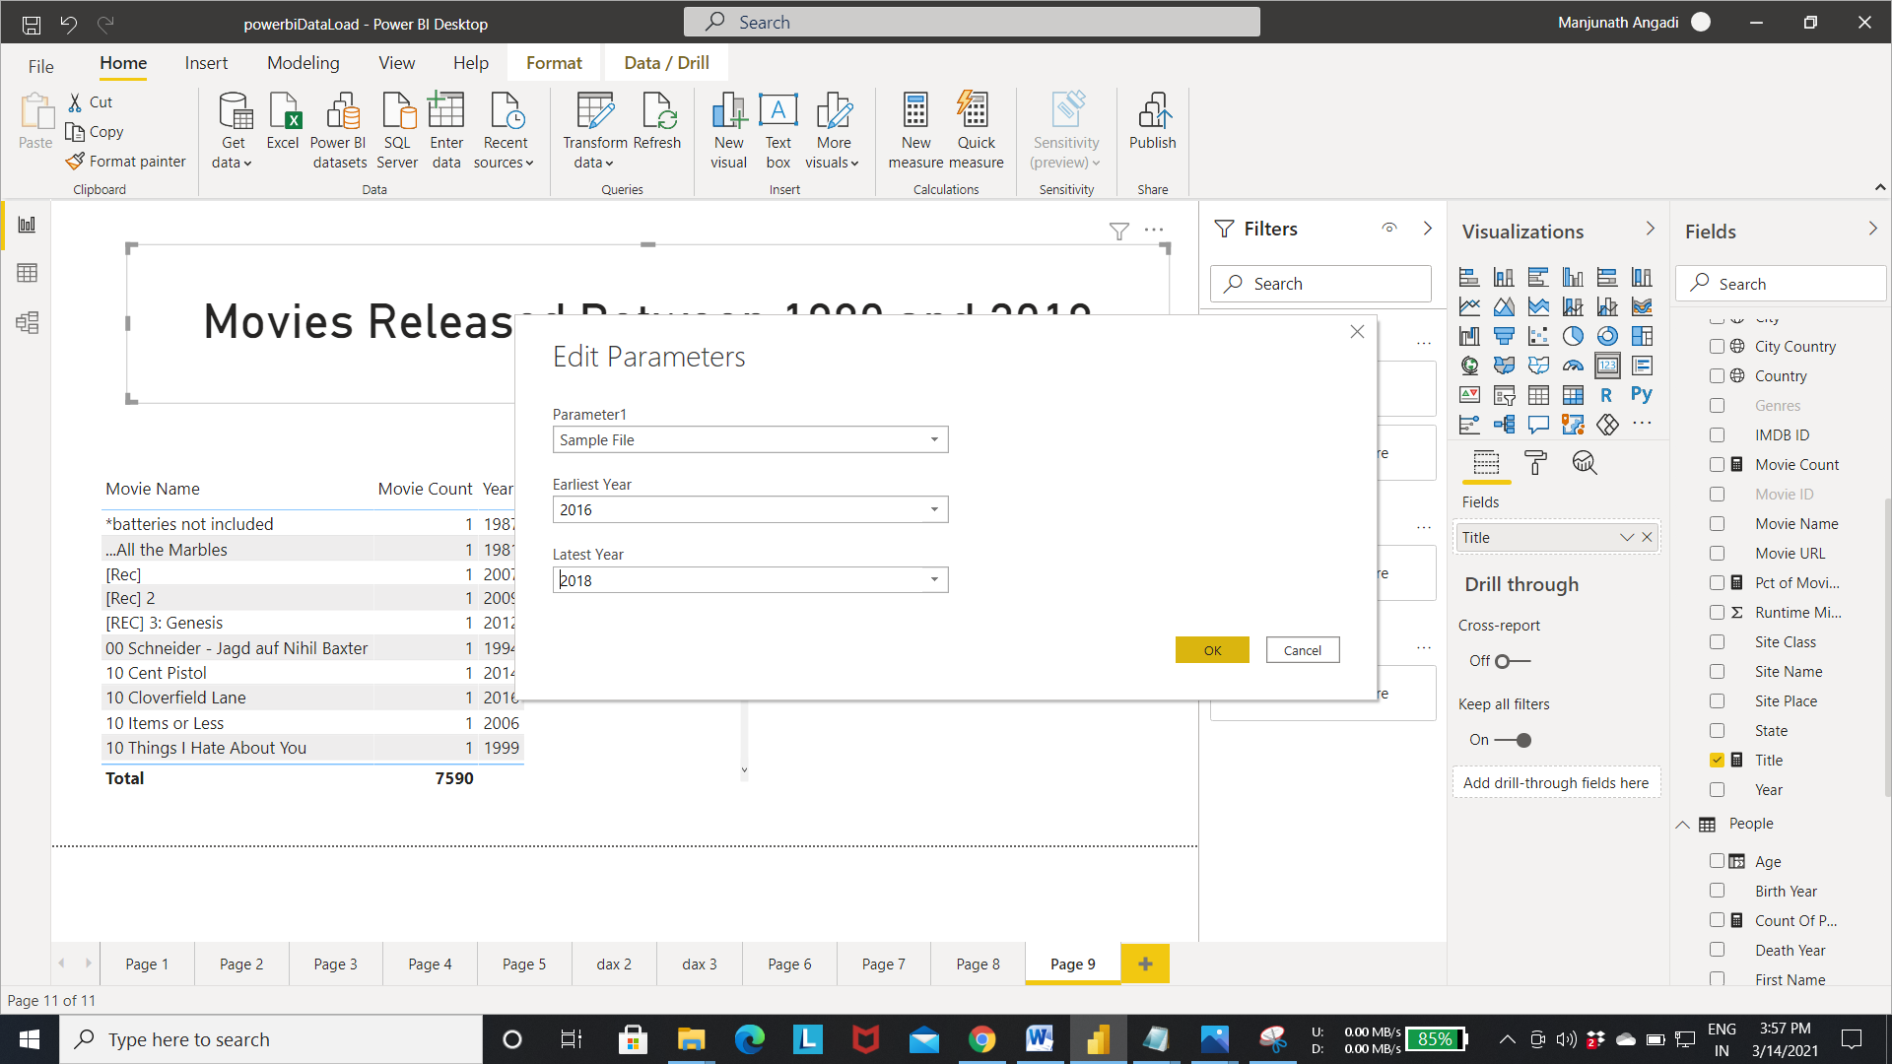

Step 17:- Now the new dataset with movies made between 2016 and 2018 year movies are fetched from the dataset and loaded into the powerbi.

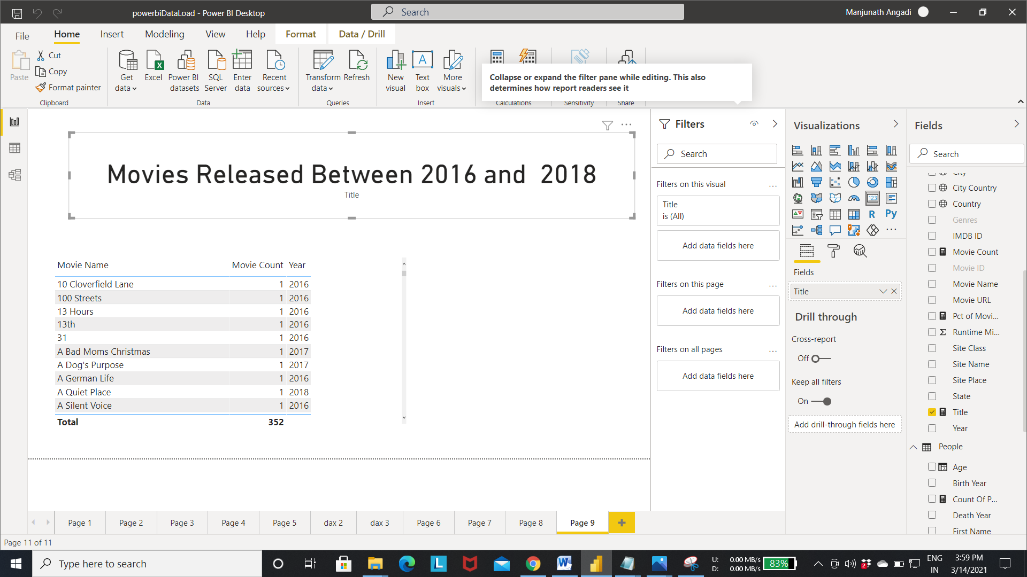

* **Working with What if parameter.**
  + What if parameter:- What If parameter in Power Bi can easily give you the ability to dynamically transform your data.
  + Purpose of what if parameter is to take the input vakue from the user.

Step 1:- Select the new measure. 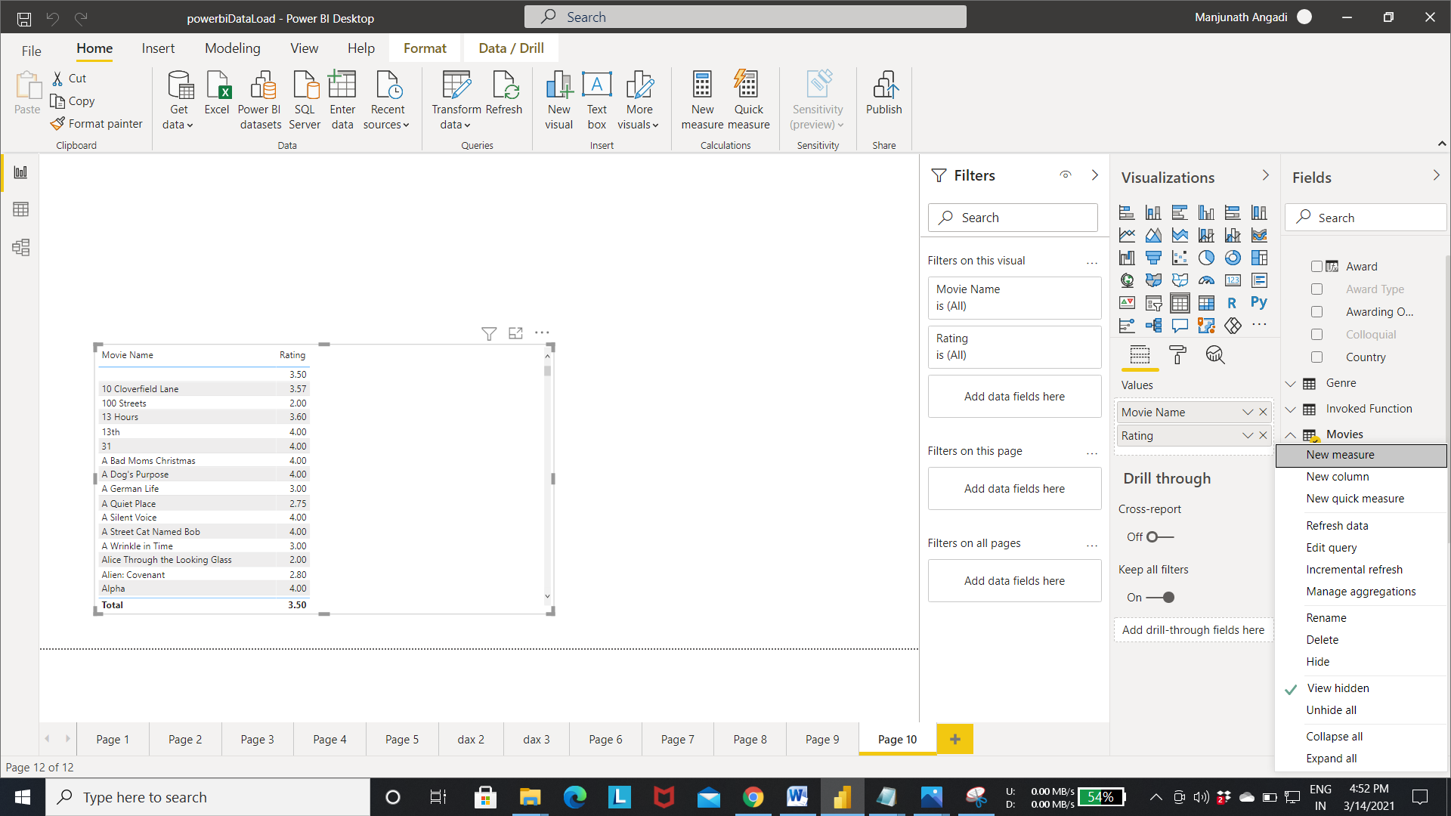

Step 2:- write a query as shown in the fig to calculate the average rating given to the particular movie.

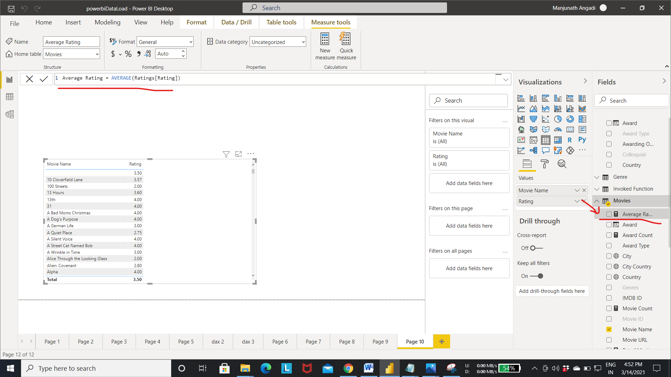

Step 3:- Add Movie Name and average rating to the table visualization as shown in fig.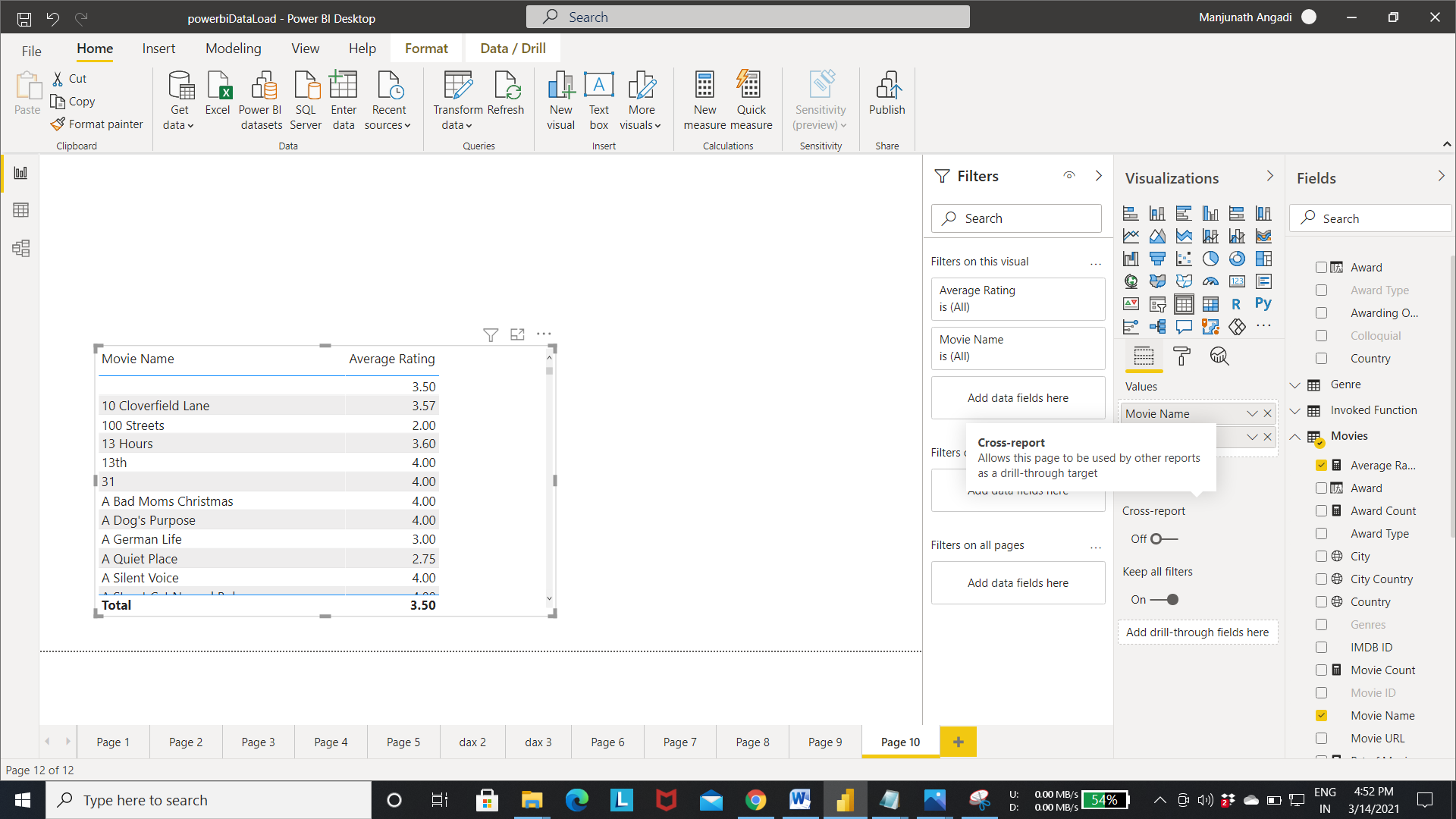

Step 4:- For creating the what if parameter select what if parameter from the modeling menu as shown in the fig.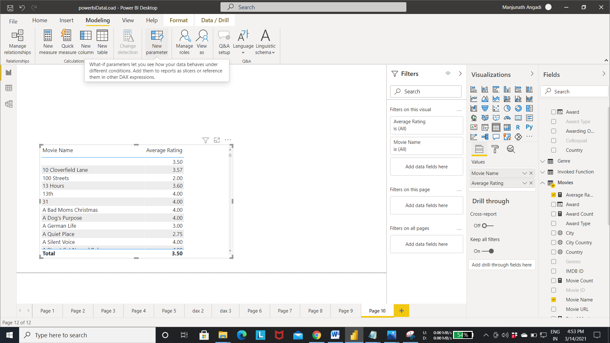

Step 5:- Enter the name of the parameter.

-> select the data Type

-> Enter the the minimum and maximum value for the parameter.

-> Enter the increment value-> click ok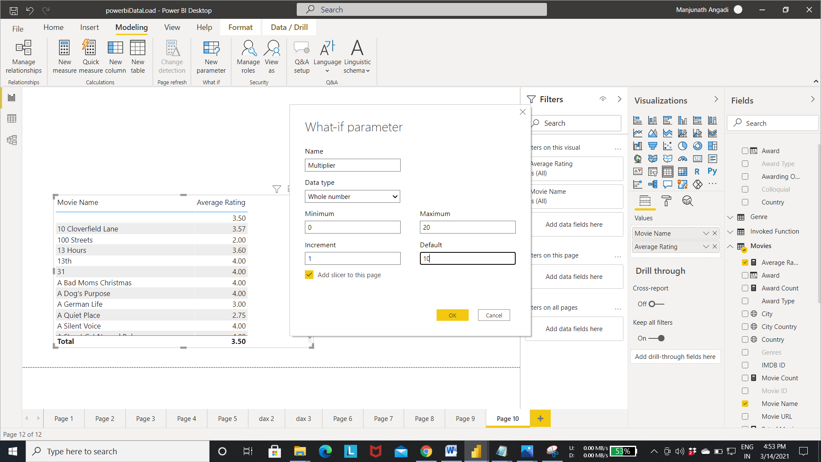

Step 6:- What if parameter got created with range of values between 0 to 20 as shown in the fig. and the slicer is added to the page.

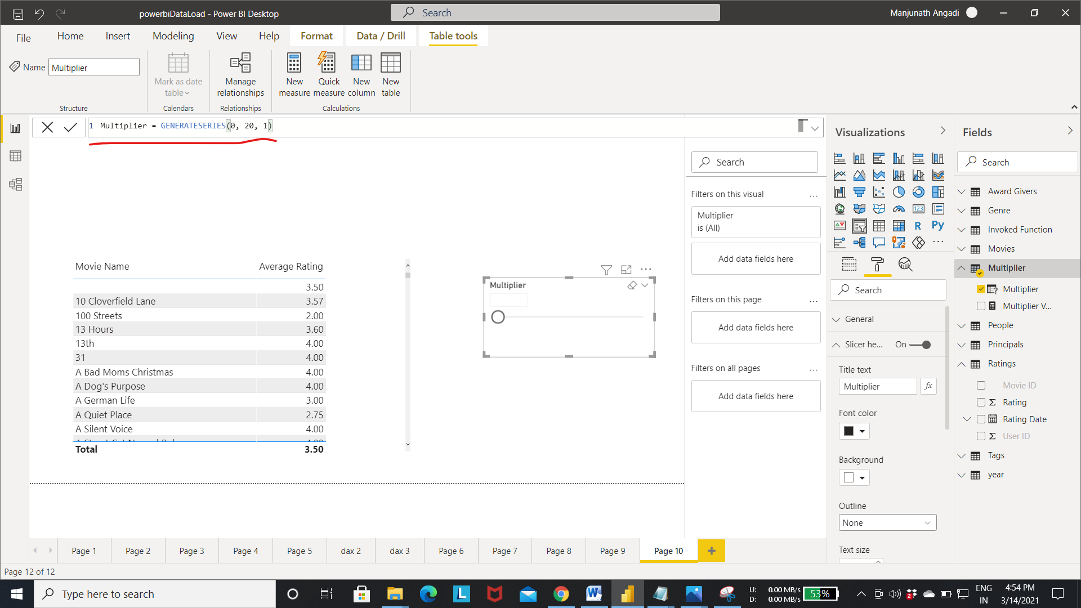

Step 7:- Create a new measure adjusted rating in movies.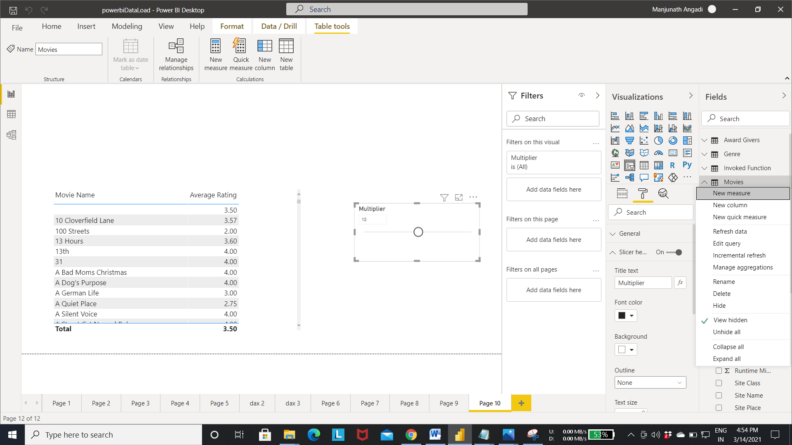

Step 8:- Adjusted rating measure calculate the average rating multiplied by the slicer value. Which allows the user to dynamically interact with the table values.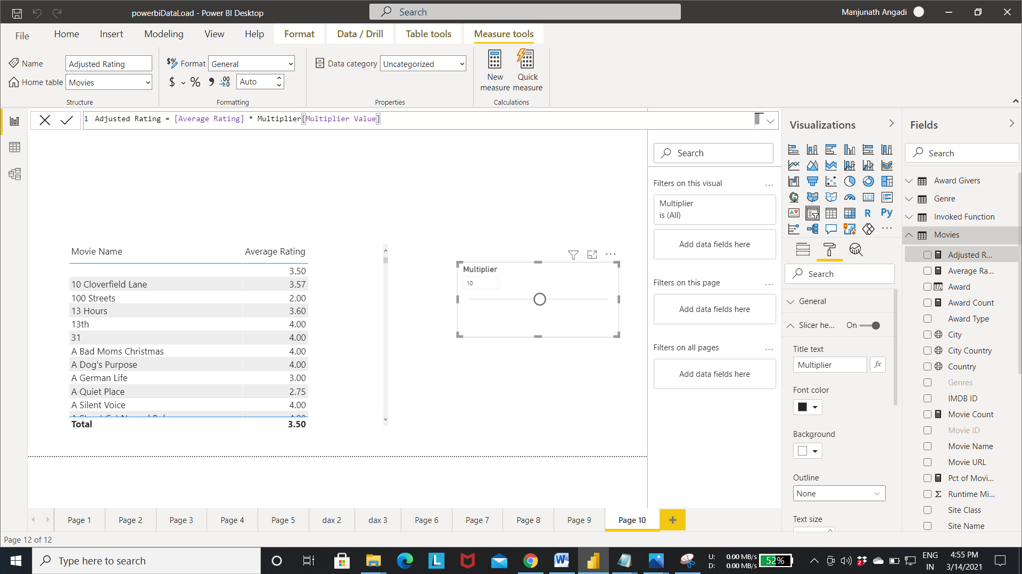

Step 9:- when we change the slicer value to the 10 . we can see the changes in the adjusted rating values.

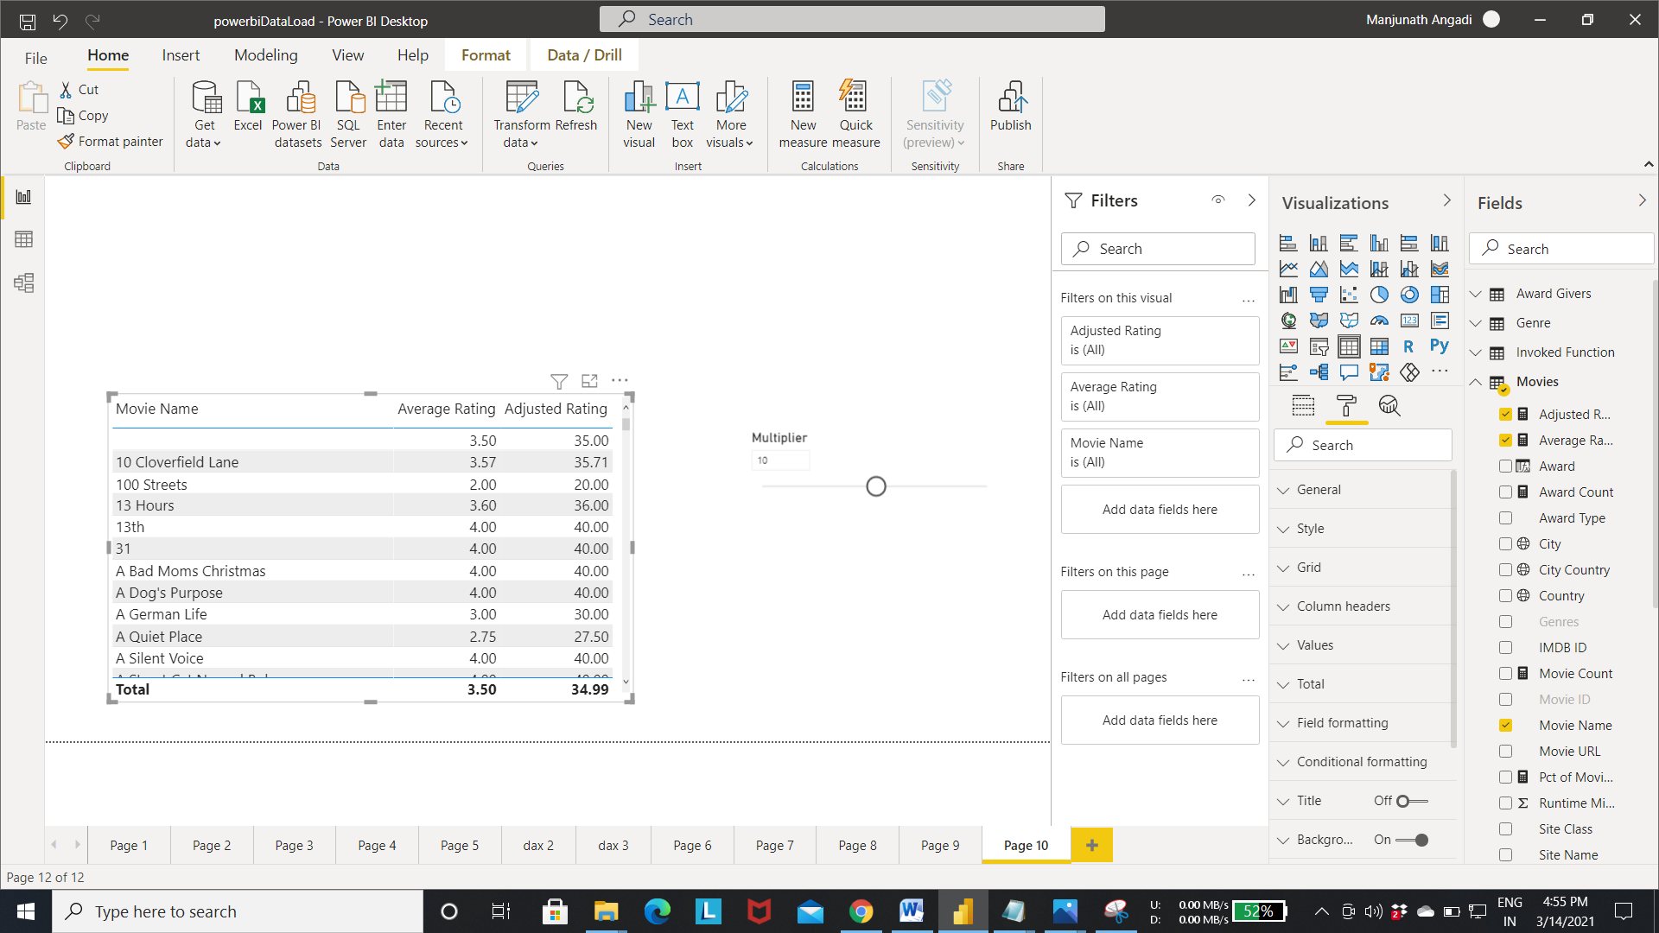

Step 10:- output of Adjusted rating when we change the slicer value to 12.

